1) The middle layer should be implemented as Microservices using Azure AKS
2) The middle layer API should be deployed as containerized application images
3) The container images will use Azure Container Repository (ACR) as the private image repository
4) The CI/CD pipelines for microservices should be implemented using Azure DevOps services.
5) The Azure DevOps should be able to access ACR and download the container images for microservices deployment
6) The image should be deployed as templates such as <image_name>:<build_id>

Steps: CI Pipeline
1. In order to conatinerise application we can to write dockerfile for missle layer api.
2. Sample Docker file name as “Dockerfile” in repo.
3. In build defination we have to create new docker image every time belons to new commited code and push the new docker image to ACR conatiner registry.
4. In order to push & pull image from ACR we have to create serive connection of resource group in which ACR exists.

5. Build an Image step thake Dockerfile path as input and create image, In order to create image
with tag <image_name>:<build_id> we have to mationed it as below.

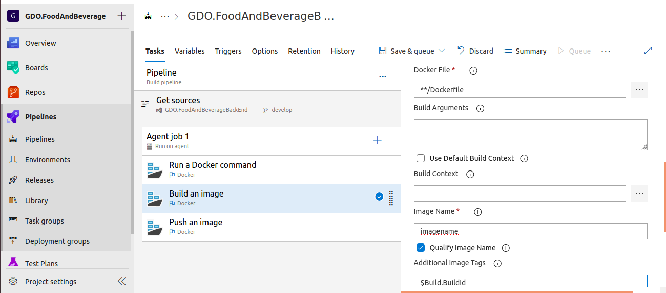
6 once image has created we will push it to ACR regisrty as below.

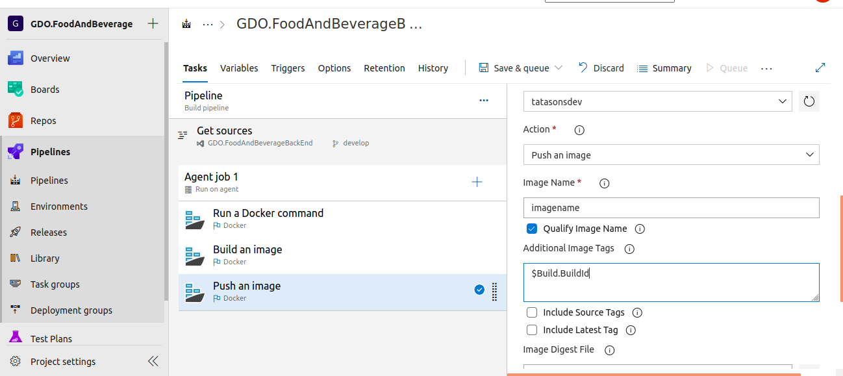

7. In CD pipekine we have to use AKS plugin and in deplyment.yaml file we will provide image name so for evry new deployment it will take lattest image and deployed to AKS cluster.

