1) The build should trigger as soon as anyone in the dev team checks in code to master branch.

Ans: We have to enable trigger on master in branch in CI pipeline as below. So whenever their is commit in master branch CI build pipeline will get trigger.
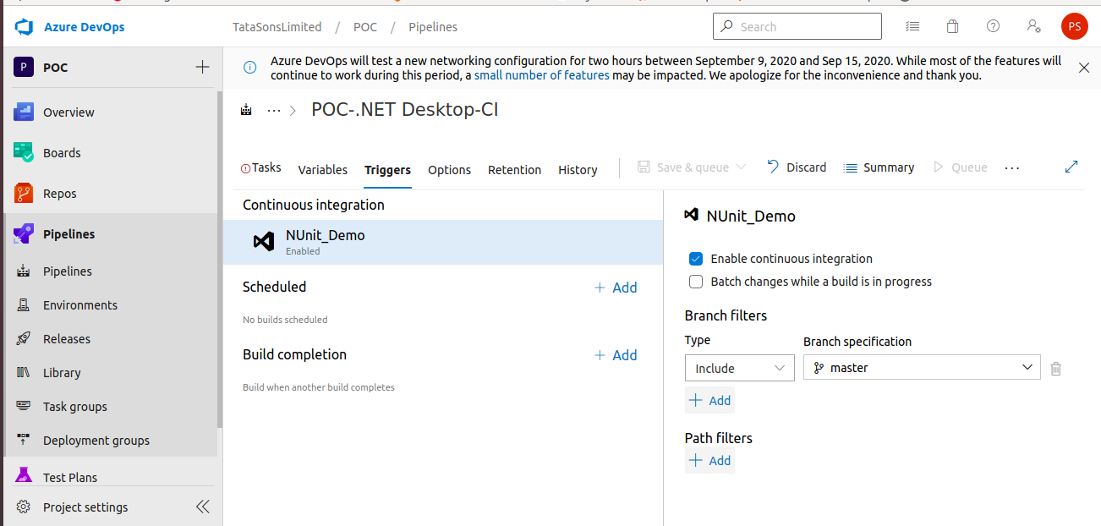

2) There will be test projects which will create and maintained in the solution along the Web and API. The trigger should build all the 3 projects - Web, API and test.
The build should not be successful if any test fails.

Ans:
1. Nuget plugin being used to restore the dependancy packages.
2. Visual studio build solution used to build the web,api & test sln file.
3. Vs Test used to run test cases and stored result in provided path, if any test failed then build will fail.

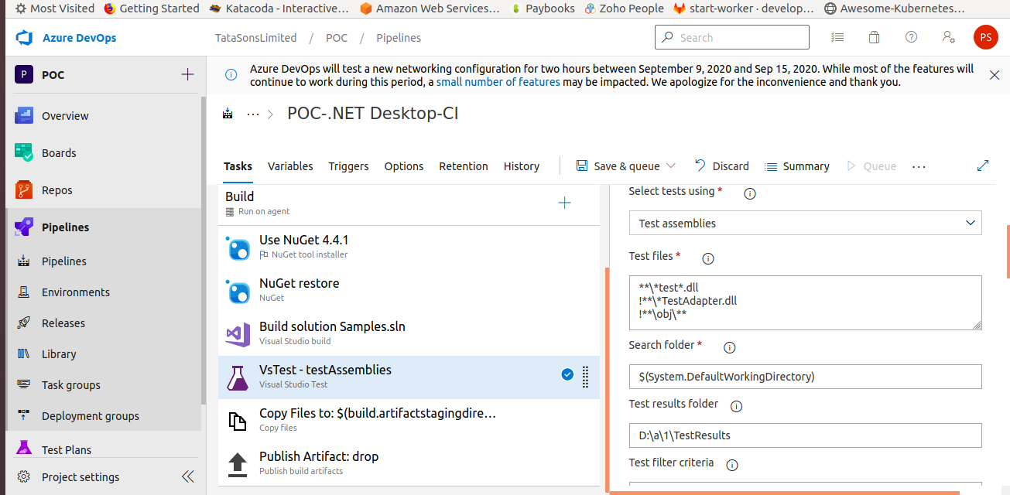

3) The deployment of code and artifacts should be automated to Dev environment.

ANS:
Using continous deployment trigger if Artifact available from master branch then release will get crerate & artifacts deployed to Dev env.

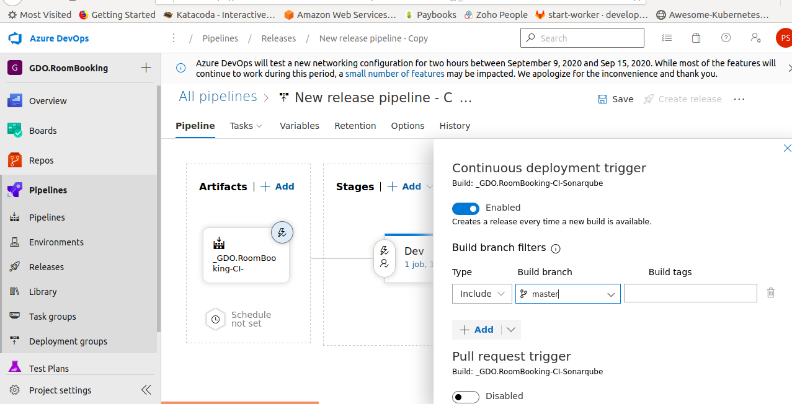
4) Upon successful deployment to the Dev environment, deployment should be easily promoted to QA and Prod through automated process.

ANS:

QA & Prod stage configured as below using after stage configuration, so it will get promoted from Dev to QA and QA to Prod .

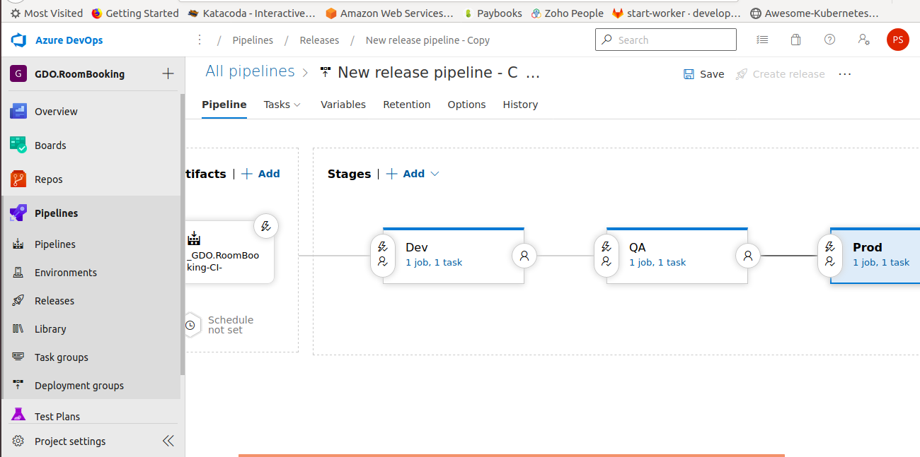

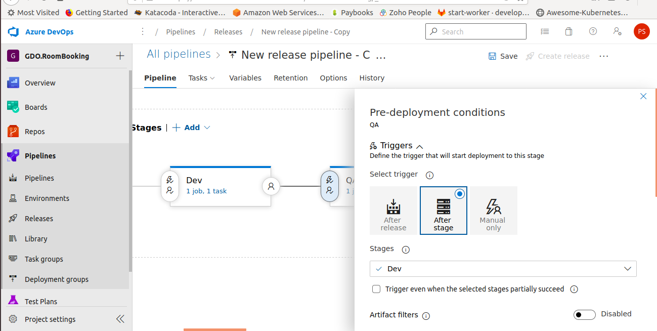
5) The deployments to QA and Prod should be enabled with Approvals from approvers only.

ANS:
We have set Pre-Deployment approver name as below so after approval QA & Prod stage will get start.

