A

Project Report On

“VACCINE MANAGEMENT SYSTEM”

**Submitted By**

**Mr. Pratik Namdev Korane 2020082253**

**Mr. Kiran Ashok Patil. 2020078624**

**Mr. Rohan Ramesh Chavan 2020082228**

**Mr. Prathamesh Shrimant Mali 2020078649**

**Mr. Pratik Jotiram Patil 2020078666**

**Under the Guidance of**



**DEPARTMENT OF COMPUTER SCIENCE AND ENGINEERING**

**Dr. D. Y. Patil Pratishthan’s College of Engineering**

**Shivaji University, Kolhapur**

**2021-2022**

**CERTIFICATE**

*This is to certified that, following are the students of class SE, Computer Science and Engineering, has satisfactorily completed mini project work as per the syllabus of* ***Shivaji University****, Kolhapur, In the subject of* ***OBJECT ORIENTED PROGRAMMING*** *within the given span as per the rules.*

**Name :-**

**Mr. Pratik Namdev Korane**

**Mr. Kiran Ashok Patil.**

**Mr. Rohan Ramesh Chavan**

**Mr. Prathamesh Shrimant Mali**

**Mr. Pratik Jotiram Patil**

**Date –**

Prof. Dr. S. R. Arlimatti

**PROJECT GUIDE H.O.D**

Dr. S. D. Mane Dr. A.M. Mane **PRICIPAL** **CAMPUS DIRECTOR**

### **ACKNOWLEDGMENT**

### I would like to express my special thanks of gratitude to our guide

### **Prof. Vanashri Shinde (Internal guide)** as well as our **HOD** **Dr. Shivaleela Arlimatti** and our **Principal Dr . S. D. Mane** who gave us the golden opportunity to do this research oriented project, which also helped me in doing a lot of research as well as study and We came to know about so many new things related to “**Vaccine Management System”.** I am really thankful to my friends who helped me throughout to complete this project. Secondly I would also like to thank my parents who helped me a lot in finalizing this project within the limited time frame.

**Student Name**

1. **Mr. Pratik Namdev Korane**
2. **Mr. Kiran Ashok Patil.**
3. **Mr. Rohan Ramesh Chavan**
4. **Mr. Prathamesh Shrimant Mali**
5. **Mr. Pratik Jotiram Patil**

**Abstract**

This software project is a traditional vaccine management system with some added functionality. This system is built for fast data processing and record keeping of vaccinated people. The vaccine management system consists of a File Handling and effective front end designed in C++. A vaccinated person when vaccinated is searched from the file handled and its information is displayed on to the screen. The system also contains customizing the number of vaccines i.e we can add vaccines when the lot is available. The vaccine management system is built to help doctors to calculate and display remaining vaccine quantity and to view the vaccinated person’s details by searching by name, age, gender or aadhar number in a faster and efficient manner. This software project consists of an effective to help the doctors in easy management of vaccines.

### **DECLARATION BY STUDENT**

I hereby declare that the Project work entitled “**Vaccine Management System using C++”** completed and written by me has not previously formed the basis for the award of any Degree or Diploma or other similar title of this or any other University or examining body.

**Date:**

**Place:**

**Student Name**

1. **Mr. Pratik Namdev Korane**
2. **Mr. Kiran Ashok Patil.**
3. **Mr. Rohan Ramesh Chavan**
4. **Mr. Prathamesh Shrimant Mali**
5. **Mr. Pratik Jotiram Patil**

**1.Introduction**

Vaccine management system is the system to automate the process of vaccination of a peoples. Vaccines save millions of lives each year. Vaccines work by training and preparing the body's natural defences the immune system to recognize and fight off the viruses and bacteria they target. If the body is exposed to those disease-causing germs later, the body is immediately ready to destroy them, preventing illness.

There are currently several COVID-19 vaccine available in market. Few vaccines are approved for use in INDIA. WHO is working in collaboration with scientists, business, and global health organizations through the ACT Accelerator to speed up the pandemic response. So all safe and effective vaccine founded are allowed to facilitate the equitable access to all the countries and distribution of these vaccines are done to protect people in all countries. People most at risk were prioritized. While we work towards rolling out a safe and effective vaccine fairly, we must continue the essential public health actions to suppress transmission and reduce mortality. Use of this system will reduce efforts of doctors and also save the time of vaccination.

**2. Proposed System Block Diagram**

Admin

Password

Username

Vaccine Mgmt. System

Search

Add Record

Name

Reg. no.

By Age

Gender

By Gender

Age

By Aadhar no.

Profession

B.P

By Phone no.

Body temp

Addr.

Mo. No.

Vaccine name.

**3. Development**

**4.1 Methodology**

1. We collected the Information About the given micro-project topic.
2. We distributed the given work related to the micro-project to all the team members.
3. We discussed about flow of the program in considering the algorithm as were as the flowchart.
4. We executed program in a Visual Studio Code software properly.
5. We have successfully run the program using the C++.
6. We had printout the print of the micro-project.
7. We submitted the project to concerned teacher by taking signature on the report of the Micro-project.

**4.2 Software Requirement details**

## Operating System : Windows 10 Front-end : C++

Languages Used : C++

**4.3 Hardware requirement details**

## Processor : Intel Core i5 Processor

RAM : 8GB(Minimum)

## HDD : 40GB(Minimum)

**4. Data Flow Diagram**

Also known as DFD, Data flow diagrams are used to graphically represent the flow of data in a business information system. DFD describes the processes that are involved in a system to transfer data from the input to the file storage and reports generation.

Data flow diagrams can be divided into logical and physical. The logical data flow diagram describes flow of data through a system to perform certain functionality of a business. The physical data flow diagram describes the implementation of the logical data flow

* **Data Flow Diagram**

**Level 0 DFD**

Person

No. of vaccines

Data Mgmt

Vaccine Management System

* **Data Flow Diagram**

**Level 1 DFD**

Adding Details

Verification of

vaccination

Vaccine Name

Person

availability

of vaccine

* **Data Flow Diagram**

**Level 2 DFD**

Adding Details

Registration

Vaccine Management System

Person

Record Data

Vaccine Data

Admin

**5. Activity Diagram**

An activity diagram is a **behavioural diagram** i.e. it depicts the behaviour of a system. An activity diagram portrays the control flow from a start point to a finish point showing the various decision paths that exist while the activity is being executed.

Start

Username

Admin

Account

Password

Registration

Person

By registration no.

Search

By age

By vaccine

By profession

View vaccine data

Vaccine data

**6. Outputs**

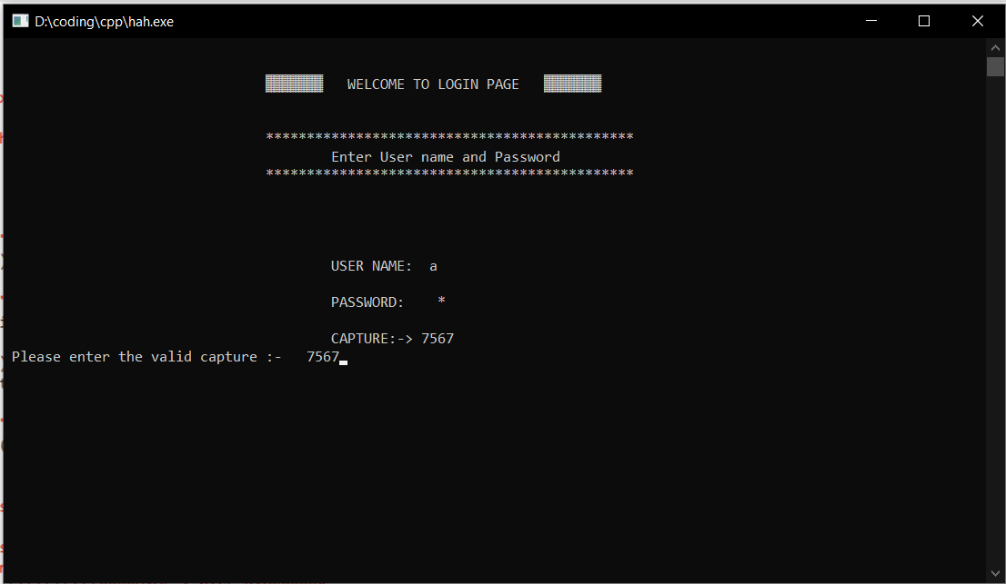

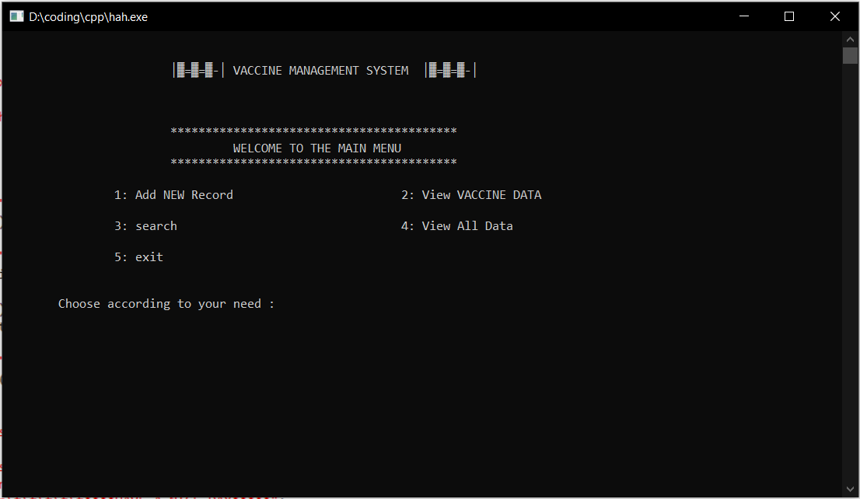

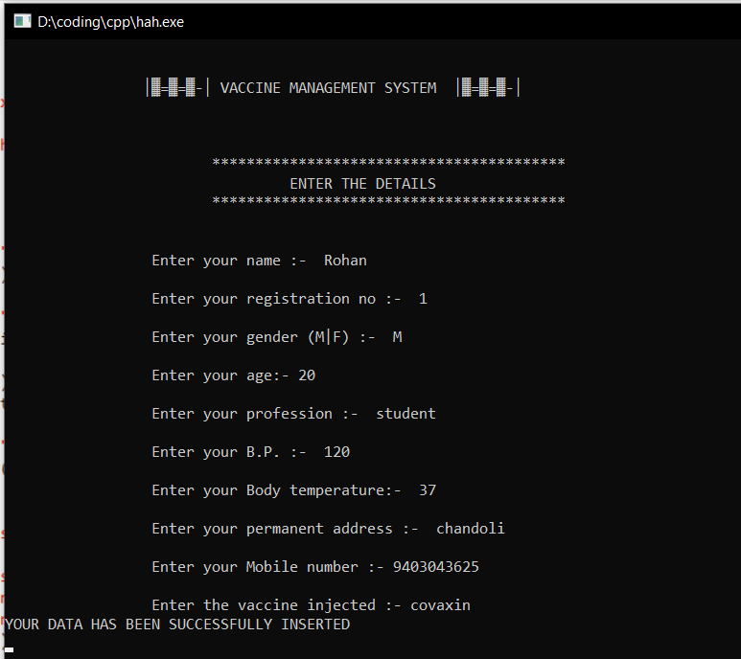

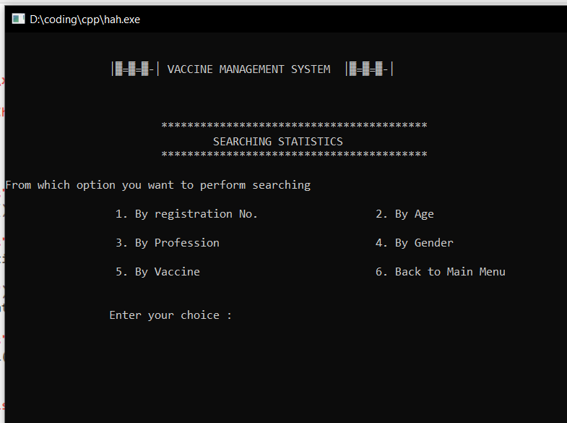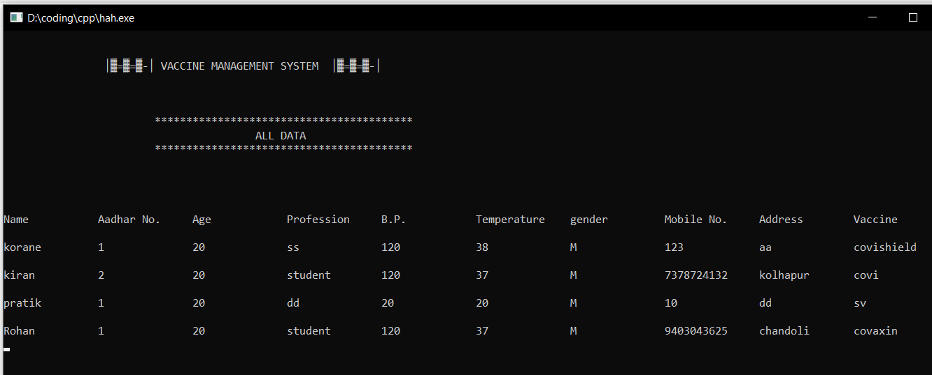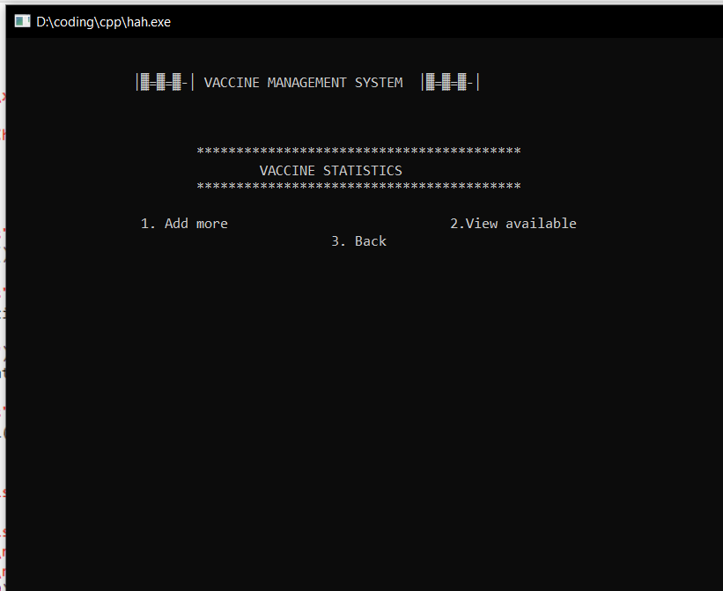

**7. Conclusion**

This software has been developed designed to reduce the time taken to handle the vaccination activity. It is designed to replace an existing manual record system for reducing time taken for calculations and for storing vaccines. This system has been developed with oops concepts. The system is strong to handle daily operations where the database is cleared over certain time. This system will reduce manual work, calculations and will also provide periodic reports any time.

**8. Bibliography**

**Document Reference**

1. https://www.w3schools.com/CPP/.
2. https://www.javatpoint.com/cpp-tutorial.
3. https://www.cdc.gov.in.
4. http://www.cplusplus.org/.
5. https://www.youtube.com