Weapon Detection and Person Tracking

# Pratik Kamble1, Aditya Jadhav2, Gayatri Bagal3, Monali Jamdade4

*Under the Guidance of Prof. Nita Dimble. (Guide)*

# Navsahyadri College of Engineering, Pune, Savitribai Phule Pune University, India

Corresponding Author Tel: 7710097662 Email: [pratikk.co.in@gmail.com](mailto:pratikk.co.in@gmail.com)

**KEYWORDS ABSTRACT**

*Weapon Detection, Person Tracking, ,Public Safety, Transfer learning*

*Deep Learning, YOLOv8, DeepSORT.*

*This paper presents a review of weapon detection and person tracking systems using deep learning techniques. The proposed system utilizes YOLOv8, a state-of- the-art model in object detection, to detect firearms and other weapons, integrated with the DeepSORT algorithm for object tracking. After extensive testing and evaluation, YOLOv8 was found to offer superior accuracy and performance, outperforming alternative models such as YOLOv5 and YOLOv11. Additionally, this system is optimized to detect weapons using a standard webcam, making it adaptable for real-time surveillance. This paper provides a comprehensive overview of the research, objectives, methodology, and current progress, along with future directions for this technology.*

1. Introduction

With increasing concerns over public safety in environments such as airports, schools, and shopping centers, there is a critical need for advanced surveillance systems that can reliably detect weapons and track individuals in real-time.

Traditional surveillance methods relying on human operators are limited by potential fatigue, human error, and delays in response. In response, this study explores the development of an automated weapon detection and person tracking system, leveraging deep learning techniques to provide a real-time, reliable solution. The proposed system integrates YOLOv8, a cutting edge object detection model, with the DeepSORT tracking algorithm [1]. Through extensive testing, YOLOv8 demonstrated the highest accuracy in detecting weapons, outperforming models such as YOLOv5, YOLOv7 [2], and even experimental versions like YOLOv11. This paper highlights the objectives, challenges, and methodologies undertaken to create a robust, real-time surveillance solution capable of adapting to diverse environments and challenges, such as low lighting and crowded scenes.

By optimizing YOLOv8 to operate with a standard web- cam, this system enhances the accessibility and deployability of AI-powered surveillance, with potential applications in both public and private security sectors.

1. Research Elaboration

This section delves into the core modules of the system, including data collection, the weapon detection model using YOLOv8, and person tracking via DeepSORT.

1. *Data Collection and Preprocessing*

Data collection plays a critical role in ensuring the robustness and accuracy of the weapon detection model. For this project, a dataset comprising thousands of images of various weapons, including firearms and knives, was gathered from public databases such as the Custom and Roboflow dataset, as well as specialized collections for security research. The dataset includes diverse scenarios and lighting conditions, to ensure that the model performs well in various environments, from well-lit areas to lowvisibility situations.

Each image was carefully preprocessed, resized, and annotated to define the exact location of weapons within frames. To further enhance the model’s generalization ca- pabilities, data augmentation techniques, such as rotation, scaling, flipping, and brightness adjustments, were applied. These techniques help simulate real-world conditions and improve the model’s robustness, ensuring accurate detection even in crowded and complex scenes. This comprehensive approach to data preparation is crucial to achieving high detection accuracy with YOLOv8 in realtime applications.

1. *Weapon Detection Module Using YOLOv8*

The weapon detection module relies on the YOLOv8 model, chosen after extensive experimentation with various architectures. YOLOv8’s architecture allows for highspeed processing and accurate detection, which is critical for real-time surveillance. Earlier iterations with models like YOLOv5, YOLOv7, and even an experimental YOLOv11 version were tested, but none matched the accuracy and efficiency of YOLOv8. This model was finetuned using transfer learning on the specialized dataset, significantly enhancing detection precision for diverse weapon types.

A key feature of YOLOv8 is its ability to handle complex backgrounds and crowded environments, where false posi- tives can often arise. The model’s high accuracy in detecting even small or partially occluded weapons is particularly valuable for applications in public spaces where fast, re- liable identification is essential. Additionally, the system is configured to work with standard webcams, enabling adapt- ability for both indoor and outdoor scenarios. By leveraging YOLOv8’s strengths in real-time detection and integrating it with live video feeds, the model has proven capable of providing accurate weapon detection across varied settings, establishing its utility for enhanced surveillance.

1. *Person Tracking and System Integration Using Deep- SORT*

To enhance weapon detection capabilities, DeepSORT is employed to track individuals in real-time following the identification of a weapon. DeepSORT is particularly effective for multi-object tracking, as it utilizes both motion information and appearance features to accurately follow individuals across frames, ensuring reliable identification and reducing the occurrence of ID switches. This tracking functionality is essential for monitoring individuals who may be carrying weapons, as it allows security personnel to keep a continuous watch on suspects’ movements, even in crowded environments where individuals might be momentarily obscured or change directions.

Integrating YOLOv8 with DeepSORT creates a seamless, end-to-end system that triggers alerts when a weapon is detected and proceeds to track the individual in real time. The system continuously updates security personnel on the individual’s location, allowing for rapid and informed responses. This combination enhances situational awareness and enables a proactive approach to security by equipping teams with real-time movement insights, allowing them to anticipate suspects’ movements and prepare appropriate responses. This integrated system thus adds significant value to security operations by enabling more dynamic and respon- sive threat management.

1. System Diagrams

The system uses YOLOv8 for weapon detection and DeepSORT for person tracking. It identifies weapons in

images/videos, draws bounding boxes, and tracks the person carrying the detected weapon in real time.

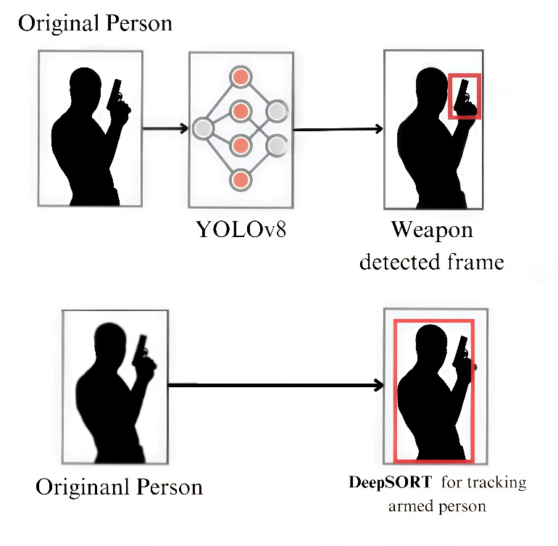

Fig. 1. System Workflow

1. Results

The system effectively detects weapons, estimates the pose of the person carrying the weapon, and tracks them in real-time.

Results:

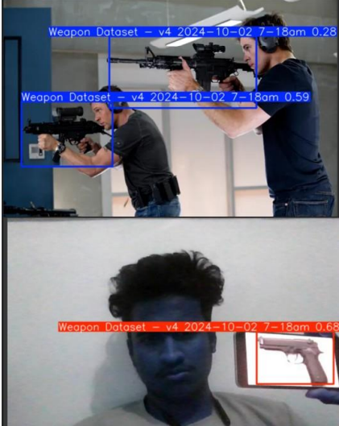

Fig. 2. Detection and Tracking result

**Person Tracking:** Uses DeepSORT to continuously track the individual carrying the weapon, even in crowded envi- ronments.

1. Challenges and Future Work

Although the YOLOv8 and DeepSORT integration has facing issue but the system faces ongoing challenges with environmental variability. Lighting conditions, occlusions, and the presence of non-standard weapon appearances can impact detection accuracy. Future research aims to address these issues by integrating multimodal data, such as thermal and audio inputs, to enhance the detection accuracy in challenging settings.

Additionally, optimizing the system for edge device deploy- ment could further reduce latency and power consumption, making it suitable for deployment on security cameras and other constrained hardware. Another focus for improvement is reducing the model’s computational load, which would enable faster processing without compromising accuracy. These enhancements could significantly improve the scal- ability and effectiveness of the system, particularly in high- density public areas and resource-limited environments.

1. Conclusion

This review presents a robust approach to weapon detec- tion and person tracking by integrating YOLOv8 and B. The use of YOLOv8 offers high detection accuracy and speed, making it ideal for real-time surveillance applications. The model’s compatibility with webcam based detection adds to its flexibility, allowing deployment in various environments. Combined with the DeepSORT, this system provides a seam- less solution for monitoring individuals carrying weapons and continuous tracking to security personnel

References

1. T. Diwan, G. Anirudh, and J. V. Tembhurne, ”Object detection using YOLO: challenges, architectural successors, datasets and applications,” 2021. DOI: 10.1007/s11042-022-13644-y
2. M. T. Bhatti, M. G. Khan, M. Aslam, and M. J. Fiaz, ”Weapon detection in real-time CCTV videos using deep learning,” *IEEE Access*, 2021. DOI: 10.1109/ACCESS.2021.XXXXX.
3. N. Wojke, A. Bewley, and D. Paulus, ”Simple online and realtime tracking with a deep association metric,” in *Proc. IEEE Int. Conf. Image Processing (ICIP)*, 2017. DOI: 10.48550/arXiv.1703.07402.
4. J. Redmon, S. Divvala, R. Girshick, and A. Farhadi, ”You Only Look Once: Unified, real-time object detection,” in *Proc. IEEE Conf. Computer Vision and Pattern Recognition (CVPR)*, 2016. DOI: 10.1109/CVPR.2016.91.
5. A. Demidovskij et al., ”OpenVINO deep learning workbench: Towards analytical platform for neural networks inference optimization,” *J. Phys.: Conf. Ser.*, vol. 1828, 2021.DOI: 0.1088/1742-6596/1828/1/012012.
6. S. Kumar et al., ”Automatic weapon detection in surveillance videos: State-of-the-art, challenges, and future directions,” *ACM Computing Surveys*, 2021. DOI: 10.4018/IJSKD.2020010103.
7. R. Szeliski, *Computer Vision: Algorithms and Applications*, Springer, 2021.DOI: 10.49750/arXiv.1703.07402.
8. BoxYifu Zhang1, Peize Sun2, Yi Jiang3, Dongdong Yu3, Fucheng Weng1”ByteTrack: Multi-Object Tracking by Associating Every Detection ” *Object tracking via ByteTrack*, 2017. DOI: 10.48550/arXiv.2110.06864.
9. malie Perera1., Shehan Senavirathna1., Aseni Jayarathne1., Shamendra Egodawela.,Vehicle Tracking based on an Improved DeepSORT Algorithm and the YOLOv4 Framework,” *arXiv preprint arXiv:1603.00831*, 2016. DOI: 10.48550/arXiv.1703.07402.
10. J. Zhu et al., ”Online multi-object tracking with dual matching attention networks,” in *Proc. European Conf. Computer Vision (ECCV)*, 2018.DOI: 0.1109/ICIAfS52090.2021.9606052.