TECHNICAL DESIGN AND FEASIBILITY REPORT
User-Anchored Local GFlowNet Refinement of a
tsinfer + tsdate Ancestral Recombination Graph
A boundary-aware method for regenerating target-dependent history while conditioning on a fixed exterior
SCIENTIFIC VERDICT The approach is theoretically coherent and practically useful as a conditional local refinement procedure. Exact global-posterior claims require stronger factorization or an explicit correction step.
Working technical design | 20 July 2026
Audience: research collaborators and implementation partners

Contents
The report is organized around the scientific decision first, followed by the trace-to-context algorithm, the probabilistic target, and the evidence required before claiming posterior correctness.
- Executive conclusion and feasibility assessment
- Starting scaffold: what tsinfer + tsdate does and does not mean
- Current implementation status
- User request and cut semantics
- Frontier construction and lineage classes
- Dependency-tracing algorithm
- Boundary contract and splice invariants
- Backward-time GFlowNet formulation
- Conditional prior, likelihood, and terminal reward
- End-to-end procedure
- Scalability and operational safeguards
- Advantages, disadvantages, and failure modes
- Validation program and research roadmap
- Technical appendix
- References

Status labels
Label | Meaning
IMPLEMENTED | Present in the current repository and exercised by structural tests.
PROPOSED | Specified in this report but not yet implemented in the new_rl workflow.
APPROXIMATION | Useful working target whose relationship to the exact global posterior is qualified.
FUTURE | Optional extension after the v1 correctness gates are satisfied.

1. Executive conclusion and feasibility assessment
RECOMMENDATION Proceed with user-anchored dependency tracing as the v1 context-selection mechanism. Treat it as a controlled conditional refinement problem, not as automatic proof that a globally closed CwR subproblem has been found.
The proposed method is scientifically meaningful because it narrows an otherwise enormous ARG search space using a user-chosen locus and historical cut. At the cut, the existing trace provides the active ancestral material. Interval-aware dependency tracing then determines which parts of the older history may be regenerated, which outside participants must be promoted into the mutable problem, and which connections must remain fixed. A GFlowNet can subsequently amortize sampling over the resulting constrained construction space.
The key qualification is that structural locality is not automatically probabilistic independence. Conditioning on a fixed exterior can leave cross-boundary survival or attachment terms that depend on the evolving local state. Therefore the v1 target is best described as a boundary-conditioned local posterior when those terms are represented, or as a restricted local pseudo-posterior when boundary-crossing events are removed by construction. The latter can still be useful for targeted improvement, but it is not identical to sampling a complete ARG from the global coalescent-with-recombination posterior.

Decision summary
- Do use global biological parameters. Effective population size, recombination map, mutation model, and time units remain global model inputs.
- Do compute hazards from the permitted state. The relevant event rate is determined by locally mutable/promoted lineages, ancestral material, and any state-dependent boundary terms - not by an unrelated global lineage count.
- Do retain boundary-crossing lineages. If they cannot be modified, keep them as fixed context and attachment constraints rather than deleting them.
- Do begin with a full spliced-ARG likelihood. It is the safest correctness oracle; local likelihood deltas should be introduced only after parity tests.
- Do not score the synthetic exterior as a realized CwR history. Synthetic routing nodes and deconflicted times are structural devices, not biological events inferred from a full prior.

What success means
A successful first implementation generates multiple valid alternative local histories, reconnects them to the same fixed boundary, improves or diversifies the conditional posterior score, leaves the unauthorized exterior unchanged, and exposes uncertainty around a user-selected locus. It does not need to solve genome-wide posterior ARG sampling in its first version.

2. Starting scaffold: what tsinfer + tsdate does and does not mean

2.1 Li-Stephens copying as a scalable scaffold
tsinfer uses ancestral haplotype matching and the Li-Stephens copying model to infer a succinct tree-sequence topology at very large scale (Li and Stephens, 2003; Kelleher et al., 2019). The output is an efficient estimate of ancestry encoded as local trees and shared edges. This is exactly why it is attractive as an initializer: it supplies a coherent, data-informed scaffold without requiring full posterior ARG inference.
However, the copying construction is not a recorded realization of the continuous-time coalescent with recombination. An internal node can summarize a shared ancestral haplotype or a multifurcating junction. It should not automatically be counted as one binary biological coalescence. Likewise, changes between local trees do not, by themselves, uniquely identify the complete recombination history that generated the data.

2.2 What tsdate adds
tsdate holds the supplied topology fixed and estimates node and mutation times from a molecular-clock model and temporal constraints. Its output provides dated nodes suitable for ordering and temporal initialization (Wohns et al., 2022). Those point estimates remain uncertain, especially for weakly informed or ancient nodes, so a user-selected event time should be treated as a cut coordinate and subjected to neighboring-cut sensitivity analysis.
TERMINOLOGY RULE Call original internal nodes ancestral junctions unless the representation proves they correspond to a biological coalescence. Call inserted paired nodes synthetic routing splits, not inferred recombination events.

2.3 Why a scaffold can still support refinement
Posterior refinement does not require the initializer itself to be drawn from the final target. Optimization, MCMC, sequential Monte Carlo, and GFlowNet methods routinely start from approximate configurations. What matters is that the refined state space, transition rules, boundary conditions, and scoring distribution are defined consistently. The scaffold supplies a high-quality location in graph space; the local method supplies uncertainty and alternatives around that location.

3. Current implementation status
The current new_rl package implements deterministic structural conversion and backward replay. User-anchored dependency tracing, boundary-aware local GFlowNet reconstruction, and conditional posterior scoring are not yet implemented in this workflow. The table below is the authoritative status split for this report.
Component | Status | Role in the proposed method
synthetic_full_arg.py | IMPLEMENTED | Adds explicit paired routing nodes, unique trace times, sanitized mutation times, and provenance.
trace.py | IMPLEMENTED | Builds the compact event schedule and reversible active-material frontier used to resolve a user cut.
normal_ts_edge_closed_regions.py | EXPLORATORY | Automatic structural region proposals; not required by the user-anchored v1 workflow.
exact_closed_cones.py | EXPLORATORY | Exact witness experiments and a possible future oracle for validating selected contexts.
User-anchored dependency tracing | PROPOSED | Maps a user interval and event/time to mutable, promoted, boundary, and exterior classes.
Local GFlowNet + conditional reward | PROPOSED | Regenerates target-dependent history and samples in proportion to a qualified local target.

REPRODUCIBILITY SNAPSHOT On 20 July 2026, the repository collected 45 tests under arg/new_rl/tests and the suite completed successfully in the phylogfn_311 Python 3.11 environment. These are structural tests; they do not yet validate the proposed local posterior.

3.1 Why the synthetic trace is still useful
The synthetic trace turns a tree sequence into a deterministic sequence of reveal, junction, and routing operations. Its active frontier records which node identifiers currently carry which half-open material intervals. That is exactly the information needed to resolve the state at a user-selected time and to project ancestral material onto a genomic range. The trace is therefore a structural indexing device, not a biological training trajectory.

4. User request and cut semantics
PROPOSED INTERFACE The operational selector is a user-supplied half-open genomic interval plus either a trace event identifier or a time. Automatic closed-cone discovery is not a prerequisite.
RefinementRequest(
genomic_range=[left, right),
cut_event_id=<event id> | cut_time=<time>,
cut_side="before"
)

4.1 Event identifiers
An event identifier resolves to the trace state immediately before the selected event. This convention makes the selected event and all older target-dependent events eligible for regeneration. The context records both the selected event index and the resolved cut step so there is no off-by-one ambiguity.

4.2 Numeric times
For a numeric time t*, order trace events from younger to older and choose the state before the first event whose trace time is greater than or equal to t*. In array notation, cut_step = searchsorted(event_time, t*, side="left"). Report the next event index, its trace time, the current frontier time, and the time discrepancy. If the request is older than the terminal trace or younger than time zero, reject it with a clear range error.
cut_step = min { j : event_time[j] >= t* }

4.3 Time is a coordinate, not ground truth
The cut is defined on the dated synthetic trace. Deconflicted and midpoint times make event ordering deterministic, but those inserted values do not become biological observations. A robust analysis repeats refinement at neighboring event indices or over a time interval representing tsdate uncertainty.

5. Frontier construction and lineage classes
At the resolved trace step, let M_i be the union of ancestral-material intervals carried by active lineage i and let R be the user interval. The target projection is:
M_i^target = M_i ∩ R
Every lineage with nonempty target projection seeds the dependency analysis. Crucially, a node does not have a single genomic position. Inside/outside decisions must be made using the intervals on edges or carried material. If a seeded lineage also carries material outside R, that outside portion remains visible as a frozen tether unless the dependency rules explicitly promote it.
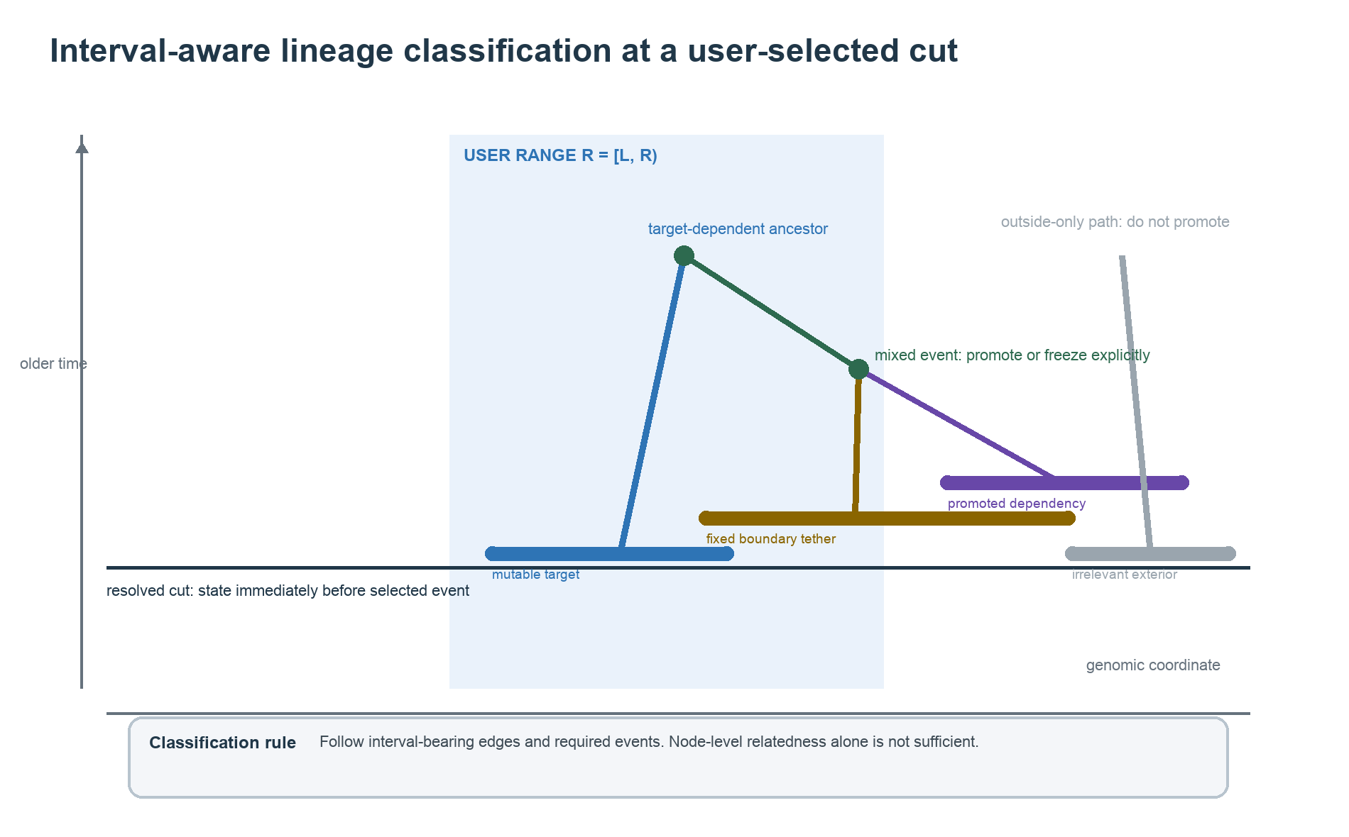
Figure 1. Interval-aware lineage classification. Target-dependent ancestry is followed through material-bearing edges; node-level relatedness alone does not trigger promotion.
Class | Mutable? | Included in state? | Definition
Mutable target | Yes | Yes | Carries target material and its authorized local history may be regenerated.
Promoted dependency | Yes, as required | Yes | Initially outside the seed set but needed to represent a target-bearing event.
Fixed boundary | No | Yes, as context | Connects local history to the frozen exterior and supplies legal terminal attachments.
Irrelevant exterior | No | No | Has no interval-aware target dependency and remains unchanged in the source ARG.

6. Dependency-tracing algorithm
CORE CORRECTION A lineage that overlaps the target but reaches unauthorized exterior ancestry is not deleted. It becomes fixed boundary context unless the relevant mixed event must itself be regenerated, in which case the required participant is promoted.

6.1 Invariant
At every older event, the context must contain enough information to reproduce all ancestry of the target material and to reconnect a regenerated history to the unchanged exterior. The algorithm follows interval-bearing dependencies, not all ancestors or descendants of a node. This avoids the common failure mode in which ordinary graph reachability expands to the root and turns a local request into a global one.

6.2 Event scan
- Resolve the trace state. Materialize the full active frontier at cut_step.
- Seed target material. For each lineage, compute M_i ∩ R and retain nonempty projections.
- Scan older events. Visit events from cut_step toward older time while maintaining the dependency set.
- Include target-bearing transitions. Select events that carry, join, or split currently dependent material.
- Promote only when necessary. Add an outside participant when a selected event cannot be represented without it.
- Freeze legal exits. Record a nonmutable parent or partner as a boundary attachment when propagation can stop without losing target ancestry.
- Fail explicitly on unresolved coupling. Reject the context when neither promotion nor a fixed attachment preserves the splice contract.
- Summarize complexity. Report selected events, mutable/promoted/boundary counts, segment counts, and candidate-action estimates.

6.3 Promotion, freezing, and rejection
Observed event relation | Decision | Reason
All target-bearing participants already dependent | Include | The event is internal to the current mutable dependency set.
Required participant is outside the seed set but carries/produces target material | Promote | The event cannot be regenerated validly without that participant.
Outside participant is a legal, unchanged attachment | Freeze | Condition on the participant and stop propagation along the exterior branch.
Connection exists only on material outside R | Ignore | Node-level relatedness alone is not a target dependency.
Mixed event would require unauthorized exterior changes | Reject context | Silent omission would produce an invalid splice or incorrect probability.

state = trace.state_at_step(cut_step, include_active=True)
dependent = {l : material(l) intersects user_range}
for event in trace.events[cut_step:]:
relation = interval_aware_relation(event, dependent, user_range)
if relation.is_internal: include(event)
elif relation.requires_participant: promote(relation.participant)
elif relation.is_fixed_attachment: freeze(relation.attachment)
elif relation.changes_unauthorized_exterior: reject_with_diagnostics()

7. Boundary contract and splice invariants
The boundary is not merely a list of node identifiers. It is a typed contract describing fixed lineages, the material intervals through which they attach, lower and upper time constraints, and the events or edges that must remain unchanged. This contract is part of both the action mask and the terminal validity test.

7.1 Required boundary fields
- Fixed node identifier and fixed time, or an explicitly allowed attachment-time interval.
- Half-open genomic intervals governed by each attachment.
- Direction and role of the connection: fixed parent, fixed child-side anchor, or fixed event partner.
- Exterior node, edge, site, mutation, and provenance identifiers that must remain unchanged.
- Allowed multiplicity: whether one or several regenerated lineages may attach to the boundary object.

7.2 Terminal validity
A sampled local history is terminal only when every target segment has the required ancestry, every boundary attachment is satisfied exactly once according to its multiplicity, all node-time inequalities hold, no active target material remains unresolved, and the combined tables form a valid tree sequence or augmented ARG representation.

7.3 Exterior invariance
After splicing, compare the candidate against the source representation outside the authorized edge/event set. Nodes, edges, sites, mutations, populations, individuals, times, and metadata in the exterior should be identical after stable sorting. A cryptographic or canonical table digest is a convenient regression check, but structural equality remains the scientific invariant.

8. Backward-time GFlowNet formulation
The local problem is naturally a directed acyclic construction process. Starting from the younger frontier at the cut, each action moves backward in time and adds one valid ancestral event. A terminal object is a complete local history satisfying the fixed boundary. This matches the compositional-object setting for which GFlowNets were developed (Bengio et al., 2023) and parallels the bottom-up construction used by PhyloGFN for trees (Zhou et al., 2024), with the additional complications of recombination and genomic material.

8.1 State
s_t = (A_t, M_t, T_t, P_t, B, H_t)
A_t is the ordered collection of mutable and promoted active lineages; M_t records their material intervals; T_t records current time and node-time bounds; P_t contains sequence-likelihood partials; B is the immutable boundary contract; and H_t records the constructed local events needed for inversion, splicing, and backward-policy evaluation. Fixed boundary lineages may be encoded as separate context tokens so they influence decisions without appearing as freely mutable actions.

8.2 Actions
Action | Parameters | Validity requirements
Coalescence | lineage pair; event time | Permitted pair, time older than both children, material update consistent with the chosen ARG model.
Recombination | lineage; breakpoint; event time | Breakpoint lies in permitted ancestral material and produces nonempty valid parents.
Boundary attachment | local lineage; boundary anchor; time if variable | Attachment role, interval, multiplicity, and time constraints all satisfied.
Stop | none | All target material resolved and all required boundary attachments completed.

8.3 Policy versus biological prior
The learned forward policy is a proposal/construction distribution, not the biological prior. It may deliberately oversample rare high-reward actions to explore modes. GFlowNet correctness is defined by flow constraints and the terminal reward, not by forcing the policy at each step to equal a coalescent prior. Prior-derived features and proposal initialization can still improve learning.

8.4 Training objective
Trajectory Balance can train from complete local trajectories. Subtrajectory objectives can reuse partial segments, but partial rewards must be accounting devices whose terminal correction recovers the exact chosen terminal log reward. If multiple action orderings generate the same terminal ARG, backward probabilities and state canonicalization must account for that multiplicity.

9. Conditional prior, likelihood, and terminal reward

9.1 Target distribution
Let C denote the regenerated local history, O the frozen exterior, B the explicit boundary contract, and D the sequence data. The desired conditional target is:
p(C | O, B, D) ∝ p(D | C, O, B) p(C | O, B)
Because O and B are fixed within one refinement request, terms depending only on them are constants. Terms that change with the number, material, or times of local lineages are not constants and must remain in the score.

9.2 Global parameters, local state
Use the same effective population-size history N_e(t), recombination map r(x), mutation model, sample ploidy convention, and time scale as the intended global model. Compute the instantaneous local coalescence hazard by summing the pairwise hazard over the coalescence actions actually permitted by the local representation. Compute the recombination hazard by integrating or discretely summing r(x) over the currently eligible ancestral material. Do not use a global total hazard while allowing only local actions; that would assign survival probability to events that the local process cannot choose.
λ_local(s,t) = λ_coal,allowed(s,t) + λ_recomb,allowed(s,t) + λ_boundary(s,t)

9.3 Cross-boundary terms
Fixed outside-only event densities cancel in a conditional ratio. Cross-boundary hazards require more care: the probability that no local-outside interaction occurs can depend on the evolving local lineage count and material. If the model gives these interactions zero rate by construction, state that restriction. If they are possible under the global CwR, include their survival contribution, represent them as boundary actions, or apply a correction. Omitting a state-dependent cross hazard while calling the result exact is not justified.

9.4 Terminal reward
log R(C) = log p(D | G_spliced) + log p_local(C | B,O; N_e,r) + constant
The complete spliced-ARG likelihood is the recommended v1 oracle because it automatically includes any data contribution affected by changed trees, branch lengths, or mutation placement. Once an optimized affected-region calculation matches this oracle across randomized local edits, the full calculation can be replaced by a cached exterior constant plus a local likelihood delta.

9.5 Avoiding prior double counting
Accounting design | During construction | At terminal
Incremental prior | Accumulate event-choice and waiting-time log-prior increments. | Add sequence likelihood and any boundary/terminal correction only.
Terminal prior | Do not add prior increments to the reward state. | Evaluate the complete local conditional prior plus likelihood once.
Forward-looking/SubTB | Use partial terms for credit assignment. | Set correction = final target - accumulated partial reward.

APPROXIMATION LABEL If boundary-crossing interactions are excluded by the local action definition rather than derived from the conditional global model, call the reward a restricted local pseudo-posterior. It may be useful, but the qualifier is scientifically important.

10. End-to-end procedure
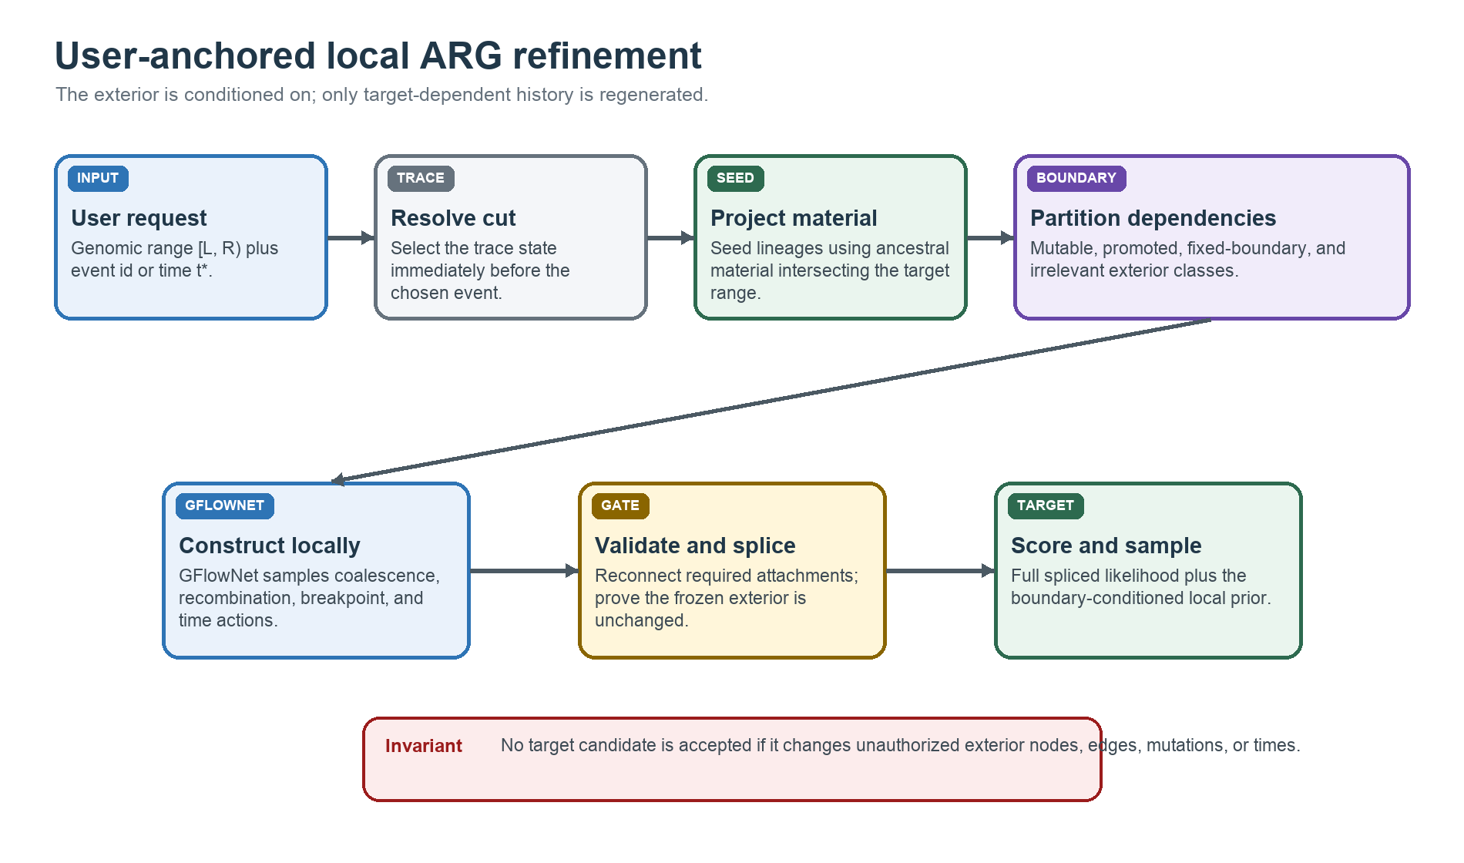
Figure 2. User-anchored refinement workflow. The trace defines a cut and dependency-aware boundary; the GFlowNet regenerates only authorized history before splicing and scoring.
- Infer and date the scaffold. Run tsinfer and tsdate, retain uncertainty summaries when available, and preserve the original tree sequence.
- Create the structural trace. Convert to the deterministic synthetic representation and build the reversible active-material trace.
- Resolve the request. Validate [L,R), map the event/time to cut_step, and materialize the frontier.
- Build the dependency context. Seed target material, scan older events, promote required participants, and freeze legal boundary attachments.
- Run preflight checks. Reject invalid or near-global contexts before allocating GFlowNet training resources.
- Construct alternative histories. Sample valid coalescence, recombination, time, breakpoint, and attachment actions backward in time.
- Validate and splice. Check local graph validity, boundary completeness, time constraints, and exterior invariance.
- Score. Evaluate full data likelihood plus the selected local conditional prior accounting.
- Sample or correct. Use GFlowNet terminal samples directly for the declared target, or apply MH correction when exactness under a separate target is required.
- Summarize uncertainty. Report posterior distributions for local trees, times, breakpoints, and other locus-specific quantities instead of only the best ARG.

11. Scalability and operational safeguards
The genomic width of the user interval is not the main computational predictor. A short locus can connect to many lineages and events at an old cut, while a longer recent interval can remain simple. Preflight complexity should therefore be based on the induced dependency state.

11.1 Primary cost drivers
Driver | Why it matters | Diagnostic
Active lineage count k | Coalescence candidates can grow approximately quadratically in k. | Mutable + promoted + attachable boundary counts.
Material segments m | Breakpoint choices and overlap checks scale with fragmented ancestral material. | Segment count and total eligible material.
Selected event depth e | Controls trajectory length and the number of possible histories. | Events scanned and events included.
Boundary size b | Adds context tokens, attachment actions, and cross-boundary accounting. | Fixed anchors and mixed events.
Likelihood footprint v | Determines the cost of recomputing affected site/tree likelihoods. | Affected variants, trees, and cached partials.

11.2 Recommended safeguards
- Preflight before training. Materialize the context and report k, m, e, b, candidate coal pairs, recombination choices, and estimated memory.
- Warn on closure expansion. A target that recruits a substantial fraction of global lineages or events is no longer operationally local.
- Fail instead of truncating dependencies. An arbitrary cap that drops required participants creates invalid or biased contexts.
- Cache fixed exterior contributions. Likelihood partials and outside-only prior constants should be reused across candidates.
- Batch action scoring. Transformer encodings, candidate features, and terminal likelihoods should be vectorized across trajectories.
- Use coarse-to-fine time and breakpoints. Begin with defensible discretization, then refine continuous variables around high-flow regions.

11.3 Best- and worst-case behavior
Best case: a recent cut, few target-bearing lineages, limited recombination, and a small fixed boundary. The local state is dramatically smaller than the full ARG and repeated posterior sampling can amortize training cost. Worst case: an old cut with fragmented material and repeated mixed events; promotion cascades toward the root and the dependency context becomes nearly global. The method remains conceptually valid, but loses its computational advantage.

12. Advantages, disadvantages, and failure modes
Advantages | Disadvantages and risks
Direct control over the locus and historical depth. | Dependence on the initial tsinfer + tsdate scaffold and chosen cut.
No automatic closed-cone discovery required for v1. | Unrestricted relatedness can expand to most of the ARG.
Reuses the implemented reversible event trace. | Dropping boundary-crossing lineages invalidates splicing and probability.
Targets suspicious loci or uncertain events. | A single tsdate event time can be unstable or weakly informed.
Produces a deterministic, auditable context. | Synthetic routing topology and midpoint times are representation-dependent.
Scales well when dependency closure remains small. | A short interval can still have a large old-time frontier.
Separates mutable history from the frozen exterior. | Structural selection does not automatically imply CwR factorization.

12.1 Failure-mode register
Failure mode | Consequence | Required response
Node-only reachability | Context expands to ancient/global ancestry. | Use edge intervals and carried material for dependency decisions.
Silent boundary deletion | Candidate cannot be spliced or has the wrong likelihood. | Freeze the lineage or reject the request.
Filtered actions with global hazard | Waiting-time density is inconsistent with available actions. | Use allowed-state hazards plus justified boundary terms.
Whole-synthetic-ARG prior | Arbitrary routing events/times receive biological probability. | Score only the declared local conditional model.
Time-cut instability | Results change sharply at a neighboring event. | Run adjacent-cut and time-interval sensitivity analyses.
Action-order multiplicity | Terminal objects receive unintended flow weight. | Canonicalize states or model backward parent multiplicity.
Approximate local likelihood drift | Optimized reward no longer matches the oracle. | Maintain randomized parity tests against the full likelihood.

13. Validation program and research roadmap

13.1 Structural validation
Scenario | Expected classification/behavior | Acceptance check
Exact event id | Cut immediately before the chosen event. | Resolved step and event match the request.
Time between events | Cut before the first event at or older than t*. | Search rule and discrepancy are reported.
Target-only lineage | Mutable target. | Target projection is nonempty.
Target lineage with outside ancestry | Fixed boundary unless the mixed event must be regenerated. | Lineage remains visible; never silently deleted.
Required outside participant | Promoted dependency. | Selected event is representable after promotion.
Outside-only relation | Irrelevant exterior. | No promotion through nonoverlapping edge material.
Unresolvable mixed event | Invalid context. | Diagnostic names the event and forbidden exterior change.
Near-global expansion | Warning or refusal before training. | Complexity summary crosses a declared policy threshold.
Terminal candidate | All attachments satisfied. | No unresolved target material or missing boundary anchor.
Spliced candidate | Exterior unchanged. | Canonical table comparison passes.

13.2 Probabilistic validation
- Tiny exact cases. Enumerate all valid local histories for very small ARGs and compare normalized GFlowNet frequencies with the declared reward distribution.
- Prior unit tests. Compare each event-choice, breakpoint, waiting-time, and boundary-survival term with a hand calculation.
- Likelihood parity. Compare full spliced likelihoods with cached-exterior plus local-delta likelihoods over randomized edits.
- Posterior calibration. Simulate ARGs and sequences under the assumed model; measure credible-interval coverage for local topology, event time, TMRCA, and breakpoints.
- Baseline comparison. Compare with the initial tsinfer + tsdate point estimate, prior sampling, a local MCMC kernel, ARGweaver/ARGinfer where feasible, and SINGER-style posterior sampling at supported scales.
- Sensitivity. Repeat over neighboring cuts, interval padding, demographic parameters, and synthetic split rules.

13.3 Performance validation
Measure preprocessing time, context size, actions per state, rollout length, terminal validity rate, reward-evaluation time, training throughput, effective sample diversity, and peak memory. Report results as functions of k, m, e, b, and affected variants rather than only base-pair span. This makes it possible to predict when a user request will be tractable.

13.4 Staged research roadmap
Stage | Deliverable | Scientific gate | Scale
0. Context builder | RefinementRequest -> RefinementContext with diagnostics. | Hand-built classification cases and exterior invariance pass. | Toy + 25 kb
1. Exact tiny sampler | Enumerated local target and GFlowNet sampler. | Sample frequencies match exact normalized rewards. | Very small ARGs
2. Full-likelihood v1 | Boundary-aware local GFlowNet with oracle reward. | High terminal validity and reproducible posterior summaries. | 25 kb
3. Optimized scoring | Cached exterior and local likelihood deltas. | Numerical parity with full likelihood. | 25 kb to 1 Mb
4. Corrected inference | Optional MH correction or rigorously derived conditional prior. | Calibration under simulation and robust sensitivity results. | Selected loci

14. Technical appendix

14.1 Notation
Symbol | Meaning
R = [L,R) | User-defined half-open genomic interval.
t* | Requested event time or trace-time coordinate.
M_i | Ancestral material carried by active lineage i.
C | Regenerated local ARG history.
O | Frozen exterior ARG.
B | Boundary lineages, interval attachments, and constraints.
D | Observed sequence data.
G_spliced | Complete ARG/tree sequence after inserting C into O.
N_e(t) | Effective population-size history used by the prior.
r(x) | Per-position recombination map.

14.2 Proposed conceptual context schema
RefinementContext(
requested_range, requested_cut, resolved_cut_step, resolved_cut_time,
mutable_lineages, promoted_dependency_lineages,
fixed_boundary_lineages, boundary_attachments,
selected_events, target_material_intervals, excluded_exterior,
validity_diagnostics, complexity_summary
)

14.3 Minimum correctness claims
- The trace state at the resolved cut matches the original synthetic tree sequence.
- Every selected event is connected to target material through interval-aware dependencies.
- Every excluded object is either irrelevant to target material or preserved through a fixed boundary attachment.
- Every accepted terminal history can be spliced into a valid full representation.
- The exterior is unchanged after splicing.
- The reported reward corresponds exactly to the declared conditional or restricted target.
- Synthetic nodes and times are never misrepresented as biological observations.

14.4 Relationship to local ARG samplers
Local or bridge-based ARG inference has precedent: Arbores conditions on flanking trees so that an intervening bridge can be sampled locally, while ARGweaver and SINGER use threading or re-threading operations to update parts of an ARG (Heine et al., 2019; Rasmussen et al., 2014; Deng et al., 2025). The present proposal differs in selecting the subproblem jointly by genomic material and a backward-time cut, then amortizing constrained construction with a GFlowNet. These precedents support feasibility but do not automatically prove the proposed boundary factorization.

15. References
Bengio, Y., Lahlou, S., Deleu, T., Hu, E. J., Tiwari, M., and Bengio, E. (2023). GFlowNet Foundations. Journal of Machine Learning Research 24(210), 1-55. JMLR article
Deng, Y., Nielsen, R., and Song, Y. S. (2025). Robust and accurate Bayesian inference of genome-wide genealogies for hundreds of genomes. Nature Genetics 57, 2124-2135. Nature Genetics article
Heine, K., Beskos, A., Jasra, A., Balding, D., and De Iorio, M. (2019). Bridging trees for posterior inference on ancestral recombination graphs. Bioinformatics. Article record
Hudson, R. R. (1983). Properties of a neutral allele model with intragenic recombination. Theoretical Population Biology 23, 183-201. Publisher record
Kelleher, J., Wong, Y., Wohns, A. W., Fadil, C., Albers, P. K., and McVean, G. (2019). Inferring whole-genome histories in large population datasets. Nature Genetics 51, 1330-1338. Open-access article
Li, N., and Stephens, M. (2003). Modeling linkage disequilibrium and identifying recombination hotspots using single-nucleotide polymorphism data. Genetics 165, 2213-2233. Genetics article
Mahmoudi, A., Koskela, J., Kelleher, J., Chan, Y.-B., and Balding, D. (2022). Bayesian inference of ancestral recombination graphs. PLOS Computational Biology 18, e1009960. Open-access article
Rasmussen, M. D., Hubisz, M. J., Gronau, I., and Siepel, A. (2014). Genome-wide inference of ancestral recombination graphs. PLOS Genetics 10, e1004342. Open-access article
Wohns, A. W., Wong, Y., Jeffery, B., et al. (2022). A unified genealogy of modern and ancient genomes. Science 375, eabi8264. Science article
Zhou, M., Yan, Z., Layne, E., Malkin, N., Zhang, D., Jain, M., Blanchette, M., and Bengio, Y. (2024). PhyloGFN: Phylogenetic inference with generative flow networks. International Conference on Learning Representations. ICLR paper

Repository sources consulted
The implementation-status descriptions in this report are based on arg/new_rl/README.md, synthetic_full_arg.py, trace.py, normal_ts_edge_closed_regions.py, exact_closed_cones.py, and the tests under arg/new_rl/tests. The proposed user-anchored context builder and local GFlowNet layer are intentionally not described as implemented.

