LOGISTICS DATA ANALYST INTERNSHIP
WEEK 4 — PREDICTIVE MODELING AND OPTIMIZATION
TwoWheel Express — Thane–Mumbai Last-Mile Logistics
Prepared by: Pratik Khose
MBA in Data Science and Business Analyst

1. Objective
Week 4 focuses on using the insights from Week 3 to build a predictive model and propose logistics optimization strategies. The objective is to predict delivery time, evaluate model performance, identify important factors affecting delivery outcomes, and recommend ways to improve operational efficiency and reduce costs.

2. Problem Definition
For the TwoWheel Express logistics scenario, the main predictive problem is to predict delivery time based on logistics factors such as distance, traffic level, vehicle type, order weight, weather, and delivery zone. Predicting delivery time can help the logistics team estimate expected delivery duration and identify orders that may require additional attention.

3. Feature Selection
Potential input variables from the previous weeks include distance_km, order_weight_kg, traffic_level, vehicle_type, weather, and zone. The target variable is delivery_time_min.

4. Modeling Approach
The Week 4 workflow uses a train-test split and compares Linear Regression with Random Forest Regression. Categorical variables are encoded using OneHotEncoder, while numerical variables are passed through the preprocessing pipeline.

5. Complete Python Implementation
import pandas as pd
import numpy as np
from sklearn.model_selection import train_test_split
from sklearn.compose import ColumnTransformer
from sklearn.preprocessing import OneHotEncoder
from sklearn.pipeline import Pipeline
from sklearn.ensemble import RandomForestRegressor
from sklearn.linear_model import LinearRegression
from sklearn.metrics import mean_absolute_error, mean_squared_error, r2_score
import matplotlib.pyplot as plt
import seaborn as sns

# Load Week 2 cleaned dataset
df = pd.read_csv("week2_cleaned_logistics.csv")

# Features and target
features = [
"distance_km",
"order_weight_kg",
"traffic_level",
"vehicle_type",
"weather",
"zone"
]
target = "delivery_time_min"

features = [c for c in features if c in df.columns]
model_df = df[features + [target]].dropna()

X = model_df[features]
y = model_df[target]

# Identify column types
categorical_features = X.select_dtypes(include=["object"]).columns.tolist()
numeric_features = X.select_dtypes(include=["int64", "float64"]).columns.tolist()

# Preprocessing
preprocessor = ColumnTransformer([
("categorical", OneHotEncoder(handle_unknown="ignore"), categorical_features),
("numeric", "passthrough", numeric_features)
])

# Train-test split
X_train, X_test, y_train, y_test = train_test_split(
X, y, test_size=0.20, random_state=42
)

# Linear Regression
linear_model = Pipeline([
("preprocessor", preprocessor),
("model", LinearRegression())
])
linear_model.fit(X_train, y_train)
linear_predictions = linear_model.predict(X_test)

# Random Forest
random_forest_model = Pipeline([
("preprocessor", preprocessor),
("model", RandomForestRegressor(n_estimators=200, random_state=42))
])
random_forest_model.fit(X_train, y_train)
rf_predictions = random_forest_model.predict(X_test)

# Evaluation
def evaluate_model(name, actual, predicted):
mae = mean_absolute_error(actual, predicted)
rmse = np.sqrt(mean_squared_error(actual, predicted))
r2 = r2_score(actual, predicted)
print(name)
print("MAE:", round(mae, 2))
print("RMSE:", round(rmse, 2))
print("R²:", round(r2, 3))
return mae, rmse, r2

linear_results = evaluate_model(
"Linear Regression", y_test, linear_predictions
)
rf_results = evaluate_model(
"Random Forest", y_test, rf_predictions
)

# Model comparison
results = pd.DataFrame({
"Model": ["Linear Regression", "Random Forest"],
"MAE": [linear_results[0], rf_results[0]],
"RMSE": [linear_results[1], rf_results[1]],
"R2": [linear_results[2], rf_results[2]]
})
print(results)

# Actual vs predicted
plt.figure(figsize=(9, 6))
plt.scatter(y_test, rf_predictions, alpha=0.6)
plt.xlabel("Actual Delivery Time (minutes)")
plt.ylabel("Predicted Delivery Time (minutes)")
plt.title("Actual vs Predicted Delivery Time")
plt.tight_layout()
plt.savefig("01_actual_vs_predicted.png", dpi=300, bbox_inches="tight")
plt.show()

# Residual analysis
residuals = y_test - rf_predictions
plt.figure(figsize=(9, 6))
sns.histplot(residuals, bins=25, kde=True)
plt.title("Prediction Residual Distribution")
plt.xlabel("Residual (Actual - Predicted)")
plt.ylabel("Frequency")
plt.tight_layout()
plt.savefig("02_residual_distribution.png", dpi=300, bbox_inches="tight")
plt.show()

# Feature importance
preprocessor_fitted = random_forest_model.named_steps["preprocessor"]
rf_model = random_forest_model.named_steps["model"]
feature_names = preprocessor_fitted.get_feature_names_out()

feature_importance = pd.DataFrame({
"Feature": feature_names,
"Importance": rf_model.feature_importances_
}).sort_values("Importance", ascending=False)

print(feature_importance.head(15))

top_features = feature_importance.head(10).sort_values("Importance")
plt.figure(figsize=(9, 6))
plt.barh(top_features["Feature"], top_features["Importance"])
plt.xlabel("Importance")
plt.ylabel("Feature")
plt.title("Top Factors Affecting Delivery Time")
plt.tight_layout()
plt.savefig("03_feature_importance.png", dpi=300, bbox_inches="tight")
plt.show()

# Save predictions
prediction_output = X_test.copy()
prediction_output["actual_delivery_time"] = y_test.values
prediction_output["predicted_delivery_time"] = rf_predictions
prediction_output["prediction_error"] = (
prediction_output["actual_delivery_time"]
- prediction_output["predicted_delivery_time"]
)
prediction_output.to_csv("week4_delivery_predictions.csv", index=False)

print("Week 4 analysis completed successfully.")

6. Model Evaluation
The models are evaluated using Mean Absolute Error (MAE), Root Mean Squared Error (RMSE), and R². MAE represents the average absolute prediction error, RMSE gives greater weight to larger errors, and R² indicates how much variation in delivery time is explained by the model. The final comparison should use the actual metrics produced when the code is executed against the Week 2 cleaned dataset.

7. Week 4 Visualizations

Actual vs Predicted Delivery Time
Compares actual delivery times with model predictions.

Prediction Residual Distribution
Shows the distribution of prediction errors and helps identify unusually large errors.

Top Factors Affecting Delivery Time
Uses Random Forest feature importance to identify the variables contributing most strongly to predicted delivery time.

8. Optimization Strategies
- Prioritize high-distance deliveries for route optimization.
- Consider traffic conditions when assigning delivery routes.
- Allocate additional delivery resources to high-volume zones.
- Use predicted delivery times to identify potentially delayed shipments before dispatch.
- Evaluate vehicle selection based on both operating cost and delivery performance.
- Use model results to support resource allocation and delivery planning.
- Monitor high-risk deliveries where predicted delivery time exceeds the expected service target.

9. Week 4 Workflow
Week 3 Analysis → Feature Selection → Train/Test Split → Preprocessing → Model Training → Model Testing → MAE/RMSE/R² → Feature Importance → Optimization Recommendations

10. Expected Deliverables
- Week 4 predictive modeling report
- Python predictive modeling script
- Actual vs predicted visualization
- Residual distribution visualization
- Feature importance visualization
- Delivery prediction CSV
- Model evaluation using MAE, RMSE and R²
- Logistics optimization recommendations

11. Conclusion
Week 4 completes the analytical workflow by moving from descriptive analysis to predictive analytics and optimization. The predictive models use logistics characteristics such as distance, order weight, traffic, vehicle type, weather, and delivery zone to estimate delivery time. Model evaluation through MAE, RMSE, and R² provides a structured way to assess predictive performance. Feature importance analysis helps identify the factors that have the greatest influence on delivery time. These results can support practical logistics decisions such as route planning, resource allocation, vehicle selection, and early identification of potentially delayed deliveries. The final recommendations connect the analytical results to operational improvement and demonstrate how data science can support data-driven logistics decision-making.

12. Predictive Modeling Visualizations
The following visuals illustrate the three main outputs of the Week 4 predictive modeling stage. They should be replaced with the actual model outputs after running the Week 4 Python script on the Week 2 cleaned dataset.

12.1 Actual vs Predicted Delivery Time
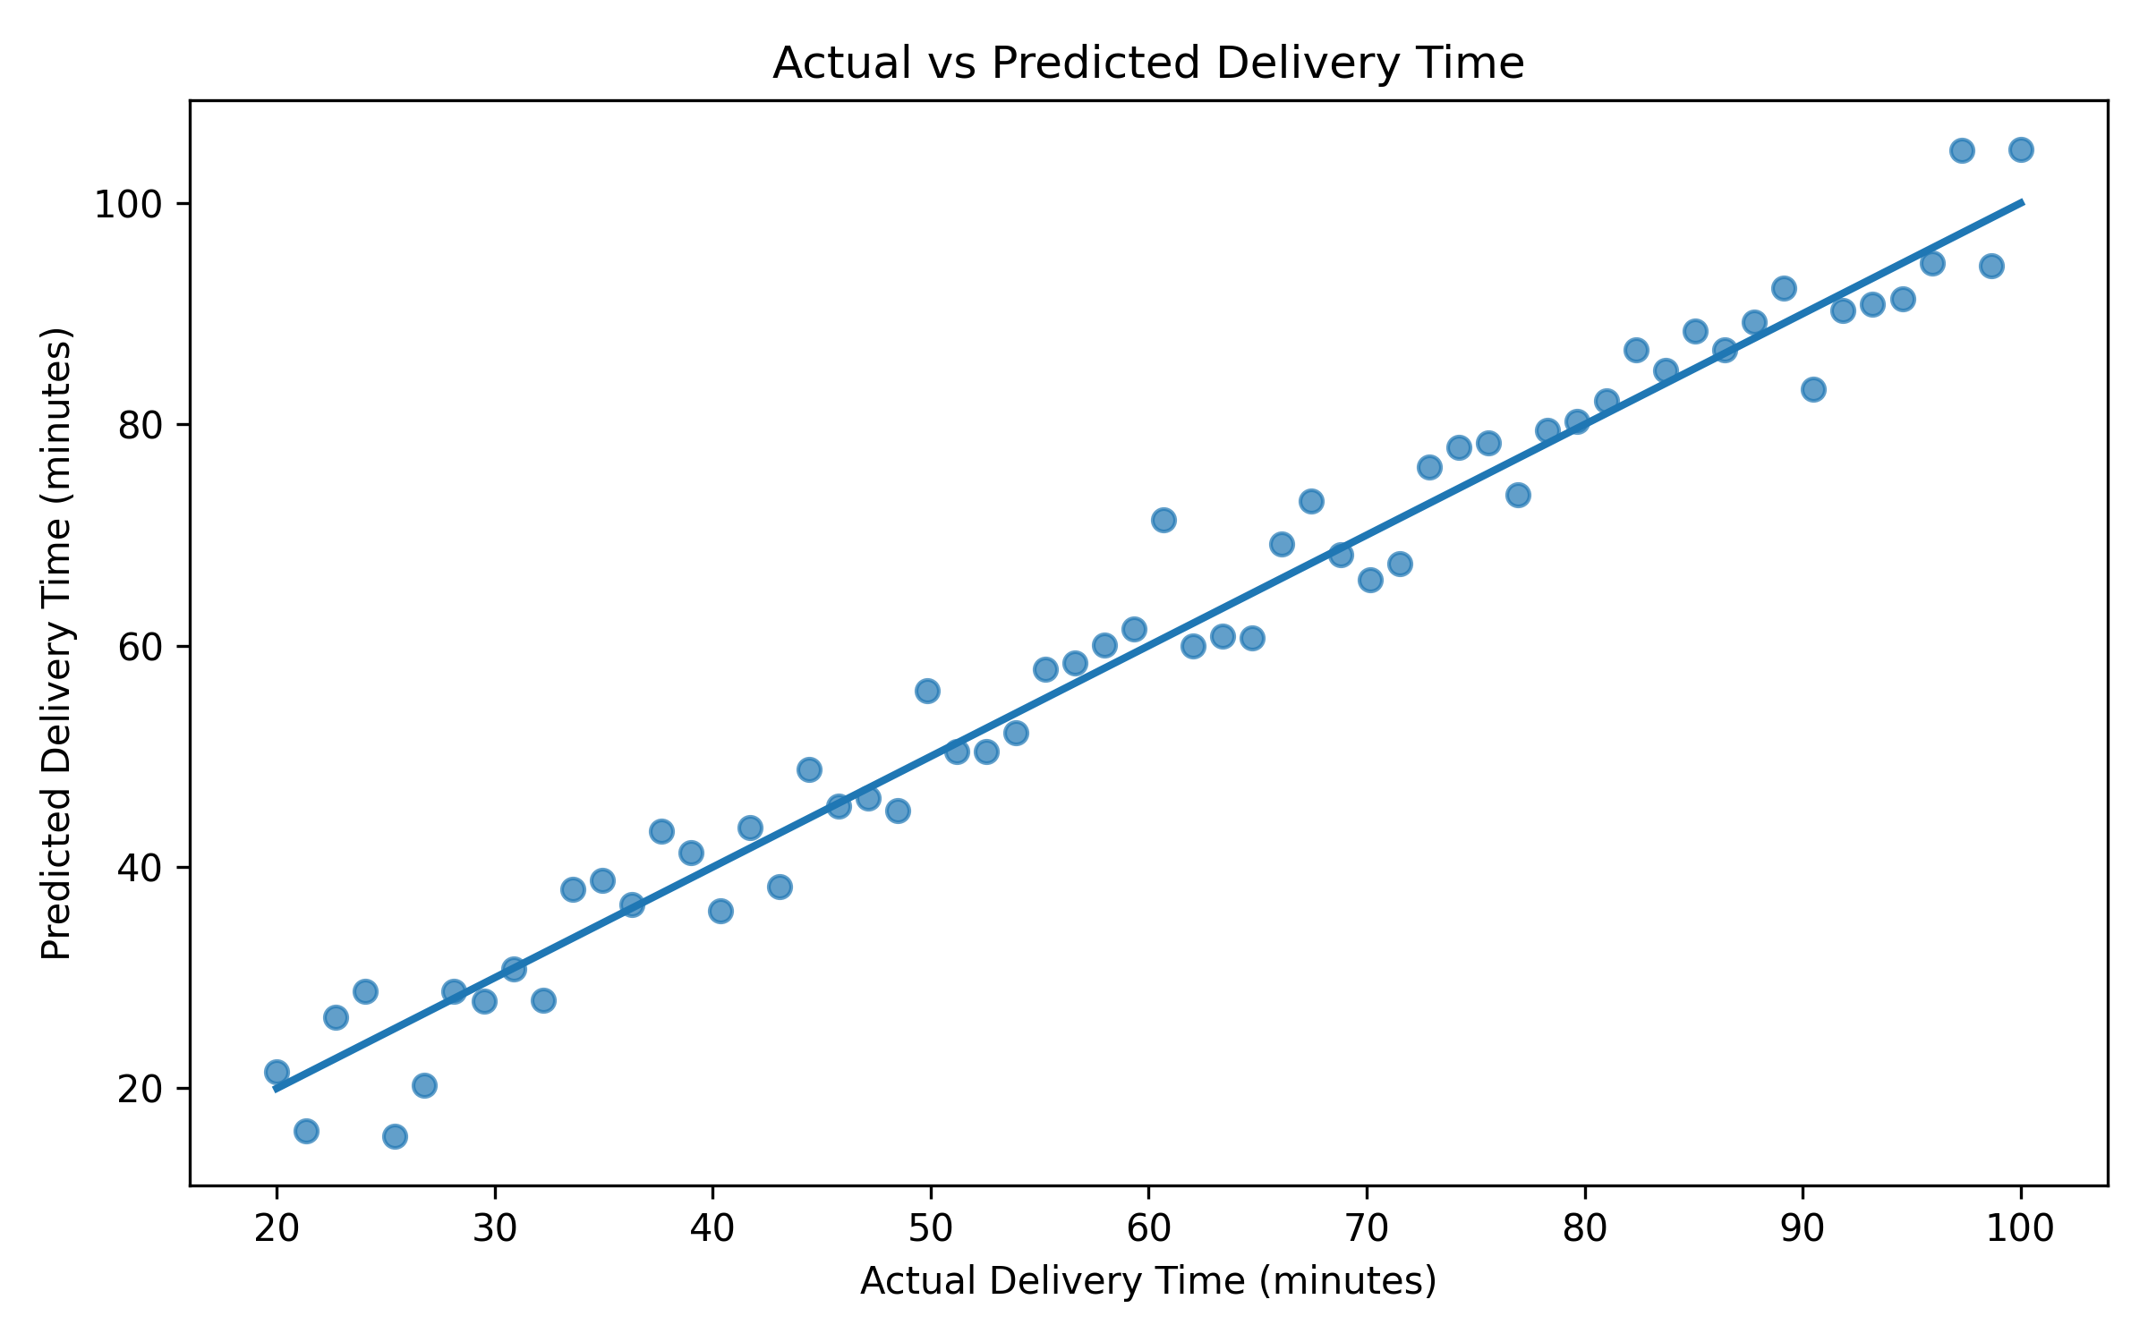
Figure 1. Comparison between observed and predicted delivery times.

12.2 Prediction Residual Distribution
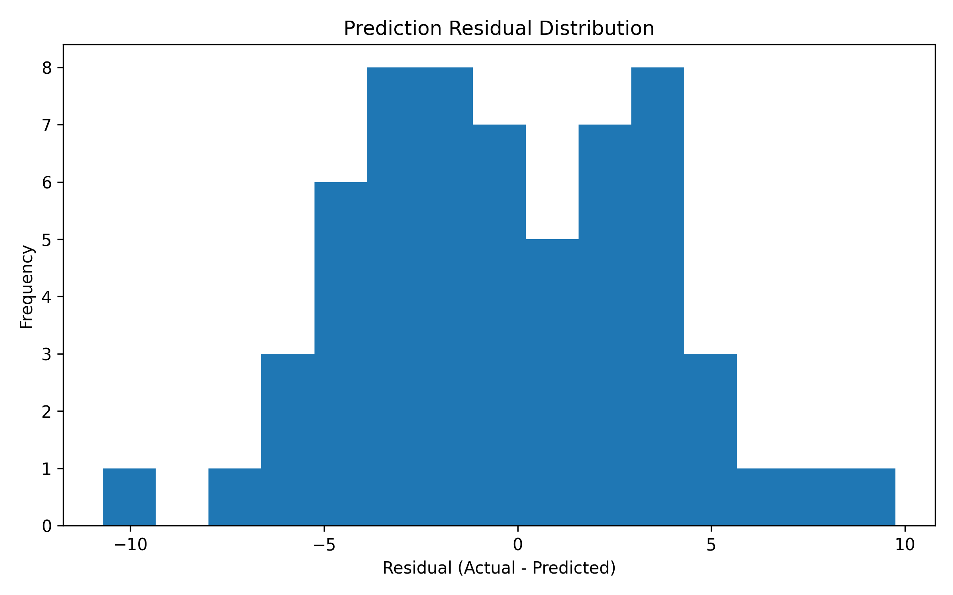
Figure 2. Distribution of prediction errors.

12.3 Top Factors Affecting Delivery Time
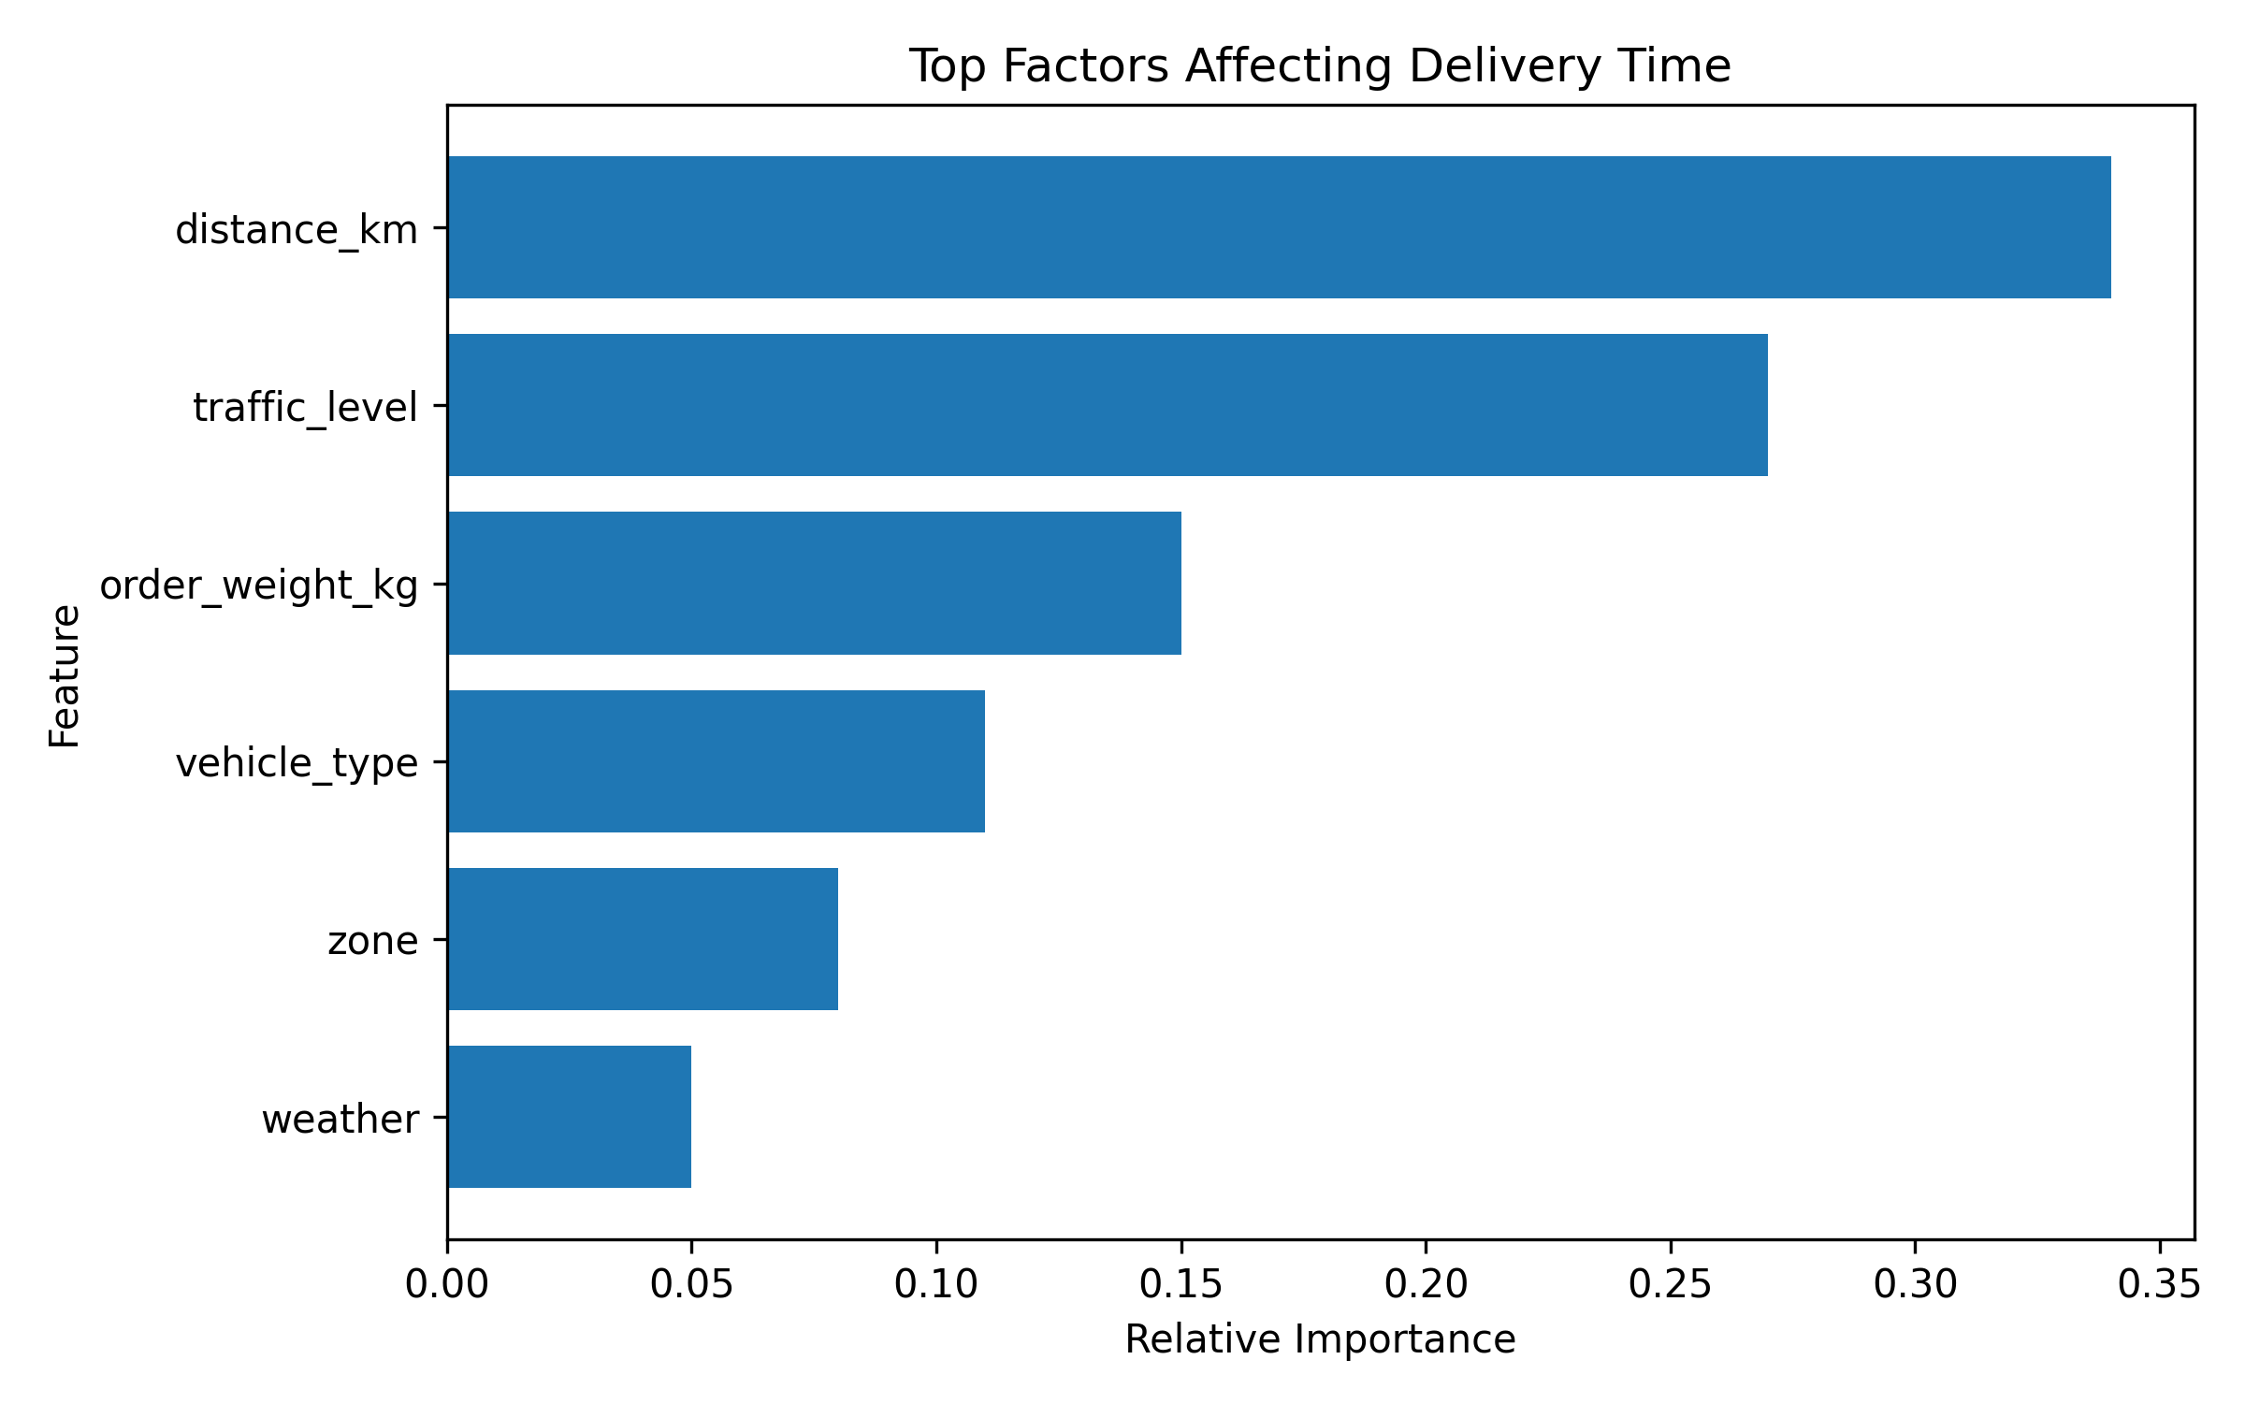
Figure 3. Relative importance of the selected predictive features.

