WEEK 1 TASK
Strategic Planning & Data Exploration in Logistics
Optimizing Two-Wheeler Last-Mile Delivery Operations in the Thane–Mumbai Corridor
Prepared by: Pratik Khose
MBA in Data Science and Business Analyst
Thane, Maharashtra
Data Analytics Internship — Yuva Intern Program
Submission Date: August 2026

Executive Summary
Two-wheelers (scooters, motorcycles, and electric scooters) are the backbone of last-mile delivery across dense Indian metro corridors such as Thane–Mumbai, where narrow lanes, mixed traffic, and short average trip distances make four-wheelers inefficient. This report defines a data-driven strategic plan for improving last-mile delivery performance for a hypothetical two-wheeler logistics fleet, “TwoWheel Express,” operating across ten zones in the Thane–Mumbai belt.
The plan covers scenario definition, relevant KPIs, a literature-grounded discussion of applicable data science techniques, an end-to-end analytical roadmap, and a working Python implementation covering data cleaning, exploratory analysis, predictive modelling, clustering-based zone segmentation, and route optimization. A synthetic but realistic 1,200-order dataset was generated, cleaned, and analyzed to validate the approach end to end.
Headline results: an overall on-time delivery rate of 82.7%, an average delivery time of 19.6 minutes, a Random Forest delivery-time predictor achieving an R² of 0.81 (MAE ≈ 3.4 minutes), a 3-tier zone segmentation identifying Thane West, Ghodbunder Road, and Kalyan as high-priority hub locations, and a nearest-neighbour route optimization that cuts a sample multi-stop route distance by ~3.5%.

1. Project Definition

1.1 Logistics Scenario
TwoWheel Express is a last-mile delivery fleet supporting e-commerce, food, and grocery partners across ten zones in the Thane–Mumbai suburban corridor: Thane West, Thane East, Ghodbunder Road, Mulund, Bhandup, Vikhroli, Kalyan, Dombivli, Airoli, and Vashi. The fleet uses a mix of petrol scooters, motorcycles, and electric scooters, dispatched from zone-level micro-hubs. The operational challenge is threefold: (a) delivery times vary sharply with traffic, weather, and distance, causing missed delivery-window promises; (b) hub and rider capacity is not matched to real demand across zones; and (c) multi-stop rider routes are often sequenced manually rather than distance-optimized.
This scenario is deliberately scoped around two-wheelers because they dominate last-mile delivery economics in Indian metro logistics — lower fuel and parking cost, better maneuverability in congested lanes, and faster turnaround on sub-10 km trips — while remaining highly sensitive to traffic and weather, which makes them an ideal subject for predictive and prescriptive analytics.

1.2 Key Performance Indicators (KPIs)
Four KPIs were selected to jointly capture service quality, operational efficiency, and cost:
- On-Time Delivery Rate (OTDR) — percentage of orders delivered within the promised delivery window; the primary customer-facing service metric.
- Average Delivery Time — mean minutes from pickup to drop-off; a direct driver of rider throughput and customer satisfaction.
- Cost per Kilometre — average fuel/energy cost incurred per kilometre travelled; the core unit-economics metric for fleet mix decisions (petrol vs electric).
- Rider Productivity — average orders completed per rider per day; used to right-size fleet and hub staffing against demand.

2. Literature and Data Research
Last-mile delivery optimization is a well-studied intersection of operations research and applied machine learning. Three data science paradigms are directly relevant to this scenario:
- Regression — supervised models (Linear Regression, ensemble tree methods such as Random Forest) are widely used to predict delivery time or ETA from trip-level features (distance, traffic, weather, vehicle type). Accurate ETA prediction underpins realistic promised-time commitments and dynamic dispatch decisions.
- Clustering — unsupervised methods such as K-Means are used in hub-location and demand-zoning problems to group geographic zones by demand volume, distance profile, and service-level patterns, informing where to place micro-hubs or consolidate low-density zones.
- Route Optimization — combinatorial optimization techniques (nearest-neighbour heuristics, 2-opt, and full Vehicle Routing Problem / VRP solvers such as Google OR-Tools) minimize total distance or time across multi-stop rider routes, directly reducing fuel cost and delivery time.
For this task, publicly-documented logistics KPIs (on-time delivery rate, cost-per-km, rider productivity) commonly reported by delivery platforms and supply-chain research were used to define the scenario's metrics. Because no proprietary fleet-ops dataset was available, a synthetic dataset was generated with realistic distributions (gamma-distributed trip distances, traffic- and weather-adjusted speeds, zone-weighted demand) to faithfully emulate the structure of real dispatch-system exports — including the messiness (missing values, inconsistent text casing, duplicates, outliers) that real raw exports contain, so the cleaning step is genuine rather than assumed.

3. Strategic Roadmap
The end-to-end analysis roadmap follows five stages, implemented in Python:
- Data Collection — simulate/ingest dispatch-system order-level records (distance, timestamps, vehicle, traffic, weather, rider, zone).
- Data Cleaning — standardize categorical text, remove duplicate order records, correct impossible values (negative durations, sensor-glitch distances), impute missing values group-wise, and engineer derived fields (speed, delay, cost-per-km).
- Exploratory Data Analysis — compute KPIs overall and per zone; visualize on-time rate by zone, delivery-time distribution by traffic level, and distance-vs-time relationships by vehicle type.
- Predictive Modelling — train and compare Linear Regression and Random Forest models to predict delivery time from trip features; evaluate with MAE and R².
- Prescriptive Analytics — apply K-Means clustering to segment delivery zones by demand and service profile for hub-priority planning, and a nearest-neighbour heuristic to optimize a sample multi-stop rider route.
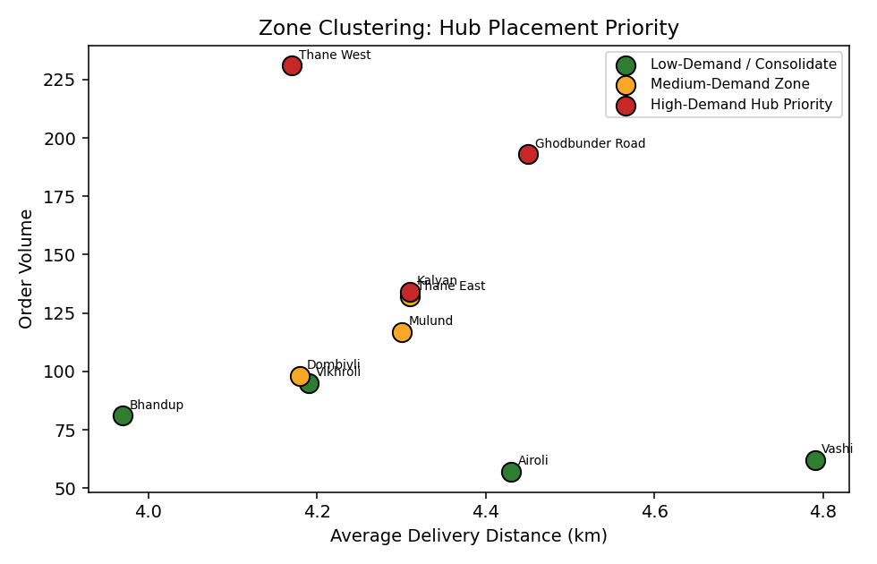
Figure 1. Zone segmentation by order volume, distance, and delivery-time profile.

4. Code Illustration
The following excerpt shows the core structure of the delivery-time prediction pipeline (full scripts — data generation, cleaning, and analysis — accompany this report):
# --- Predictive model: delivery time regression ---
features_num = ['distance_km', 'order_weight_kg']
features_cat = ['vehicle_type', 'traffic_level', 'weather', 'time_slot']

preprocess = ColumnTransformer([
('num', 'passthrough', features_num),
('cat', OneHotEncoder(handle_unknown='ignore'), features_cat),
])

rf_model = Pipeline([
('prep', preprocess),
('reg', RandomForestRegressor(n_estimators=300, max_depth=8))
])
rf_model.fit(X_train, y_train)
predicted_time = rf_model.predict(X_test)
Pseudocode for the route-optimization step (nearest-neighbour heuristic over zone coordinates):
FUNCTION nearest_neighbor_route(start_zone, stop_list, coordinates):
route <- [start_zone]
remaining <- copy(stop_list)
current <- start_zone
WHILE remaining is not empty:
next_stop <- zone in remaining with MIN haversine_distance(current, zone)
route.append(next_stop)
current <- next_stop
remaining.remove(next_stop)
RETURN route

5. Results

5.1 Fleet-Wide KPI Summary
KPI | Value
On-Time Delivery Rate | 82.67 %
Average Delivery Time | 19.57 min
Average Cost per Km | ₹1.78
Average Delivery Speed | 13.94 km/h
Avg. Orders per Rider per Day | 1.19

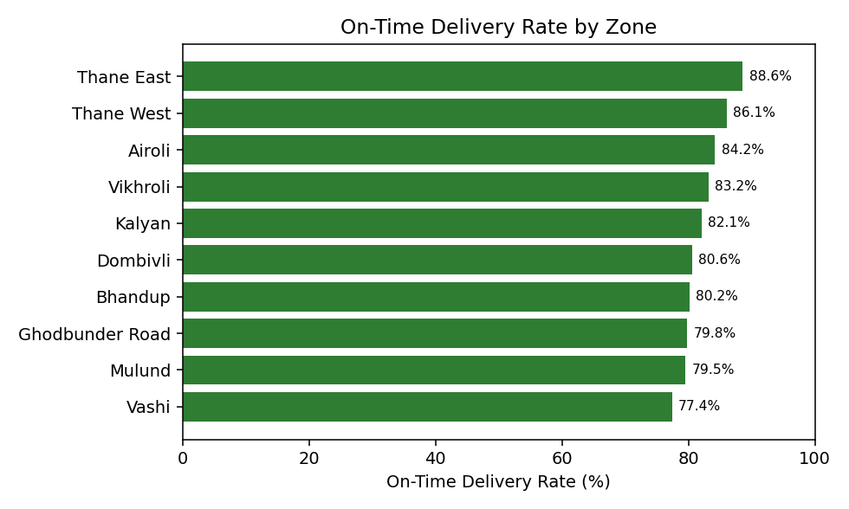
Figure 2. On-time delivery rate varies by up to 11 percentage points across zones — Vashi and Mulund trail the fleet average.
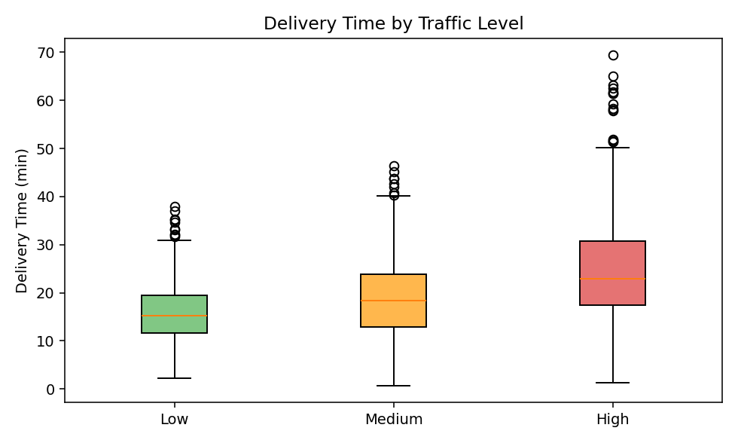
Figure 3. High-traffic conditions add meaningfully to delivery time and its variability.
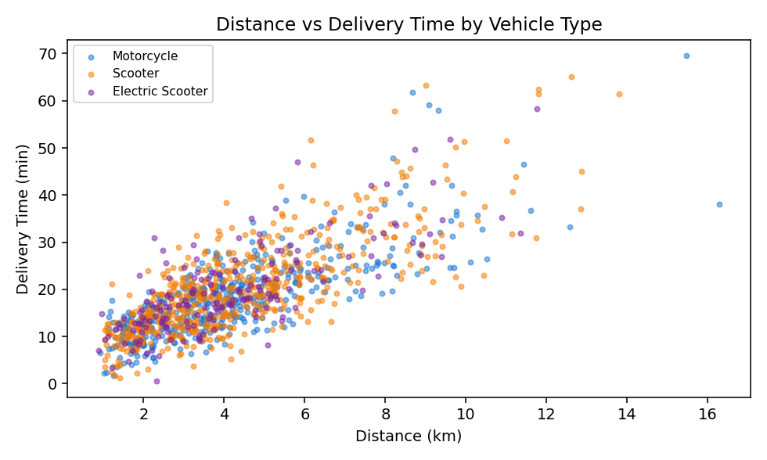
Figure 4. Delivery time scales with distance, with vehicle-type-driven spread at longer trips.

5.2 Predictive Model Performance
Model | MAE | R² Score
Linear Regression | 3.62 min | 0.768
Random Forest Regressor | 3.44 min | 0.807

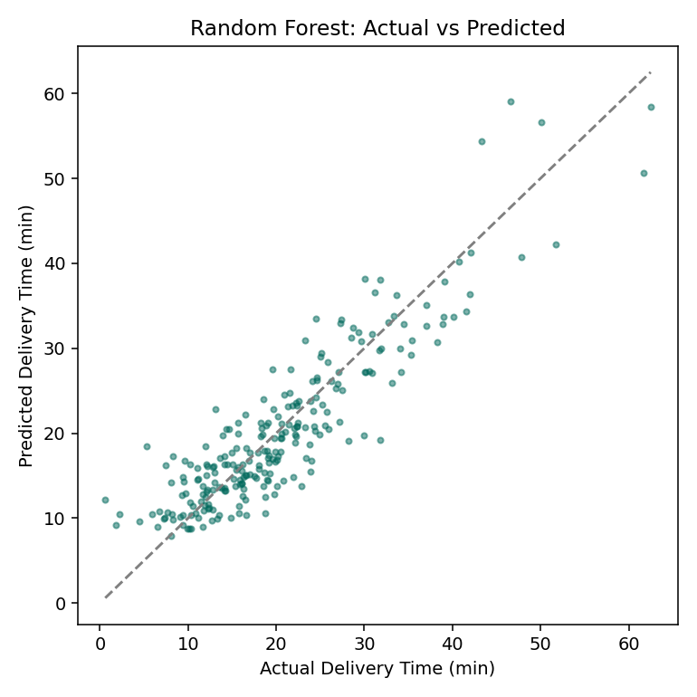
Figure 5. Random Forest predictions track actual delivery time closely (R² = 0.81).

5.3 Zone Segmentation for Hub Planning
Zone | Orders | Avg. Delivery Time | Priority Tier
Thane West | 231 | 18.79 min | High-Demand Hub Priority
Ghodbunder Road | 193 | 21.00 min | High-Demand Hub Priority
Kalyan | 134 | 19.38 min | High-Demand Hub Priority
Thane East | 132 | 18.96 min | Medium-Demand Zone
Mulund | 117 | 20.40 min | Medium-Demand Zone
Dombivli | 98 | 19.45 min | Medium-Demand Zone
Vikhroli | 95 | 18.38 min | Low-Demand / Consolidate
Bhandup | 81 | 18.76 min | Low-Demand / Consolidate
Vashi | 62 | 20.73 min | Low-Demand / Consolidate
Airoli | 57 | 20.10 min | Low-Demand / Consolidate

5.4 Route Optimization
For a sample 5-stop delivery run starting at Thane West, sequencing stops by nearest-neighbour distance instead of listed order reduced total route distance from 29.87 km to 28.84 km — a 3.5% cut. At fleet scale across thousands of daily multi-stop runs, this class of saving compounds into meaningful fuel-cost and rider-time reduction.

6. Conclusion
This strategic plan demonstrates that a modest, well-structured analytics pipeline — cleaning, EDA, regression, clustering, and route optimization — can directly inform three operational decisions for a two-wheeler logistics fleet: (1) where delivery-time predictions can tighten promised-time commitments and improve on-time rate, (2) which zones justify additional hub investment versus consolidation, and (3) how much distance (and therefore fuel cost and rider time) can be saved through basic route sequencing, even before adopting a full VRP solver.
Expected business impact of operationalizing this pipeline includes measurable gains in on-time delivery rate through better ETA-driven promising, reduced per-km cost through optimized hub placement and route sequencing, and improved rider utilization through demand-aware staffing. Subsequent weeks of this internship will extend the model to live/streaming order data, incorporate a full VRP solver for multi-rider route batching, and add a rider-assignment optimization layer.

