**Parking Lot System**

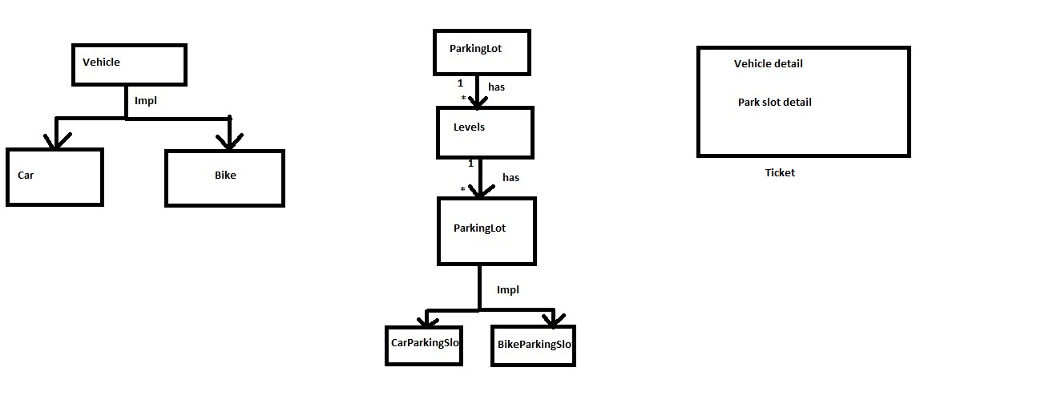

* Parking log has 3 levels
* Each level has 6 slots for bike and 3 slots for car
* Parking will be allocated in the increasing order or level and slot number
* Slot numbers are given with <bike code> <slot number><level code> <level number>. Example as given below
  + B1L1 -> Slot 1 for bike at level 1
  + B4L2-> Slot 4 for bike at leve 2
  + C3L3-> Slot 3 for car at level 3
* For every successful parking, a ticket is generated with vehicle number, in time, parking slot number etc
* For every successful unparkinig, a ticket is generated with additional, out time
* Below given are the sample endpoint URL
  + <http://localhost:9091/parking/getAllAvailableSlots>
  + <http://localhost:9091/parking/parkVehicle/Bike?registrationNumber=1234>
  + <http://localhost:9091/parking/getAllRegistrationNumbers/bike>
  + <http://localhost:9091/parking/getParkingSlotNumber/?registrationNumber=1234>
  + <http://localhost:9091/parking/unparkVehicle/?registrationNumber=1234>
* **Park vehicle mechanism has been provided synchronized behavior so that no two vehicle can book the same slot (thread safe)**