# JENKINS TUTORIAL COMMANDS

# Integrating Jenkins with Maven and Junit

* Create a Maven project in eclipse

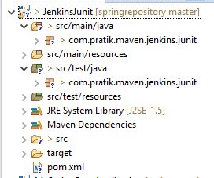

* Write your business logic in src/main/java package

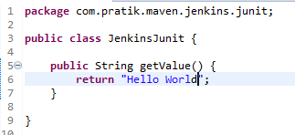

* Write your business logic in src/test/java package
* 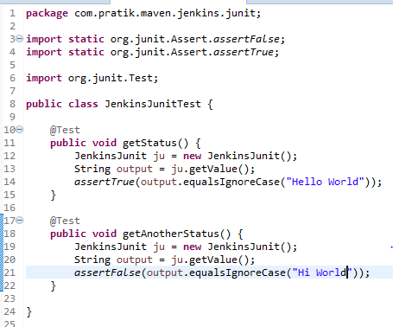
* Now move to Jenkins console and create a new Job

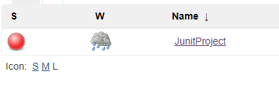

* Go to Configure Job and go to Build

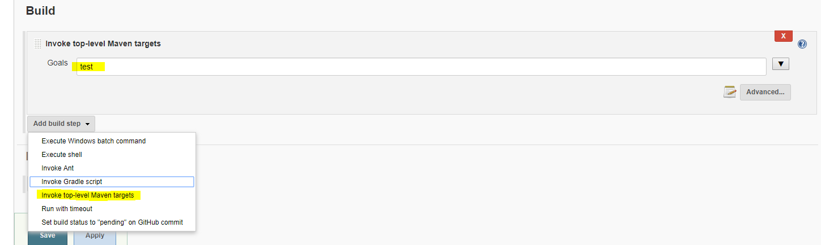

* Click on Advance and in POM provide the pom.xml file location

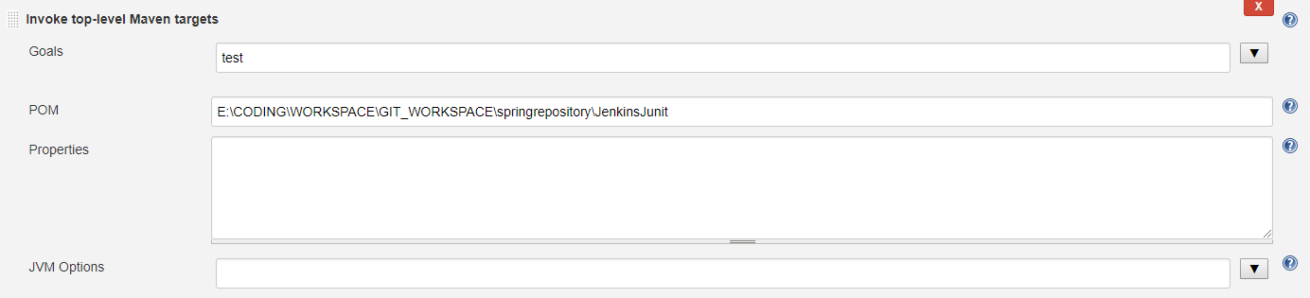

Once done save the file and run the job.