**`Assignment**

**Q1:what is software? What is software engineering?**

**Answer**:The parts of computer that we cannot see or touch are called software.

:-software is a collection of data or set of instruction. That is used to operate computer hardware and execute specific task.

There are two types of software

**1**.System software

**2**.Application software

**EX-M.s word,M.s Excel,linux,notepad…..etc.**

Software engineering is a technique through which we can developed or created software for computer systems and any other electronic devices.

In other words, software engeering is a process in which user needs are analyzed and software is designed based on these needs.

Software engineering the development of software using well define scientific principle method and procedures.

Software engineers build these software and application by using designing and programming languages.

**Q2. Explain types of software**.

**Answer**:The two main categories of software are application software and system software.

An application is software that fulfills a specific need or performs tasks. System software is designed to run a computer is hardware and provides a platform for applications to run on top of.

**:::::types of software:::::**

●Application software

● System software

● Driver software

● Middleware

● Programming software

* **Application Software**

The most common type of software, application software is a computer software package that performs a specific function for a user, or in some cases, for another application.

**Ex:Microsoft Office, Paint, Powerpoint etc.**

* **System Software**

- These software programs are designed to run a computer's application programs and hardware.

- System software coordinates the activities and functions of the hardware and software.

**Ex:Notepad ,Calculator etc**.

* **Driver Software**

Also known as device drivers, this software is often considered a type of system software.

- Device drivers control the devices and peripherals connected to a computer, enabling them to perform their specific tasks.

- Every device that is connected to a computer needs at least one device driver to function.

**Ex: Audio Driver,Video Driver etc.**

* **Middleware**

- The term middleware describes software that mediates between application and system software or between two different kinds of application software

**Ex: database middleware,application server middlewar**.

* **Programm ing Software**

- Computer programmers use programming software to write code. Programming software and programming tools enable developers to develop, write, test and debug other software programs.

**Ex : Turbo c,Eclipse,Sublime etc**.

**Q3. What is SDLC? Explain each phase of SDLC.**

**Answer**: **SDLC** ::-The Software Development Life Cycle.

* In simple word “entire life line of software from beginning to ending”.
* The Software Development Life Cycle (SDLC) refers to a methodology with clearly defined processes for creating high-quality software. in detail, the SDLC methodology focuses on the following phases of software development
* **It contains six main stages.**

1.)Requirement Gathering

2.)Analysis

3.)Designing

4.)Implementation

5.)Testing

6.)Maintenance

**Q4. What is DFD? Create a DFD diagram on Flipkart**

Answer:DFD=”Data flow diagram”.

The graphical represention which provides information flow and transformation between input and output data.

Data Flow Diagram represents the flow of data within information systems.

* **DFD Diagram on flipkart.**

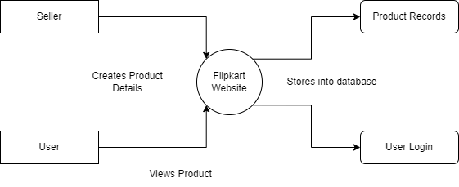

**Q-5. What is Flow chart? Create a flowchart to make addition of two numbers.**

**Answer. Flow chart:**

**The flow chat are diagrams showing the exact sequence of logical steps.**

**They use geometrical shapes and arrows to show process,relationships and data/process flow.**

**Flowchats is a graphical representation of an algorithem.**

**Programmers often use it as a program planning tool to solve a problem.**

* **Flowchart for Adding Two Numbers:**

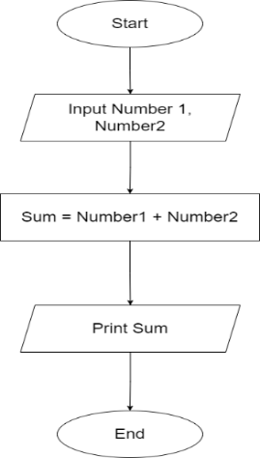

**Q-6. What is Use case Diagram? Create a use-case on bill payment on Paytm.**

**Answer .Use case:**

A use case diagram is a graphical depiction of a user's possible interactions with a system.

A use case diagram shows various use cases and different types of users the system has and will often be accompanied by other types of diagrams as well.

* **Use-Case Scenario for Paying Bills on Paytm:**

