**EXPERT SYSTEM FOR CARDIOVASCULAR DISEASES**

**User’s manual which contain compiling instructions & to execute our software.**

Step 1: download swi-prolog from <www.swi-prolog.org/download.html>

Step 2: Right click on file “cardivascularSystem.pl” & open it with swi-prolog app.

Step 3: type “solve(cardioDisease(X)).” & enter.

Step 4: You’ll see below help-screen that shows how to use this expert system.

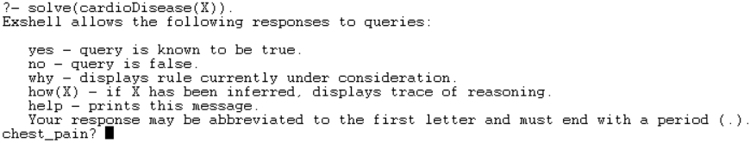

Step 5 : choose y for yes or n for no or w for why or how(X). You can choose one of the different option. (Note : don’t forget to put ‘.’ at end of each of your ans.)

Step 6 : basically our expert system will ask you series of questions one by one, and based on your response yes/no to the series of questions, it will checks the rules in the working memory i.e. inference rules and knowledge base rule facts, it will detect cardiovascular disease from which the patient is suffering from and will provide you it’s flow of treatment.

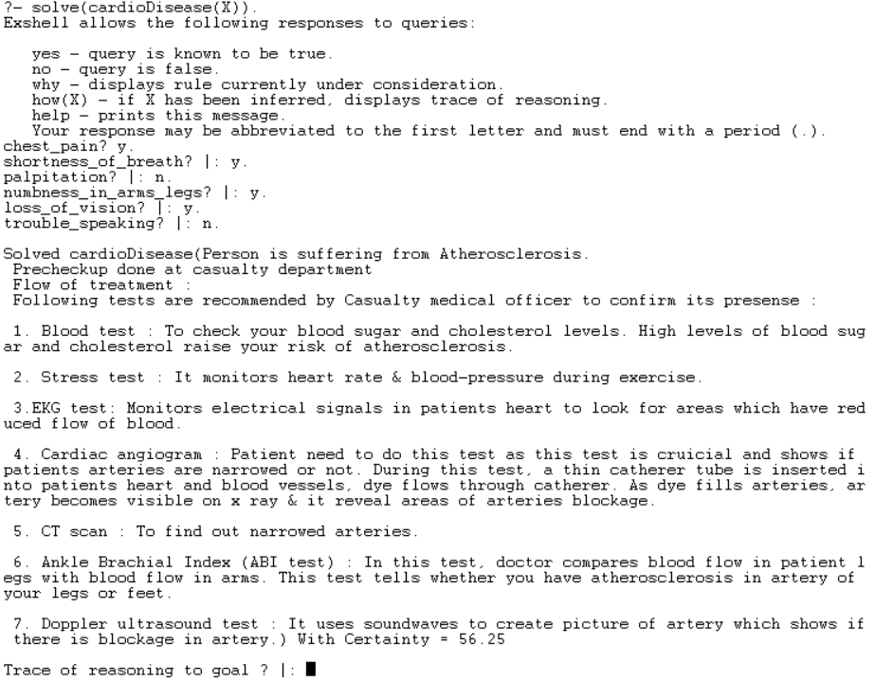

Step 7 :- At the end you’ve option of tracing_your_answer.