Question | Consider the following statements  p : 2 is an even prime number  q : If $z_{1}=2−i,z_{2}=−2+i$ where $i=\sqrt{−1},$ then Im  r : tan$\left(−945°\right)=−1$  then which of the following has truth value True.
Type | MCQ
Difficulty | Easy
Option | $$\left(p→q\right)↔(q⋀r)$$ | correct
Option | q $↔$ r | incorrect
Option | p → q | incorrect
Option | $$\left(p→r\right)↔q$$ | incorrect
Solution | If p : switch $s_{1}$ is closed, q : switch $s_{2}$ is closed then correct interpretation from the following circuit is  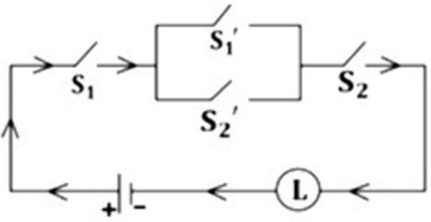
Subject | Mathematics
Chapters | Calculs,Algebra
Tags | Tag 1,Tag2,Tag 4
PYQ | Exam Name,2022

Question | The earth is round
Type | true_false
Difficulty | Medium
Answer | true
Solution | Sample Solution
Subject | General Knowledge
Chapters
Tags
PYQ

Question | This is a sample numeric type question?
Type | numeric
Difficulty | Hard
Answer | 1.2
Solution | Sample Solution
Subject
Chapters
Tags
PYQ

Question | This is a sample numeric type question 2?
Type | numeric
Answer | 1.2-3.4
Solution | Sample Solution
Subject
Chapters
Tags
PYQ

