**Name:** Pratik Rajkumar Mulik

**PRN:** 123B1F063

**Class :** TY I.T (A)

**Assignment 2**

**Problem Statement**: Read an image, plot its histogram then do histogram equalization. Comment about the result. Implement various spatial domain and frequency domain filters.

**Aim:** To read a grayscale image, plot its histogram, perform histogram equalization for contrast enhancement, and implement various spatial domain and frequency domain filters for image enhancement and analysis.

**Objective:**

1. To study the concept of image histogram and its importance in image processing.
2. To apply histogram equalization for contrast improvement.
3. To implement spatial domain filters (smoothing and sharpening) to enhance image details.
4. To implement frequency domain filters (low-pass and high-pass) using Fourier Transform.
5. To analyze and compare the results of spatial and frequency domain filtering.

## **Outcomes:**

1. Understand histogram equalization and its effect on image contrast.
2. Gain practical experience with spatial domain filtering techniques.
3. Implement frequency domain filters using Fourier Transform.
4. Analyze and compare the impact of different image enhancement techniques.

## **Theory**

### **1. Histogram & Histogram Equalization**

* Image Histogram: A graph representing the distribution of pixel intensities in an image.
* Histogram Equalization: A technique to spread out pixel intensities more evenly, improving image contrast.

**Formula**:

sk = pr (rj)

where,

sk = output intensity level

L = total number of intensity levels

Pr (rj) = probability of intensity level rj

### **2. Spatial Domain Filtering**

* Operates directly on pixels.
* A filter (mask/kernel) is convolved with the image.

**Formula:**

g(x,y) =

where,

f(x,y) = input image

g(x,y) = output image

w(s,t) = filter mask / kernel

**Examples:**

* Gaussian Blur (Smoothing) → reduces noise.
* Sharpening (Laplacian/High-boost) → enhances edges.

**3. Frequency Domain Filtering**

* Based on Fourier Transform, where the image is represented in terms of frequency components.
* High frequencies → edges, noise, fine details.
* Low frequencies → smooth background, general shape.

**Discrete Fourier Transform Formula:**

X(k) =

**Inverse Discrete Fourier Transform:**

x(n) =

* **Low-pass filter** → retains low frequencies, removes high frequencies → smoothing.
* **High-pass filter** → retains high frequencies, removes low frequencies → edge enhancement.

## **Pseudocode:**

Algorithm ImageEnhancement

Input: Grayscale image f(x,y)

Output: Enhanced images using histogram equalization, spatial filters, and frequency domain filters

Step 1: Read the grayscale image

f ← ReadImage("input_image.jpg")

Step 2: Plot original histogram

hist_f ← ComputeHistogram(f)

Plot(hist_f, title="Original Histogram")

Step 3: Perform histogram equalization

f_eq ← HistogramEqualization(f)

hist_eq ← ComputeHistogram(f_eq)

Plot(hist_eq, title="Equalized Histogram")

Step 4: Comment on results

Print("Histogram equalization redistributes pixel intensities to enhance contrast")

Step 5: Implement Spatial Domain Filtering

// Smoothing filters

f_mean ← ApplyFilter(f, MeanFilter(3x3)) // Average filter

f_weighted ← ApplyFilter(f, WeightedAverageFilter()) // e.g., Gaussian weights

f_median ← ApplyFilter(f, MedianFilter(3x3)) // Non-linear, removes salt & pepper noise

f_gaussian ← ApplyFilter(f, GaussianFilter(σ=1.0)) // Smooths while preserving edges better than mean

// Display results

Display(f_mean, "Mean Filtered Image")

Display(f_weighted, "Weighted Average Filtered Image")

Display(f_median, "Median Filtered Image")

Display(f_gaussian, "Gaussian Filtered Image")

Step 6: Implement Frequency Domain Filtering

// Compute Fourier Transform

F ← DFT(f)

// Apply frequency domain filters

F_lowpass ← ApplyLowPassFilter(F, cutoff_radius)

F_highpass ← ApplyHighPassFilter(F, cutoff_radius)

// Inverse transform to get spatial images

f_lowpass ← IDFT(F_lowpass)

f_highpass ← IDFT(F_highpass)

Display(f_lowpass, "Low-Pass Filtered Image")

Display(f_highpass, "High-Pass Filtered Image")

Step 7: Comment on overall results

Print("Spatial filters modify local pixel neighborhoods, useful for smoothing, sharpening, and edge detection.")

Print("Frequency domain filters selectively enhance or suppress certain frequency components.")

Print("Histogram equalization enhances overall contrast by redistributing intensity values.")

End Algorithm

**Result:**

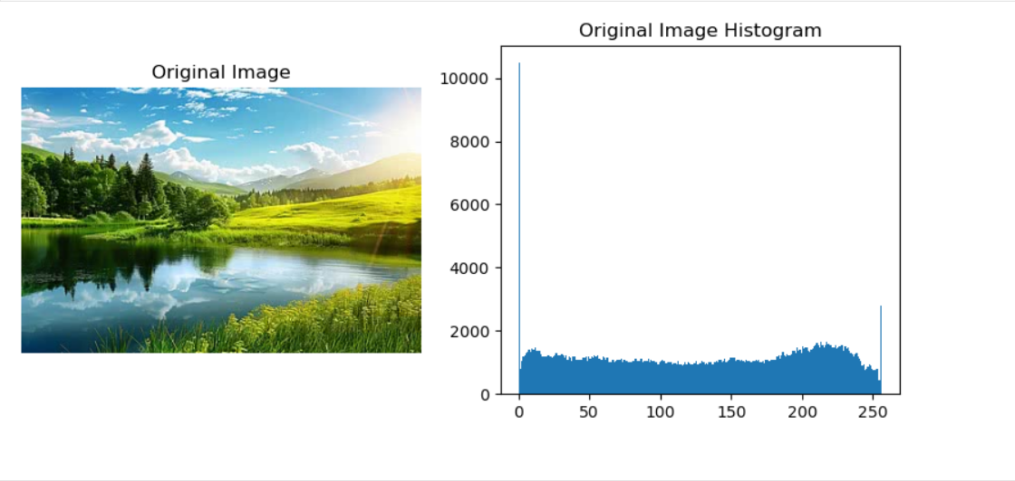

Original Image Original Histogram

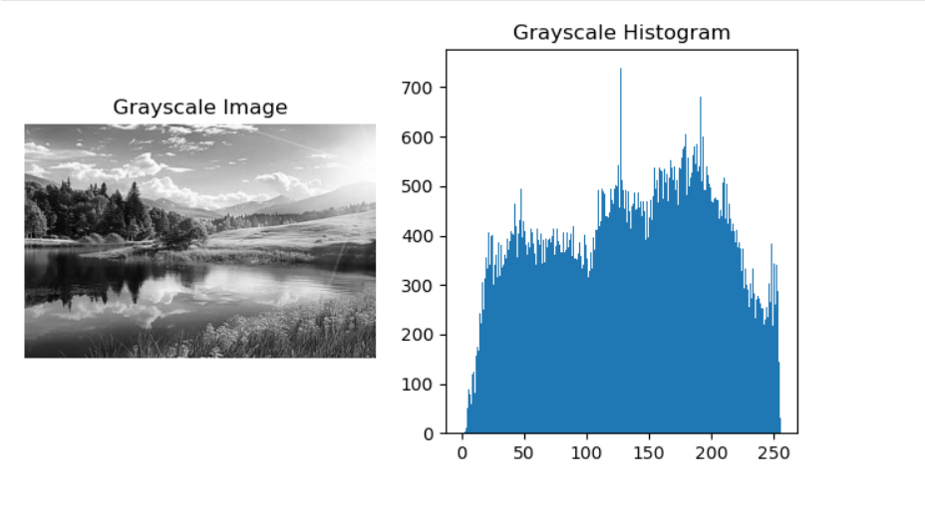

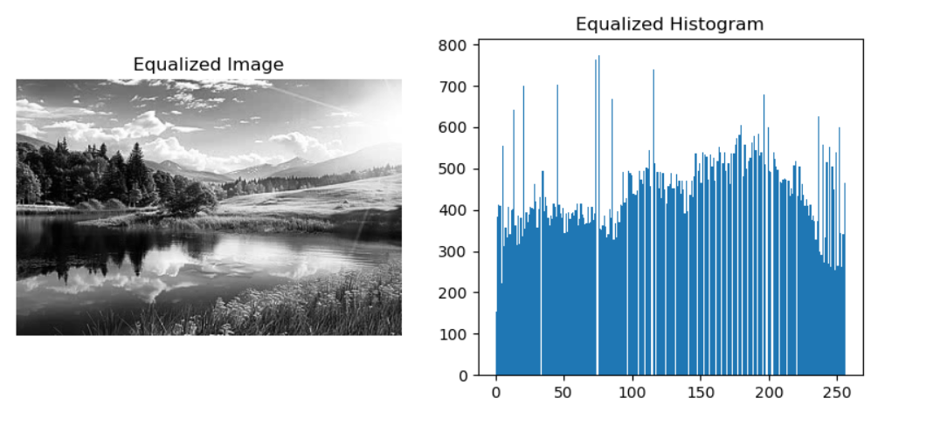Histogram Equalised Image Equalised Histogram

**Histogram and Histogram Equalization**

* The histogram of the original grayscale image is concentrated in a narrow range, which results in low contrast.
* After applying histogram equalization, the histogram becomes more spread out across intensity values (0–255).
* This leads to **enhanced contrast** in the image, making dark regions brighter and details more visible.
* Histogram equalization is especially useful for images with poor lighting conditions.

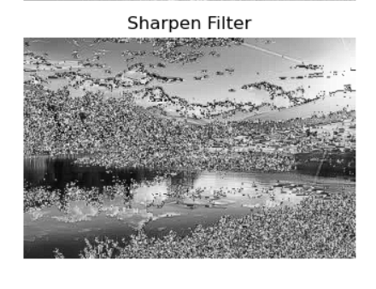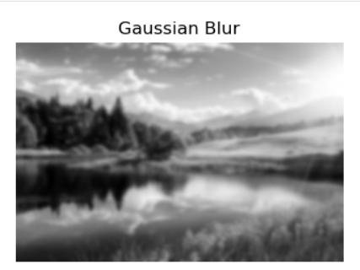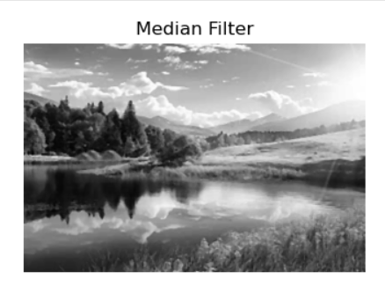

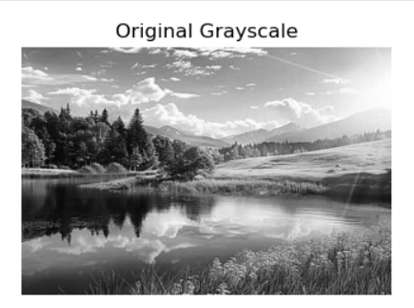Spatial Domain Filters

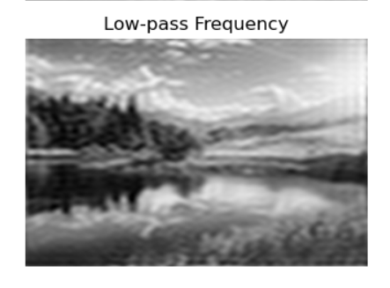

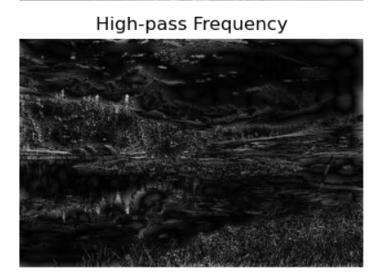

Frequency Domain Filters

**Conclusion:**

Histogram equalization improves image contrast by redistributing pixel intensities, making hidden details clearer. Spatial domain filters help in noise removal and edge enhancement, while frequency domain filters are effective for global transformations and periodic noise reduction. Each method has its own importance, and together they provide powerful tools for image enhancement and preprocessing in various applications like medical imaging and computer vision.