# **Assignment No. 4**

### **Problem Statement:**

Consider any suitable image dataset with enough sample size to evaluate the effect of noise models. Implement noise models like Gaussian, Salt & Pepper, and Impulse noise, and generate their histograms.

### **Aim:**

To study the effect of different noise models on images and analyze their histograms for understanding noise characteristics.

### **Objectives:**

1. To study the concept of image noise and its impact on image quality.
2. To implement Gaussian noise, Salt & Pepper noise, and Impulse noise models.
3. To generate histograms of noisy images and compare them with the original.
4. To analyze noise behavior and its effect on image processing applications.

### **Outcomes:**

1. Understand how Gaussian, Salt & Pepper, and Impulse noise distort images.
2. Learn histogram-based analysis of noise.
3. Gain practical experience in noise modeling for image datasets.
4. Build knowledge about suitable filtering techniques for each noise model.

### 

### **Theory:**

**1. Image Noise**Image noise is the random variation of brightness or color information in images. It occurs due to sensor limitations, poor illumination, high temperature, transmission errors, or environmental disturbances. Noise degrades image quality and makes object recognition and segmentation difficult.

**2. Gaussian Noise**

* Gaussian noise follows a **normal distribution** with mean (µ) and variance (σ²).
* Probability density function:

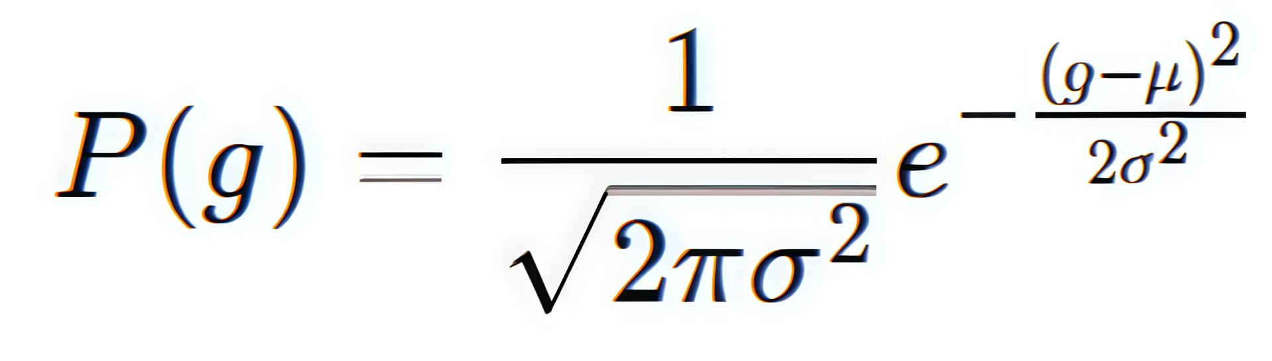

**Where,**

**g** = gray-level intensity value of a pixel.

**µ (mu)** = mean of the Gaussian distribution (average noise value).

**σ (sigma)** = standard deviation of the Gaussian distribution (controls spread of noise).

**σ²** = variance (square of standard deviation).

**P(g)** = probability density for pixel intensity g.

* Appears as smooth, grainy intensity variations across the entire image.
* Common in low-light imaging and thermal sensors.
* **Histogram effect:** values spread smoothly around the mean intensity.
* **Filtering:** Gaussian blur or Wiener filter is often used to reduce Gaussian noise.

**3. Salt & Pepper Noise**

* Also called **impulsive noise**, where pixels are randomly set to black (0) or white (255).
* Caused by faulty memory cells, transmission errors, or sensor malfunction.
* **Mathematical Model**

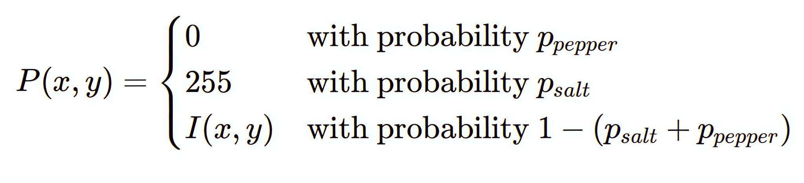

**Where,**

* P(x,y): Represents the pixel value at coordinates (x,y) in the output or noisy image.
* 0: The minimum possible pixel intensity value.
* 255: The maximum possible pixel intensity value.
* I(x,y): The original pixel value at coordinates (x,y) in the input (noise-free) image.
* p_pepper: Probability that a pixel will be corrupted by pepper noise (set to 0).
* p_salt: Probability that a pixel will be corrupted by salt noise (set to 255).
* 1 - (p_salt + p_pepper): Probability that a pixel will not be affected by noise.
* Appears as sparse bright and dark dots on the image.
* **Histogram effect:** spikes at intensity 0 and 255.
* **Filtering:** Median filter is highly effective for removing Salt & Pepper noise.

**4. Impulse Noise**

* A general form of random noise that introduces sudden intensity spikes at arbitrary levels.
* Similar to Salt & Pepper but not restricted to only black or white pixels.
* **Mathematical Model**

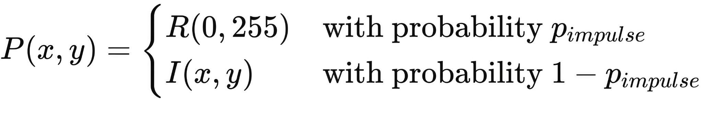

**Where,**

* **P(x,y):** Represents the pixel intensity value at coordinates (x,y) in the noisy (output) image.
* **I(x,y):** Represents the original (noise-free) pixel intensity value at coordinates (x,y).
* **R(0,255):** Denotes a random value, typically either 0 (black, representing "pepper" noise) or 255 (white, representing "salt" noise), in an 8-bit grayscale image.
* **p_impulse:** Probability of a pixel being corrupted by impulse (salt and pepper) noise.
* **1 - p_impulse:** Probability of a pixel remaining uncorrupted (retaining its original value).
* Caused by sudden disturbances in image acquisition or faulty transmission lines.
* **Histogram effect:** irregular spikes at random intensities.
* **Filtering:** Adaptive Median or Alpha-Trimmed Mean filters are commonly used.

**5. Importance of Histogram Analysis**

* Histograms display pixel intensity distribution and help visualize the presence of noise.
* Gaussian noise broadens the histogram symmetrically.
* Salt & Pepper noise introduces extreme peaks at 0 and 255.
* Impulse noise creates uneven histogram spikes.
* By analyzing histograms, appropriate denoising methods can be selected.

**Pseudocode**

Input: Grayscale image f(x,y)  
 Output: Noisy images and their histograms side by side with original

Step 1: Read the grayscale image  
   f ← ReadImage("image.jpg")

Step 2: Define Gaussian Noise Function  
   Function AddGaussianNoise(image, mean, sigma):  
     Generate Gaussian random matrix of same size  
     Add it to image pixels  
     Clip values to [0,255]  
     Return noisy image

Step 3: Define Salt & Pepper Noise Function  
   Function AddSaltPepperNoise(image, salt_prob, pepper_prob):  
     Copy original image  
     Randomly select pixels for salt → set to 255  
     Randomly select pixels for pepper → set to 0  
     Return noisy image

Step 4: Define Impulse Noise Function  
   Function AddImpulseNoise(image, noise_prob):  
     Copy original image  
     Randomly select pixels  
     Replace them with random intensity values [0,255]  
     Return noisy image

Step 5: Generate noisy images  
   gauss_img ← AddGaussianNoise(f, mean=0, sigma=25)  
   sp_img ← AddSaltPepperNoise(f, salt_prob=0.01, pepper_prob=0.01)  
   impulse_img ← AddImpulseNoise(f, noise_prob=0.02)

Step 6: For each noise type in [Gaussian, Salt & Pepper, Impulse]:  
   Display original image (top-left) and noisy image (top-right)  
   Display original histogram (bottom-left) and noisy histogram (bottom-right)

End Algorithm

### **Result:**

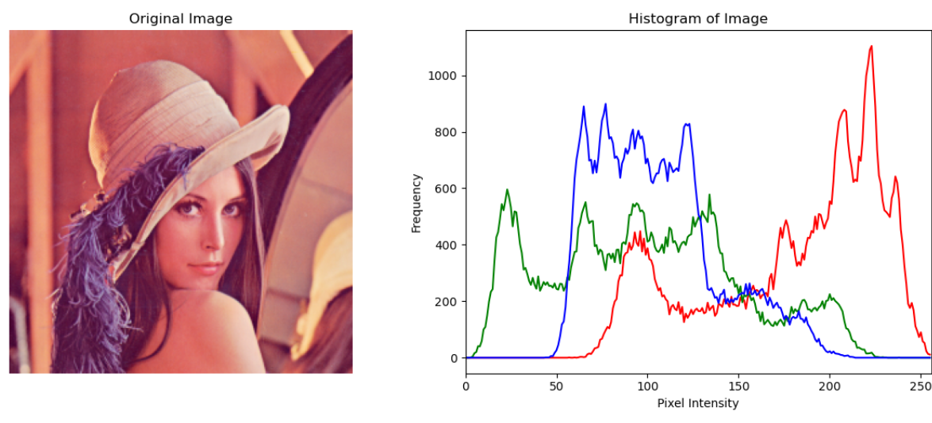

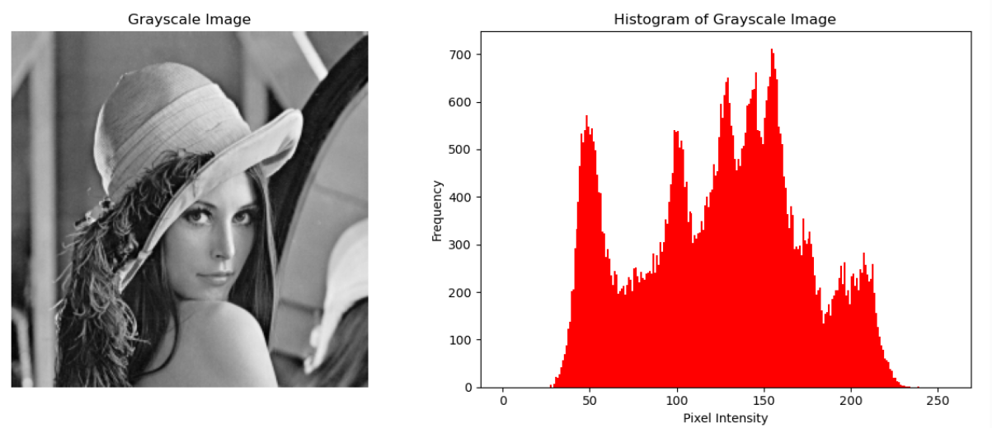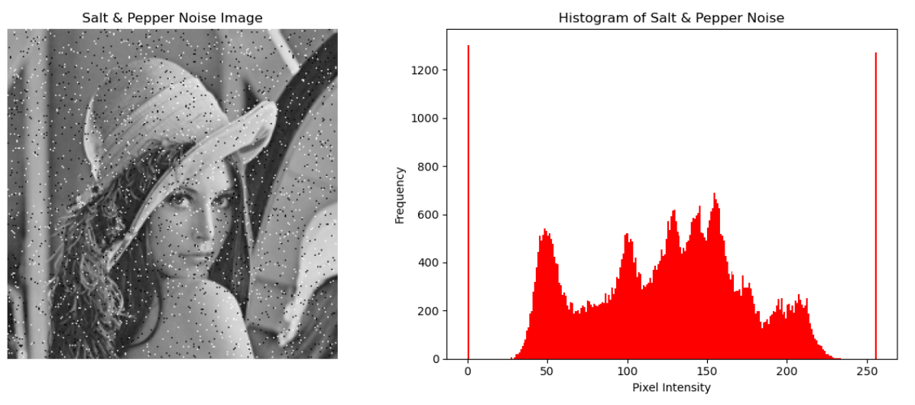

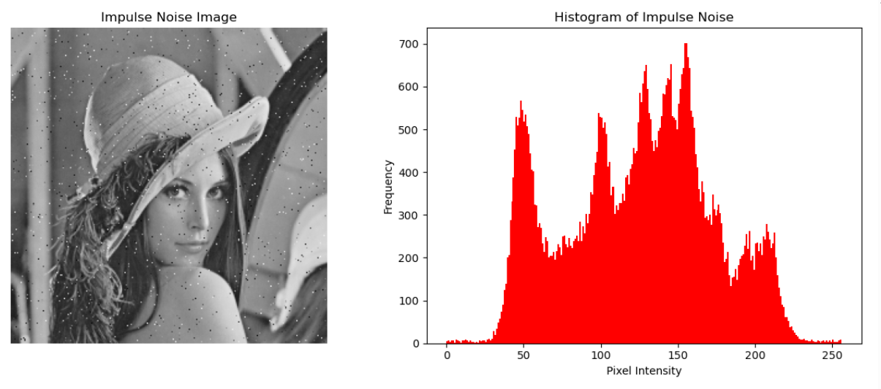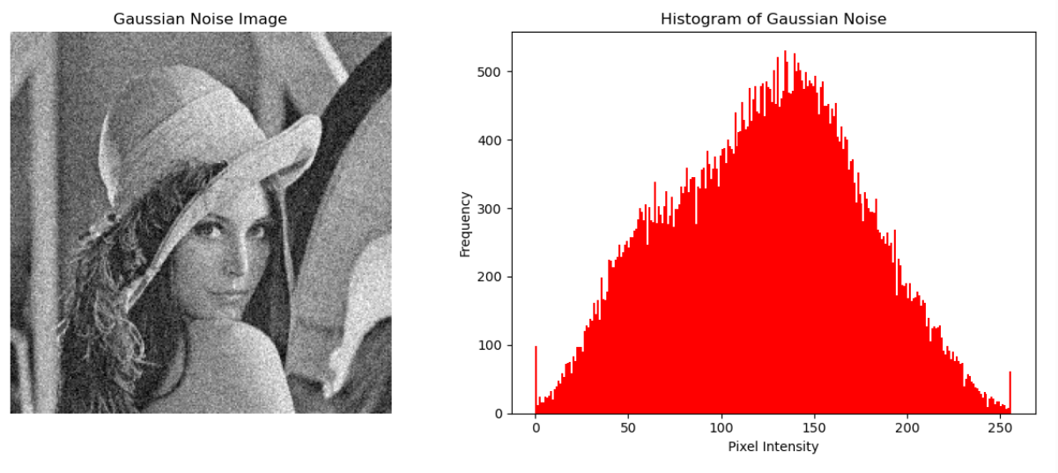

### **Conclusion:**

Gaussian noise spreads pixel intensities smoothly around the mean, Salt & Pepper noise introduces sharp black/white spikes, and Impulse noise generates irregular intensity spikes. Their histograms highlight these differences, helping in noise identification. Understanding noise behavior allows us to apply appropriate denoising filters (Median for Salt & Pepper, Gaussian/Wiener for Gaussian, Adaptive filters for Impulse). Thus, histogram analysis is a valuable tool for noise modeling and image preprocessing.