**Assignment No. 5**

**Problem Statement :** Perform Contrast stretching of a low contrast image to enhance the image quality and compare their Histogram. Perform Histogram Equalization to create uniform distribution of pixel intensities.

**Aim :** To study and implement contrast stretching and histogram equalization techniques on a grayscale image for improving visual quality and redistributing pixel intensity values.

**Objectives :**

1. To analyze the effect of low contrast on grayscale images.
2. To apply contrast stretching to expand intensity range and improve clarity.
3. To apply histogram equalization to redistribute pixel intensities uniformly.
4. To compare histograms before and after enhancement.

### **Expected Outcomes :**

1. Understand contrast stretching and its role in enhancing the visibility of low-contrast images.
2. Study histogram equalization and its effect on redistributing pixel intensities for improved contrast.
3. Compare histograms of original, contrast-stretched, and equalized images to analyze enhancement differences.
4. Gain practical understanding of intensity-based image enhancement techniques in the spatial domain.

### **Theory:**

### **1. Low Contrast Image**

* A grayscale image represents pixel intensities between 0 (black) and 255 (white).
* In a normal image, pixel values are spread across this full range, so we can clearly distinguish dark and bright regions.
* In a low contrast image, most of the pixel values are grouped in a narrow intensity range (for example, between 90 and 130 only).
* As a result, the image looks dull, washed out, or unclear, because the difference between light and dark areas is very small.
* Such images usually occur when pictures are taken in foggy conditions, low light environments, medical imaging (X-rays), or hazy weather.
* To make these images clearer, we apply image enhancement techniques such as contrast stretching or histogram equalization.

### **2. Contrast Stretching (normalization)**

* This method improves image contrast by expanding the range of gray levels present in the image.
* If the pixel values in the original image are only between 90 and 130, contrast stretching maps them to the full range 0–255.
* This increases the separation between dark and bright areas, making the image visually clearer.
* It is a linear transformation technique because the mapping from input to output pixel values follows a straight line.

**Formula:**

s = $\frac{(r-r_{min })}{(r_{max}-r_{min})}$ x (L-1)

Where:

* r= input pixel value
* rmin,rmax= minimum and maximum intensity values of the image
* L = number of gray levels (256 for 8-bit image)
* s = output pixel value

**Effect on Histogram:**

* The histogram of the original low contrast image is compressed in a small range.
* After contrast stretching, the histogram spreads across the entire range (0–255), resulting in better contrast.

**3. Histogram Equalization**

* Histogram equalization is a more advanced method of contrast enhancement compared to contrast stretching.
* Instead of simply expanding the intensity range, it redistributes pixel values so that the histogram of the image becomes flatter and more uniform.
* This technique enhances both dark and bright regions simultaneously, making hidden details visible.
* It is especially useful in applications like medical images, satellite imagery, and CCTV footage, where details in both light and dark regions are important.
* The method is based on the Cumulative Distribution Function (CDF) of pixel intensities, which is used to remap each pixel to a new intensity value.

**Formula:**

sk=(L-1) X $\sum_{j=0}^{k}{}p(r_{j})$

* p(rj)= probability of occurrence of intensity level rj
* s​k= new intensity value after equalization
* L = total gray levels (256 for 8-bit image)

**Effect on Histogram:**

* The histogram of the original image may be concentrated in one part (narrow range).
* After histogram equalization, the histogram spreads more evenly across all gray levels.
* The image contrast improves globally, and more features become visible.

### **Comparison**

* **Contrast Stretching**: Linear method, good for simple low contrast cases, expands intensity range.
* **Histogram Equalization**: Non-linear method, redistributes intensities, provides global contrast improvement and reveals hidden details.
* **Pseudocode:**

**Step 1 :** Read the grayscale input image

f ← ReadImage("input_image.jpg")

Display(f, "Original Image")

**Step 2 :** Plot histogram of the original image

hist_f ← ComputeHistogram(f)

Plot(hist_f, "Original Histogram")

**Step 3 :** Apply Contrast Stretching

r_min ← minimum intensity of f

r_max ← maximum intensity of f

For each pixel p in f:

s = ((p - r_min) / (r_max - r_min)) * 255

stretched(p) = round(s)

Display(stretched, "Contrast Stretched Image")

hist_stretched ← ComputeHistogram(stretched)

Plot(hist_stretched, "Stretched Histogram")

**Step 4:** Apply Histogram Equalization

f_eq ← HistogramEqualization(f)

Display(f_eq, "Histogram Equalized Image")

hist_eq ← ComputeHistogram(f_eq)

Plot(hist_eq, "Equalized Histogram")

**Step 5:** Compare results

Print("Contrast Stretching spreads pixel values linearly across 0–255 range.")

Print("Histogram Equalization redistributes intensity values to achieve uniform distribution.")

**Results: Add the Output Images in Following Format.**

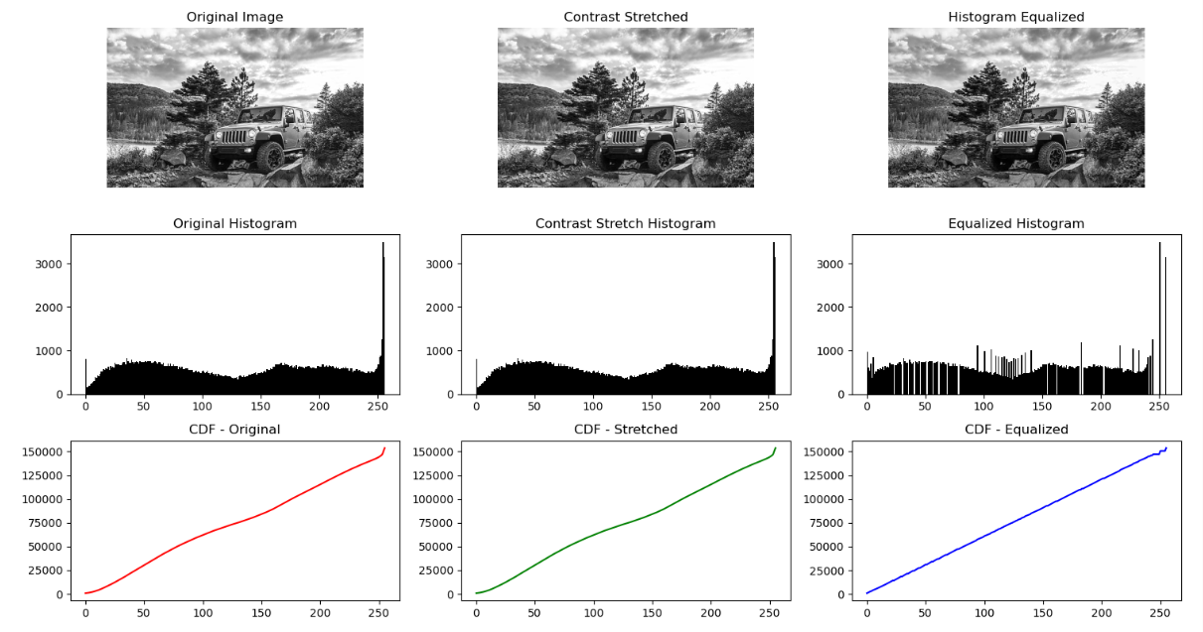

**Conclusion**

In this experiment, the concept of image enhancement for low contrast grayscale images was studied using contrast stretching and histogram equalization. Contrast stretching improved the visibility of the image by expanding the narrow intensity range to the full gray level range of 0–255, making dark regions darker and bright regions brighter. On the other hand, histogram equalization redistributed the pixel intensities to produce a more uniform histogram, thereby enhancing both dark and bright areas simultaneously and revealing hidden details. By comparing the histograms before and after processing, it was observed that both techniques significantly improved image quality, with histogram equalization providing a more balanced global contrast. These methods are widely applied in fields such as medical imaging, satellite image analysis, low-light photography, and surveillance, where improved clarity is essential.