**Name:** Pratik Rajkumar Mulik

**PRN:** 123B1F063

**Class :** TY I.T (A)

**Assignment 1**

**1**. **Title :** Image Enhancement Techniques on 8-bit Grayscale Image

**2. Aim:**

The aim is to apply various image enhancement techniques on an 8-bit grayscale image to study their effects.

**3. Methods / Techniques Used:**

* List each method performed.
  1. Brightness Improvement: Adding a constant to make the image brighter.

Adjusting the brightness of an image in OpenCV is done by adding a constant value to all pixels, making the overall image appear lighter

* 1. Brightness Reduction: Subtracting a constant to make the image darker.

Brightness reduction decreases pixel values by subtracting a constant, which makes the image appear darker and can help suppress overly bright features.

* 1. Thresholding: Converting grayscale to binary using a threshold value.

Thresholding converts a grayscale image to a binary one by assigning pixels above a certain intensity to one value (e.g., white) and below it to another (e.g., black); this process emphasizes significant objects or regions within the image.

* 1. Negative Transformation: Inverting pixel values to get the image negative.

A negative transformation inverts all the pixel values in an image, effectively creating a photographic negative where bright areas become dark and vice versa.

* 1. Log Transformation: Enhancing details in dark areas through a logarithmic operation.

Log transformation enhances details in the darker regions of an image while compressing high-intensity values, which helps in expanding the visibility of features present in shadows.

* 1. Power-law (Gamma) Transformation: Adjusting image brightness and contrast nonlinearly.

This transformation applies a nonlinear curve to pixel values, enabling control over image brightness and contrast for feature enhancement; using a gamma value less than one brightens the image, while greater than one darkens it

**4. Code Snippet :**







**5. Results :**

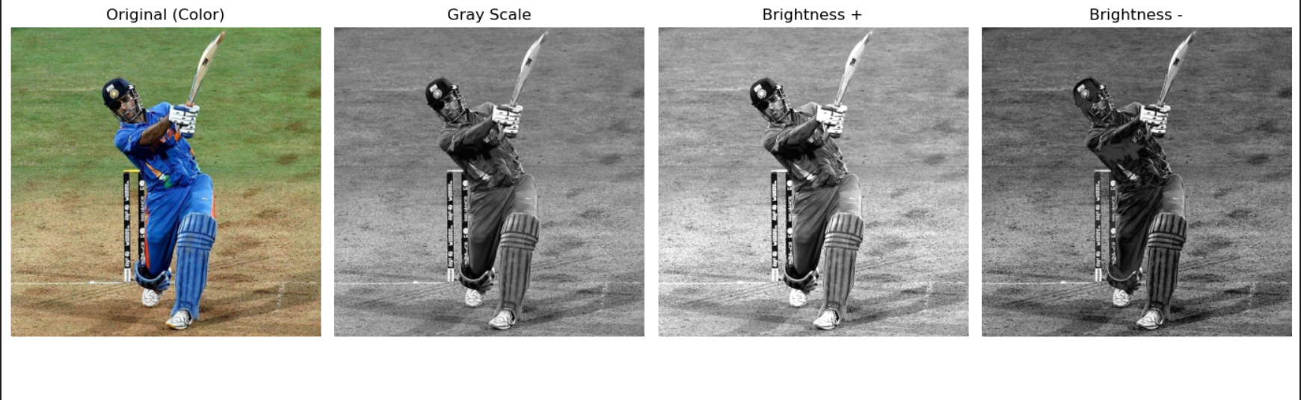

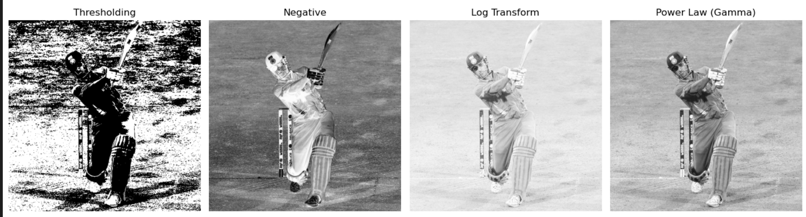

**6. Discussion**

Each enhancement technique has a distinct impact on the image. Brightness adjustment makes features more or less visible depending on the factor applied. Thresholding simplifies the visual information, enabling easier distinction between objects and background. Negative, logarithmic, and gamma transformations reveal hidden features and adjust contrast, aiding better analysis of different image regions.

**7. Conclusion**

Applying various image enhancement techniques improves the quality and interpretability of digital images. These simple processing operations form the basis for more advanced procedures in computer vision and image analysis, demonstrating how altering pixel intensity values can highlight important features and aid further processing tasks.

**8. References**

* OpenCV Documentation: <https://docs.opencv.org/>
* GeeksforGeeks, "Image Enhancement Techniques using OpenCV": <https://www.geeksforgeeks.org/machine-learning/image-enhancement-techniques-using-opencv-python/>
* IvyPanda, "Digital Image Processing: Basics": <https://ivypanda.com/essays/digital-image-processing-basics/>