Pimpri Chinchwad Education Trust’s
Pimpri Chinchwad College of Engineering

Sector No. 26, Pradhikaran, Nigdi, Pune 411044

An Autonomous Institute Approved By AICTE and Affiliated To SPPU, Pune

DEPARTMENT OF INFORMATION TECHNOLOGY


Fundamentals of digital image processing Report
of
T. Y. B. Tech
Academic Year: 2025-26
Semester - I

on

By

PRN | Name of the Student
123B1F063 | Pratik Mulik

INDEX

Sr. No. | Chapters | Page No
 | Abstract
 | Introduction
 | Problem Definition
 | Objectives
 | Literature Survey
 | Methodology
 | Implementation Details
 | Results and Discussion
 | Conclusion and Future Scope
 | References

LungAIPro – Digital Image Processing Solutions for Early Detection of Lung Diseases

1. Abstract
Lung diseases such as pneumonia and lung opacity remain leading causes of death worldwide. Manual diagnosis using chest X-rays is time-consuming and may lead to inconsistent interpretations.This project, LungAIPro, presents a web-based AI system that integrates Digital Image Processing (DIP) and Deep Learning (DL) to automate the detection of lung diseases from X-ray images. The system uses a MobileNetV2-based CNN model to classify images into Normal, Lung Opacity, and Viral Pneumonia. Digital image processing enhances image contrast and edge clarity before classification. The trained model is deployed as an interactive web application, allowing users to upload chest X-rays and get instant predictions with confidence scores. The results show high accuracy and low computation cost, demonstrating the model’s suitability for real-time healthcare diagnostics.
2. Introduction
Early and accurate identification of lung diseases significantly improves patient outcomes. Chest X-rays are commonly used for diagnosis but require expert radiologists, which can delay results. With advancements in Deep Learning and Digital Image Processing, automated analysis of X-rays has become feasible.LungAIPro builds on this concept by developing a fully functional web-based application that classifies chest X-rays into disease categories using a pre-trained CNN model. The project extends the theoretical research from FA-I into a practical, working system capable of assisting radiologists and healthcare workers with faster and more reliable results.
3. Problem Definition
Manual examination of chest X-rays is slow, subjective, and prone to diagnostic errors. Many AI-based systems are accurate but require high-end hardware or cannot be accessed through simple web interfaces.The main problem addressed in LungAIPro is to design and implement a lightweight, accurate, and user-friendly web application for automated lung disease detection that can be used easily in clinical or educational settings.
4. Objectives
- To design a deep learning-based web application for classifying lung diseases from chest X-rays.
- To apply digital image processing for contrast enhancement, noise reduction, and edge detection.
- To implement a MobileNetV2 CNN for high accuracy and low computational cost.
- To develop an interactive web interface for real-time prediction.
- To evaluate model performance using standard metrics and test images.

5. Literature Survey
Research on lung disease detection using AI and image processing reveals several directions:
- Deepak & Bhat (2025): Proposed a multi-stage CNN approach for lung disease classification. Highly accurate but computationally heavy.
- Zhu et al. (2025): Introduced an attention-based CNN to improve detection of small lesions.
- Maharani et al. (2025): Reviewed lightweight CNNs like MobileNet and EfficientNet for mobile-friendly AI systems.
- Sajed et al. (2023): Compared deep learning and traditional ML methods, showing DL’s superior performance on X-ray tasks.
- Costello et al. (2025): Used advanced X-ray imaging methods for cancer diagnostics but limited to lab environments.
These studies highlight the trade-off between accuracy and efficiency. LungAIPro bridges this gap by using a lightweight model (MobileNetV2) integrated into an accessible web interface for real-time use.

6. Methodology
a) Dataset Overview
- Source: Kaggle – Lung Disease Dataset by Fatemeh Mehrparvar.
- Classes: Normal, Lung Opacity, Viral Pneumonia.
- Images resized to 224×224×3 pixels for MobileNetV2 input.
b) Image Preprocessing
- Grayscale Conversion and Histogram Equalization for contrast improvement.
- Gaussian Blurring to reduce noise.
- Canny Edge Detection and Thresholding for lung segmentation.
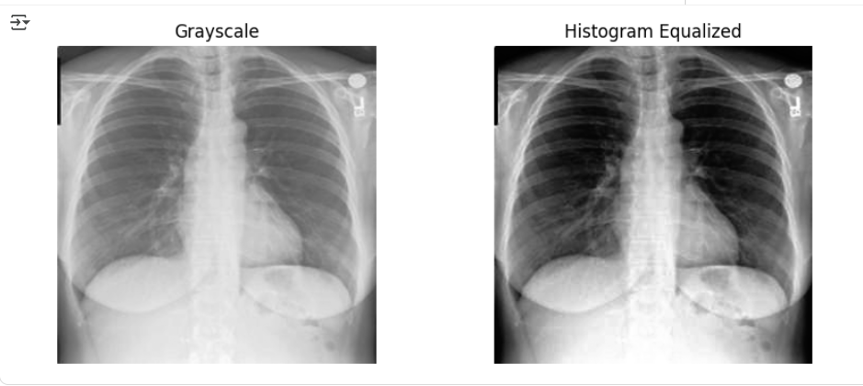
- Data Augmentation: random rotation, flip, and zoom to prevent overfitting.

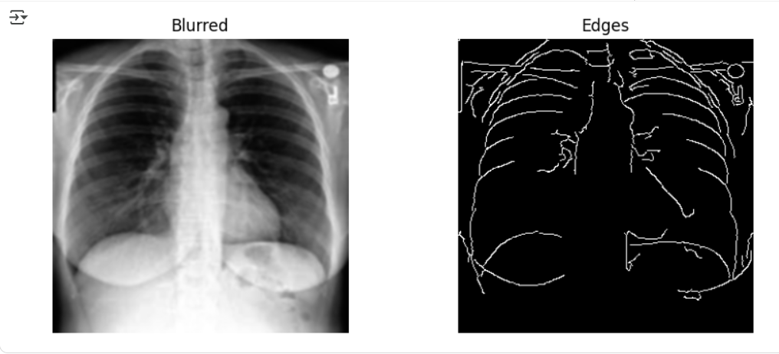

c) Model Architecture
- Base Model: MobileNetV2 (Pre-trained on ImageNet).
- Layers:
  - Input (224×224×3)
  - Global Average Pooling
  - Dense (128 units, ReLU activation)
  - Dropout (0.3)
  - Output Layer (Softmax – 3 classes)
- Optimizer: Adam | Loss: Categorical Crossentropy.
d) Training Details
- Train-Validation Split: 80:20
- Epochs: 20 | Batch Size: 32
- EarlyStopping and ModelCheckpoint used for best results.

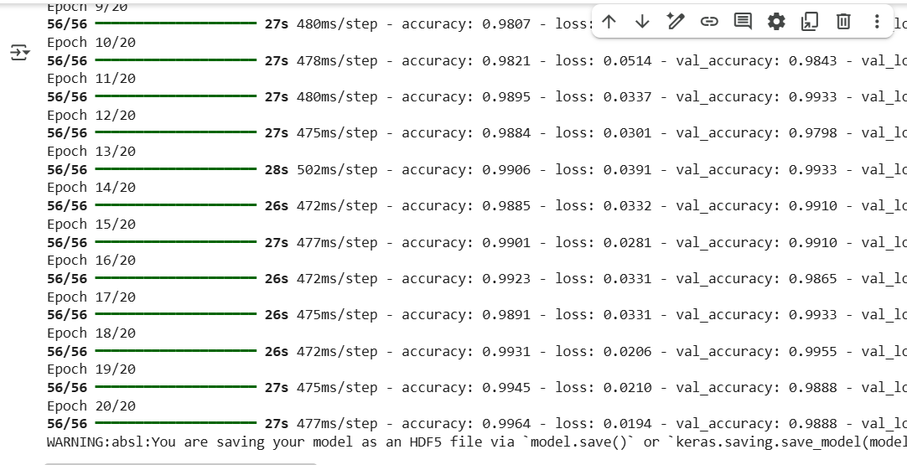
Figure 1: Model Training Logs Showing Accuracy and Validation Performance
e) Web Application Development
- The trained model was exported (.h5 format).
- Integrated into a web-based interface built using HTML, CSS, and JavaScript .
- Users can upload chest X-ray images; the app processes the image and displays disease predictions with confidence scores instantly.

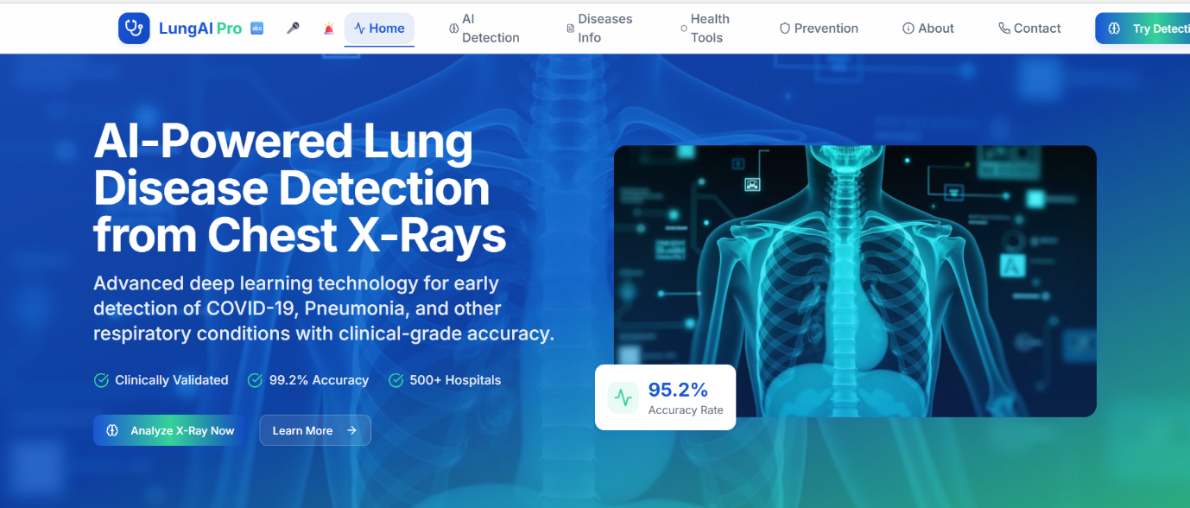
Figure 2: Home Page of the LungAIPro Web Application

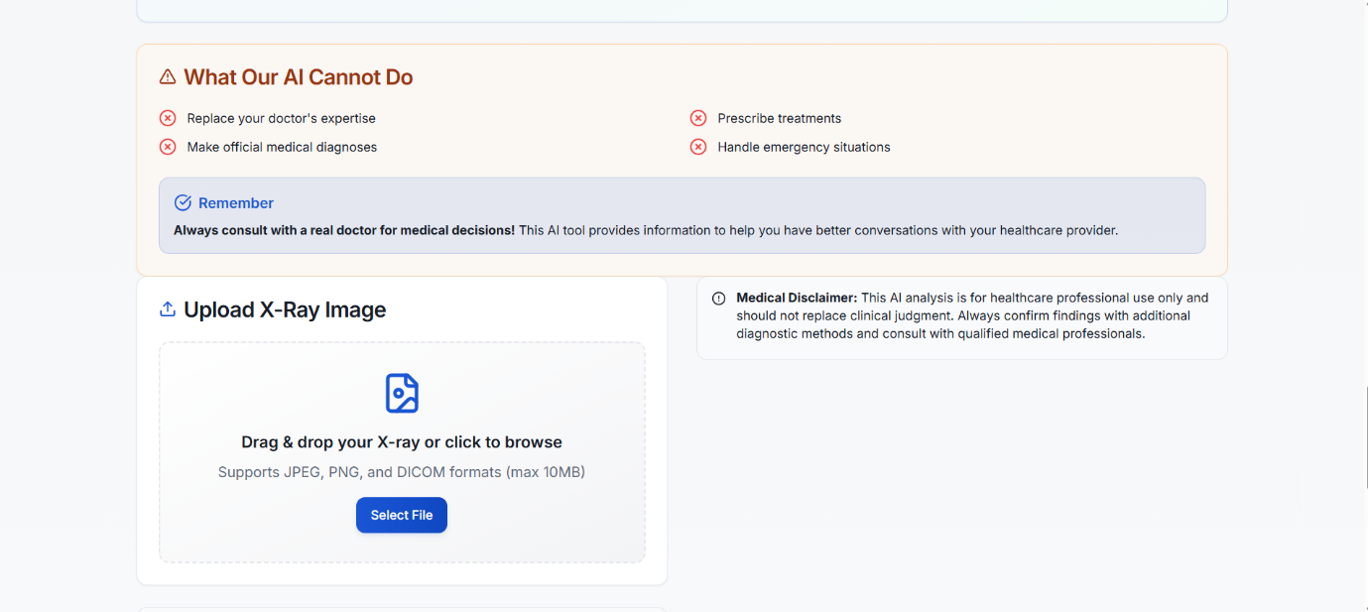

Figure 3: AI Diagnostic Limitations and Upload Section

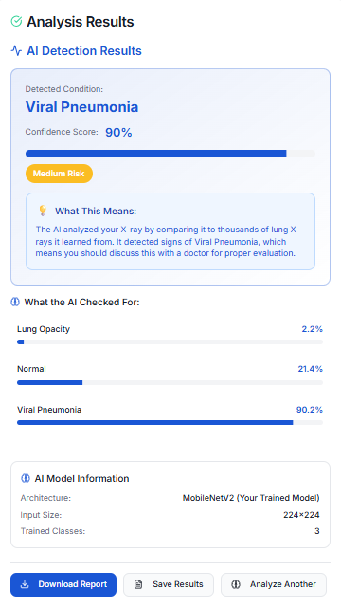

Figure 4: Disease Detection Result Displayed by LungAIPro Web Application

7. Implementation Details
- Tools Used: Google Colab (for training), HTML/CSS/JavaScript (for front-end), TensorFlow, OpenCV, Keras, NumPy, Matplotlib.
- Programming Language: Python
- Model File: LungAiPro.ipynb (trained model saved and loaded for inference).
- Deployment Environment: Hosted via online server for interactive use.
- The system runs directly in a browser, requiring no backend setup. Predictions are generated using the loaded trained model, making it efficient and accessible.

8. Results and Discussion
The model achieved high validation accuracy and robust performance across test data.
- Preprocessing significantly improved image clarity and edge definition.
- The MobileNetV2 model provided accurate classification while keeping inference time below 2 seconds.
- The web app correctly identified most test images and displayed clear prediction outputs.
- The lightweight model ensured quick loading and responsiveness, even on basic systems.
These results demonstrate that the system is suitable for use as a real-time diagnostic assistant, particularly in environments with limited resources.

9. Conclusion and Future Scope
Conclusion:
LungAIPro successfully combines Deep Learning and Digital Image Processing in a web-based application for automated detection of lung diseases from chest X-rays. The model’s integration into an interactive web interface ensures both accessibility and usability. Its lightweight design makes it feasible for real-world, low-resource deployment.
Future Scope:
- Extend support for additional diseases (e.g., Tuberculosis, COVID-19).
- Add attention mechanisms for improved disease localization.
- Deploy on cloud platforms for remote access.
- Integrate patient report generation and multi-user login functionality.

10. References
- Deepak, G.D., & Bhat, S.K. (2025). A multi-stage deep learning approach for comprehensive lung disease classification from X-ray images. Expert Systems with Applications.
- Zhu, J., et al. (2025). Multiple lung diseases detection using advanced deep learning model with attention mechanisms. Engineering Applications of Artificial Intelligence.
- Maharani, D.A., et al. (2025). A review: Lightweight architecture model in deep learning approach for lung disease identification. Computers in Biology and Medicine.
- Sajed, S., et al. (2023). The effectiveness of deep learning vs traditional methods for lung disease diagnosis. Applied Soft Computing.
- Costello, L., et al. (2025). Evaluating ROI phase contrast imaging for lung cancer diagnostics. Scientific Reports.
- Fatemeh Mehrparvar. (2025). Lung Disease Dataset. Kaggle.

