Name: Pratik Rajkumar Mulik
PRN: 123B1F063
CLASS : TY I.T (A)
BATCH : A3

Assignment No.3

Aim
To understand the fundamentals of Object-Oriented Modeling and Design (OOMD) and to apply this knowledge by creating and analyzing a comprehensive Use Case diagram for a software project.
Objective
- To define Object-Oriented Modeling and Design (OOMD).
- To understand the purpose of the Unified Modeling Language (UML) and its diagrams.
- To learn the importance and core concepts of a Use Case diagram.
- To identify actors, use cases, and their associations for our Organic Farming Marketplace project.
- To prepare and explain a detailed Use Case diagram for the project.

Theory :
Q 1. What is OOMD ?
Object-Oriented Modeling and Design (OOMD) is a systematic approach used in software engineering to analyze, design, and model a system using object-oriented concepts.It focuses on representing a system as a collection of objects, which are real-world entities having attributes (data) and methods (behavior). These objects interact with each other to perform system functionality.
OOMD makes use of Unified Modeling Language (UML) diagrams to visually represent system structure and behavior before implementation. This helps developers, designers, and stakeholders understand the system clearly and avoid ambiguities.

Key Features
- Abstraction – Focus only on essential details of objects.
- Encapsulation – Grouping data and behavior inside classes.
- Inheritance – Reusing existing classes to create specialized ones.
- Polymorphism – Allowing objects to take many forms (flexibility).

Benefits of OOMD
- Provides a clear blueprint before coding.
- Enhances reusability and scalability of software.
- Makes complex systems easier to design and maintain.
- Improves communication among team members through UML diagrams.
By using OOMD, developers can manage the complexity of large systems, create more maintainable and reusable code, and design systems that are easier to adapt to future changes.

Q 2. What are UML diagrams ?
UML (Unified Modeling Language) is a standardized modeling language used to represent the design and structure of object-oriented software systems. It provides a set of diagrams that allow developers, analysts, and stakeholders to understand and communicate both the static structure and the dynamic behavior of a system.
UML diagrams are broadly categorized into Structural Diagrams and Behavioral Diagrams.

Structural Diagrams (Static View of the System)
These diagrams describe the components, classes, and physical aspects of the system that do not change frequently.
- Class Diagram:
Represents the classes of the system, their attributes, operations (methods), and the relationships between them (association, inheritance, aggregation, composition). It is the most widely used UML diagram.
- Object Diagram:
Shows a snapshot of objects and their relationships at a particular moment in time, useful for understanding examples of data structures.
- Component Diagram:
Illustrates the organization and dependencies among physical software components such as executables, libraries, or databases.
- Deployment Diagram:
Describes how software components are deployed across hardware nodes, showing servers, devices, and their connections.
- Package Diagram:
Groups related classes, components, or use cases into packages to simplify large system designs.

Behavioral Diagrams (Dynamic View of the System)
These diagrams focus on how the system behaves over time, including interactions and workflows.
- Use Case Diagram:
Depicts the system’s functional requirements from the user’s perspective. It includes actors (users/external systems) and use cases (functionalities).
- Sequence Diagram:
Shows how objects interact with each other in a sequence of messages arranged in a time-ordered manner.
- Activity Diagram:
Similar to a flowchart, it represents the workflow of activities and actions, including decisions, concurrency, and loops.
- State Machine Diagram:
Represents different states of an object and the transitions between those states triggered by events.
- Communication Diagram:
Focuses on the interactions between objects and the messages they pass, emphasizing relationships rather than time order.
- Interaction Overview Diagram:
Provides a high-level view of control flow among interactions, combining activity and sequence diagrams.
- Timing Diagram:
Shows how the state of an object changes over time, with emphasis on timing constraints.

Q 3. Importance of UML Diagrams
Unified Modeling Language (UML) diagrams are an essential part of object-oriented analysis and design. They provide a visual blueprint of the system, which helps in understanding, designing, and maintaining complex software projects.
Key Points of Importance
- Better Visualization of Systems
  - UML diagrams give a clear picture of both the static structure and dynamic behavior of the system.
  - They simplify complex ideas into easy-to-understand models.
- Standardized Communication
  - UML provides a common modeling language that developers, designers, testers, and stakeholders can understand.
  - Reduces miscommunication in large teams.
- Requirement Analysis
  - Use Case diagrams help capture functional requirements directly from the user’s perspective.
  - Ensures the system design aligns with user needs.
- Efficient System Design
  - Class, Sequence, and Activity diagrams make the design process systematic and organized.
  - Helps in identifying relationships, workflows, and dependencies early.
- Improves Reusability and Maintenance
  - Clearly defined designs allow parts of the system to be reused in future projects.
  - Easier to maintain, debug, and enhance the system since diagrams act as documentation.
- Bridges the Gap Between Requirements and Implementation
  - UML acts as a blueprint between high-level user requirements and low-level coding.
  - Developers can directly translate UML models into code.

Q 4. What is a Use Case Diagram?
A Use Case Diagram is one of the most important behavioral diagrams in UML (Unified Modeling Language). It visually represents the functional requirements of a system from the perspective of the end users (actors).
It shows:
- Actors → Users or external systems that interact with the system.
- Use Cases → Functionalities or services the system provides to the actors.
- Relationships → How actors and use cases are connected (association, include, extend).
Purpose of a Use Case Diagram
- To capture the functional requirements of the system.
- To provide a high-level view of system behavior.
- To act as a communication tool between stakeholders, users, and developers.

Description of the Organic Farming Marketplace Use Case Diagram
- Actors and Their Roles:
  - The diagram defines four primary actors:
    - Farmer – manages their account, lists products, and receives notifications.
    - Consumer – browses products, places orders, makes payments, and reviews products.
    - Admin – oversees platform integrity by approving listings, verifying farmers, and resolving disputes.
    - Support Agent – handles complaints and queries from users.
  - This classification clearly distinguishes the roles of each actor in the ecosystem.
- Key System Functionality:
The use cases are logically grouped based on user roles:
  - Farmer Functionalities: Register/Login, Manage Profile, List Product, Receive Notifications.
  - Consumer Functionalities: Register/Login, Manage Profile, Search/Browse Products, Add to Cart, Place Order, Make Payment, Track Order, Give Review/Rating, Receive Notifications.
  - Admin Functionalities: Approve Listings, Verify Farmers, Resolve Disputes.
  - Support Agent Functionalities: Handle Complaints/Queries.
- System Workflow & Relationships:
  - Farmers and Consumers share common functions like Register/Login and Manage Profile, which emphasizes that both require account management.
  - Consumers’ shopping-related functions (Add to Cart → Place Order → Make Payment → Track Order) form a clear transaction workflow.
  - Admin ensures trust and security by verifying farmers before allowing product listings, thereby safeguarding consumers.
  - Support Agents act as mediators to maintain user satisfaction by resolving complaints and queries.
- Notable Observations:
  - Unlike some systems, this diagram does not explicitly use <<include>> or <<extend>> relationships, but implicit dependencies exist (e.g., Place Order naturally requires Add to Cart first).
  - The system provides a balanced interaction model between producers (Farmers), consumers, and regulating authorities (Admin & Support Agent), ensuring a holistic marketplace environment.

Use Case Diagram for the Organic Farming Marketplace :
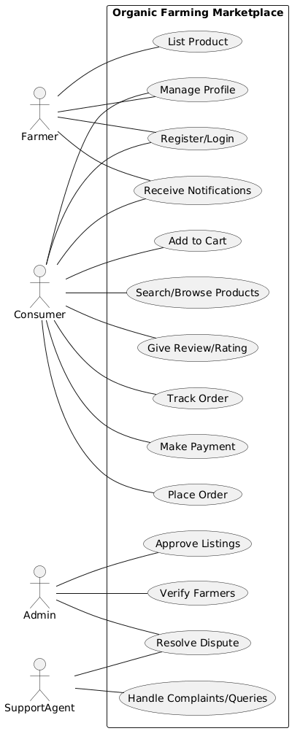
Conclusion
This assignment provided a practical introduction to Object-Oriented Modeling and Design and the Unified Modeling Language. By creating and analyzing a Use Case diagram, we successfully captured the functional requirements of the Organic Farming Marketplace project from a user-centric perspective.
The diagram effectively identifies all actors, their goals, and the relationships between system functions, creating a clear visual map of the project's scope. It serves as a foundational blueprint that clarifies the system's purpose for all stakeholders and will guide the development of more detailed diagrams in subsequent design phases.

