Name: Pratik Rajkumar Mulik
PRN: 123B1F063
CLASS : TY I.T (A)
BATCH : A3

Assignment No.4

Aim
To understand and create a UML Analysis Class Diagram, which serves as the primary conceptual and structural blueprint for an object-oriented software system.

Objective
- To learn the definition and core components of a UML Class Diagram.
- To understand the difference between an analysis class diagram and a design class diagram.
- To learn the systematic steps required to create an analysis class diagram.
- To apply this knowledge by preparing a detailed Analysis Class Diagram for the chosen case study, the Organic Farming Marketplace project.

Theory
Q.1 What is a Class Diagram?
A Class Diagram is a static structural diagram that shows the classes, their attributes (data members), operations (methods/functions), and the relationships among them within a system. It represents the blueprint of an object-oriented system, similar to a database schema or a skeleton of the system’s code.
Key Components of a Class Diagram:
- Classes:
  - Represented as rectangles divided into three parts:
    - Class Name
    - Attributes (fields/variables)
    - Methods (functions/operations)
- Relationships:
  - Association → Simple connection between two classes (e.g., Student – Enrolls – Course).
  - Multiplicity → Defines how many objects participate (1..*, 0..1, etc.).
  - Inheritance (Generalization) → Shows "is-a" relationship (e.g., Car → Vehicle).
  - Aggregation → “Has-a” relationship but weak (e.g., Department has Faculty).
  - Composition → Strong ownership (e.g., House has Rooms).
  - Dependency → One class depends on another temporarily.

Q.2 What is an Analysis Class Diagram?
An Analysis Class Diagram is a type of UML class diagram created during the analysis phase of software development. It is different from the design class diagram because it focuses on what the system must do, not on how it will be implemented.
An Analysis Class Diagram represents the conceptual model of the problem domain. It captures the key entities (classes), their attributes, and relationships that exist in the real-world system, without including implementation-specific details like database keys, data types, or method signatures.
Key Characteristics:
- Focus on concepts, not implementation
  - Represents real-world entities (e.g., Customer, Order, Product) instead of programming classes.
  - Avoids technical details like private/public modifiers, return types, or SQL mapping.
- Bridges requirements and design
  - Derived directly from use case models and requirements.
  - Provides a foundation for later creating the Design Class Diagram.
- Shows only essential details
  - Attributes: high-level (e.g., name, address)
  - Methods: often omitted or described abstractly (e.g., "calculate bill").
Purpose of Analysis Class Diagram:
- To understand the problem domain better.
- To communicate requirements with stakeholders in a simple, conceptual form.
- To provide a foundation for the design class diagram.
- To ensure all entities needed for system functionality are identified.

Q.3 What are the steps to draw an Analysis Class Diagram?
An Analysis Class Diagram is created during the analysis phase of software development, based on requirements and use cases. Here are the structured steps:
Step 1: Identify the Classes (Concepts)
- Read the problem statement and use cases carefully.
- Pick out the nouns → they usually become classes/entities.
  - Example: Customer, Order, Product, Payment.
Step 2: Identify Attributes for Each Class
- Look for properties that describe each class.
- Keep attributes conceptual, not technical.
  - Example: Customer → name, email, address.
  - Avoid data types at this stage (no String name, just name).
Step 3: Identify Relationships Between Classes
- Look for verbs/actions in the requirements → they indicate relationships.
- Types of relationships:
  - Association → simple connection (e.g., Customer places Order).
  - Aggregation/Composition → whole-part relationship (e.g., Order contains Products).
  - Generalization (Inheritance) → "is-a" relationship (e.g., Admin is a type of User).
Step 4: Define Multiplicity (Cardinality)
- Show how many objects participate in the relationship.
  - Example:
    - A Customer can place many Orders → Customer 1..* ←→ 1 Order.
    - An Order contains many Products → Order 1 ←→ * Product.
Step 5: Refine with Use Cases
- Go back to the Use Case Diagram.
- Make sure every use case has supporting classes in the class diagram.
Step 6: Review and Simplify
- Remove unnecessary or duplicate classes.
- Keep it conceptual and high-level (no database keys, no technical constraints).
UML Analysis Class Diagram of the Organic Farming Marketplace :
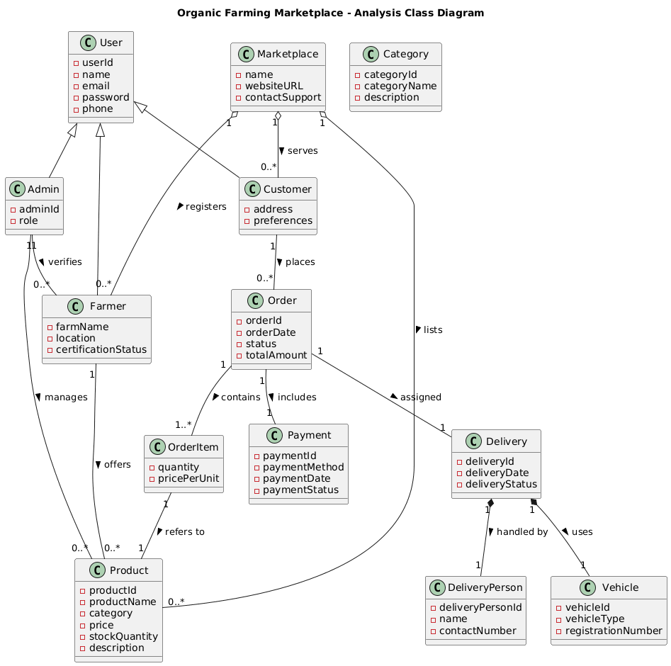

Conclusion
This assignment provided a comprehensive study of the UML Class Diagram, focusing specifically on its application as an Analysis Model. By defining its core components and following a systematic process, we successfully created a conceptual Class Diagram for the Organic Farming Marketplace project.
This diagram serves as an essential high-level blueprint. It visually communicates the static structure of the problem domain, clarifies the fundamental relationships between all major entities, and establishes a shared understanding among all project stakeholders. It forms the crucial first step before proceeding to a more detailed Design Class Diagram, ensuring that the system's foundation is logical

