Name: Pratik Rajkumar Mulik
PRN: 123B1F063
CLASS : TY I.T (A)
BATCH : A3

Assignment No.5

Aim
To evolve a conceptual Analysis Class Diagram into a detailed Design Class Diagram, creating a complete and implementation-ready blueprint for an object-oriented software system.
Objective
- To understand the purpose and components of a Design Class Diagram.
- To compare the differences between an Analysis Class Diagram and a Design Class Diagram.
- To learn the systematic steps required to create a detailed Design Class Diagram.
- To apply this knowledge by preparing a complete Design Class Diagram for the chosen case study, the Organic Farming Marketplace project.

Theory
Q.1 What is a Design Class Diagram?
A Design Class Diagram (DCD) is a type of UML (Unified Modeling Language) diagram used during the design phase of software development.It refines the Conceptual Class Diagram (CCD) by adding details necessary for implementation. While a conceptual diagram focuses on what the system needs, a design class diagram focuses on how it will be built in code.
It is a static structural diagram that provides a complete and unambiguous picture of the system's architecture. Its high level of detail is its defining characteristic, specifying the exact structure of the code to be written. This includes:
- Precise Attributes: Each attribute is defined with a visibility mode and a specific programming data type. Visibility modes enforce encapsulation, a core principle of object-oriented programming.
  - - Private: The attribute is only accessible from within the class itself. This is the most common choice for attributes to protect data integrity.
  - + Public: The attribute is accessible from any other class. This is rarely used for attributes.
  - # Protected: The attribute is accessible within its own class and any of its subclasses (children).
- Full Method Signatures: Each method (or operation) is fully specified, leaving no room for interpretation. This includes:
  - Visibility: Defines who can call the method. Public (+) methods form the class's interface.
  - Parameters: A list of all input values the method requires, each with its own name and data type (e.g., (email: String)).
  - Return Type: The data type of the value the method returns after execution (e.g., : boolean, : void).
- Implementation-Specific Classes: A design diagram often introduces classes that are not part of the core business domain but are necessary for the technical implementation. These can include:
  - Controller Classes: To manage the flow of data between the user interface and the model.
  - Utility Classes: To provide helper functions (e.g., PasswordHasher).
  - Data Access Objects (DAOs): To handle communication with the database.

Q.2 Compare Analysis & Design Class Diagrams
Aspect | Analysis Class Diagram | Design Class Diagram
Purpose | Represents the problem domain (what the system should do). | Represents the solution domain (how the system will do it).
Level | Conceptual / high-level. | Technical / implementation-level.
Focus | Focuses on business concepts, real-world entities, and relationships. | Focuses on software classes, methods, data structures, and interactions.
Abstraction | More abstract – hides implementation details. | More detailed – includes implementation decisions.
Elements Shown | Attributes and responsibilities of entities, without data types or full operations. | Attributes with data types, full operations with parameters and return types, visibility (+, -, #).
Example | Student has a name, rollNo, and is associated with Course. | Student class has String name, int rollNo, methods like enroll(Course c), connected with multiplicities.
Audience | Business analysts, domain experts, stakeholders. | Developers, architects, system designers.

Q.3 What are the steps to draw a Design Class Diagram?
Creating a design class diagram involves systematically adding technical details to an existing analysis model. The steps are as follows:
- Start with the Analysis Diagram:
The approved Analysis Class Diagram of the Organic Farming Marketplace acts as the base. It already includes all major business entities such as Farmer, Customer, Product, Order, and Marketplace. These core classes and their conceptual relationships must be preserved while transitioning into the design phase.
- Specify Attributes in Detail:
For every class, each attribute is defined with proper data types and visibility modifiers. For example:
  - Product class includes productId: int, productName: String, price: double, and stockQuantity: int.
  - Customer class includes customerId: int, name: String, email: String, and address: String.
  - Attributes are made private (-) to ensure encapsulation and are accessed through getter and setter methods.

- Define Detailed Methods:
Each class is given a set of well-defined methods that support its behavior:
  - Constructors: Used to create objects, e.g., Product(int id, String name, double price).
  - Accessor and Mutator Methods: e.g., getPrice(): double, setPrice(double newPrice): void.
  - Business Logic Methods:
    - Farmer → addProduct(), updateProduct(), viewOrders().
    - Customer → browseProducts(), placeOrder(), trackOrder().
    - Order → calculateTotal(), confirmOrder(), cancelOrder().
    - Payment → processPayment(), refundPayment().
Each method includes visibility (+), parameters, and return type.
- Add Implementation-Specific Classes:
To represent the technical structure of the web-based marketplace, additional Controller, Boundary, and Service classes are introduced:
  - Controller Classes:
    - ProductController → manages product listings and updates.
    - OrderController → handles order placement and tracking.
    - UserController → manages user registration and login.
  - Boundary Classes (Interface Components):
    - ProductPage → displays available organic products.
    - CheckoutPage → manages the customer’s order and payment details.
  - Service Classes:
    - PaymentService → integrates with external payment gateways.
    - DeliveryService → coordinates delivery tracking and assignment.
- Review and Refine Relationships:
All relationships are re-evaluated to ensure technical feasibility:
  - A one-to-many relationship exists between Farmer and Product.
  - A one-to-many relationship exists between Customer and Order.
  - One-to-one relationships exist between Order and Payment, and between Order and Delivery. Navigability arrows are added to show direction — for instance, Customer knows about Order, but Order does not directly reference Customer.
Many-to-many associations (if any) are converted into linking classes (e.g., OrderItem between Order and Product).
- Draw the Final Diagram:
Using UML tools or PlantUML, the final Design Class Diagram is created with all implementation-level details — including visibility symbols, precise data types, method signatures, and refined relationships. This final version is technically complete, enabling developers to start coding classes directly without ambiguity.
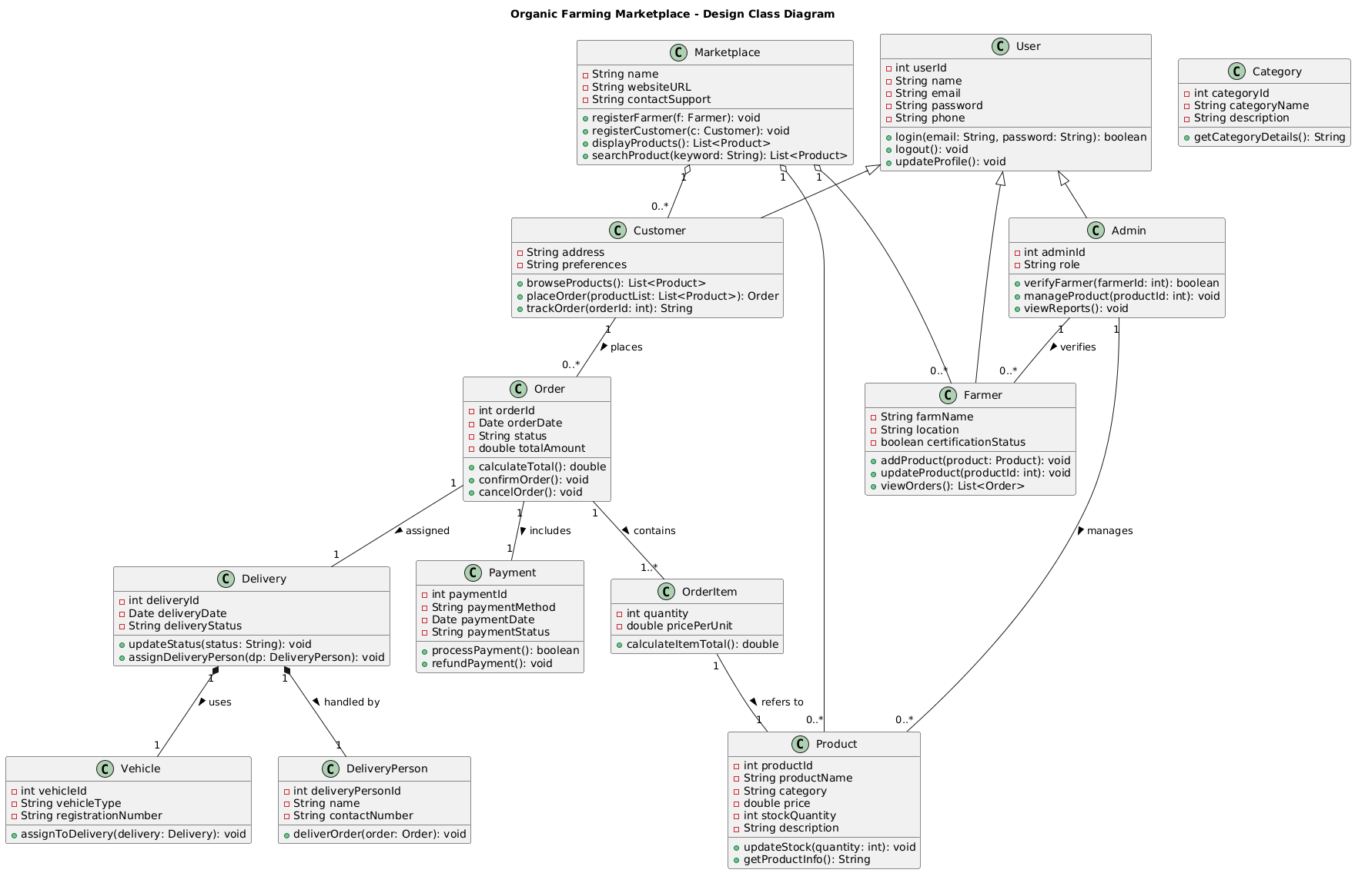
UML Design Class Diagram of the Organic Farming Marketplace :
Conclusion :
This assignment detailed the process of evolving a conceptual model into an implementation-ready Design Class Diagram. By comparing the analysis and design stages and following a systematic process, we successfully created a detailed technical blueprint for the Organic Farming Marketplace project.
The Design Class Diagram is the final and most critical structural model before the commencement of coding. It provides an unambiguous, detailed specification for developers, defining the exact structure of classes, attributes, methods, and their interactions. This level of detail minimizes errors, promotes a consistent architecture, and serves as the essential link between the design phase and the construction

