Name: Pratik Rajkumar Mulik
PRN: 123B1F063
CLASS : TY I.T (A)
BATCH : A3

Assignment No.6

Aim
To understand and model the dynamic behavior of a software system by creating UML Sequence Diagrams for key interaction scenarios.
Objective
- To learn the definition, purpose, and core components of a UML Sequence Diagram.
- To understand advanced UML notations, specifically Combined Fragments, for modeling complex logic like loops and conditions.
- To identify major interaction scenarios within the chosen case study (Organic Farming Marketplace).
- To create detailed Sequence Diagrams for three different scenarios.
- To analyze the concept of combining sequence diagrams for a case study.

Theory
1) What is a Sequence Diagram?
A Sequence Diagram is a type of interaction diagram in UML that visually represents how different objects or components of a system communicate with each other in a particular sequence of time. It describes the dynamic behavior of a system, focusing on the order in which messages are exchanged between the interacting elements to accomplish a specific task or process.
In a sequence diagram, each participating element (such as a user, object, or system module) is depicted as a lifeline—a vertical dashed line that indicates the presence of that element over time. Across the top of the diagram, these lifelines are arranged horizontally. Communication between them is shown through horizontal arrows, which represent the messages, method calls, or data transfers occurring during the interaction.
The flow of time progresses vertically from top to bottom, showing the chronological sequence of operations. Activation bars (thin rectangles on lifelines) indicate the time duration when an object is actively executing a process or responding to a request. Dashed arrows often represent return messages or responses from one object back to another.
A sequence diagram provides a clear, step-by-step visual of how a use case is executed, showing how control passes from one component to another as the process unfolds. It helps in understanding the logical flow of operations, the dependencies between objects, and the exact order of interactions in the system.
In essence, it acts as a timeline-based representation of object interactions, capturing how messages travel between system components to complete a specific scenario or function.

2) What are the different components in a Sequence Diagram?
A Sequence Diagram consists of several key components that together describe how objects interact over time to complete a specific process. Each component has a specific role in representing the flow of messages, timing, and structure of the system’s interactions.
1. Actors
Actors represent the external entities that interact with the system. They can be users, devices, or other systems that initiate or participate in a sequence of actions.
Example: A Customer or Farmer interacting with the Organic Farming Marketplace.
2. Objects (Participants)
Objects are the internal system components or classes that take part in the interaction. Each object performs certain operations and communicates with others by sending or receiving messages.
Example: Marketplace, OrderController, PaymentService.
3. Lifelines
A lifeline is a vertical dashed line drawn from an actor or object that represents its existence over time during the interaction. The top of the lifeline marks the creation of the object, and its continuation shows the time span during which it is active.
4. Messages
Messages are horizontal arrows that represent the communication or interaction between objects. They indicate the flow of information or function calls between participants.
Types of messages include:
- Synchronous message: Sender waits for a response.
- Asynchronous message: Sender proceeds without waiting.
- Return message: Dashed arrow showing the result or acknowledgment of a call.
5. Activation Bars (Execution Occurrences)
These are thin rectangles placed on a lifeline that show the period when an object is performing an operation or active in processing a message. The length of the bar indicates how long the action takes place.
6. Return Messages
Return messages are dashed arrows drawn back to the calling object, showing the completion of a method call and often carrying return data or confirmation of success.
7. Object Creation and Destruction
- Creation: A new object can be created during the sequence, represented by a message arrow pointing to the object’s lifeline.
- Destruction: When an object is no longer needed, an ‘X’ mark at the end of its lifeline indicates its termination.
8. Frames (Optional)
Frames are rectangular boxes that enclose parts of the diagram to represent control structures or conditions such as loops, alternatives, or options. They are labeled with operators like:
- alt → Alternative flow (if-else condition)
- loop → Repetitive actions
- opt → Optional behavior

3) What are Combined Fragments in a Sequence Diagram?
Combined Fragments in a Sequence Diagram are used to represent different control flow scenarios such as decisions, repetitions, and parallel executions within object interactions. They allow the diagram to show how and when certain messages are sent, based on specific conditions or loops.
Each combined fragment is shown as a rectangular frame enclosing part of the sequence, with an operator name (like alt, opt, or loop) written in the top-left corner. Inside the frame, guard conditions (e.g., [paymentSuccess]) specify when that particular section executes.
Common types of Combined Fragments include:
- alt (Alternative): Represents a choice or branching (if–else condition).
- opt (Optional): Executes only if a condition is true.
- loop: Repeats an action multiple times until a condition is false.
- par (Parallel): Shows concurrent or simultaneous interactions.
- break: Interrupts the normal sequence when a condition occurs.
- ref (Reference): Refers to another sequence diagram for reuse.

UML Sequence Diagrams for the Organic Farming Marketplace:
Scenario 1: Customer Places an Order
This diagram shows the sequence of events when a Customer browses for organic products, adds them to the cart, and successfully places an order. It includes an alt fragment to check product availability.
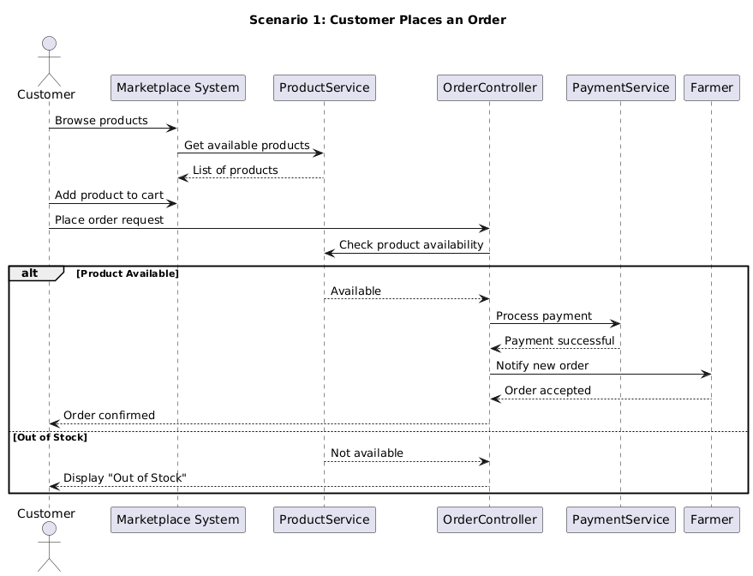
Scenario 2: Farmer Lists a New Product
This diagram models the process where a Farmer lists a new organic product. The system validates the details, saves it as “Pending Approval,” and notifies the admin for review.
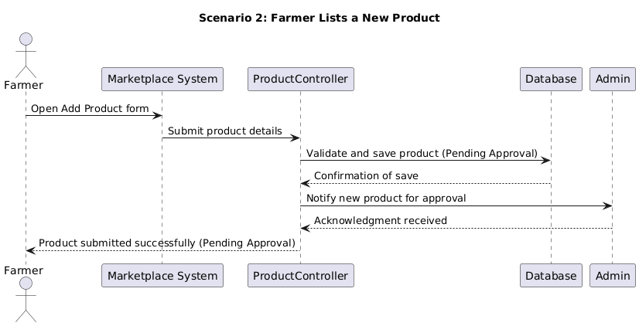
Scenario 3: Admin Approves or Rejects Product Listing
This diagram shows how an Admin reviews a new product listing and uses an alt fragment to handle two possible outcomes — approval or rejection.
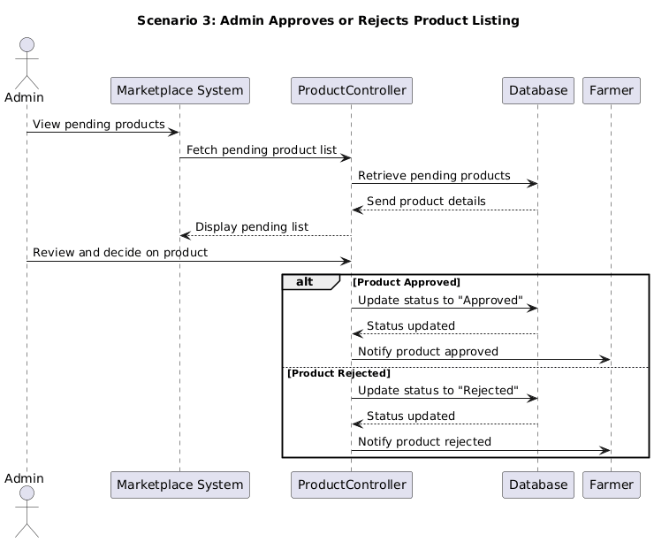
6) Combined Sequence Diagram for the Case Study – Organic Farming Marketplace
A “Combined Sequence Diagram” that merges all scenarios of the Organic Farming Marketplace (such as product listing, customer order placement, and admin approval) is not recommended in UML modeling.
A Sequence Diagram is meant to represent one specific scenario or interaction flow between system components over time. Combining multiple distinct processes like Customer placing an order, Farmer listing a product, and Admin approving listings in a single sequence diagram would make it overly complex and confusing. It would include too many actors (Customer, Farmer, Admin) and too many message exchanges happening at different times, resulting in overlapping lines and unclear message order.
Instead, the proper approach is to keep separate sequence diagrams for each major scenario, as done earlier, since they clearly represent the flow of messages for individual processes.
To represent the overall flow of activities in the Organic Farming Marketplace how different users interact with the system and how one action can lead to another a UML Activity Diagram is more appropriate.
For example:
- After Login, a Customer can browse and purchase products.
- A Farmer can list new products for sale.
- An Admin can review and approve or reject listings.
An Activity Diagram can effectively show these user actions, decision points, and transitions between processes in a single, unified view — giving a complete picture of system behavior without losing clarity.
Therefore, a combined sequence diagram will not be created for this case study, as it is not valid or useful for representing multiple unrelated scenarios. The three separate sequence diagrams (Customer Order, Product Listing, and Admin Approval) correctly illustrate the dynamic behavior of the Organic Farming Marketplace.

Conclusion:
This assignment focused on understanding the dynamic behavior of the Organic Farming Marketplace using UML Sequence Diagrams. It illustrated how different users — customers, farmers, and admins — interact with the system to perform actions like placing orders, listing products, and managing approvals.
The diagrams clearly showed the flow of messages between system components and highlighted how conditional logic can be represented using Combined Fragments (alt). Overall, it provided a clear visualization of system operations and improved understanding of how object interactions support real-world functionalities.

