Name: Pratik Rajkumar Mulik
PRN: 123B1F063
CLASS : TY I.T (A)
BATCH : A3

Assignment No.7

Aim:
The aim of this assignment is to design and analyze an Activity Diagram for the Organic Farming Marketplace system. The goal is to model the dynamic behavior of the platform, showing how different users and system components interact to complete key processes such as product listing, order placement, payment, and delivery tracking.
Objectives:
- To understand the dynamic workflow of the Organic Farming Marketplace system.
- To represent sequential and parallel actions involved in product listing, order placement, payment, and delivery using UML Activity Diagram symbols.
- To identify decision points and alternative paths such as product availability checks and payment success or failure in the system’s workflow.
- To illustrate the responsibilities of different actors — Customer, Farmer, Admin, and Payment Gateway — within the marketplace.
- To visually model how an order request flows from product selection to payment confirmation and delivery completion, ensuring a clear understanding of the overall process.

Theory:
Q1. What is an Activity Diagram?
An Activity Diagram is a type of UML (Unified Modeling Language) diagram that represents the workflow or sequence of activities in a system. It visually describes how different actions, decisions, and processes flow from one step to another, showing both sequential and parallel behavior.
It is mainly used to model the dynamic aspects of a system — focusing on the flow of control rather than the exchange of messages between objects. Each activity represents a specific task or operation, and arrows indicate the order in which these tasks are executed. Decision nodes represent conditional branching, while swimlanes are used to show which actor or component performs each activity.
In simple terms, an Activity Diagram provides a high-level view of system processes, making it easier to understand how users and system components work together to complete a business workflow.
Q2. What is the difference between an Activity Diagram and a Flowchart?
Aspect | Activity Diagram | Flowchart
Purpose | Models the dynamic behavior and workflow of a software system. | Represents a step-by-step process or algorithm.
Used In | Primarily used in UML for software design and system modeling. | Commonly used in general process documentation or programming logic.
Focus | Focuses on activities, decisions, and parallel workflows in a system. | Focuses on the sequence of operations or decisions.
Elements | Includes activities, swimlanes, forks/joins, and decision nodes. | Includes process boxes, decision diamonds, and arrows.
Actors / Responsibilities | Can show who performs each activity using swimlanes. | Does not indicate actors or ownership of actions.
Parallelism | Can represent concurrent or parallel actions. | Typically shows sequential flow only.
Usage Context | Used in system analysis and design (UML). | Used in basic logic representation and documentation.

Q3. What is an Activity Diagram used for?
An Activity Diagram is used to visualize the workflow of a system or business process. It shows how different actions are carried out, how control flows between them, and how decisions or parallel tasks occur within the system.
It is commonly used to:
- Model business processes and system workflows in a clear, step-by-step manner.
- Describe the sequence of activities involved in a particular use case or function.
- Identify decision points, loops, and parallel actions within a process.
- Clarify responsibilities by using swimlanes to show which actor or component performs each task.
- Bridge the gap between high-level business requirements and detailed system design.
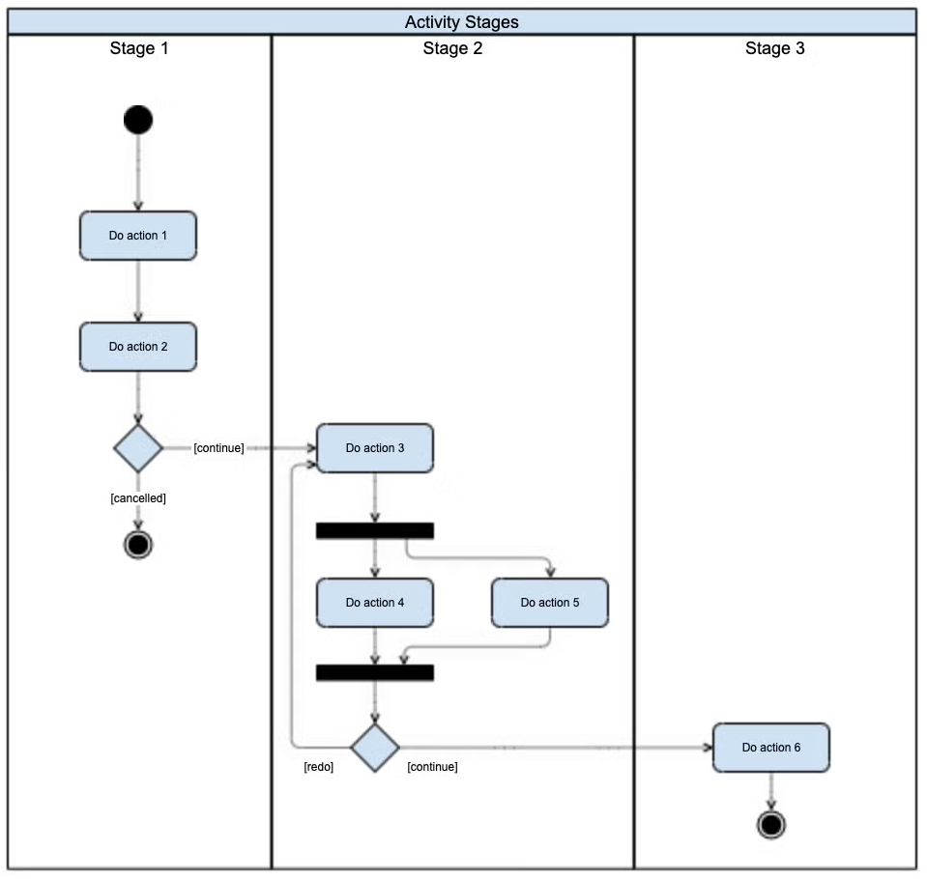

Q4. What are the steps to draw an Activity Diagram?
Creating an Activity Diagram for the Organic Farming Marketplace involves showing how users like customers, farmers, and admins interact with the system to complete different processes. The steps are as follows:
- Identify the Process or Use Case:
Choose a specific use case such as Customer placing an order, Farmer listing a new product, or Admin approving listings.
- Define the Start and End Points:
Mark the start node (e.g., “User logs in”) and end node (e.g., “Order confirmed” or “Product approved”) to indicate the boundaries of the workflow.
- List the Main Activities:
Identify all major actions in the process. For example:
  - Customer: Browse Products → Add to Cart → Make Payment → Receive Confirmation
  - Farmer: Enter Product Details → Submit for Approval → Wait for Admin Response
  - Admin: Review Product → Approve/Reject Listing
- Determine the Flow of Control:
Connect activities with arrows to show how the process progresses from one step to another (e.g., after “Payment Successful,” flow moves to “Notify Farmer”).
- Add Decision Points:
Include decision nodes to represent conditional logic, such as Product Available? or Admin Approval Status (Approved/Rejected).
- Include Forks and Joins (if needed):
Show parallel activities — for instance, when the system notifies both Customer and Farmer after an order is placed.
- Assign Swimlanes (optional):
Use swimlanes to separate actions performed by different actors — Customer, Farmer, Admin, and System.
- Review and Simplify:
Verify that the diagram clearly shows the workflow from start to end and that all user roles and system processes are logically represented.

Q5. Mention the symbols used in the Activity Diagram. Explain their use.
Symbol | Name | Description / Use | Example in Organic Farming Marketplace
⚫ | Initial Node | Represents the starting point of the activity flow. | The process starts when a Customer logs in or Farmer opens the product listing page.
◎ | Final Node | Marks the end of the activity or workflow. | The activity ends when an Order is confirmed or Product is approved by Admin.
⬭ | Activity / Action State | Represents a specific task or operation performed by an actor or system. | Browse Products, Make Payment, Approve Product.
◇ | Decision Node | Used to show a branch or conditional path (yes/no, true/false). | Is Product Available? → Yes → Proceed to Payment; No → Show Out of Stock.
↔️ (Arrows) | Control Flow / Transition | Indicates the direction of process flow between actions. | From Add to Cart → Proceed to Payment.
⎯⎯⎯ | Swimlanes | Divides the diagram into lanes for different actors or components. | Separate lanes for Customer, Farmer, Admin, and System.
─┬─ (Thick horizontal bar) | Fork / Join Node | Fork: Splits a flow into parallel paths. Join: Merges concurrent paths into one. | After an order is placed, the system notifies both Farmer and Customer simultaneously.
🔷 | Merge Node | Combines multiple decision paths back into a single flow. | After checking product availability or stock, the flow merges into Confirm Order.
⧉ | Object Node | Represents data or objects passed between actions. | Order Details, Product Information, Payment Receipt.

Q6. Consider your case study and explain the lab assignment for it.
Case Study: Organic Farming Marketplace System
Key Actors:
- Customer
- Organic Marketplace System
- Farmer
- Payment Gateway
- Admin

Key Activities and Action Flow:
- Customer logs into the Organic Marketplace and browses available organic products.
- The System validates user credentials and displays a list of products uploaded by verified farmers.
- Customer selects a product and adds it to the cart.
- System checks product availability and stock quantity.
- Decision 1:
  - If the product is out of stock, the system displays “Product Not Available” → End Process.
  - If the product is available, proceed to payment.
- Customer confirms the order and proceeds to the payment section.
- The System sends a payment request to the Payment Gateway.
- Payment Gateway processes the payment and returns the status to the system.
- Decision 2:
  - If payment fails, the system displays “Payment Unsuccessful” → End Process.
  - If payment succeeds, the system updates the order status to “Confirmed”.
- The System notifies the Farmer to prepare the product for dispatch.
- The Farmer updates the delivery status after shipping the product.
- The Admin monitors the transaction and ensures smooth operation.
- Finally, the System generates an order confirmation receipt, and the process ends successfully.
Activity Diagram of Organic Farming Marketplace:

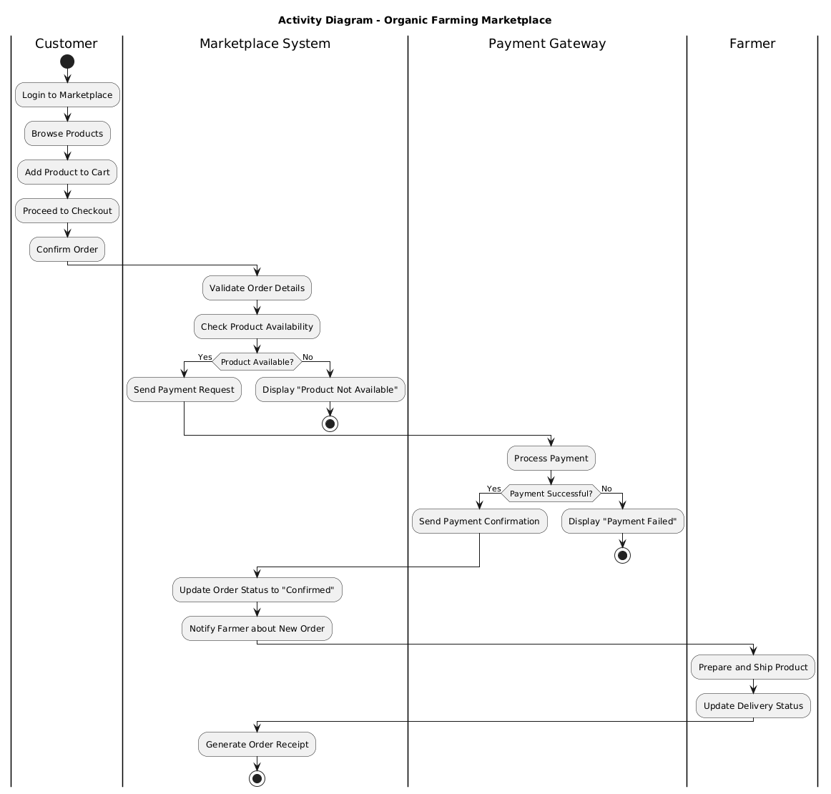
Conclusion:
The activity diagram effectively illustrates the complete workflow of the Organic Farming Marketplace, from customer login and product selection to payment and delivery. It highlights the coordination between different actors such as the customer, system, payment gateway, and farmer to ensure a smooth transaction process.
By using swimlanes, the diagram clearly defines the responsibilities of each participant and shows how actions flow between them. This helps in understanding the system’s functionality, decision points, and interaction sequence, making it easier to design and implement the system efficiently.

