* **State mission statement(s) and mission objectives for the client.**

Mission statement:

To maintain the database of Silver Oak cooperative school

The database aids in operating and maintaining the data in an efficient, streamlined manner. It also makes storing, updating and accessing the student and staff data easier. Adding to this, it makes communication more effective and maintains a track of all the activities going on in the school.

* **Finalize ER schema and diagram.**

Entities, Attributes and Primary Keys:

Department (**dptId**, dptName)

Student (**stdId**, -stdLastName, -stdFirstName, stdGender, stdDateOfBirth, stdAddress, stdClass, stdSection)

Staff (**stfId**, -stfLastName, -stfFirstName, stfType, stfDesignation)

Subject (**sbjId**, sbjTitle, sbjDescription)

Guardian (**grdName**, grdEmail, grdPhoneNo, grdRelationship)

Activity (**actId**, actName, actDate, actDescription)

Relationships, Attributes, Degrees, Participating Entities and Constraints

Report: binary relationship

1 Staff to 1 Department

1 Department to 1 or more Staff

Relate: binary relationship

1 Guardian to 1 or more Student

1 Student to 1 or more Guardian

Score(grade): binary relationship

1 Student to 1 or more Subject

1 Subject to 0 or more Student

Participate: ternary relationship

1 Staff and 1 Student to 1 or more Activity

1 Staff and 1 Activity to 0 or more Student

1 Activity and 1 Student to 1 or more Staff

Teach: ternary relationship

1 Staff and 1 Subject to 1 or more Student

1 Staff and 1 Student to 0 or more Subject

1 Subject and 1 Student to 1 Staff

ER Diagram:

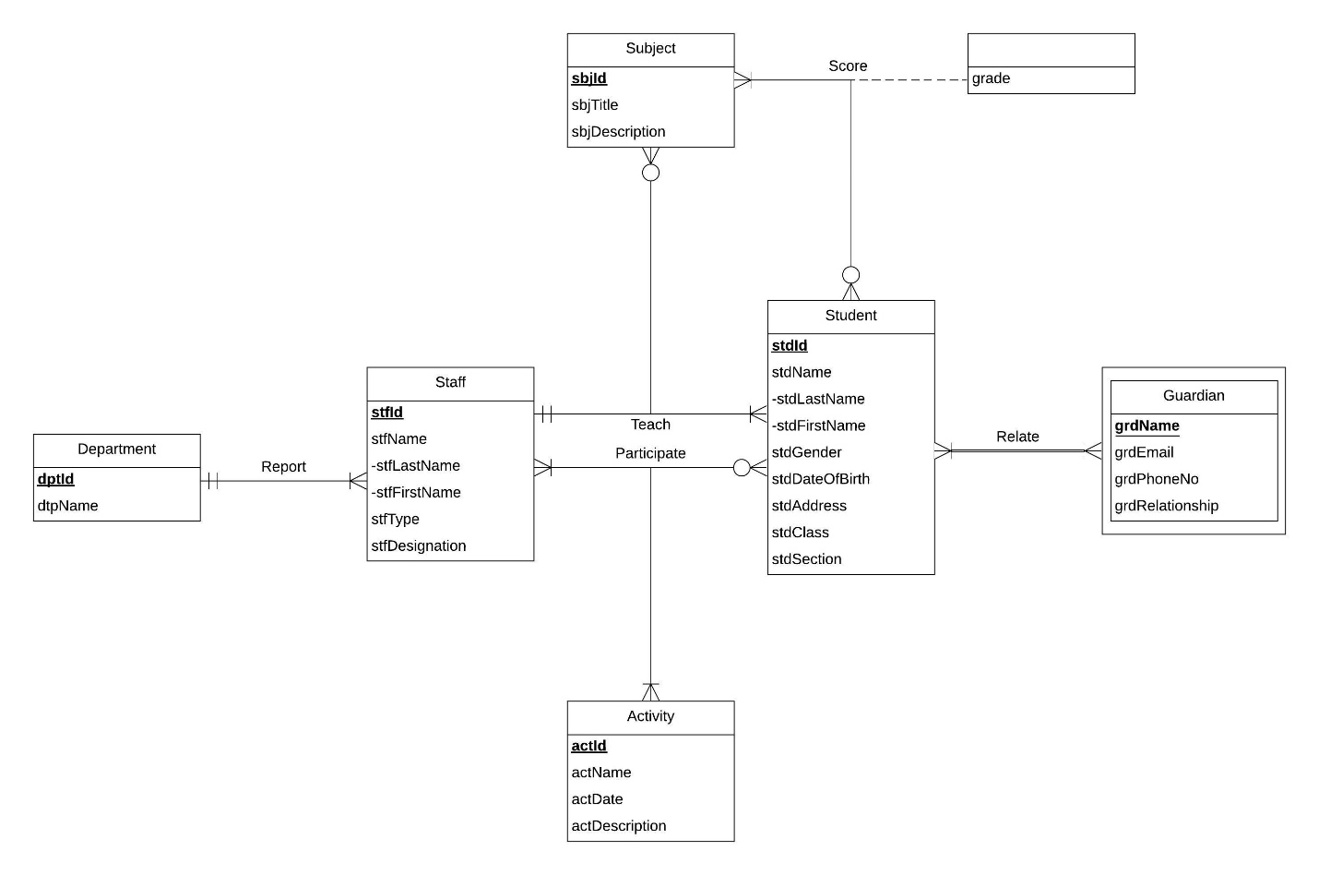

* **Convert ER model into relational schema and identify primary and foreign keys.**

## Relations:

Department (**dptId**, dptName)

Staff (**stfId**, stfLastName, stfFirstName, stfType, stfDesignation, *dptId*)

Student (**stdId**, stdLastName, stdFirstName, stdGender, stdDateOfBirth, stdAddress, stdClass, stdSection)

Subject (**sbjId**, sbtTitle, sbjDescription)

Activity (**actId**, actName, actDate, actDescription)

Guardian (***stdId*, grdName**, grdEmail, grdPhoneNo, grdRelationship)

Teach (***stfId***, ***stdId***, ***sbjId***)

Participate (***stfId***, ***stdId***, ***actId***)

Score (***stdId***, ***sbjId***, grade)

* **Determine functional dependencies and perform normalization to 3NF.**

Functional dependencies:

dptId 🡪 dptName

stfId 🡪 stfLastName, stfFirstName, stfType, stfDesignation, dptId

stdId 🡪 stdLastName, stdFirstName, stdGender, stdDateOfBirth, stdAddress, stdClass, stdSection

sbjId 🡪 sbtTitle, sbjDescription

actId 🡪 actName, actDate, actDescription

stdId**,** grdName 🡪 grdEmail, grdPhoneNo, grdRelationship

stdId, sbjId 🡪 grade

## Normalizaton:

Department (**dptId**, dptName) = 3NF

Staff (**stfId**, stfLastName, stfFirstName, stfType, stfDesignation, *dptId*) = 3NF

Student (**stdId**, stdLastName, stdFirstName, stdGender, stdDateOfBirth, stdAddress, stdClass, stdSection) = 3NF

Subject (**sbjId**, sbtTitle, sbjDescription) = 3NF

Activity (**actId**, actName, actDate, actDescription) = 3NF

Guardian (***stdId*, grdName**, grdEmail, grdPhoneNo, grdRelationship) = 3NF

Teach (***stfId***, ***stdId***, ***sbjId***) = 3NF

Participate (***stfId***, ***stdId***, ***actId***) = 3NF

Score (***stdId***, ***sbjId***, grade) = 3NF

* **Generate business rules and determine referential integrity actions.**

Exploring referential integrity:

* 1. When a department information is updated in the database, the staff information should be updated accordingly.  
     When a department is deleted from the database, the staff information should be retained and updated accordingly.
  2. When the information about a student is updated or deleted, the information about the corresponding guardian should be updated or deleted respectively.
  3. If record of a staff member is being updated or deleted, the corresponding details in teach should be updated.  
     If a student is being taught a subject by a staff member, the details of the subject cannot be updated or deleted for the academic year.  
     If record of a student is being updated or deleted, the corresponding details in teach should be updated or deleted respectively.
  4. If record of a staff member is being updated or deleted, the corresponding details in participate should be updated or deleted respectively.  
     If a staff member (in capacity of an organizer) and a student are participating in an activity, the details of participate cannot be updated or deleted for 48 hours before the scheduled time.  
     If record of a student is being updated or deleted, the corresponding details in participate should be updated or deleted respectively.
  5. Details in score would not be changed even when details of a subject changes.   
     When details of a student are updated or deleted, details of the score correspondingly change.

|  |  |  |  |  |  |  |  |
| --- | --- | --- | --- | --- | --- | --- | --- |
| Relation | Foreign Key | Base Relation | Primary Key | Business Rule | Constraint: ON DELETE | Business Rule | Constraint: ON UPDATE |
| Guardian | stdId | Student | stdId | R2 | CASCADE | R2 | CASCADE |
| Staff | dptId | Department | dptId | R1 | CASCADE | R1 | CASCADE |
| Score | stdId | Student | stdId | R5 | CASCADE | R5 | CASCADE |
| Score | sbjId | Subject | sbjId | R5 | NO ACTION | R5 | NO ACTION |
| Teach | stfId | Staff | stfId | R3 | CASCADE | R3 | CASCADE |
| Teach | stdId | Student | stdId | R3 | CASCADE | R3 | CASCADE |
| Teach | sbjId | Subject | sbjId | R3 | NO ACTION | R3 | NO ACTION |
| Participate | stfId | Staff | stfId | R4 | CASCADE | R4 | CASCADE |
| Participate | stdId | Student | stdId | R4 | CASCADE | R4 | CASCADE |
| Participate | actId | Activity | actId | R4 | NO ACTION | R4 | NO ACTION |

* **Describe sample data for every relation.**

Department (‘001’, ‘Social Sciences’)

Staff (‘GD00120’, ‘Vaz’, ‘Alice’, ’Teaching’, ‘Associate Teacher’, ‘001’)

Student (‘15A76’, ‘Baker’, ‘Hannah’, ‘F’, ‘10/23/2010’, ‘3424 Tulane Drive, Hyattsville, MD 20783’, ‘3’, ‘A’)

Subject (‘SS01’, ‘Social Sciences Level 3’, ‘Third level of social sciences’)

Activity (‘PA12’, ‘Talent Hunt’, ‘12/05/2019’, ‘A chance for students to showcase their talent’)

Guardian (‘15A76’, ‘Daniel Baker’, ‘baker.daniel@gmail.com’, ‘3015634362’, ‘Father’)

Teach (‘GD00120’, ‘15A76’, ‘SS1’)

Participate (‘GD00120’, ‘15A76’, ‘PA12’)

Score (‘15A76’, ‘SS1’, ‘B-‘)