**Grevillea Robusta**

We have developed our front end of our application in Tableau as it provides strong visualization with interactive UI. We have attached the Tableau file (.twb) on ELMS. So, by directly opening the file in Tableau software, we will be able to access our application’s frontend.

Following are the steps to open the file and go through it:

1. Open Tableau software and go to ‘File’🡪 ‘Open’

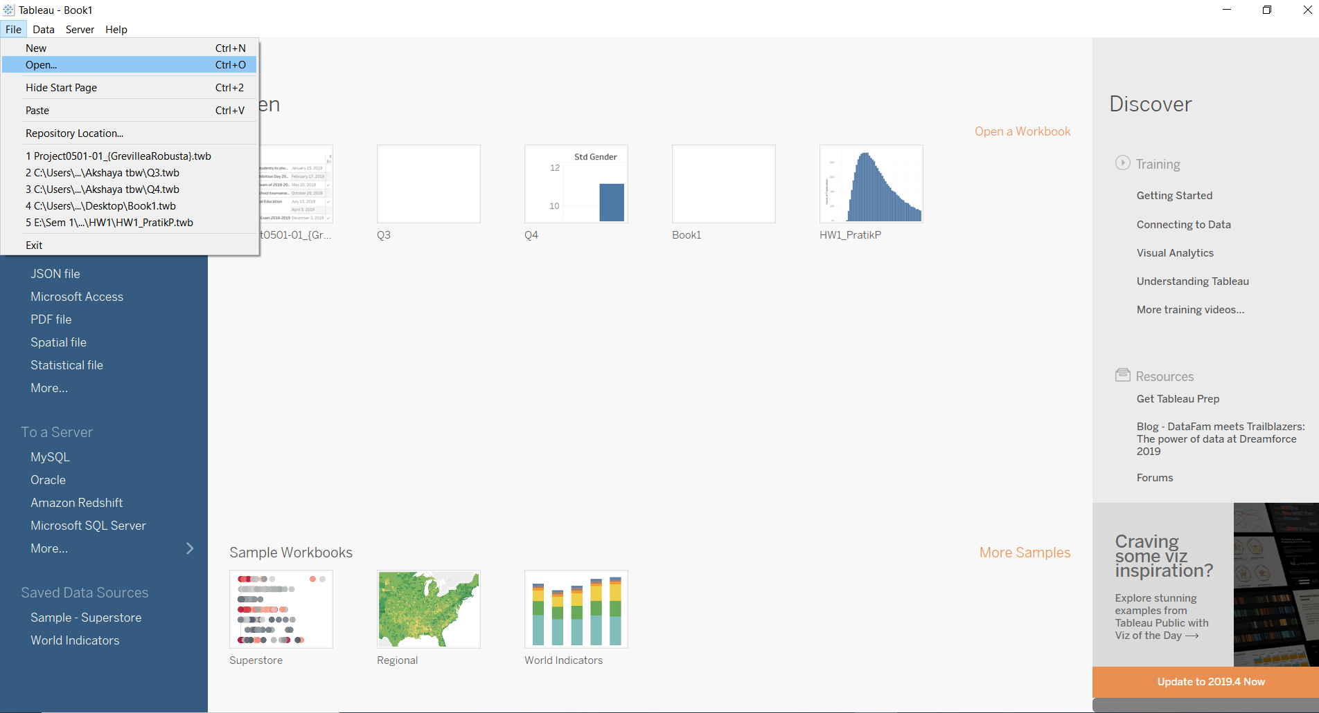

1. Choose your Tableau file and click ‘Open’

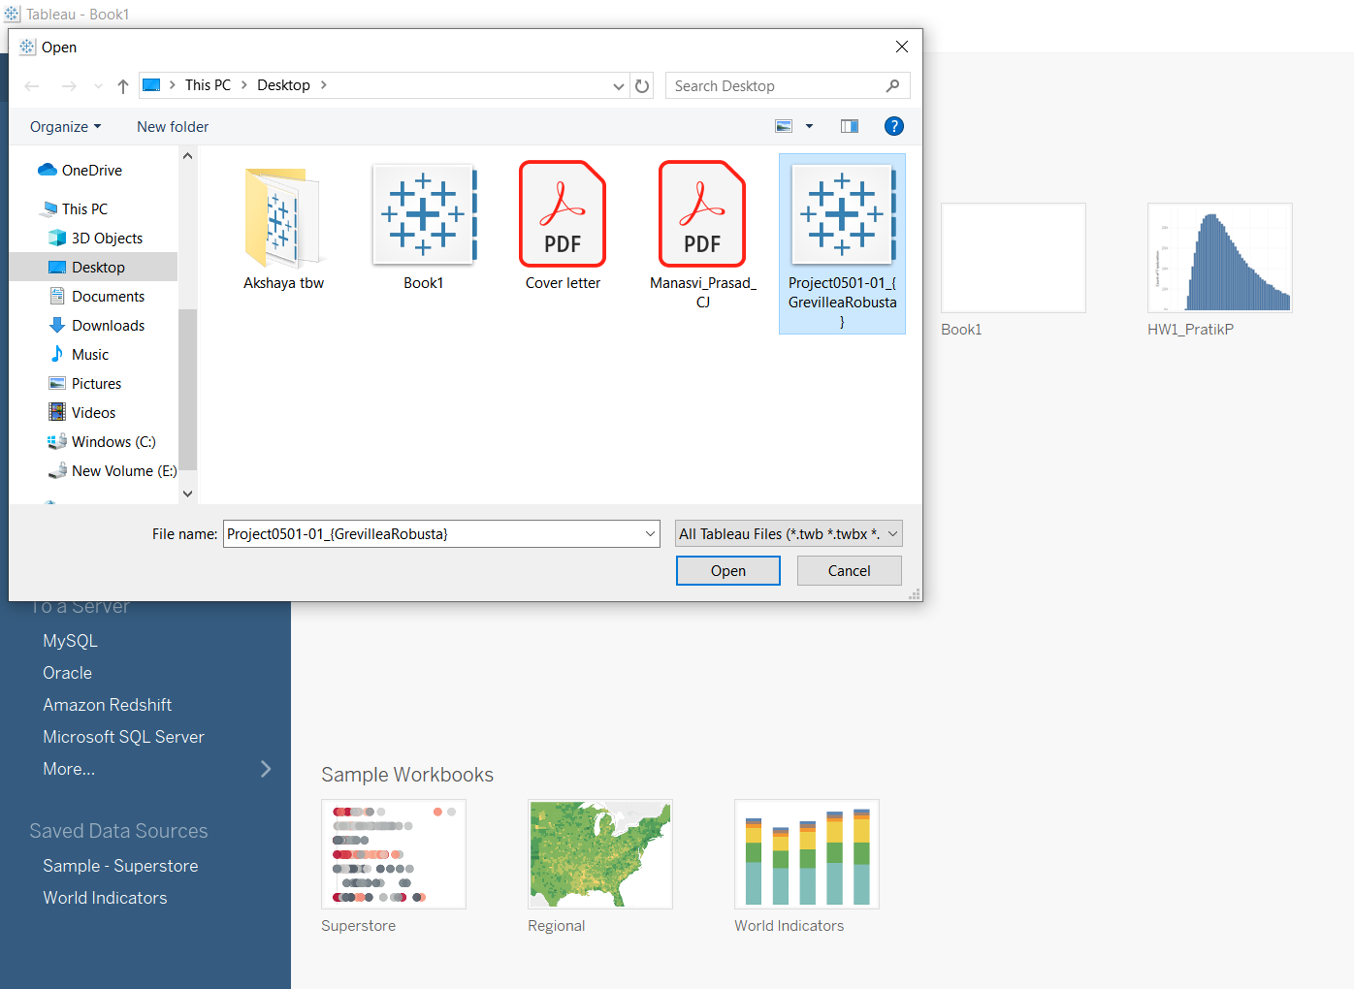

1. It will ask you for SQL Authentication.

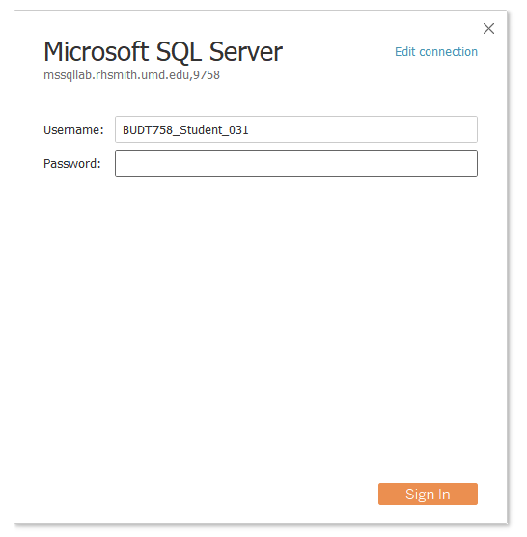

1. Once you are authenticated, you will be able to see all the 7 sheets and the Dashboard of our application.

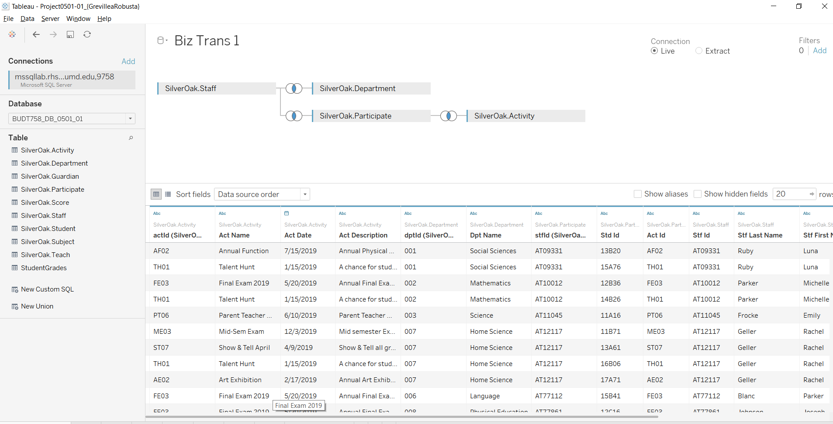

1. Use the tabs at the bottom to navigate through the sheets and view the application

