**Important Instruction:**

1. Please read the document thoroughly before you code.

2. Import the given skeleton code into your Eclipse.

3. You have to create the input file for the methods.

4. Refer/Use the solution file only when you are not able to complete the case study within 1 hours

A leading retail shop is looking out solution providers to build an IT system which can help them to run their business in a more organized way. For this they want to maintain the details of the products sold for a particular date. Product may be of 3 different type(LP – Ladies Product, GP-Gents Product and CP- Children Product).

**Skeleton File for Development:**

Import the below attached skeleton code into your eclipse project and implement the required functionalities



**Requirements:**

**Develop an application for the below 2 requirements.**

**Requirement 1:**

Validating the input data.

Validations to be done:

1. All fields are mandatory.
2. The length of the ProductCode field should be 11.
3. The ProductType should be any one of the below options

* LP
* GP
* CP

1. The ProductNumber should be numeric and its length should be 8 digit long.
2. PurchaseDate in the input file should be in MM-dd-yyyy format.

If any of the above validations fails, the system should throw a user defined exception “ShoppingCartException”.

**Requirement 2:**

Provide the input date as String and the application will read the records from the input text file and based on the input date return an output Map containing the list of products.

#### Output Map structure:

|  |  |
| --- | --- |
| Key – Integer | Value – TreeSet |
| 1 | TreeSet<String> having Product Type as LP |
| 2 | TreeSet<String> having Product Type as GP |
| 3 | TreeSet<String> having Product Type as CP |

**Technical Specifications:**

|  |  |  |  |  |
| --- | --- | --- | --- | --- |
| **ClassName** | **Method Name** | **Input Parameters** | **Sample Input** | **Output Parameters** |
| ShoppingCart | getProductDetails | **String filePath** – path of the folder along with the filename where the data feed is located.  **String inputDate -** date for which you want to see the list of products sold. | **"C:\\data\\retails.txt",**  **“03-31-2012”** | Map<Integer,TreeSet<String>> |
| ShoppingCart | validateData | **String[] inputdata** all the fields of the file | **LP-12424515,Arun,**  **5,03-31-2012,50000** |  |

**Input File:** Create an input file with the name “**retails.txt”** and store the sample product details records(each line is a record). Use the delimiter “,” to separate the field values.

The record format is given below

**ProductCode,CustomerName,QuantityPurchased,DateOfPurchase,TotalCost**

Field Constraints:

**ProductCode –** Unique Code to identify the product.

**Name** – Name of the Customer.

**QuantityPurchased** – Quantity of product purchased.

**DateOfPurchase --** Date of purchase.

Format of the **ProductCode** is LP**-**12424515. (First 2 character denotes **ProductType** and last 8 digit is a unique number that denotes **ProductNumber**).

Sample Input File:

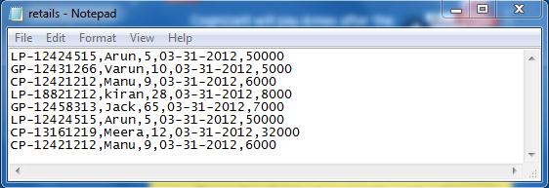

**Sample Output Map:**

|  |  |
| --- | --- |
| Key – Integer | Value – TreeSet |
| 1 | {LP-12424515, LP-18821212} |
| 2 | {GP-12431266, GP-12458313} |
| 3 | {CP-12421212, CP-13161219} |