Title - 5N/6D

Quotation

Package cost for 10 people in INR | Train/Flight cost for 10 people in INR | Total cost for 10 people in INR

Overview

Destination | Arrival Date | No of people | Rooms | Meal | Vehicle | Hotel

Train no | Train Name | Category | Meal

Daywise Itinerary

Day 1:

Day 2:

Day 3:

Day 4:

Day 5:

Day 6:

Day 7:

Day 8:

Terms and Conditions

- AC will not work in Hilly areas.
- Check in and checkout time Will be as per hotels 12 PM & 2PM
- Early check in & late checkout payments are directly settled by the guest in hotels.
- Rooms are subject to availability in Hotels.
- Base category rooms will be provided in every package.
- Base category rooms will be booked in hotels until and unless specified in the quotation.
- In case the rooms are not available in selected hotels, rooms will be provided in similar hotels.
- In case guests demand higher category rooms, guests will pay the difference amount in the hotel directly.
- Meals Plan must be followed as per the hotels Menu. We are not responsible for any kind of unavailable Meal.
- Please carry your valid identity proof (Aadhar Card) during the Tour.
- Transportation charges will be extra in case guest book their hotels far away from City (In case Guest have own booking with hotels )

Tour Cost Excludes
- Air Fare / Train Fare.
- Expenses such as Ropeway, Joy ride (Toy Train), River Rafting & Paragliding.
- Additional sightseeing or extra usage of vehicles other than specified in the itinerary.
- Entrance Fees & Guide Charges.
- Any cost arising due to natural calamities such as: landslides, road blockages, strikes etc. (to be borne by the client)
- Room heater charges.
- Anything which is not mentioned in the inclusion.
- GST (5%) if the GST bill is required.

Child Policy

- Up to 5 years complimentary without an extra bed.
- 6 to 12 years charged as per child policy.
- Above 12 years charged as Extra Adults (with / without an extra bed).

Cancellation Policy

- Any confirmed package booking cancellation will attract Rs 2000/- as an administrative charge.
- Any confirmed package booking cancelled within 0-15 days before arrival date will attract 100% of the total package amount as retention charges.
- Any confirmed package booking cancelled within 15-30 days before arrival date will attract 50% of the total package amount as retention charges.
- Any confirmed package booking cancelled within 30-60 days will attract 25% of the total package amount as retention charges.

Payment Details

Account details
Name | Bank Name | Branch | Account No | IFSC
Basavaraj Virupaksh Parshetti | Bank of Baroda | Udagaon | 14490200001002 | BARB0UDGAON

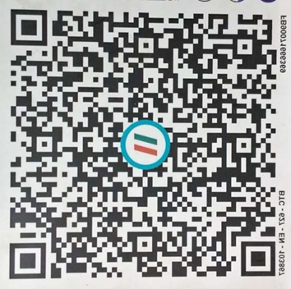
Regards,
Basavaraj Parshetti,
Happy Holidayz

