**DLDA Mini Project Report**

To create an MQTT Microcontroller Client that can be controlled via Signals published by the Desktop Client which:

1. Controls the LED

2. Controls which sensor is sending the information (if any)

3. Sends the Proximity( UltraSonic/HC SR-04) reading from the Micro Controller Client to the Desktop

4. Sends the Temperature( MPU6050) reading from the Micro Controller Client to the Desktop

Via the Internet

Features

* A user-friendly Desktop GUI application to control the sensors and LED.
* LED can be controlled wirelessly using Desktop app.
* Gives live readings from the Ultrasonic and Temperature Sensor.
* Buzzer rings on Desktop when obstacles are detected in certain threshold range.
* The data is logged into the online server so that it can viewed anytime anywhere by the administrator.

Components

* NodeMCU microcontroller with inbuilt ESP8266 Wi-Fi module.
* Ultrasonic Sensor (HC-SR04).
* Temperature Sensor (MPU6050).
* LED and Resistor.
* Micro-USB cable.
* Jumper Wires.
* Breadboard.

Circuit Diagram

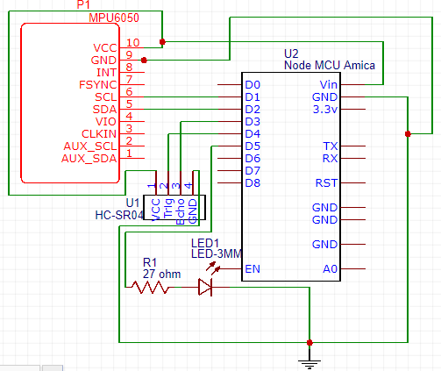

This is the client which we have built with all the controls

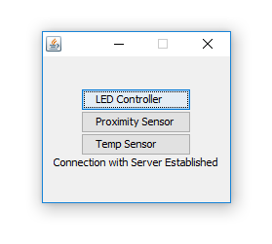

Turning on the led

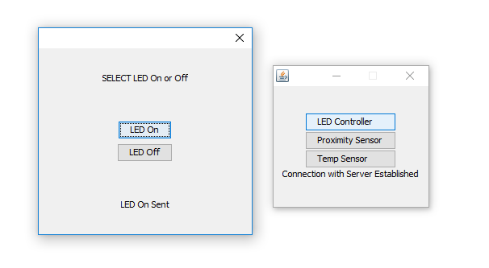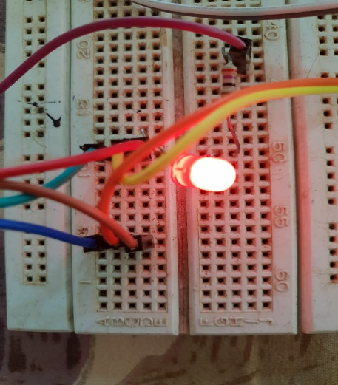

Turning it back off

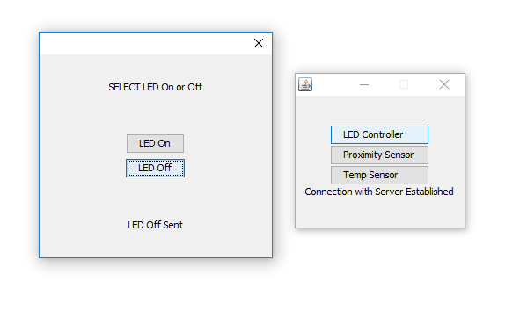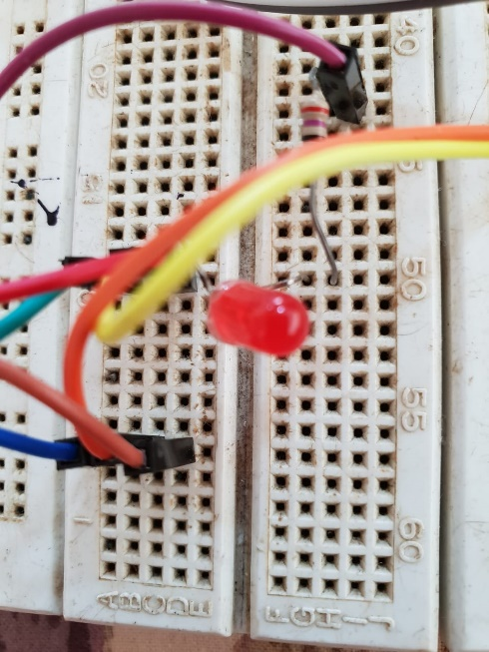

Turning on Proximity Sensor with no obstacle in from of it

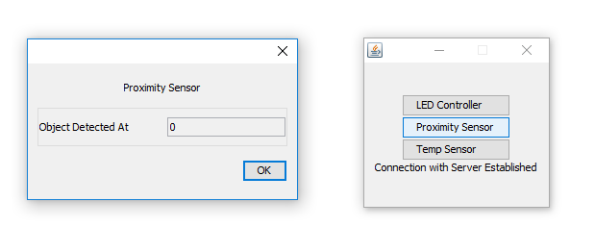

A buzz sound is heard on client when an obstacle is detected. Reding is also provided on the client

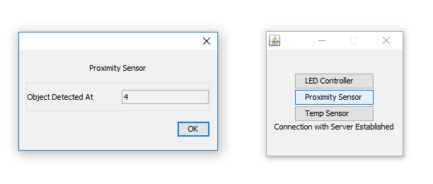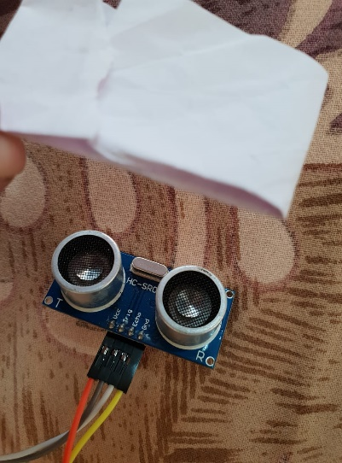

Clicking on Temperature Sensor option on the client the live readings are shown immediately

