LAB REPORT
Subject: Foundations of Data Science
Name: Pratik Pokhrel
Roll no: ACE081BCT059
BCT-B
Date: 2025-12-23

Title of the Lab
Data Visualization Using Python

Objective of the Lab
To learn how to create a Python virtual environment and perform data visualization using pie chart, histogram, box plot, scatter plot, and heat map using Matplotlib and Seaborn.

Theory of the Lab
Data visualization helps in understanding patterns, trends, and relationships in data. Python virtual environments allow isolated package management. Matplotlib is used for plotting graphs, while Seaborn provides advanced statistical visualizations.

Pie Chart
Code:
EXPLODE=(0,0.2,0,0,0.2)
plt.pie(df['Age'],labels=df['S.N'],autopct='%1.1f%%',
hatch='/',explode=EXPLODE,shadow=True,startangle=25)
plt.show()
Output:
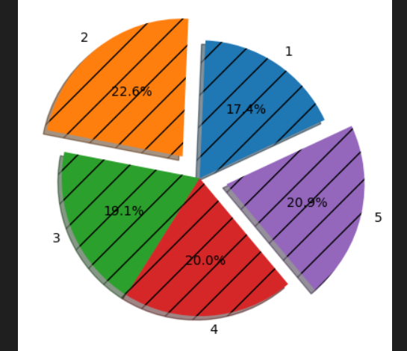

The pie chart depicts the percentage distribution of age values, with exploded slices and shadow effects for visual emphasis.

Histogram
Code:
plt.hist(df['Age'],hatch='*0',bins=11)
plt.show()
Output:
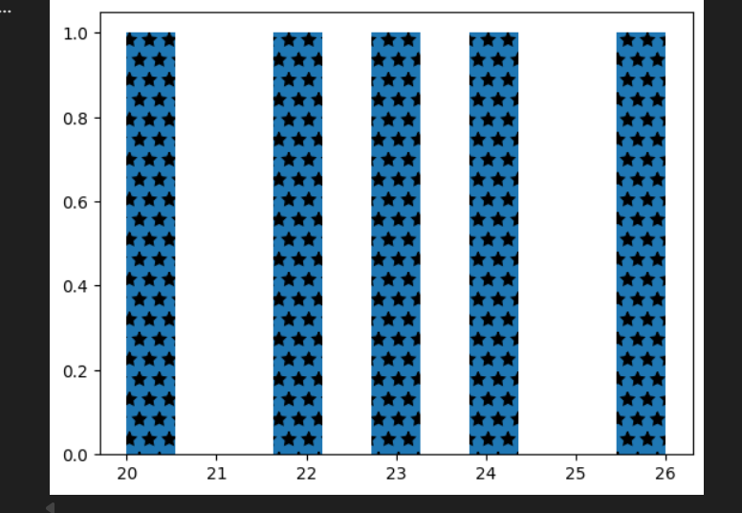
The histogram shows the frequency distribution of Age using multiple bins respectively.

Box Plot (Single Variable)
Code:
plt.boxplot(df['Age'])
plt.xticks([1],['Age'])
plt.show()
Output:
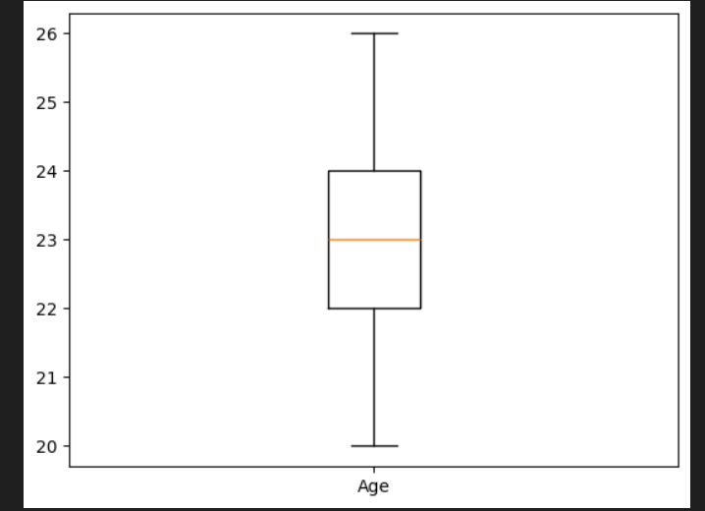
Here, the single variable box plot shows the median, quartiles, and spread of Age values.

Box Plot (Double Variable)
Code:
plt.boxplot(df['Age'],df[‘S.N’])
plt.xticks([1,2],['Age',’S.N’])
plt.show()
Output:
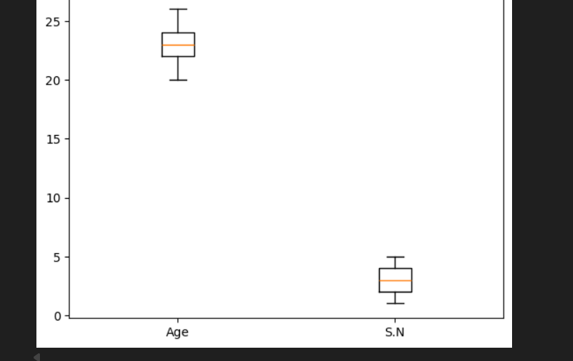

Scatter Plot with Regression Line
Code:
plt.scatter(df['Age'],df['S.N'],marker='*',color="red",s=300)
m,c=np.polyfit(df['Age'],df['S.N'],1)
plt.plot(df['Age'],m*df['Age']+c)
plt.show()
Output: 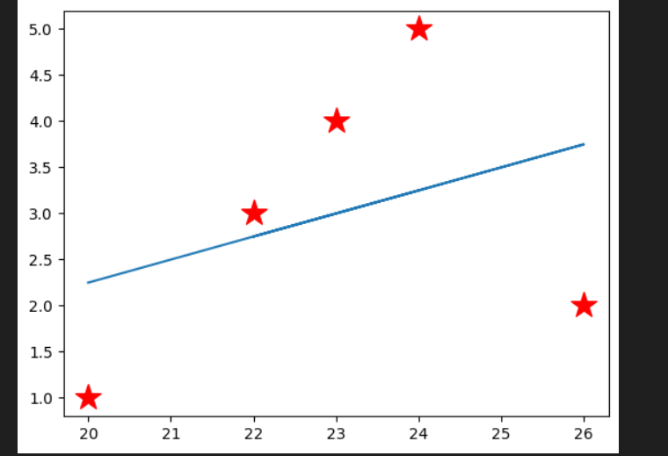

Here, the scatter plot shows the relationship between Age and Serial Number along with a best-fit line.

Heat Map
Code:
corr=df.corr(numeric_only=True)
sns.heatmap(corr,annot=True,cmap='coolwarm',
linewidth=0.5,linecolor='black')
plt.show()
Output:
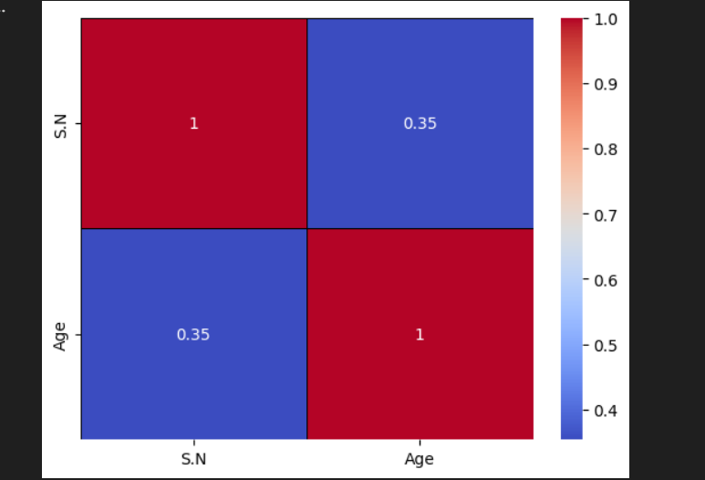
The heat map visualizes correlation between numeric variables using color intensity respectively.

Discussion

The lab session provided practical exposure to Python data visualization techniques. Multiple types of plots were employed to analyze data characteristics such as distribution, dispersion, relationships, and correlation. These visualization methods are fundamental to exploratory data analysis and aid in data-driven decision-making.

Conclusion
The lab successfully demonstrated the use of Python virtual environments and data visualization libraries. The skills acquired are fundamental to data science and are applicable to real-world analytical tasks.

