 | Minor Exam II
Course Code: 17EECC305 |  |  |  | Course Title: Automotive Electronics
Duration: 75 Minutes
Max. Marks: 40 |  |  |  | Date: 15th April , 2019
Note: Answer any TWO full questions.
Q.No |  | Questions |  |  | Marks | PO | CO | PI | B L
1.a. |  | Discuss the physical mechanism of wheel lock and vehicle skid that can occur during braking; discuss the suitable control system which provides solution for wheel lock.  - If the vehicle longitudinal acceleration is zero,  - Calculate the wheel slip if vehicle speed is matching with wheel speed?  Calculate wheel slip for Fl(Front left) and Fr(Front right), for which the wheel rpm is measured as 6000 rpm and 6400 rpm with wheel radius as 0.4m. when vehicle speed is 70 kph. |  |  | 08 |  | 3 | 2.1.2 | 3
b. |  | Compare event driven and time triggered communication strategies. Calculate nominal and maximum T_{Header} , T_{Response} and T_{Frame,} if LIN is operating at 20 Kbps baud rate and reserved time is set to 40% for transmitting four bytes of data. |  |  | 06 |  | 4 | 1.4.1 | 3
c. |  | Explain SAE levels of autonomous driving and name the OEM, which has achieved SAE Level-3. |  |  | 06 |  | 3 | 1.4.1 | 3
2.a. |  | How can you improve the efficiency/performance/reliability of engine control unit by adding any extra sensors for the existing system? Mention the significance of sensors & related variables to be measured for engine control system. |  |  | 08 |  | 3 | 1.4.1 | 3
b. |  | Discuss the suitable control system, which avoides wheel spinning with related control functions. |  |  | 06 |  | 3 | 2.1.2 | 3
c. |  | The fast moving car is turning at the corner, if the vehicle is turning less/more than the driver’s intention suggest a suitable control system along with the break circuit configuration to overcome this condition. |  |  | 06 |  | 3 | 2.1.2 | 3
3.a. |  | Answer the following with respect to CAN communication  - Explain the data frame format.  - How small nodes can be kept from overloading with received messages.  - Message prioritization in case of CAN protocol.  - What is the data seen by the CAN bus for the following condition?  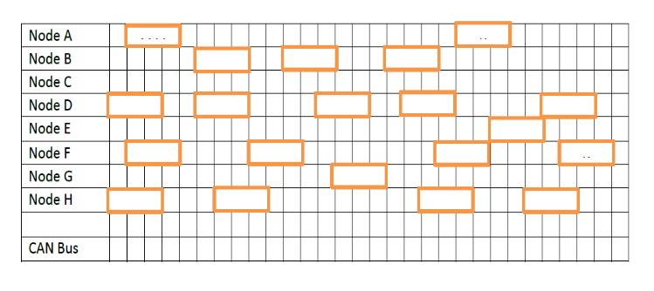 |  |  | 08 |  | 4 | 1.4.1 | 3
b. |  | Suggest and explain the sensor used for closed loop operation of an Engine control system to maintain desired air/fuel ratio. |  |  | 06 |  | 3 | 1.4.1 | 2
c. |  | What is ride and handling of an automobile? Provide an electronic solution managing these conditions. |  |  | 06 |  | 4 | 1.4.1 | 3

