

**Review - 2**

**Team – A11**

**USN:** 02FE21BEC058 – POOJA NANDAGAON

**USN:** 02FE21BEC059 – PRAJWAL HALGI

**USN:** 02FE21BEC061 – PRAJWAL KAMBLE

**USN:** 02FE21BEC068 – RAKSHITA SHIVAPOOJI

**Topic:**

**Write a C program to demonstrate the concept of ROUND ROBIN task switching mechanisms for 2 tasks.**

**a. 1st Task- Stepper motor anti- clockwise**

**b. 2nd Task- Blink LED with delay of 2secs**

Under The Guidance Of:

Prof. Swati M Guide Signature

* **Code:**

#include <lpc21xx.h>

#include <rtl.h>

#include <stdio.h>

// Function prototypes

__task void taskLed(void);

__task void anticlock(void);

void delay(void);

// Main function

int main(void) {

os_sys_init(taskLed); // Start the RTX kernel with the LED task

while (1) {

// Initialize your hardware and RTX here

os_sys_init(taskLed);

}

}

// LED task

__task void taskLed(void) {

os_tsk_create(anticlock, 0);

IODIR0 = 0x000f0000;

IOSET0 = 0x000f0000;

while (1) {

IOCLR0 = 0x000f0000;

delay();

IOSET0 = 0x000f0000;

delay();

}

}

// Stepper motor anticlockwise task

__task void anticlock(void) {

IODIR0 = 0X0000F000;

PINSEL0 = 0X00000000;

while (1) {

IOSET0 = 0X00008000;

delay();

IOCLR0 = 0X00008000;

IOSET0 = 0X00004000;

delay();

IOCLR0 = 0X00004000;

IOSET0 = 0X00002000;

delay();

IOCLR0 = 0X00002000;

IOSET0 = 0X00001000;

delay();

IOCLR0 = 0X00001000;

}

}

// Delay function

void delay() {

unsigned int i;

for (i = 0; i < 65000; i++);

}

* **System And Thread Viewer:**

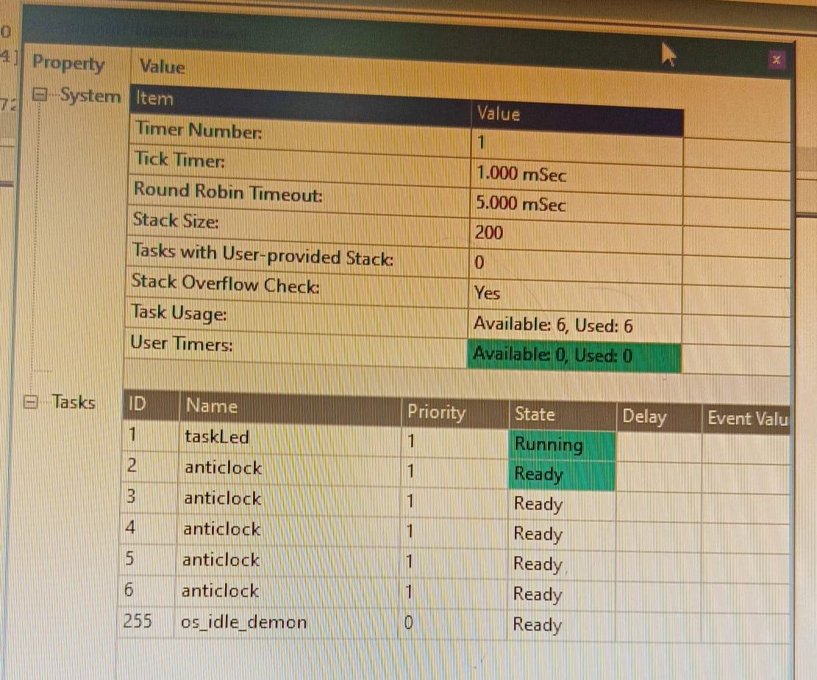

**OUTPUT**

