

**Review - 2**

**Team –A13**

**USN:** 02FE21BEC035 – HARSH PATIL

**USN:** 02FE21BEC018 – BASAVESH PATIL

**USN:** 02FE21BEC006 – ALEENA MULLA

**USN:** 02FE21BEC063 – PRATIK PATIL

**Topic:**

PRE-EMPTIVE Write a C code to demonstrate the concept of Task Switching

1st Task- Toggleleds.

2nd Task- Rotate stepper motor clockwise

Under The Guidance Of:

Dr. Swati Mavinkattimath. Guide Signature

**Code:**

#include<rtl.h>

#include<lpc21xx.h>

#include<stdio.h>

void delay(void);

OS_TID tsk1,tsk2,tsk3; //declare task identification number

int cnt1,cnt2;

int i;

__task void job1(void); //led

__task void job2(void); // stepper motor

__task void job1(void)

{

IODIR0 = 0x00ff0000;

//IOSET0 = 0x000F0000;

os_tsk_prio_self(2); //assign priority to job1

tsk2 = os_tsk_create(job2,1); //create job2

while(1)

{

IOCLR0 = 0x000f0000; //LEDS on

for(i=0;i<65000;i++);

for(i=0;i<65000;i++);

IOSET0 = 0x000f0000; //LEDS off

for(i=0;i<65000;i++);

for(i=0;i<65000;i++);

os_tsk_prio(tsk2,2); //change priority to tsk2

}

}

__task void job2(void) //job2function declaration

{

PINSEL0 = 0x00000000;

IODIR0 = 0x0000F000;

while(1)

{

IOSET0 = 0x00008000;

delay();

IOCLR0 = 0x00008000;

IOSET0 = 0x00004000;

delay();

IOCLR0 = 0x00004000;

IOSET0 = 0x00002000;

delay();

IOCLR0 = 0x00002000;

IOSET0 = 0x00001000;

delay();

IOCLR0 = 0x00001000;

delay();

}

}

void delay(void)

{

unsigned long int j;

for (j=0; j<65000; j++);

}

int main(void)

{

cnt1= 0;

cnt2 =0;

os_sys_init(job1); //initialize job1

while(1);

}

**Implementation:**

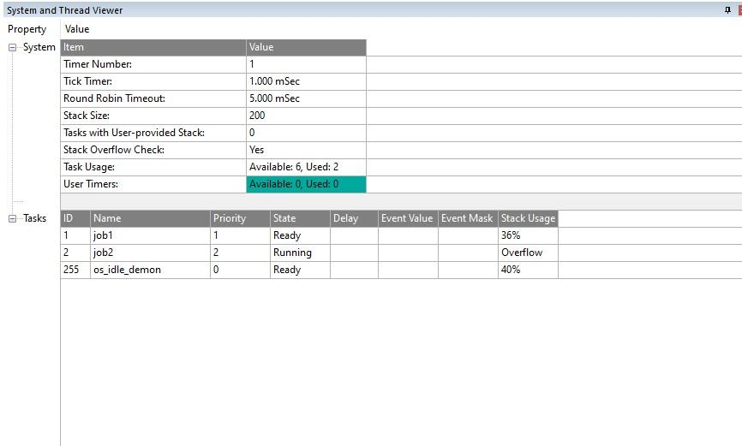

**Output:**

