

**SUBJECT: OPERATING SYSTEMS AND EMBEDDED SYSTEM DESIGN**

**SUBJECT CODE:22EECP302**

**TOPIC: Write a C code to demonstrate the concept of Task Switching**

**1st Task- Toggle leds**

**2nd Task- Display on Seven segment**

**3rd Task- Rotate stepper motor anti-clockwise**

| **SL.NO** | **NAME** | **ROLL NO** | **USN** |
| --- | --- | --- | --- |
| **01** | **Manav Palkar** | **42** | **02FE22BEC047** |
| **02** | **Omkar Kalghatgi** | **48** | **02FE22BEC053** |
| **03** | **Parvati Halse** | **52** | **02FE22BEC057** |
| **04** | **Prerana Kolkar** | **60** | **02FE21BEC065** |

**UNDER THE GUIDANCE OF:** 

**Prof. Shivaling Hunagund GUIDE SIGNATURE**

**CODE:**

**#include <lpc21xx.h>**

**#include <rtl.h>**

**#include<stdio.h>**

**void sev(void);**

**void delay(unsigned int);**

**unsigned int i;**

**unsigned int Disp[10] = {0x003F0000, 0x00060000, 0x005B0000, 0x004F0000, 0x00660000,**

**0x006D0000, 0x007D0000, 0x00070000, 0x007F0000, 0x006F0000};**

**__task void job1(void);**

**__task void job2(void);**

**__task void job3(void);**

**void delay(unsigned int j) {**

**unsigned int i;**

**for (i = 0; i < j; i++);**

**}**

**__task void job1(void) {**

**os_tsk_create(job2, 0);**

**while (1) {**

**sev();**

**}**

**}**

**__task void job2(void) {**

**PINSEL0 = 0x00000000;**

**IODIR0 |= 0x0000F000;**

**while (1) {**

**IOSET0 = 0x00001000;**

**delay(1000000);**

**IOCLR0 = 0x0000F000;**

**sev();**

**IOSET0 = 0x00002000;**

**delay(1000000);**

**IOCLR0 = 0x0000F000;**

**sev();**

**IOSET0 = 0x00004000;**

**delay(1000000);**

**IOCLR0 = 0x0000F000;**

**sev();**

**IOSET0 = 0x00008000;**

**delay(1000000);**

**IOCLR0 = 0x0000F000;**

**job3();**

**}**

**}**

**void sev(void) {**

**IODIR0 |= 0x0FF0000;**

**IOSET0 |= 0xF0000000;**

**for (i = 0; i < 10; i++)**

**{**

**IOSET0 |= Disp[i];**

**delay(1000000);**

**IOCLR0 |= 0x00FF0000;**

**}**

**job3();**

**}**

**__task void job3(void)**

**{**

**PINSEL0 = 0x00000000;**

**IODIR0 = 0x0000F000;**

**while (1) {**

**IOSET0 = 0x00001000;**

**delay(65000);**

**IOCLR0 = 0x00001000;**

**IOSET0 = 0x00002000;**

**delay(65000);**

**IOCLR0 = 0x00002000;**

**IOSET0 = 0x00004000;**

**delay(65000);**

**IOCLR0 = 0x00004000;**

**IOSET0 = 0x00008000;**

**delay(65000);**

**IOCLR0 = 0x00008000;**

**sev();**

**}**

**}**

**int main(void) {**

**os_sys_init(job1);**

**while (1);**

**}**

**IMPLEMENTATION:**

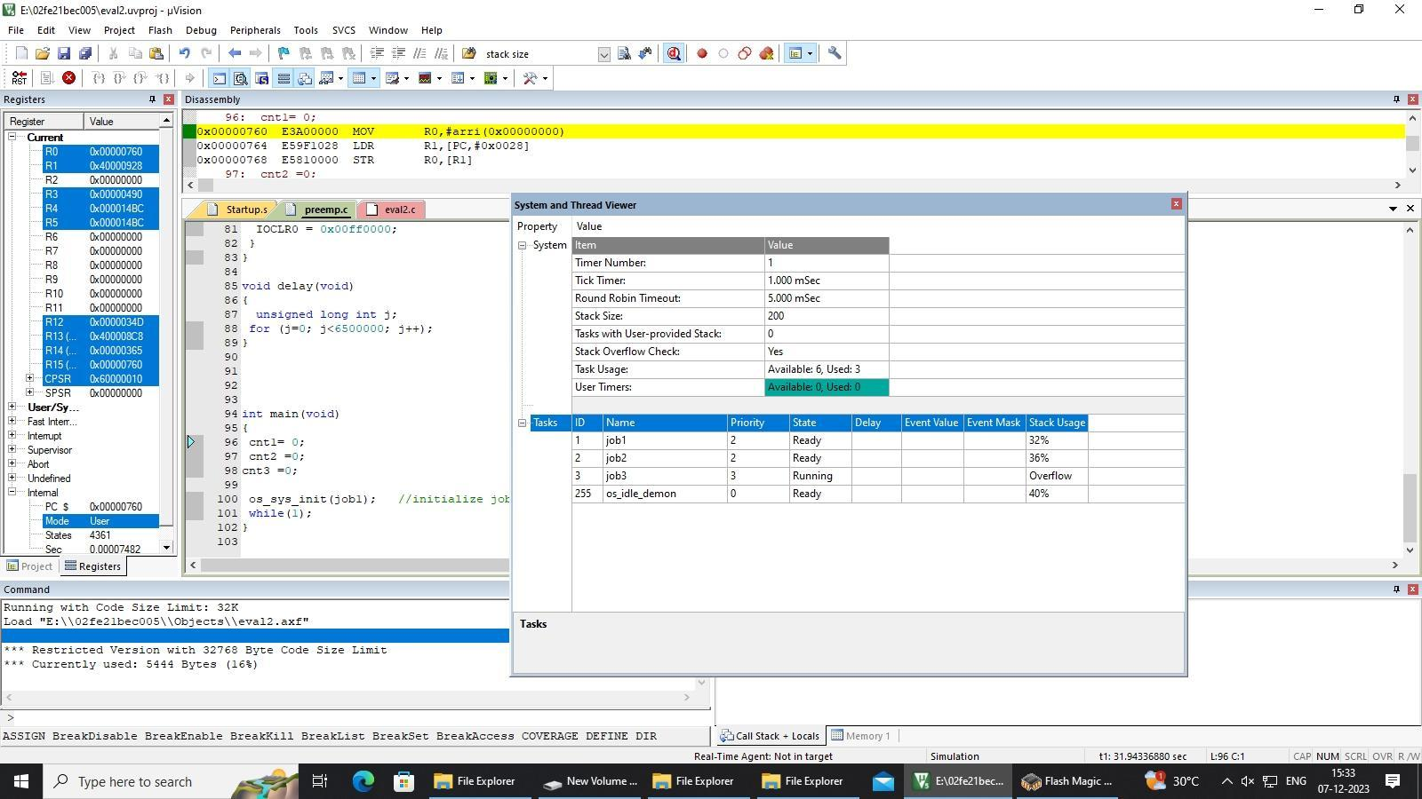

**OUTPUT:**