# Self-appraisal form

|  |  |  |  |
| --- | --- | --- | --- |
| Student | 2227422 | Name | Renisha Manandhar |
| number |  |  |  |
|  |  |  |  |
| Project | Restaurant Management System | Date | 2023/03/30 |
|  |  |  |  |
| Role | Web Designer | Team | L5CG2 (Group F) |
|  |  |  |  |
| Sprint (1 or 2) | 1 |  |  |
|  |  |  |  |

# Personal objectives – performance measurement

|  |  |  |  |  |  |
| --- | --- | --- | --- | --- | --- |
|  | **Objectives** | **Evidence provided** | **Evaluation** | | |
|  |  |  | *Student /* | | |
|  |  |  | *tutor* | | |
|  |  |  |  |  |  |
|  | Choosing for the | I picked out some web-based iconography and food-related images. A brief description of the Italian meal is included on the Italian menu, and the same is applicable for the Korean and Nepalese dishes. To make working with the frame easier, I divided it using the JPanel and set it to absolute layout. | 8 |  |  |
|  | relevant |  |  |  |  |
|  | Icons and pictures |  |  |  |  |
|  |  |  |  |  |  |
|  |  |  |  |  |  |
|  |  |  |  |  |  |
|  |  |  |  |  |  |
|  |  |  |  |  |  |
|  |  |  |  |  |  |
|  | *Tutor feedback:* |  |  |  |  |
|  |  |  |  |  |  |
|  | Choosing relevant colors for background, layout box and fonts and sizes for the web. | From the "Named Colors" and "Saturated Colors," I have selected the dark theme blue and the alice blue. | 9 |  |  |
|  |  | As far as I can tell, the font size plays the most crucial part in keeping a webpage maintained because it alters how the webpage appears. Font color is equally as important as text size. It's important that the font color blends in with the background color because when I originally tried it, the white text on the Alice Blue background looked to disappear into the background. The heading's font size is specifically chosen by Lucida Calligraphy so that it can be highlighted. Times New Roman is used for the remaining ones. |  |  |  |
|  |  |  |  |  |  |
|  |  |  |  |  |  |
|  |  |  |  |  |  |
|  |  |  |  |  | |
|  |  |  |  |  |  |
|  |  |  | 1 | P a g e | | |

*Tutor feedback:*

/17

/20

# Collaboration Document

## Evidence of good collaboration

### Good communication and file sharing



Several screenshots from Instagram, Messenger, and Basecamp are displayed. In those screenshots, we can see the conversation that took place as we checked the frontend design, clarified any uncertainties, and provided a file that was shared on Basecamp. **Though the communication was not as efficient as it was supposed to**.

Evidences of Good communication and file sharing

### Continuing Personal Development (CPD)



I looked into web ui/ux design while working on my assignment. I studied various YouTube videos, as well as those on Pinterest and Behance to check at the ideas, to learn how to design the frame for the web. In order to make the GUI look better in every aspect, I did study on the design of each page's login, signup, and food menu.

Evidences of Continuing Personal Development (CPD)

### Issue tracking

I encountered numerous problems when designing. There were numerous problems with designing, particularly when inserting and resizing images. The image's pixels were too high to fit in the frame, and as it was being compressed to make it fit, the image's quality significantly declined. I used image enhance to keep the image's quality as high as I could. Also, when I later retrieved the files from git, I was first designing on my friend's laptop. The program didn't have any graphics because all of the icons and images were stored on a different PC.



2 | P a g e

# Appendix A

## Choosing for the relevant webpages for reference

For front-end web design, there are many technologies accessible. Java, PHP, Ruby, Python, and.Net are currently the most widely used programming languages worldwide. Programming in Java is object-oriented. It is sometimes referred to as the most efficient programming language. It was made for the distributed nature of the internet. Cross-Platform (X), Apache (A), MySQL (M), PHP (P), and Perl are the letters that make up XAMPP (P). For building websites, XAMPP is employed. It can be downloaded and used for free, just like other languages. A collection of GUI elements for the Java programming language is called Java Swing. Swing was created to offer a more complex set of GUI components. Button, textfield, passwordfield, JLabel, JPanel, menu, toolbar, and other components are only a few of the many components offered by Swing. These elements are straightforward to use and can be altered by changing properties like font size, color, and layout. We must first learn Java programming in order to use Java Swing. The term "simple and productive language" is used here. One of the most used and well-known programming languages is Java. In comparison to other languages, it is more effective and productive. A lot of individuals now days like Java over other programming languages. In order to use Java Swing, we must first add swing components to the JFrame, which serves as the fundamental building block for Swing applications.

For designing, we favor Java Swing over alternative tools. The programming language Java Swing has gained popularity in the modern world and is relatively simple to master. Any operating system that supports JVM is able to run Java Swing-based applications. In order to build user interfaces, Swing also offers a large selection of GUI components. (google, 2023) (khurpaderushi143, 2023) (Waseem, 2022)



3 | P a g e

1. 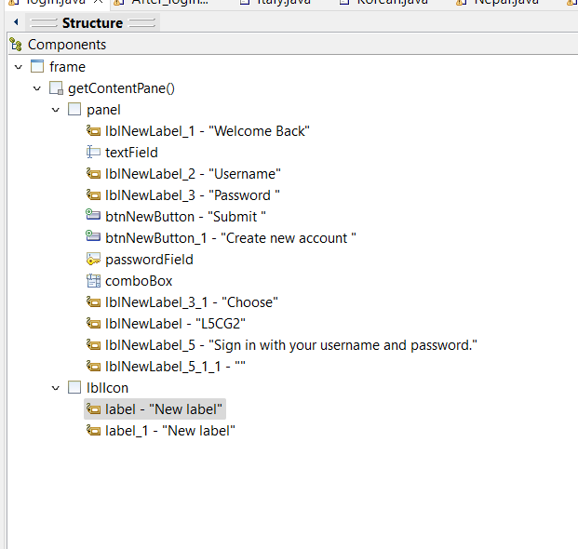Implementing functional requirement Codes and explanation

*Figure 1 Components used in Login page*

JLabel, JPanel, Buttons, a Passwordfield, Icons, and a Textfield are all used here. First, an absolute layout is applied to a frame. For username, password, welcome back, choose, L5CG2, and other terms, different JLabels are utilized. The buttons are used to submit and create a new account, which directs users to the landing page. The username is entered in the text field, and the password is entered in the password field. The image is inserted using the lbllcon.



4 | P a g e

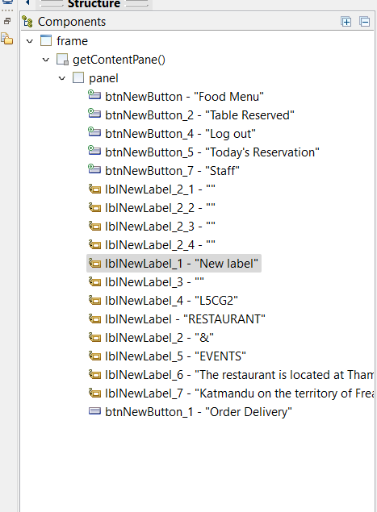

*Figure 2 Components for landing page*

JLabel, JPanel, Buttons, a Passwordfield, Icons, and a Textfield are all used here. First, an absolute layout is applied to a frame. Another JPanel is used to divide the image section and other detail section and also the newly created JPanel is set to absolute layout. For restaurant name, events, description different JLabels are utilized. The buttons are used food menu, table reservation, reserved and staff. The image is inserted using the lbllcon.

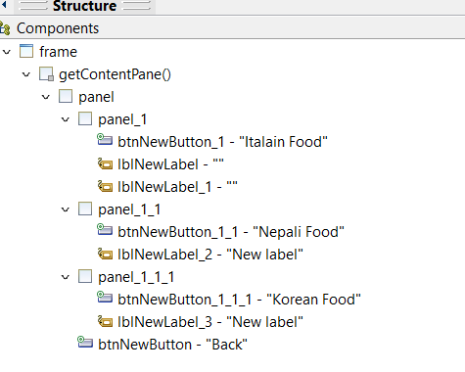 *Figure 3 Components for food menu*

**

5 | P a g e

I have first taken the frame and set it to an absolute layout. Again, for the 3 different types of dishes given in the menu, 3 different JPanels are taken, divided, and set to an absolute layout. The background color of the JPanels is changed, and JButtons and icons are used. An Italian dish button is created, which takes the user to the menu of Italian food, and icons are used for inserting the image.

#### Italian

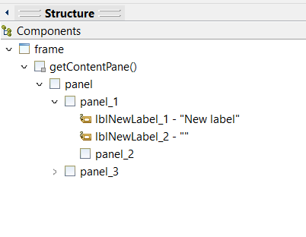

*Figure 4 Components for Italian food menu*

I have first taken the frame and set it to an absolute layout. Again, for the image and detail second 2 different JPanels are taken, divided and set to an absolute layout. The background color of the JPanels are changed, and JLabels are used for the details and to insert the image. JButton back and place an order are used which performs the action. The textfield has been used to mention the name of the items with their prices.



6 | P a g e

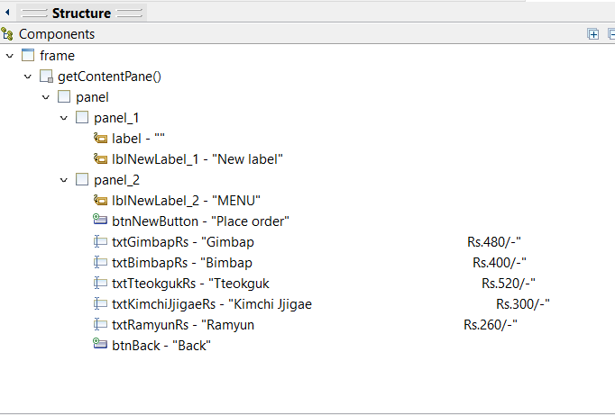

*Figure 5 Components for Korean menu*

I have first taken the frame and set it to an absolute layout. Again, for the image and detail second 2 different JPanels are taken, divided and set to an absolute layout. The background color of the JPanels are changed, and JLabels are used for the details and to insert the image. JButton back and place an order are used which performs the action. The textfield has been used to mention the name of the items with their prices.

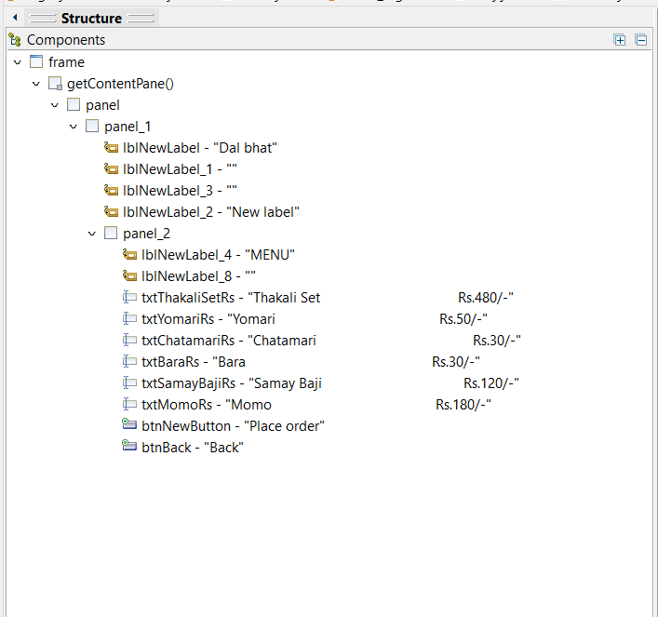

*Figure 6 Components for Nepali food*

I have first taken the frame and set it to an absolute layout. Again, for the image and detail second 2 different JPanels are taken, divided and set to an absolute layout. The background color of the JPanels are changed, and JLabels are used for the details and to insert the image. JButton back and place an order are used which performs the action. The textfield has been used to mention the name of the items with their prices.

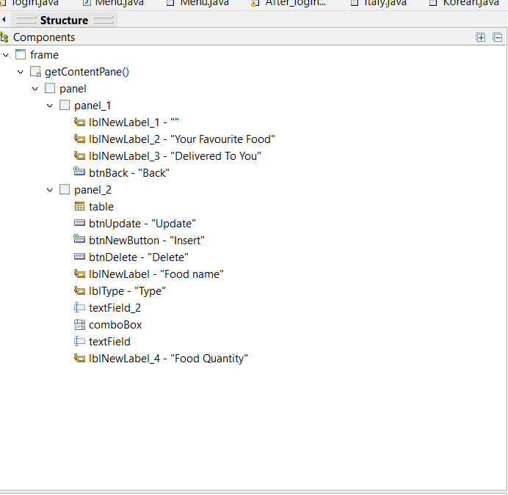

Figure 1 Components of Place an order

I’ve used a frame and set it to an absolute layout. Another two JPanel are used which both are set to the absolute layout. JPanel 1 is used to add the description of the page whereas JPanel 2 is used to insert the buttons which performs various actions and the textfield is used for the placing order food’s name and other details.



7 | P a g e

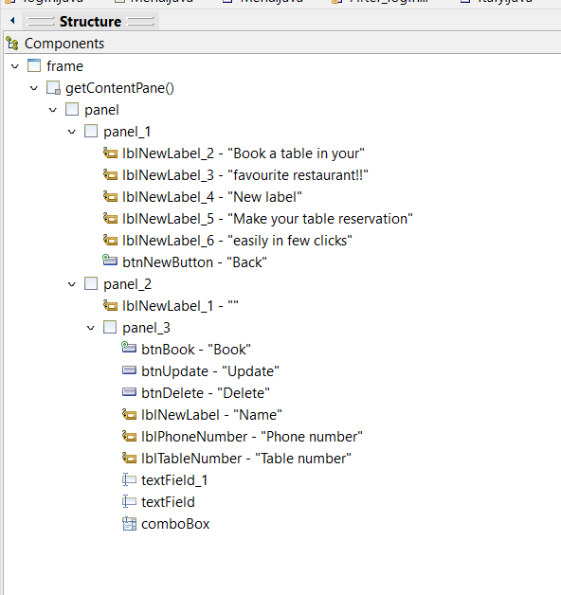

Figure 2 Components of Table Reservation

Here, I’ve taken a frame and set it to an absolute layout. In the frame 3 different JPanel are used and each JPanel are set to the absolute layout. The first panel is used for the description of the webpage, second panel is used for the image and the third panel is used for the buttons which performs action and to fill the required fields.