**Detailed Cheatsheet for Mac Terminal Commands:**

1. **Basic Commands:**

|  |  |
| --- | --- |
| **Key/Command** | **Description** |
| / (Forward Slash) | Top level directory |
| . (Single Period) | Current directory |
| .. (Double Period) | Parent directory |
| ~ (Tilde) | Home directory |
| sudo [command] | Run command with the security privileges of the super user |
| nano [file] | Opens the Terminal editor |
| open [file] | Opens a file |
| top | Displays active processes. Press q to quit |
| nano [file] | Opens the file using the nano editor |
| clear | Clears the screen |
| reset | Resets the terminal display |
| [command] -h | Get help about a command |
| man [command] | Show the help manual of the command |

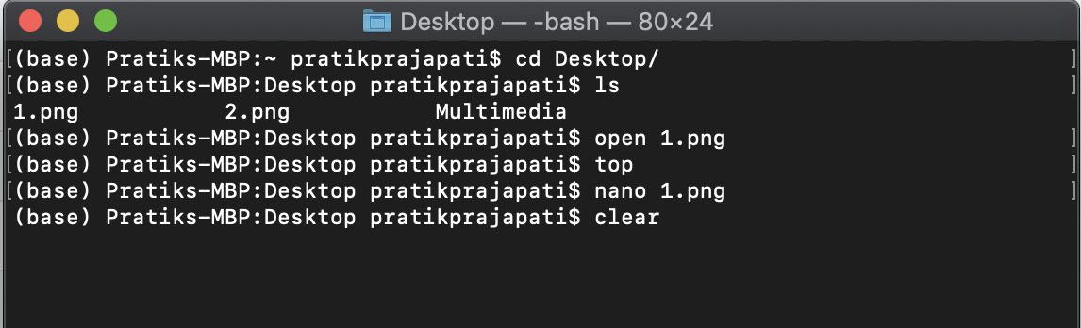

1. **Change Directory & List Directory Contents:**

|  |  |
| --- | --- |
| **Key/Command** | **Description** |
| cd [folder] | Change directory ie cd Documents |
| cd | Home Directory |
| cd ~ | Home Directory |
| cd / | Root of drive |
| cd - | Previous directory |
| pwd | Show your working directory |
| cd.. | Move up to the parent directory |
| cd../.. | Move up two levels |
| ls | Short listing |
| ls -l | Long listing |

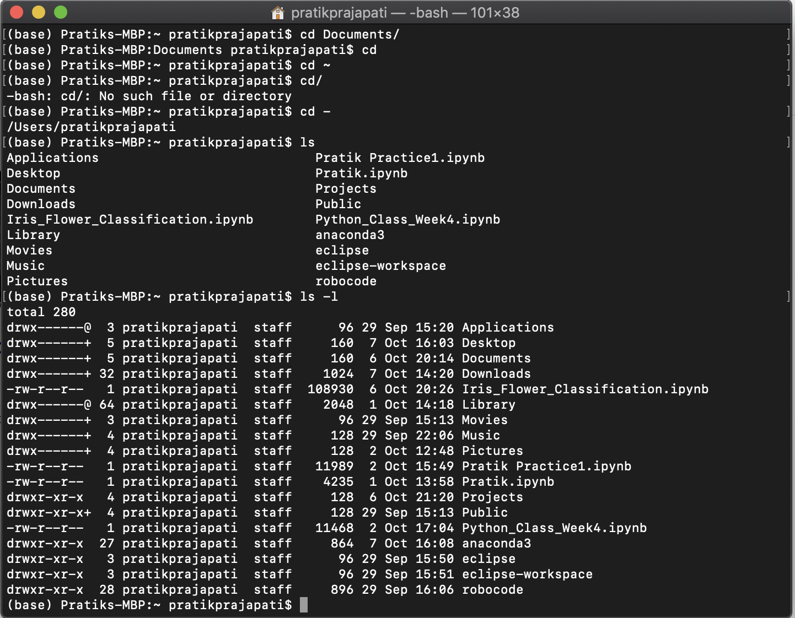

|  |  |
| --- | --- |
| Ls -a | Listing including hidden files |
| ls -lh | Long listing with human readable file size |
| ls -R | Entire content of folder recursively |

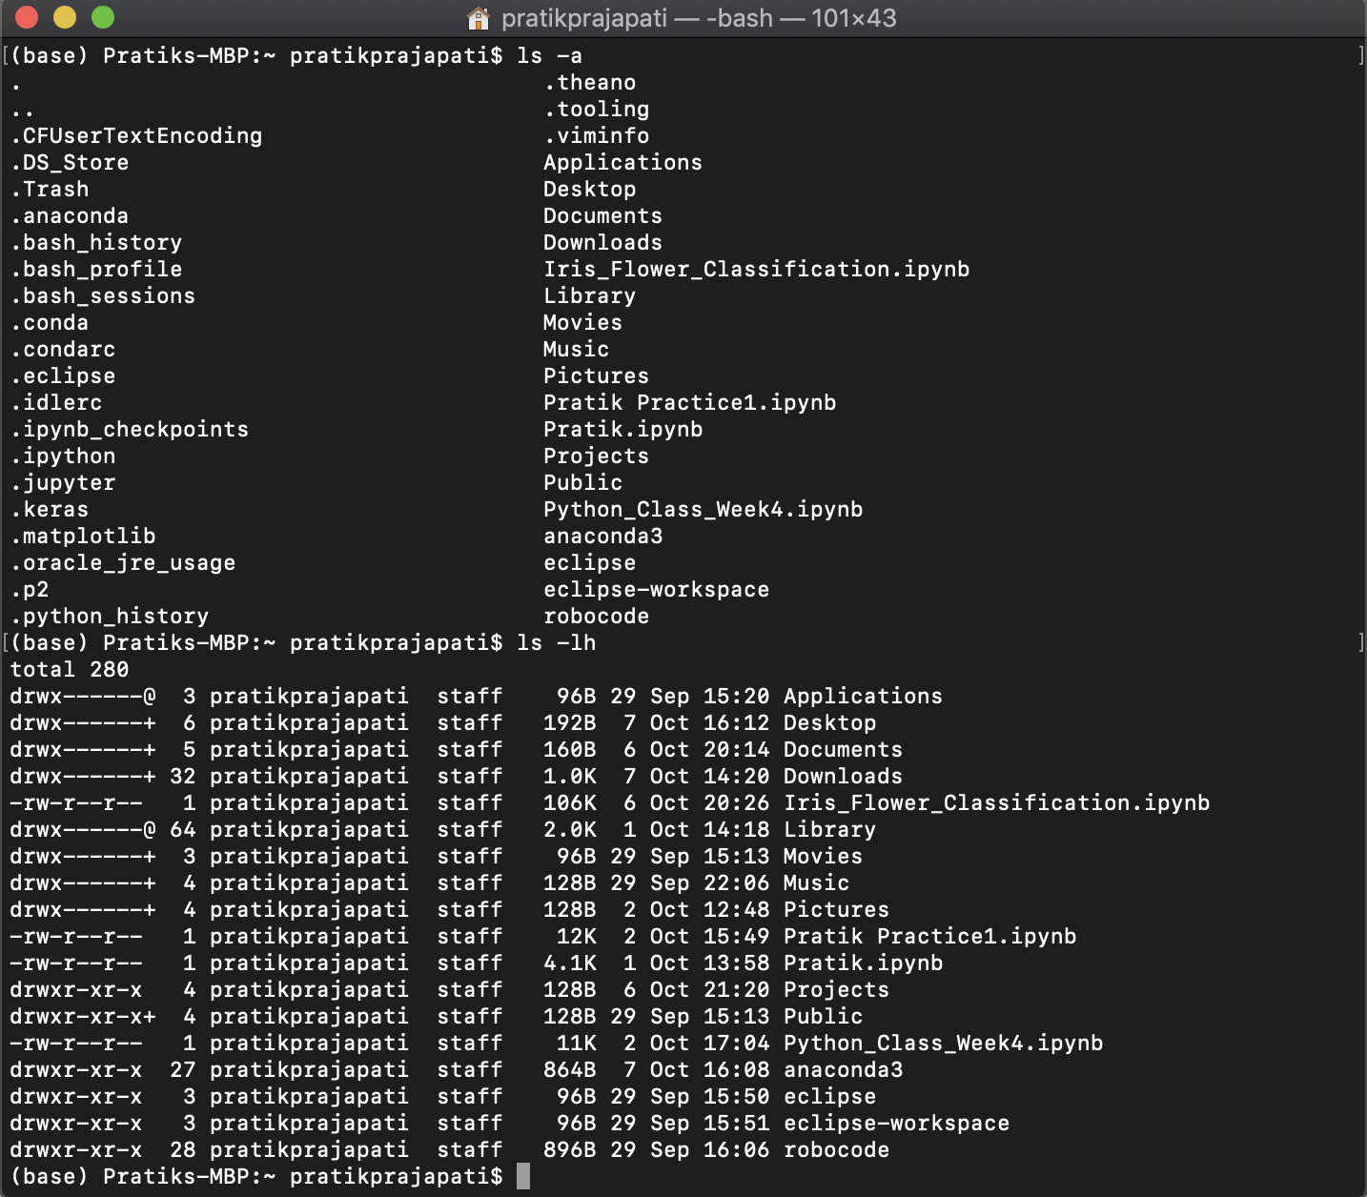

|  |  |
| --- | --- |
| ls -1 | Output the list of files in one entry per line format |
| ls -F | Display a / (slash) immediately after each path that is a directory, * (asterisk) after executable programs or scripts, and @ after a symbolic link |
| ls -S | Sort files or entries by size |
| ls -l | List in a long format. Includes file mode, owner and group name, date and time the file was modified, pathname, and more |
| ls -lt | List the files sorted by time modified (most recent first) |
| ls -lh | Long listing with human readable file sizes in KB, MB, or GB |
| ls -lo | List the file names with size, owner, and flags |
| ls -la | List detailed directory contents, including hidden files |

1. **File Size and Disk Space:**

|  |  |
| --- | --- |
| **Key/Command** | **Description** |
| du | List usage for each subdirectory and its contents |
| du -sh [folder] | Human readable output of all files in a directory |
| du -s | Display an entry for each specified file |
| du -sk* | sort -nr | List files and folders, totaling the size including the subfolders. Replace sk* with sm* to list directories in MB |
| df -h | Calculate your system's free disk space |
| df -H | Calculate free disk space in powers of 1,000 (as opposed to 1,024) |

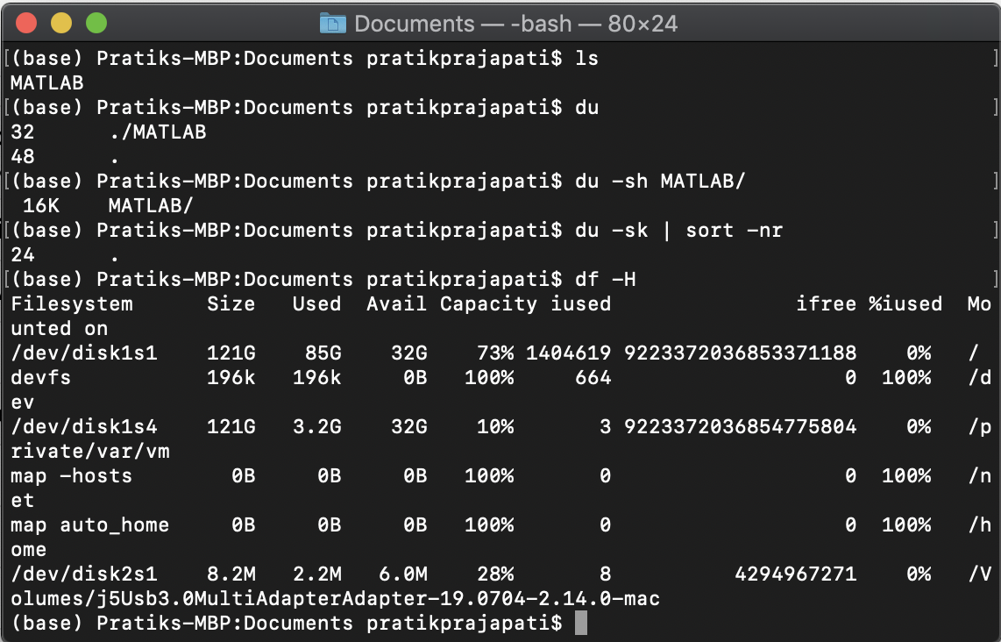

1. **File and Directory Management:**

|  |  |
| --- | --- |
| **Key/Command** | **Description** |
| mkdir <dir> | Create new folder named <dir> |
| mkdir -p <dir>/<dir> | Create nested folders |
| mkdir <dir1> <dir2> <dir3> | Create several folders at once |
| mkdir "<dir>" | Create a folder with a space in the filename |
| rmdir <dir> | Delete a folder (only works on empty folders) |
| rm -R <dir> | Delete a folder and its contents |
| touch <file> | Create a new file without any extension |
| cp <file> <dir> | Copy a file to the folder |
| cp <file> <newfile> | Copy a file to the current folder |
| cp <file>~/<dir>/<newfile> | Copy a file to the folder and rename the copied file |
| cp -R <dir> <"new dir"> | Copy a folder to a new folder with spaces in the filename |
| cp -i <file><dir> | Prompts you before copying a file with a warning overwrite message |
| cp <file1> <file2> <file3>/Users/<dir> | Copy multiple files to a folder |
| rm <file> | Delete a file (This deletes the file permanently; use with caution.) |
| rm -i <file> | Delete a file only when you give confirmation |
| rm -f <file> | Force removal without confirmation |
| rm <file1> <file2> <file3> | Delete multiple files without any confirmation |
| mv <file> <newfilename> | Move/rename |
| mv <file> <dir> | Move a file to the folder, possibly by overwriting an existing file |
| mv -i <file> <dir> | Optional -i flag to warn you before overwriting the file |
| mv *.png ~/<dir> | Move all PNG files from current folder to a different folder |

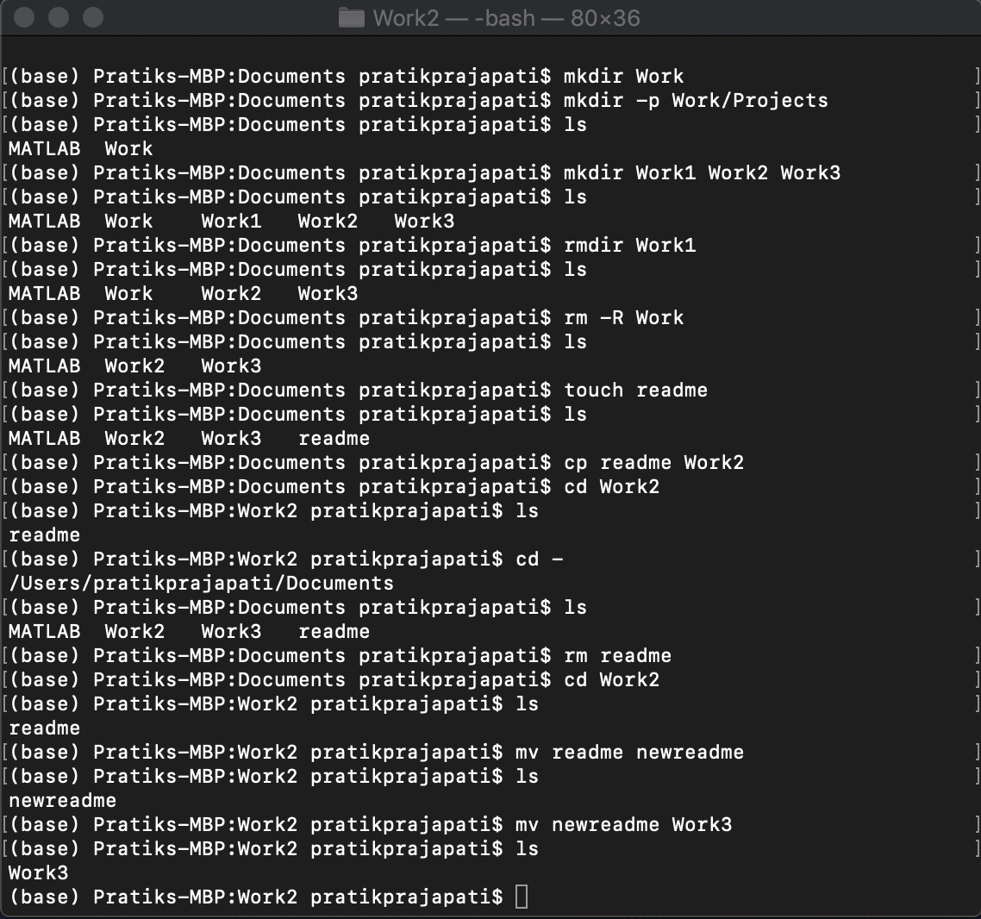

1. **Command History:**

|  |  |
| --- | --- |
| **Key/Command** | **Description** |
| Ctrl + R | Search through previously used commands |
| history n | Shows the previous commands you've typed. Add a number to limit to the last n items |
| ![value] | Execute the last command typed that starts with a value |
| !! | Execute the last command typed |

1. **Git Commands:**
2. **Getting & Creating Projects**

|  |  |
| --- | --- |
| **Key/Command** | **Description** |
| git init | Initialize a local Git repository |
| git clone ssh://git@github.com/[username]/[repository-name].git | Create a local copy of a remote repository |

1. **Basic Snapshotting**

|  |  |
| --- | --- |
| git status | Check status |
| git add [file-name.txt] | Add a file to the staging area |
| git add -A | Add all new and changed files to the staging area |
| git commit -m "[commit message]" | Commit changes |
| git rm -r [file-name.txt] | Remove a file (or folder) |

1. **Branching & Merging:**

|  |  |
| --- | --- |
| git branch | List branches (the asterisk denotes the current branch) |
| git branch -a | List all branches (local and remote) |
| git branch [branch name] | Create a new branch |
| git branch -d [branch name] | Delete a branch |
| git push origin --delete [branch name] | Delete a remote branch |
| git checkout -b [branch name] | Create a new branch and switch to it |
| git checkout -b [branch name] origin/[branch name] | Clone a remote branch and switch to it |
| git branch -m [old branch name] [new branch name] | Rename a local branch |
| git checkout [branch name] | Switch to a branch |
| git checkout - | Switch to the branch last checked out |
| git checkout -- [file-name.txt] | Discard changes to a file |
| git merge [branch name] | Merge a branch into the active branch |
| git merge [source branch] [target branch] | Merge a branch into a target branch |
| git stash | Stash changes in a dirty working directory |
| git stash clear | Remove all stashed entries |

1. **Sharing & Updating Projects:**

|  |  |
| --- | --- |
| git push origin [branch name] | Push a branch to your remote repository |
| git push -u origin [branch name] | Push changes to remote repository (and remember the branch) |
| git push | Push changes to remote repository (remembered branch) |
| git push origin --delete [branch name] | Delete a remote branch |
| git pull | Update local repository to the newest commit |
| git pull origin [branch name] | Pull changes from remote repository |
| git remote add origin ssh://git@github.com/[username]/[repository-name].git | Add a remote repository |
| git remote set-url origin ssh://git@github.com/[username]/[repository-name].git | Set a repository's origin branch to SSH |

1. **Inspection & Comparison:**

|  |  |
| --- | --- |
| git log | View changes |
| git log --summary | View changes (detailed) |
| git diff [source branch] [target branch] | Preview changes before merging |