Eleplots 09

1. CV of speed against temperature

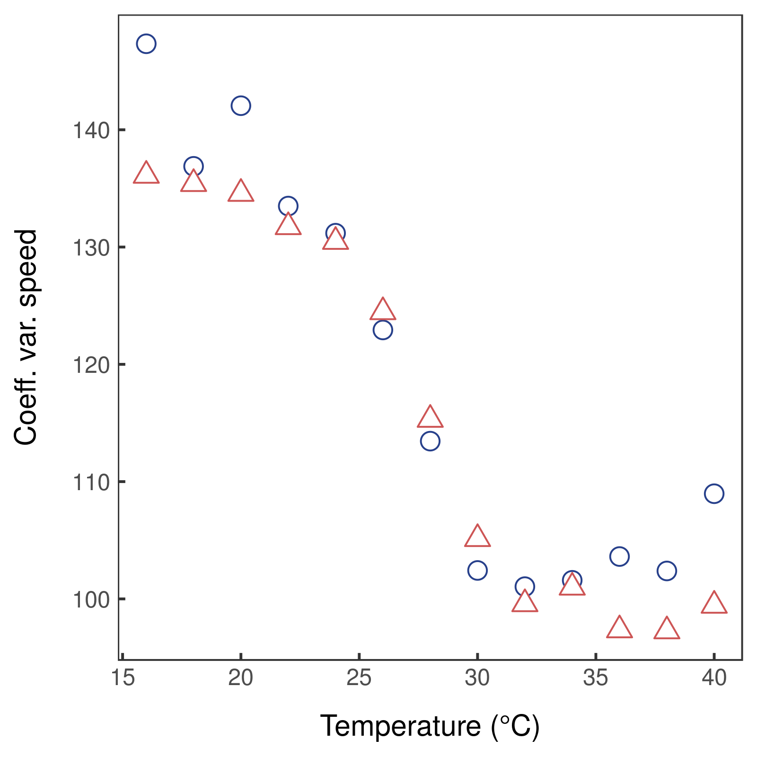Fig. 1 Coefficient of variation of speed (m/30 mins) as a function of thermochron temperature. Blue circles show the cool-dry season, red triangles the hot-wet season.

2. 3D plot of distance to water, loop stage, and speed
Insufficient data to construct a 3D surface.

3. Temperature and distance to water by geology
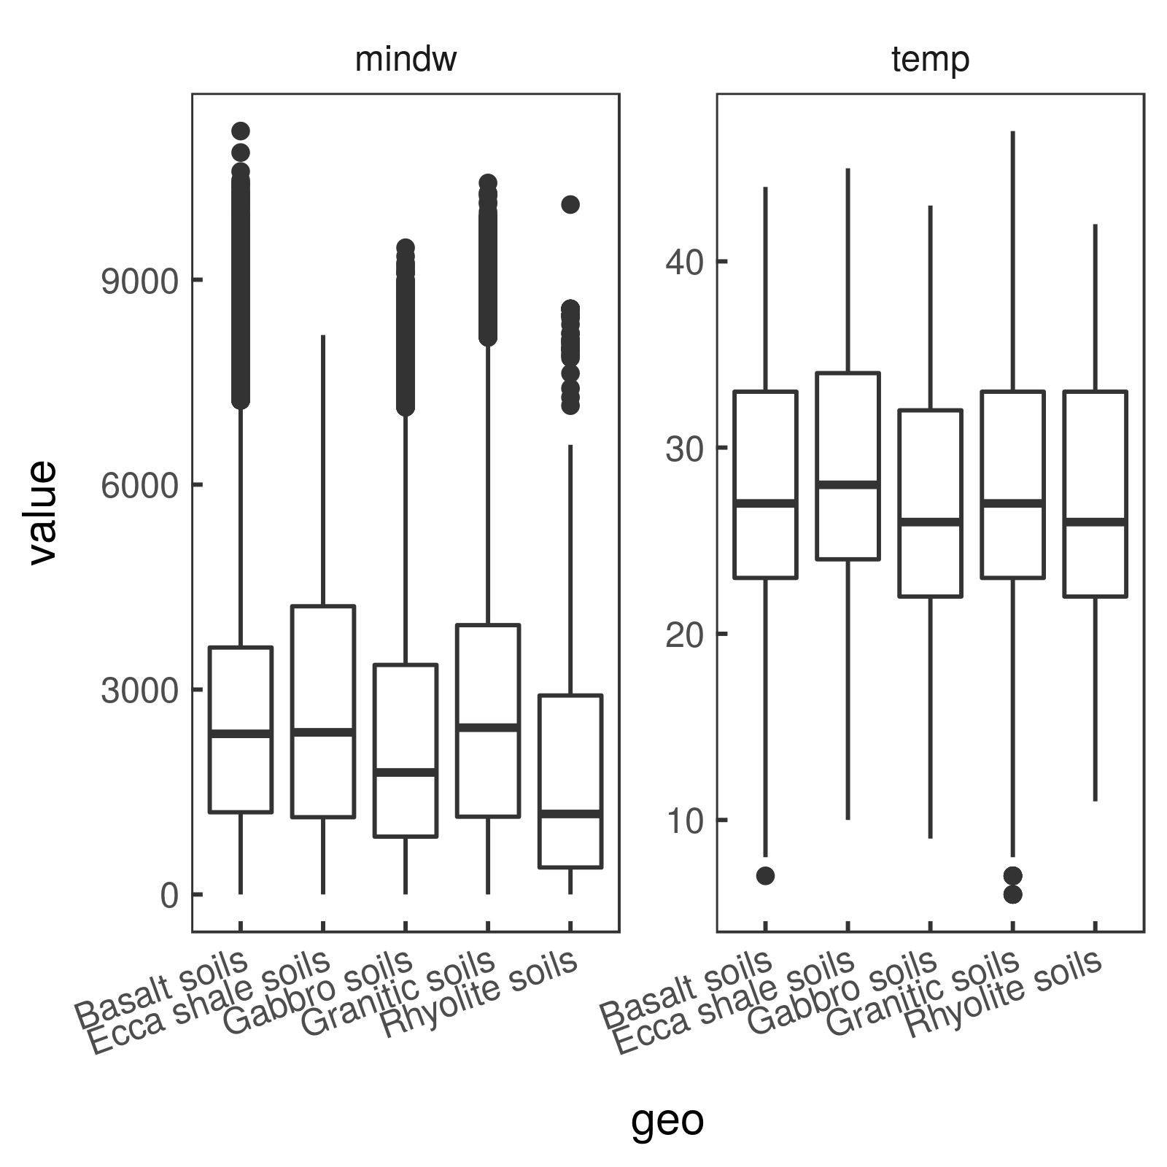Fig. 2: Values of minimum distance to water (mindw) and thermochron temperature (temp) on each soil type.

4. Time since departure
Departure is classified as the elephant leaving the 500m buffer around water. This is shown in Eleplots05 Fig. 4.

5. Steplength against time since arrival and departure
Shown in Eleplots08 Fig. 4(c).

6. Temperature against distance to water for 24 hour looping and all other elephants
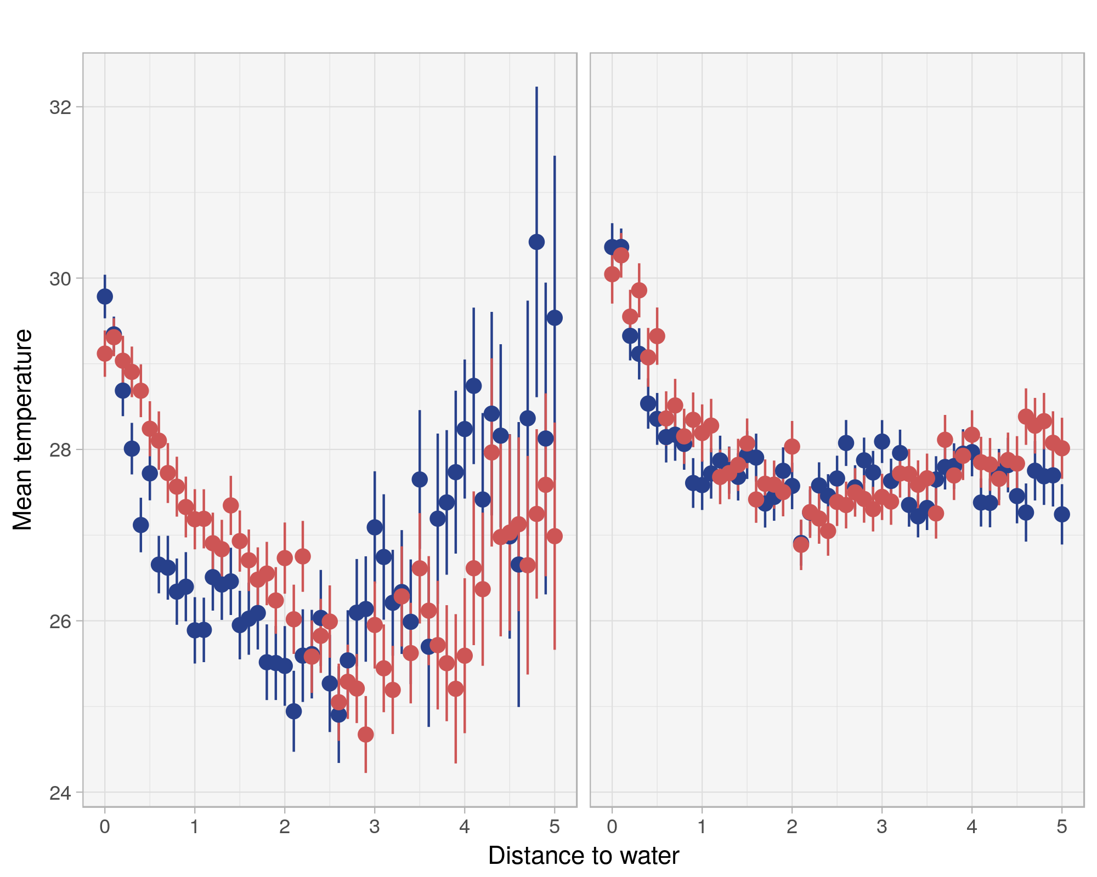Fig. 3: Mean temperature and error bars at each 100m interval from water sources in the hot-wet (red circles) and cool-dry (blue circles) seasons, for elephants engaged in a 24 hour loop back to water (left) and all other elephants (right).
7. Eleplots 08 Fig. 9 moved to main text.
8. Map of 48 hour and 72 hour visits. Under way.
9. Time since the last visit to water: this is Eleplots08 Fig. 9.
10. Data classification by min, max, and CV of daily temperature: done.

11. Revisit rates at different time scales.
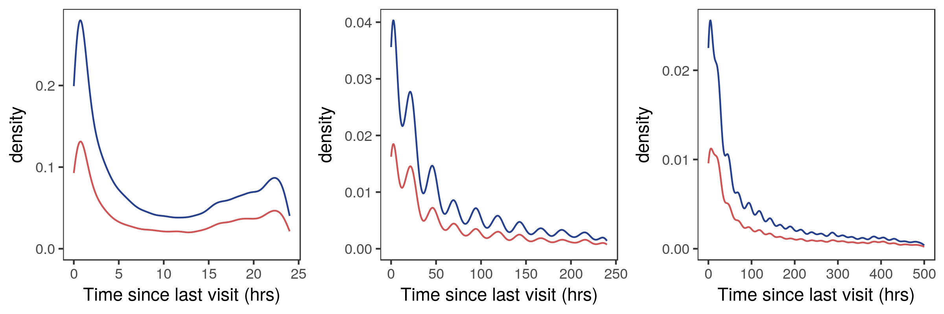Fig. 4: Density of time since last revisit to within 200m of a point (in hours). Lines coloured by season, cool-dry = blue, hot-wet = red.

12. Residence time against time of day
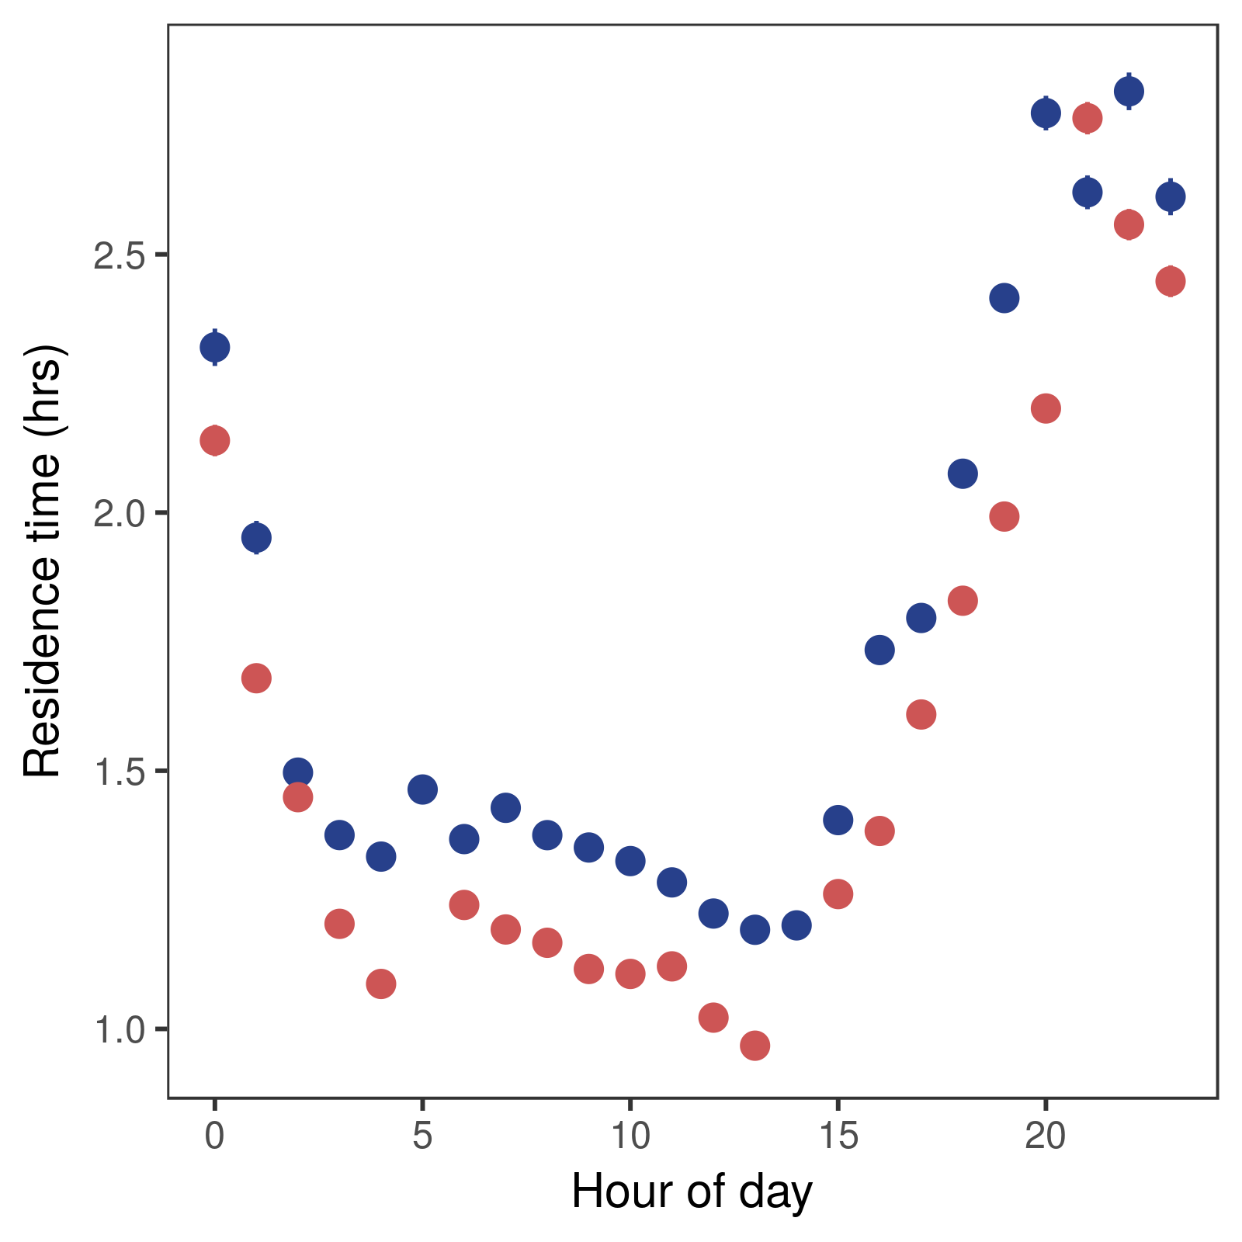Fig. 5: Residence time (hours) within 200m of a point against hour of day, in each season (cool-dry = blue, hot-wet = red). Error bars were produced but are too small to be seen.

