Elephants shuttle to thermoregulate

(**in alphabetical order**) Pratik R. Gupte *(1,2)*, Herbert T. Prins *(3)*, Rob Slotow *(4)*, Maria Thaker *(1)*, Abi T. Vanak *(2)* **et al**

1. Centre for Ecological Sciences, Indian Institute of Science, Bangalore 560012 India.
2. Ashoka Trust for Research in Ecology and the Environment, Royal Enclave, Jakkur, Bangalore 560064 India
3. Wageningen University and Research, Wageningen, The Netherlands.
4. University of Kwa-Zulu Natal, South Africa.

# Abstract

Overheating is a major concern for large animals, whose movements to avoid thermal stress may lead to selection for landscape heat-sinks. The apparent thermoregulation driven water dependence of savanna elephants *Loxodonta africana* has received much attention, but a mechanistic understanding of their movements in relation to water sources and ambient conditions, especially temperature, is lacking. This is partly because reliable measures of animal ambient temperature are missing. We addressed these lacunae by tracking elephants in South Africa, and testing temperature loggers (thermochrons) on board standard GPS transmitter collars as accurate reporters of elephant thermal landscapes. We identified frequently revisited water points, and tested how temperature affects elephant movement in relation to these sites. Elephants loop back to water-points, being closest to water during the hottest parts of the day. Elephant speeds were highest when approaching and leaving water. Elephants move faster and farther when hot, which has implications for management decisions that rely on water dependence to control their space use.

**Keywords** Savanna elephant *Loxodonta africana*, movement ecology, revisits, water sources, thermoregulation

# Introduction

Animals feel the heat, and when faced with heat stress may alter their physiology, or behaviour, or both, to preserve biological functions [**cite**]. Most organism-level physiological responses to high temperatures, such as sweating, rely on water evaporation to transfer heat away from the core-body. Many animals are either incapable of or inefficient in engaging such responses, and must rely on behaviour to complement physiological thermoregulation. Behavioural responses to overheating involve creating or occupying heat-sinks to which excess heat may be transferred. Occupancy of and behaviours at landscape heat-sinks, such as water sources or covered landscapes, constitutes an important class of behavioural responses to heat stress. For example, temperate ungulates like moose *Alces alces* seek refuge in shady forests (van Beest et al. 2012), while large tropical herbivores like Cape buffalo *Syncerus caffer* immerse themselves and wallow at water sources to rapidly cool down (Bennitt et al. 2014).

Drylands living ungulates prone to heat stress must balance their dependence on water as a thermoregulatory aid with avoiding competition for resources and predation at water sources (Redfern et al. 2003, Cain et al. 2012, Owen-Smith and Goodall 2014). This may result in only periodic visits to known sources of water and forage (Giotto et al. 2015), and when the two are spatially separated, yet frequently visited, animals pay an increased cost of movement (Cain et al. 2012). Movement variables such as speed and directionality are broadly influenced by environmental conditions such as temperature (Schmidt et al. 2016), but a finer understanding of heat stress as a driver of animal movements requires high resolution data on positions and instantaneous ambient temperatures. While miniature temperature sensors externally fitted to GPS transmitters have proven successful in logging animal ambient temperatures (Hetem et al. 2007, 2012), studies have shied away from using data from temperature sensors built into standard GPS transmitters.

Savanna elephants *Loxodonta africana* in southern Africa are an excellent study system to investigate the effect of temperature on the movements of drylands-living megafauna in relation to water. Elephants are unable to sweat, and are susceptible to heat stress. In addition to deploying behavioural mechanisms such as ear-flapping, they select for thermally stable landscapes (Johnson et al. 2002, Kinahan et al. 2007). Further, elephants periodically return to water sources to drink (Valls Fox 2015), a phenomenon that has spawned the management practice of attempting to restrict elephant space use by limiting the distribution of water sources (Redfern 2002). Elephants are reported to move faster and consequently travel farther in hot-dry seasons in Namibia and Zimbabwe (Leggett 2010, Valls Fox 2015), suggesting a direct effect of temperature on movement speed. Kruger experiences an atypical combination of hot-wet and cool-dry seasons, allowing the effect of decreased water provisioning to be decoupled from that of increased temperature. Here, we first test whether in-built temperature sensors (hereafter thermochrons) accurately report the thermal landscape of elephants, and then proceed to characterise elephant movement in relation to water sources and ambient temperature.

# Methods

We collected half-hourly positions of individual (n = 14) free-ranging female African elephants previously fitted with GPS logger-transmitter collars [**cite + collar manufacture + weight**]; each was from a different herd in Kruger National Park, South Africa (24°S, 31.5°E). Elephants were tracked for on average 637 days (range: 436 – 731) between August 2007 and August 2009 (see figure 1*b* & electronic supplementary material figure S1). To relate elephant movement to their landscape, we gathered shapefiles of the courses of park rivers, and the locations of active park waterholes.

Collar-borne thermochrons reported temperature data (hereon elephant temperature) at each position fix. Seeking to verify that thermochrons accurately reflected the thermal environment of elephants, we also collected ambient temperature data from Skukuza weather station (24.98°S, 31.5°E), and tested the hourly correlation of ambient temperatures with elephant temperatures.

We calculated the first passage time through (FPT 200), total time spent within (residence time), and the number of revisits within a 200m radius of each relocation, and sought to identify habitual water points. We then identified track segments between each visit to water points and characterised the frequency of visits, and, the temperature, speed, and distance to the nearest water source throughout a subset of 24 hour tracks. Finally, we used a mixed additive model to test whether elephants moved faster at higher temperatures.

# Results

## Elephant movement & temperature

Elephants ranged on average 4005 km (range: 1854 km – 7074 km) across southern Kruger over the tracking period (figure 1), covering 7.2 km per day (range: 5 km – 9.9 km) at a speed of 398 m/hr (range: 304 m/hr – 470 m/hr); logger fixes placed them within 500m of water 12% (range: 6% – 21%) and 11% (range: 3% – 17%) of the time in the cool-dry and hot-wet seasons respectively.

Collar thermochrons reported identical mean daily temperatures of 27.68°C (range: 6°C – 47°C) and 27.62°C (range: 7°C – 44°C) in the cool-dry and hot-wet seasons. Thermochron data from 3 elephants logged within 10km of Skukuza were well correlated with temperatures from the weather station in both seasons (mean hourly correlation: cool-dry = 0.77, hot-wet: 0.81), with all hourly correlations ⪆ 0.6.

## Visits to water

Elephants ventured beyond 200m of a relocation after 2.5 hours (range: 0.02 hours – 10 hours) on their first visit, returning to this zone 5 times (range: never – 86 times), and spent on average 8.65 hours (range: 0.02 – 55 hours) around each point. Using a combination of conservative levels of residence time (> 10 hours) and the number of revisits (> 10 times) 12,106 (38%) of 32,183 relocations within 500m of water sources were identified as habitual water points.

Segments between water points frequently took the form of loops (figures 1*c*, 2*a*), with elephants returning to within 500m of their start location in ≈ 80% of cases in both seasons (electronic supplementary material table S1). The interval of visits to water points had a multi-modal distribution, and 653 (5%) segments had a water-visit interval between 12 – 24 hours (figure 2*a*).

Elephants in these sub-24 segments moved away from water as temperatures dropped, and reversed this trend as temperatures rose (figure 2*b, c*). Elephant speed was highest in the initial and final fifths of a segment. An effect of season was also apparent, with elephants experiencing higher temperatures, moving further away from water, and travelling faster in the hot-wet season (figure 2).

Elephant temperature was found to be a significant predictor of speed (Χ2 = 4668, p < 0.01); elephants moved faster in the hot-wet season (Χ2 = 361, p < 0.01) but more slowly in denser woodland (Χ2 = 2347, p < 0.01).

# Discussion

Our results show that thermochron temperature data are highly correlated with weather station data, and can be safely used as animal ambient temperature. Elephants make frequent visits to water sources, with most tracks between water points looping back to where they began. Elephants reach their maximum displacement from water along loops when temperatures are lowest, and begin to head back to water as temperatures rise. Elephants shuttle to and from water, with the highest speeds observed in the initial and final stages of track, i.e., near water. Temperature likely mediates elephant movement in the landscape, with elephants moving faster at higher temperatures.

## Accuracy of thermochrons

Collar-borne thermochrons are a standard feature of a number of modern GPS transmitters. Despite reporting temperatures that are a combination of ambient values, animal skin surface temperature, and heat from the operation of on-board electronics, thermochrons report the thermal landscape in which they are deployed with accuracy comparable to that of black-globes, currently the most accurate external loggers available (Hetem et al. 2007). They possess the advantage of not requiring additional integration or calibration. Our results relating movement to thermochron data also support the position that external loggers are sufficient to study the physiological basis of movement.

## Elephant movements to water

Kruger elephants are faithful to habitual water points to which they periodically return, similar to findings from a more arid system in Zimbabwe (Valls Fox 2015). However, multi-modality in the visit interval distribution, with peaks at 12-hour multiples, is contrary to previous findings of a Poisson distribution of visit intervals (Purdon and Aarde 2017). Long trips between water are less common in the hot-wet season, when ephemeral water sources are likely more abundant, indicating that elephants probably prefer to use known water sources rather than incur greater travel costs exploring the landscape for new water points. The two halves of elephant shuttling to and from water may be driven by distinct yet related phenomena. As temperatures rise, elephants likely rush towards water to cool down, where they are joined by other megafauna (Hirst 1975, Bennitt et al. 2014). The resulting pressure on resources, increased competition, and higher predation risk for young calves may drive elephant herds to move quickly back to more suitable sites farther from water (Valls Fox 2015). Elephants, moving faster at higher temperatures, cover more ground in the hot-wet season, suggesting that they can successfully travel to and occupy areas farther from water sources than currently thought. This has implications for management policies seeking to control elephant space use by altering the distribution of water sources.

# Acknowledgements

We thank all the lovely elephants who confused us in this study. **real acknowledgement here**

# References

1. Bennitt, E., M. C. Bonyongo, and S. Harris. 2014. Habitat selection by African buffalo (*Syncerus caffer*) in response to landscape-level fluctuations in water availability on two temporal scales. PLOS ONE 9:1–14.
2. Cain, J. W., N. Owen-Smith, and V. A. Macandza. 2012. The costs of drinking: Comparative water dependency of sable antelope and zebra. Journal of Zoology 286:58–67.
3. Giotto, N., J. Gerard, A. Ziv, A. Bouskila, and S. Bar-David. 2015. Space-use patterns of the Asiatic wild ass (*Equus hemionus*): Complementary insights from displacement, recursion movement and habitat selection analyses. PLOS ONE 10:1–21.
4. Hetem, R. S., S. K. Maloney, A. Fuller, L. C. Meyer, and D. Mitchell. 2007. Validation of a biotelemetric technique, using ambulatory miniature black globe thermometers, to quantify thermoregulatory behaviour in ungulates. Journal of Experimental Zoology Part A: Ecological Genetics and Physiology 307A:342–356.
5. Hetem, R. S., W. M. Strauss, L. G. Fick, S. K. Maloney, L. C. Meyer, M. Shobrak, A. Fuller, and D. Mitchell. 2012. Activity re-assignment and microclimate selection of free-living Arabian oryx: Responses that could minimise the effects of climate change on homeostasis? Zoology 115:411–416.
6. Hirst, S. M. 1975. Ungulate-habitat relationships in a South African woodland/savanna ecosystem. Wildlife Monographs:3–60.
7. Johnson, C. J., K. L. Parker, D. C. Heard, and M. P. Gillingham. 2002. Movement parameters of ungulates and scale-specific responses to the environment. Journal of Animal Ecology 71:225–235.
8. Kinahan, A., S. Pimm, and R. van Aarde. 2007. Ambient temperature as a determinant of landscape use in the savanna elephant, *Loxodonta africana*. Journal of Thermal Biology 32:47–58.
9. Leggett, K. 2010. Daily and hourly movement of male desert-dwelling elephants. African Journal of Ecology 48:197–205.
10. Owen-Smith, N., and V. Goodall. 2014. Coping with savanna seasonality: Comparative daily activity patterns of African ungulates as revealed by GPS telemetry. Journal of Zoology 293:181–191.
11. Purdon, A., and R. van Aarde. 2017. Water provisioning in Kruger National Park alters elephant spatial utilisation patterns. Journal of Arid Environments 141:45–51.
12. Redfern, J. V. 2002. Manipulating surface water availability to manage herbivore distributions in the Kruger National Park, South Africa. PhD thesis, University of California, Berkeley.
13. Redfern, J. V., R. Grant, H. Biggs, and W. M. Getz. 2003. Surface-water constraints on herbivore foraging in the Kruger National Park, South Africa. Ecology 84:2092–2107.
14. Schmidt, N. M., F. M. van Beest, J. B. Mosbacher, M. Stelvig, L. H. Hansen, J. Nabe-Nielsen, and C. Grøndahl. 2016. Ungulate movement in an extreme seasonal environment: Year-round movement patterns of high-arctic muskoxen. Wildlife Biology 22:253–267.
15. Valls Fox, H. 2015. To drink or not to drink? The influence of resource availability on elephant foraging and habitat selection in a semi-arid savanna.
16. van Beest, F. M., B. V. Moorter, and J. M. Milner. 2012. Temperature-mediated habitat use and selection by a heat-sensitive northern ungulate. Animal Behaviour 84:723–735.

# Figure legends

Figure 1. **(a)** Study site in Kruger National Park, South Africa (red star), showing **(b)** park boundary (dashed grey line), weather station at Skukuza (red star), major rivers (solid blue lines), open waterholes (blue dots), and raw elephant tracks (coloured lines, n = 14). **(c)** Inset showing identified 24-hour looping behaviour centred on water sources (blue dots and lines), coloured by elephant shown (see labels, n = 3), with remaining tracks in the background (grey lines). 500m riparian zone along rivers is shaded green.

Figure 2. **(a)** Mean thermochron temperature (points) at measured ambient temperature, and **(b)** GLM fits (lines) in each season (cool-dry: blue circles & lines, hot-wet: red triangles & lines). Vertical lineranges and shaded areas (coloured by season) indicate 95% confidence intervals at each point.

Figure 3. **(a)** Density of displacement along 12,106 elephant tracks between habitual water-points. **(b)** Density of intervals between 12,106 visits to water-points; rectangle bounds 653 intervals of 12 – 24 hours. **(c)** Distance to water source, **(d)** elephant temperature, and **(e)** elephant speed along 653 elephant tracks between water sources. **(f)** Elephant speed (points) at 2°C temperature intervals in each season (cool-dry: blue circles, hot-wet: red triangles). GAMM fit (lines), data error intervals (lineranges), and fit error intervals (shaded areas) are shown.

# Figures

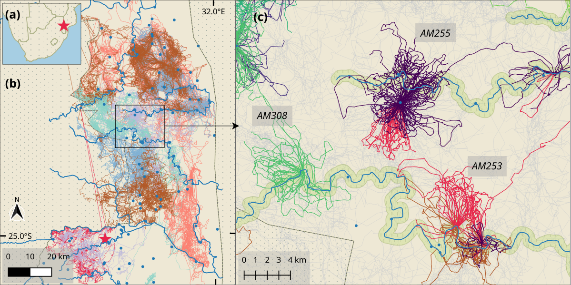

Figure 1.

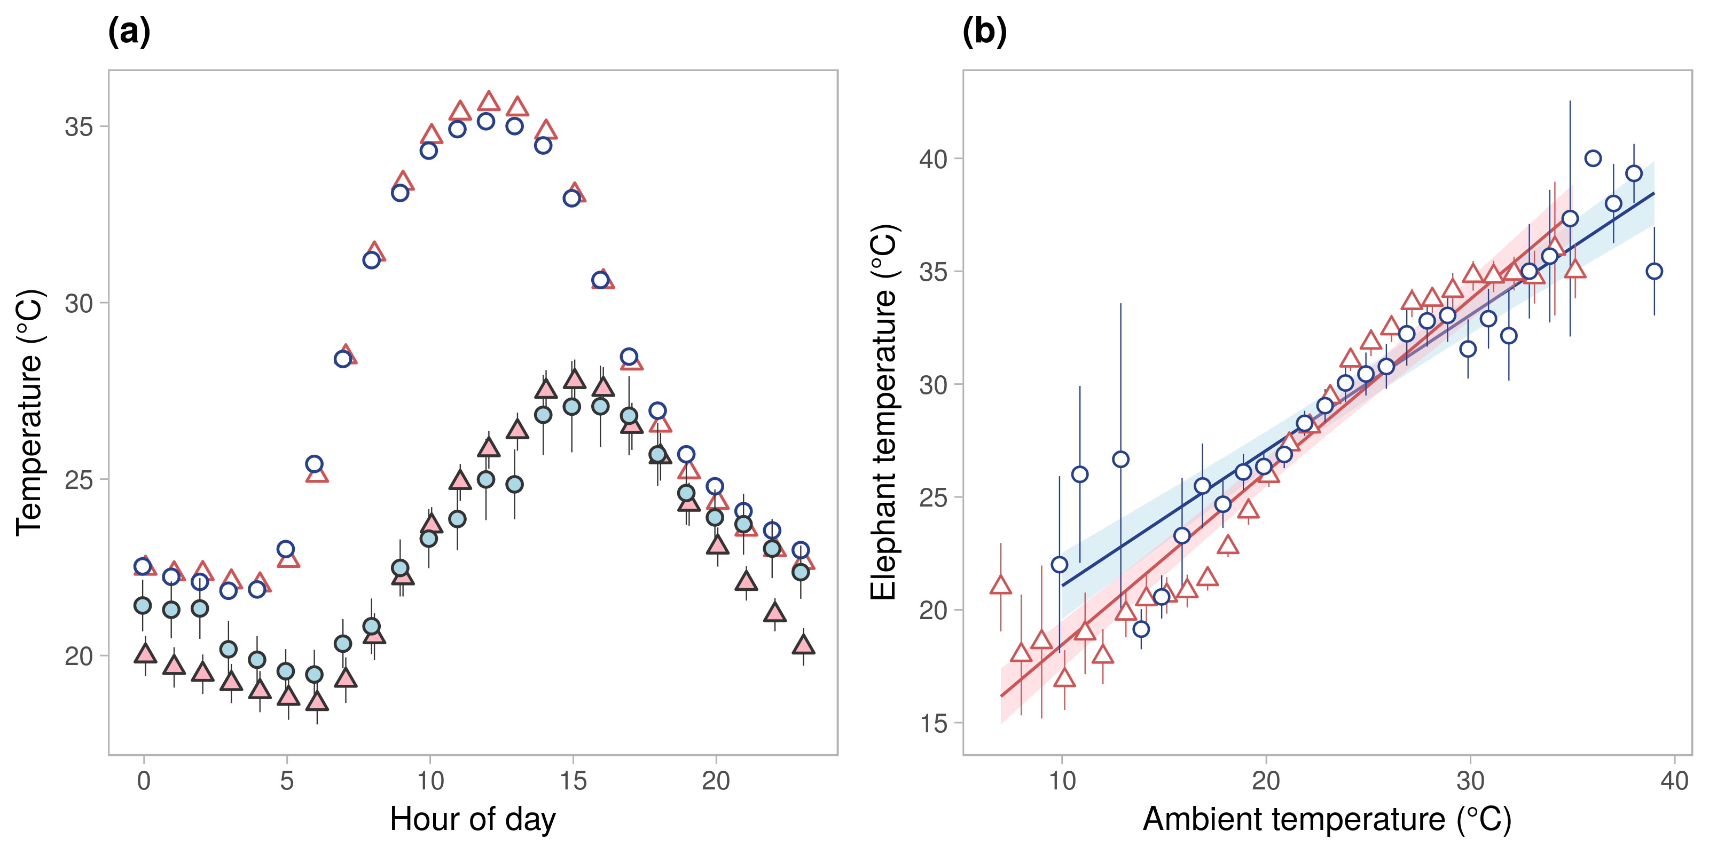

Figure 2.

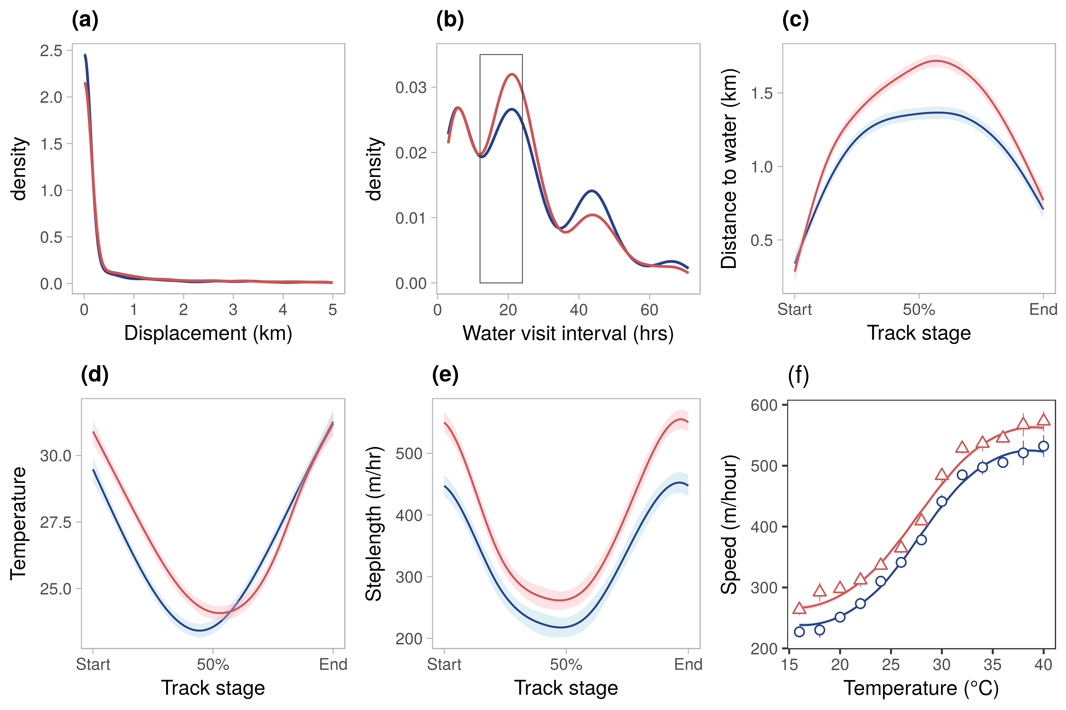

Figure 3.