Elephants shuttle to thermoregulate

**Pratik R. Gupte1,2, Herbert T. Prins3, Rob Slotow4, Maria Thaker1*, Abi T. Vanak2**

1. Centre for Ecological Sciences, Indian Institute of Science, Bangalore, India.
2. Ashoka Trust for Research in Ecology and the Environment, Bangalore, India
3. Wageningen University and Research, Wageningen, The Netherlands.
4. University of Kwa-Zulu Natal, Durban, South Africa.

* Correspondence:

Maria Thaker

For Frontiers topic Ecology and behaviour using advanced data-logging and tracking. 350 word abstract, 12,000 words text (max), 15 figs and tables combined (max), supplementary material not encouraged.

# Abstract

Overheating is a major concern for large mammals, and many species make landscape-scale movements to avoid thermal stress. The movements of savanna elephants *Loxodonta africana* have received much attention in the context of water dependence, yet temperature has seldom been invoked to explain them. We tracked 14 herds of elephants in Kruger National Park, South Africa using GPS collars over a period of 02 years. We quantified the extent to which elephants used the landscape in terms of total residence time, first passage time, and number of revisits. Using conservative criteria, we identified habitual water-points and studied elephant movement between successive visits to water. We found that elephants in Kruger are dependent on water sources, with more short trips away from water in the hot-wet season, and more long-distance forays in the cool-dry season. 80% of elephant movements between water-points are loops, ie, individuals returning to the water-point of origin. In a 24-hour period, elephants arrive at water-points when temperatures are highest (afternoon), and are farthest away when they are lowest (midnight). Elephant speed is highest when approaching and leaving water, ie, when ambient temperatures are high, which has implications for management decisions that alter water dependence to control their space use in a rapidly warming world.

# Introduction

Animals faced with heat stress thermoregulate by altering their physiology and behaviour (Angilletta 2012). Most physiological responses to high temperatures, such as sweating in mammals, rely on water evaporation to transfer heat away from the core-body. Many animals must complement physiological thermoregulation with behavioural mechanisms of losing heat. In general, behavioural responses to overheating involve utilising heat-sinks to which excess body-heat may be transferred. For example, the large ears of savanna elephants *Loxodonta africana* aid in rapid cooling by offering a large surface area that readily loses heat to the environment. Occupying landscape heat-sinks, such as water sources or shade under dense vegetation constitutes another important class of behavioural responses to heat stress. For example, temperate ungulates such as moose *Alces alces* seek refuge from high ambient temperatures in shady forests (Beest et al. 2012), while large tropical herbivores such as Cape buffalo *Syncerus caffer* wallow at water sources to rapidly cool down (Bennitt et al. 2014).

Animals must balance the energetic benefits of occupying thermally milder sites, such as water sources, with the cost of increased competition and predation risk due to aggregation at those sites (Redfern et al. 2003, Cain et al. 2012, Owen-Smith and Goodall 2014). One solution is for animals to shuttle periodically between such critical resources as water and forage (Giotto et al. 2015). In general, greater water-dependency and thus more frequent visits to water are expected for larger animals, such as buffalo, which overheat more rapidly (Angilletta 2012, Cain et al. 2012, Giotto et al. 2015), and studies that directly quantified ambient temperature as a driver of habitat selection and movement have revealed occupancy infavour of cooler sites that aid in relieving thermal stress (Hetem et al. 2007, 2012). Further, movement variables such as speed and directionality may be affected by environmental conditions such as temperature and photoperiod (Schmidt et al. 2016).

Savanna elephants Loxodonta africana in southern Africa are an excellent study system to investigate the effect of temperature on movement strategies in relation to water. Elephants are unable to sweat, and are susceptible to heat stress (ref). In addition to deploying behavioural mechanisms such as ear-flapping, savanna elephants select for thermally stable landscapes (Expand the previous point with the example from papers 10 or 11.) (Johnson et al. 2002, Kinahan et al. 2007). Further, elephants regularly return to water sources to drink (Valls Fox 2015), an observation that has motivated the management practice of restricting elephant space use by limiting the distribution of water sources (Redfern 2012). Elephants are reported to move faster and consequently travel farther in hot-dry seasons in Namibia and Zimbabwe (Leggett 2010, Valls Fox 2015), suggesting a direct effect of temperature on movement speed. Kruger experiences a contrasting and atypical combination of hot-wet and cool-dry seasons, allowing the effect of decreased water provisioning to be decoupled from that of increased temperature. Here, we first test whether in-built temperature sensors (hereafter thermochrons) accurately report the thermal landscape of elephants, and then proceed to characterise elephant movement in relation to water sources and ambient temperature.

# Methods

The study was conducted in Kruger National Park…, where we have had 1? female African elephants fitted with GPS logger-transmitter collars since 200?. Details of the capture and collaring of these elephants can be found in xxx. Transmitters were set to record the location of the animal every 30 min, as well as the temperature at the location. -hourly positions of individual (n = 14) free-ranging female African elephants previously fitted with GPS logger-transmitter collars [cite + collar manufacture + weight]; each was from a different herd in Kruger National Park, South Africa (24°S, 31.5°E). For this analysis, we selected location and temperature data from 14 females from different herds that were tracked for on average 637 days (range: 436 – 731) between August 2007 and August 2009 (see figure 1b & electronic supplementary material figure S1). To relate elephant movement to their landscape, we gathered shapefiles of the courses of park rivers, and the locations of active park waterholes.

Collar-borne thermochrons reported temperature data (hereon elephant temperature) at each position fix. We first verified that thermochrons accurately reflect the thermal environment of elephants, by comparing the ambient temperature from Skukuza weather station (24.98°S, 31.5°E), and tested the hourly correlation of ambient temperatures with elephant temperatures.

We calculated the first passage time through (FPT 200), total time spent within (residence time), and the number of revisits within a 200m radius of each relocation, and sought to identify habitual water points. We then identified track segments between each visit to water points and characterised the frequency of visits, and, the temperature, speed, and distance to the nearest water source throughout a subset of 24 hour tracks. Finally, we used a mixed additive model to test whether elephants moved faster at higher temperatures.

# Results

## Elephant movement & temperature

Elephants ranged on average 4005 km (range: 1854 km – 7074 km) across southern Kruger over the tracking period (figure 1), covering 7.2 km per day (range: 5 km – 9.9 km) at a speed of 398 m/hr (range: 304 m/hr – 470 m/hr); logger fixes placed them within 500m of water 12% (range: 6% – 21%) and 11% (range: 3% – 17%) of the time in the cool-dry and hot-wet seasons respectively.

Collar thermochrons reported identical mean daily temperatures of 27.68°C (range: 6°C – 47°C) and 27.62°C (range: 7°C – 44°C) in the cool-dry and hot-wet seasons. Thermochron data from 3 elephants logged within 10km of Skukuza were well correlated with temperatures from the weather station in both seasons (mean hourly correlation: cool-dry = 0.77, hot-wet: 0.81), with all hourly correlations ⪆ 0.6.

## Visits to water

Elephants ventured beyond 200m of a relocation after 2.5 hours (range: 0.02 hours – 10 hours) on their first visit, returning to this zone 5 times (range: never – 86 times), and spent on average 8.65 hours (range: 0.02 – 55 hours) around each point. Using a combination of conservative levels of residence time (> 10 hours) and the number of revisits (> 10 times) 12,106 (38%) of 32,183 relocations within 500m of water sources were identified as habitual water points.

Segments between water points frequently took the form of loops (figures 1c, 2a), with elephants returning to within 500m of their start location in ≈ 80% of cases in both seasons (electronic supplementary material table S1). The interval of visits to water points had a multi-modal distribution, and 653 (5%) segments had a water-visit interval between 12 – 24 hours (figure 2a).

Elephants in these sub-24 segments moved away from water as temperatures dropped, and reversed this trend as temperatures rose (figure 2b, c). Elephant speed was highest in the initial and final fifths of a segment. An effect of season was also apparent, with elephants experiencing higher temperatures, moving further away from water, and travelling faster in the hot-wet season (figure 2).

Elephant temperature was found to be a significant predictor of speed (Χ2 = 4668, p < 0.01); elephants moved faster in the hot-wet season (Χ2 = 361, p < 0.01) but more slowly in denser woodland (Χ2 = 2347, p < 0.01).

## Discussion

Our results show that thermochron temperature data are highly correlated with weather station data, and can be safely used as animal ambient temperature. Elephants make frequent visits to water sources, with most tracks between water points looping back to where they began. Elephants reach their maximum displacement from water along loops when temperatures are lowest, and begin to head back to water as temperatures rise. Elephants shuttle to and from water, with the highest speeds observed in the initial and final stages of track, i.e., near water. Temperature likely mediates elephant movement in the landscape, with elephants moving faster at higher temperatures.

## Accuracy of thermochrons

Collar-borne thermochrons are a standard feature of a number of modern GPS transmitters. Despite reporting temperatures that are a combination of ambient values, animal skin surface temperature, and heat from the operation of on-board electronics, thermochrons report the thermal landscape in which they are deployed with accuracy comparable to that of black-globes, currently the most accurate external loggers available (Hetem et al. 2007). They possess the advantage of not requiring additional integration or calibration. Our results relating movement to thermochron data also support the position that external loggers are sufficient to study the physiological basis of movement.

## Elephant movements to water

Kruger elephants are faithful to habitual water points to which they periodically return, similar to findings from a more arid system in Zimbabwe (Valls Fox 2015). However, multi-modality in the visit interval distribution, with peaks at 12-hour multiples, is contrary to previous findings of a Poisson distribution of visit intervals (Purdon and Aarde 2017). Long trips between water are less common in the hot-wet season, when ephemeral water sources are likely more abundant, indicating that elephants probably prefer to use known water sources rather than incur greater travel costs exploring the landscape for new water points. The two halves of elephant shuttling to and from water may be driven by distinct yet related phenomena. As temperatures rise, elephants likely rush towards water to cool down, where they are joined by other megafauna (Hirst 1975) Bennitt et al. 2014). The resulting pressure on resources, increased competition, and higher predation risk for young calves may drive elephant herds to move quickly back to more suitable sites farther from water (Valls Fox 2015). Elephants, moving faster at higher temperatures, cover more ground in the hot-wet season, suggesting that they can successfully travel to and occupy areas farther from water sources than currently thought. This has implications for management policies seeking to control elephant space use by altering the distribution of water sources.

References

Angilletta, M. J. 2012. Thermoregulation in animals. Oxford University Press.

Beest, F. M. van, B. V. Moorter, and J. M. Milner. 2012. Temperature-mediated habitat use and selection by a heat-sensitive northern ungulate. Animal Behaviour 84:723–735.

Bennitt, E., M. C. Bonyongo, and S. Harris. 2014. Habitat Selection by African Buffalo (Syncerus caffer) in Response to Landscape-Level Fluctuations in Water Availability on Two Temporal Scales. PLOS ONE 9:1–14.

Cain, J. W., N. Owen-Smith, and V. A. Macandza. 2012. The costs of drinking: comparative water dependency of sable antelope and zebra. Journal of Zoology 286:58–67.

Giotto, N., J.-F. Gerard, A. Ziv, A. Bouskila, and S. Bar-David. 2015. Space-Use Patterns of the Asiatic Wild Ass (Equus hemionus): Complementary Insights from Displacement, Recursion Movement and Habitat Selection Analyses. PLOS ONE 10:1–21.

Hetem, R. S., S. K. Maloney, A. Fuller, L. C. R. Meyer, and D. Mitchell. 2007. Validation of a biotelemetric technique, using ambulatory miniature black globe thermometers, to quantify thermoregulatory behaviour in ungulates. Journal of Experimental Zoology Part A: Ecological Genetics and Physiology 307A:342–356.

Hetem, R. S., W. M. Strauss, L. G. Fick, S. K. Maloney, L. C. R. Meyer, M. Shobrak, A. Fuller, and D. Mitchell. 2012. Activity re-assignment and microclimate selection of free-living Arabian oryx: responses that could minimise the effects of climate change on homeostasis? Zoology 115:411–416.

Hirst, S. M. 1975. Ungulate-Habitat Relationships in a South African Woodland/Savanna Ecosystem. Wildlife Monographs:3–60.

Owen-Smith, N., and V. Goodall. 2014. Coping with savanna seasonality: comparative daily activity patterns of African ungulates as revealed by GPS telemetry. Journal of Zoology 293:181–191.

Purdon, A., and R. J. van Aarde. 2017. Water provisioning in Kruger National Park alters elephant spatial utilisation patterns. Journal of Arid Environments 141:45–51.

Redfern, J. V., R. Grant, H. Biggs, and W. M. Getz. 2003. Surface-water Constraints On Herbivore Foraging In The Kruger National Park, South Africa. Ecology 84:2092–2107.

Schmidt, N. M., F. M. van Beest, J. B. Mosbacher, M. Stelvig, L. H. Hansen, J. Nabe-Nielsen, and C. Grøndahl. 2016. Ungulate movement in an extreme seasonal environment: year-round movement patterns of high-arctic muskoxen. Wildlife Biology 22:253–267.

Valls Fox, H. 2015. To drink or not to drink? The influence of resource availability on elephant foraging and habitat selection in a semi-arid savanna.

Figures

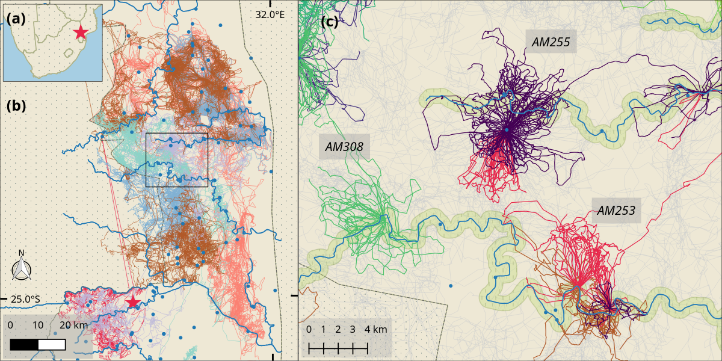

Figure 1. (a) Study site in Kruger National Park, South Africa (red star), showing (b) park boundary (dashed grey line), weather station at Skukuza (red star), major rivers (solid blue lines), open waterholes (blue dots), and raw elephant tracks (coloured lines, n = 14). (c) Inset showing 24-hour looping behaviour centred on water sources (blue dots and lines), coloured by representative elephant ID (n = 3; green, purple and red), with remaining tracks in the background (grey lines). The riparian zone along rivers (500m from river centre) is shaded in green.

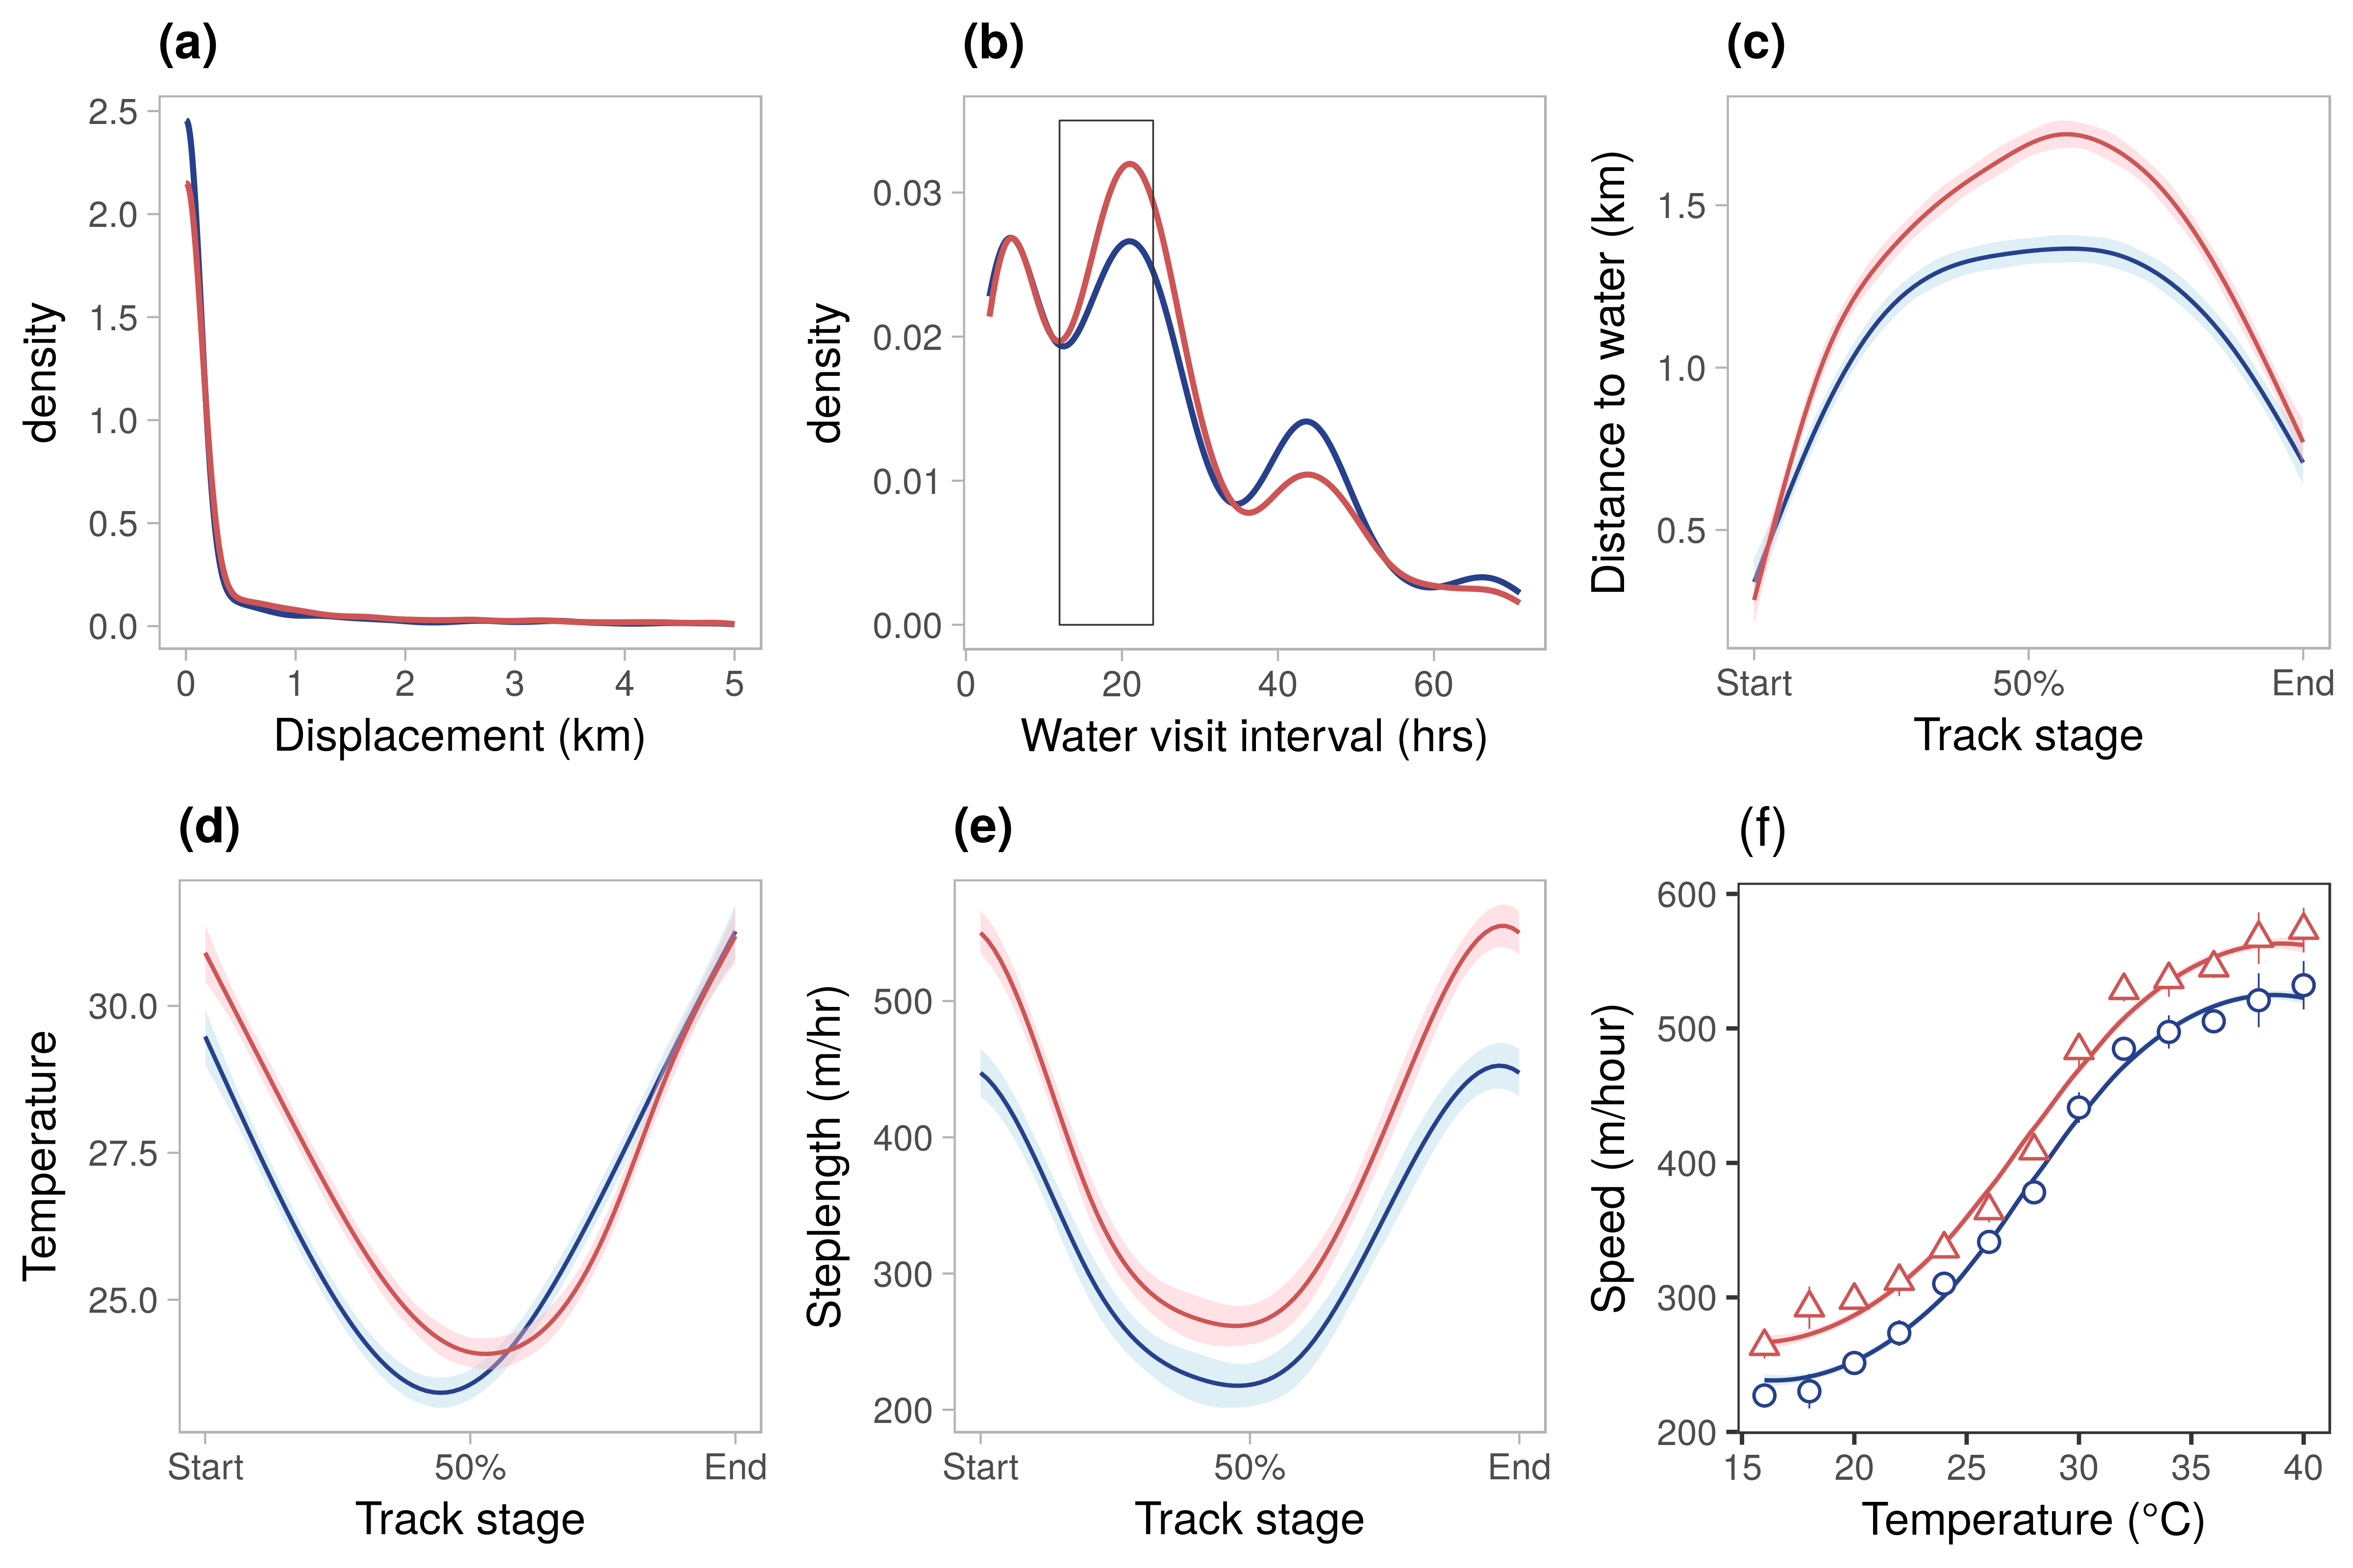

Figure 2. (a) Density of displacement along 12,106 elephant tracks between habitual water-points. (b) Density of intervals between 12,106 visits to water-points; rectangle bounds 653 intervals of 12 – 24 hours. (c) Distance to water source, (d) elephant temperature, and (e) elephant speed along 653 elephant tracks between water sources. (f) Elephant speed (points) at 2°C temperature intervals in each season (cool-dry: blue circles, hot-wet: red triangles). GAMM fit (lines), data error intervals (lineranges), and fit error intervals (shaded areas) are shown.