Elephants shuttle to thermoregulate

Pratik R. Gupte1,2, Herbert T. Prins3, Rob Slotow4, Maria Thaker11*, Abi T. Vanak2

1Centre for Ecological Sciences, Indian Institute of Science, Bangalore, India

2Ashoka Trust for Research in Ecology and the Environment, Bangalore, India

3Wageningen University and Research (Alterra), Wageningen, The Netherlands

4University of Kwa-Zulu Natal, Durban, South Africa

**\* Correspondence:**Maria Thaker  
mthaker@iisc.ac.in

Keywords: African elephant *Loxodonta africana*1, thermoregulation2, GPS telemetry3, recursion analysis4, temperature loggers5.

Abstract

Overheating is a major concern for large mammals, and many species make landscape-scale movements to avoid thermal stress. The movements of savanna elephants *Loxodonta africana* have received much attention in the context of water dependence, yet temperature has seldom been invoked to explain them. We tracked 14 herds of elephants in Kruger National Park, South Africa using GPS collars over a period of 02 years. We quantified the extent to which elephants used the landscape in terms of total residence time, first passage time, and number of revisits. Using conservative criteria, we identified habitual water-points and studied elephant movement between successive visits to water. We found that elephants in Kruger are dependent on water sources, with more short trips away from water in the hot-wet season, and more long-distance forays in the cool-dry season. 80% of elephant movements between water-points are loops, ie, individuals returning to the water-point of origin. In a 24-hour period, elephants arrive at water-points when temperatures are highest (afternoon), and are farthest away when they are lowest (midnight). Elephant speed is highest when approaching and leaving water, ie, when ambient temperatures are high, which has implications for management decisions that alter water dependence to control their space use in a rapidly warming world.

# Introduction

Animals faced with heat stress thermoregulate by altering their physiology and behaviour (Angilletta 2012). Most physiological responses to high temperatures, such as sweating in mammals, rely on water evaporation to transfer heat away from the core-body. Many animals must complement physiological thermoregulation with behavioural mechanisms of losing heat. In general, behavioural responses to overheating involve utilising heat-sinks to which excess body-heat may be transferred. For example, the large ears of savanna elephants *Loxodonta africana* aid in rapid cooling by offering a large surface area that readily loses heat to the environment (Wright 1984). Thermal stress may also be avoided by temporal changes in activity. Most desert dwelling mammals are nocturnal, yet even in milder climates, ibex *Capra ibex* and elephants shift their activity peaks to earlier in the day in the hot season (Aublet *et al.* 2009; Leggett 2010). Occupying landscapes that promote heat loss, such as water sources or shade under dense vegetation constitutes another important class of behavioural responses to heat stress. For example, moose *Alces alces* seek refuge from high temperatures in shady coniferous forests in summer (Beest et al. 2012), while Arabian oryx *Oryx leucoryx* select for covered sites during the hottest part of the day (Hetem *et al.* 2012). Some landscapes, such as water sources, may promote both behavioural and physiological thermoregulation, as water is both a direct heat sink as well as a critical resource for evaporative water loss. This allows large tropical herbivores such as Cape buffalo *Syncerus caffer* and elephants to wallow and drink at water sources to cool down (Bennitt *et al.* 2014; Purdon 2016).

Animals must balance the energetic benefits of using water as a thermoregulatory aid against the costs of negative interactions such as predation and competition at crowded waterholes (Cain *et al.* 2012; Owen-Smith and Goodall 2014). Individuals may attempt to avoid such costs by periodically shuttling between water and more optimal foraging and resting sites, but this increases movement costs and decreases time that could have been spent feeding (Johnson *et al.* 2002; Cain *et al.* 2012; Owen-Smith and Goodall 2014; Giotto *et al.* 2015). Body size may mediate how a species reckons with the costs and benefits of visiting water. Large species such as buffalo and eland *Taurotragus oryx* that overheat more quickly are likely to be more water-dependent than smaller ones such as sable antelope *Hippotragus niger,* and zebra *Equus quagga* (Cain *et al.* 2012; Shrestha *et al.* 2012; Bennitt *et al.* 2014; Owen-Smith and Goodall 2014). Water-dependence can introduce periodicity to an animal’s movement, such as that corresponding to the diel or seasonal cycle (Giotto *et al.* 2015). However, it is in turn affected by seasonal changes. For example, buffalo in the Okavango delta are found farther from permanent water sources in the hot-wet season when they can use ephemeral pools, and closer to water in the cool-dry season (Bennitt *et al.* 2014). Further, seasonal changes in temperature and resource availability can affect the activity and movement of ungulates, changing their distribution in relation to water (Leggett 2010; Shrestha *et al.* 2012; van Beest *et al.* 2012; Owen-Smith and Goodall 2014). This sets up an interaction between environmental conditions such as ambient temperature, an individual’s physiological state, and its position in relation to water sources.

Savanna elephants are an excellent study system to disentangle the effects of temperature on movement strategies in relation to water. Elephants, lacking a physiological means of thermoregulation, such as sweating or panting, must compensate by using behaviours such as ear-flapping (Hiley 1975; Wright 1984; Wright and Luck 1984). At larger spatio-temporal scales, elephants avoid thermal stress and the energetic costs of thermoregulation by shifting their activity peaks to cooler parts of the day, and select for thermally stable landscapes with reduced variation in daily temperatures (Johnson *et al.* 2002; Kinahan *et al.* 2007; Leggett 2010). Elephants, as expected for mammals of their size, are heavily water dependent, making periodic movements to water that are posited to be driven by temperature (Valls Fox 2015). Seasonal changes can have a significant effect on elephant movement, with individuals from populations in Namibia and South Africa moving faster in the wet season than the dry season, suggesting an effect of water availability on movement (Leggett 2010; Birkett *et al.* 2012). However, in both these cases, the wet and dry seasons overlap with the hot and cool seasons, respectively, opening up the possibility that differences in mean temperature between the seasons could contribute to differences in movement. Testing this hypothesis requires both high-resolution position and temperature data at each step of a movement track. Here, we characterise elephant movement in relation to water sources and ambient temperature using data from traditional satellite telemetry, coupled with instantaneous data from temperature loggers (thermochrons) borne by individuals, to test the hypothesis that savanna elephants’ movement is driven by temperature.

# Methods

## Data collection

The study was conducted in the predominantly semi-arid savanna landscape of Kruger National Park and adjacent private game reserves (extent: 31.06ºE – 32.0ºE, 23.9ºS – 25.4ºS) in South Africa, where we have had 14 female African elephants – each from a different herd – fitted with GPS logger-transmitter collars since 2007 (Fig. 1a, 1b). Details of the capture and collaring of these elephants, including an ethics and permissions statement can be found in Birkett *et al.* 2012. Transmitters and inbuilt thermochrons were set to record half-hourly position and temperature data, respectively. For this analysis, we selected location and temperature data from between August 2007 and August 2009, during which each elephant was tracked for on average 637 days (range: 436 – 731) (see Fig. 2a). To relate elephant movement to their landscape, we gathered shapefiles of the courses of park rivers, the locations of active park waterholes, and 30m resolution terrain slope from SRTM data (Farr *et al.* 2007). To relate elephant movement to ambient temperatures, we sought to verify that thermochrons reported the thermal landscape of elephants, and so we collected ambient temperature data from the weather station tower at Kruger headquarters at Skukuza (24.98°S, 31.5°E) (Fig. 1b).

## Characterising movements between water points

To examine elephants’ movements between between water, we divided each individual’s track into a set of segments between successive visits to water points, which we defined as positions within 500m of a water source, choosing this generous distance buffer so as to capture visits to water that occurred between GPS position fixes and which thus went unrecorded (see Fig. 1c). For each such segment, we identified the first and last point, and calculated the linear displacement between the two, the distance moved along the segment, and the distance of each discrete position from the nearest water source. Additionally, we obtained thermochron temperature at each discrete position along the segment, and the transmitter-reported speed at each point. We calculated the time difference between the two ends of a segment, and since each segment began and ended at water, this represented the interval between visits to water. Finding time of day (a proxy for incoming solar radiation) to be the strongest driver of variation in daily ambient temperatures and a source of cyclicity, we restricted further characterisation to track segments with a water visit interval between one-half and one complete diurnal cycle (12 – 24 hours).

## Relating movement to temperature

First, we tested the correlation of thermochron data with ambient temperatures from the Skukuza weather tower. For this, we used a subset of elephant positions (n = 4,971, 0.02% of total) within a 10km radius of the station (see Fig. 2c), computed the pooled mean temperature at each hour across individuals (hereon, thermochron temperature), matched these pooled data to hourly mean temperatures recorded at the station tower (tower temperature), and tested the correlation of elephant and ambient temperature separately in the hot-wet and cool-dry seasons as defined in Birkett *et al.* 2012.

To test whether temperature was a significant predictor of elephant speed and distance from water points, we ran a generalised additive mixed effects model (GAMM) for each response variable using the entire data. Each GAMM also included season, terrain slope, and the density of woody vegetation (see Bucini *et al.* 2010) as fixed effects, and individual identity as a random effect. We acquired and handled the slope raster using the Google Earth Engine (Gorelick *et al.* 2017), and used the R statistical environment (R Core Team 2017) for all analyses, and used the *mgcv,* and *move* packages to implement the GAMMs, and general movement data handling respectively (Wood 2013; Kranstauber and Smolla 2016; Bracis 2017).

# Results

## Elephant tracking and thermochron accuracy

We obtained 283,737 total positions from 14 elephants, which we converted to movement tracks (Fig 1b). Elephants ranged on average 4005 km (range: 1854 km – 7074 km) across southern Kruger over the tracking period, covering on average 7.2 km per day (range: 5 km – 9.9 km) at a speed of 398 m/hr (range: 304 m/hr – 470 m/hr). Individuals were within 500m of water 12% (range: 6% – 21%) and 11% (range: 3% – 17%) of the time in the cool-dry and hot-wet seasons respectively.

Thermochrons fitted on elephant collars reported nearly identical mean daily temperatures of 27.68°C (range: 6°C – 47°C) and 27.62°C (range: 7°C – 44°C) in the cool-dry and hot-wet seasons (Fig. 3a). Thermochron data from 3 elephants logged within 10km of Skukuza were well correlated with temperatures from the weather station at each hour in both seasons (mean hourly correlation: cool-dry = 0.77, hot-wet: 0.81), with all hourly correlations ⪆ 0.6 (fig 3b). We henceforth consider thermochron temperatures to be equivalent to ambient temperatures.

## Track segments between water points

Elephants were within 500m of water at 44,610 of 283,737 points (≈ 16%), leading us to identify 44,622 track segments which began and ended at water. 40,347 (≈ 90%) of these segments had a temporal duration of under 3 hours, with 89% lasting under an hour, i.e., indicating consecutive residence at water points. On excluding these, and segments with a duration above the 99th percentile (72 hours, n = 445), the remaining 3,754 (≈ 8.4%) of segments had a multi-modal distribution of segment durations, with peaks between 12 – 24 hours, 36 – 48 hours, and at 72 hours (Fig. 4). We retained 1,519 segments of durations between 12 and 24 hours for further analyses.

## Movement along track segments

Elephants began each segment 314m (range: 1.3 – 2346m) from water, and ended 907 m (range: 500 – 718m) from water (Fig. 7a). Segments usually began at 14 – 19 hours (SD = 4.84) and ended at 6 – 12 hours (SD = 4.67), with elephants reaching the halfway point at 22 – 04 hours (SD = 9.06) (Fig. 5). On average, elephants travelled 6,508 m (range: 526 – 20,326 m) along their path between water visits, reaching a mean maximum distance of 2,462 m (range: 519 – 6,832 m) from the nearest water source. In ≈8% and ≈ 30% of segments, elephants returned to within 500m and 1km of the position from which they began, respectively, with no difference between the seasons (Fig. 6).

## Temperature as a driver of movement

Elephants moving along 12 – 24 segments were initially moving away from water until about the halfway point, after which their distance from water diminished (Fig. 7a). Temperatures along segments initially decreased until halfway, and then climbed steadily (Fig. 7b). Elephant speed was highest in the initial and final fifths of each segment (Fig. 7c), with the first and last speeds (716 m/hr and 667 m/hr respectively) in a segment nearly thrice as fast as the speed at the halfway point (242 m/hr). No seasonal difference was apparent.

Thermochron temperature was found to be a significant predictor of speed (Χ2 = 4410, p < 0.01), and elephants moved faster in the hot-wet season (Χ2 = 312.97, p < 0.01) but more slowly in denser woodland (Χ2 = 2347, p < 0.01), and on steeper slopes (Χ2 = 16.64, p < 0.01) (see Fig. 8).

# Discussion

Discussion here on finalising methods and results.

# Conflict of Interest

All financial, commercial or other relationships that might be perceived by the academic community as representing a potential conflict of interest must be disclosed. If no such relationship exists, authors will be asked to confirm the following statement:

*The authors declare that the research was conducted in the absence of any commercial or financial relationships that could be construed as a potential conflict of interest*.

# Author Contributions

The Author Contributions section is mandatory for all articles, including articles by sole authors. If an appropriate statement is not provided on submission, a standard one will be inserted during the production process. The Author Contributions statement must describe the contributions of individual authors referred to by their initials and, in doing so, all authors agree to be accountable for the content of the work. Please see [here](http://home.frontiersin.org/about/author-guidelines" \l "AuthorandContributors) for full authorship criteria.

MT, AV and RS designed the study and collected the primary data. HP did xxx. PG analysed the data, made figures, and wrote the manuscript.

# Funding

Details of all funding sources should be provided, including grant numbers if applicable. Please ensure to add all necessary funding information, as after publication this is no longer possible.

# Acknowledgments

This is a short text to acknowledge the contributions of specific colleagues, institutions, or agencies that aided the efforts of the authors.

We thank SANParks for providing weather data from the Skukuza weather station, and for providing shapefiles of geographic features of Kruger. We thank xxx for xxx.

# Data Availability Statement

The datasets analsyed for this study can be found on Movebank <http://www.movebank.org/>.

# References

Aublet J-F, Festa-Bianchet M, Bergero D, and Bassano B. 2009. Temperature constraints on foraging behaviour of male Alpine ibex (Capra ibex) in summer. *Oecologia* **159**: 237–247.

Beest FM van, Moorter BV, and Milner JM. 2012. Temperature-mediated habitat use and selection by a heat-sensitive northern ungulate. *Anim Behav* **84**: 723–35.

Bennitt E, Bonyongo MC, and Harris S. 2014. Habitat Selection by African Buffalo (*Syncerus caffer*) in Response to Landscape-Level Fluctuations in Water Availability on Two Temporal Scales. *PLOS ONE* **9**: 1–14.

Birkett PJ, Vanak AT, Muggeo VMR, *et al.* 2012. Animal Perception of Seasonal Thresholds: Changes in Elephant Movement in Relation to Rainfall Patterns. *PLOS ONE* **7**: 1–8.

Bracis C. 2017. recurse: Computes Revisitation Metrics for Trajectory Data.

Bucini G, Hanan N, Boone R, *et al.* 2010. Woody fractional cover in Kruger National Park, South Africa: remote-sensing-based maps and ecological insights. *Ecosyst Funct Savannas Meas Model Landsc Glob Scales*: 219–238.

Cain JW, Owen-Smith N, and Macandza VA. 2012. The costs of drinking: comparative water dependency of sable antelope and zebra. *J Zool* **286**: 58–67.

Farr TG, Rosen PA, Caro E, *et al.* 2007. The Shuttle Radar Topography Mission. *Rev Geophys* **45**.

Giotto N, Gerard J-F, Ziv A, *et al.* 2015. Space-Use Patterns of the Asiatic Wild Ass (*Equus hemionus*): Complementary Insights from Displacement, Recursion Movement and Habitat Selection Analyses. *PLOS ONE* **10**: 1–21.

Gorelick N, Hancher M, Dixon M, *et al.* 2017. Google Earth Engine: Planetary-scale geospatial analysis for everyone. *Remote Sens Environ* **202**: 18–27.

Hetem RS, Strauss WM, Fick LG, *et al.* 2012. Activity re-assignment and microclimate selection of free-living Arabian oryx: responses that could minimise the effects of climate change on homeostasis? *Zoology* **115**: 411–6.

Hiley P. 1975. How the elephant keeps its cool. *Nat Hist* **84**: 34–41.

Johnson CJ, Parker KL, Heard DC, and Gillingham MP. 2002. Movement parameters of ungulates and scale-specific responses to the environment. *J Anim Ecol* **71**: 225–235.

Kinahan AA, Pimm SL, and Aarde RJ van. 2007. Ambient temperature as a determinant of landscape use in the savanna elephant, *Loxodonta africana*. *J Therm Biol* **32**: 47–58.

Kranstauber B and Smolla M. 2016. move: Visualizing and Analyzing Animal Track Data.

Leggett K. 2010. Daily and hourly movement of male desert-dwelling elephants. *Afr J Ecol* **48**: 197–205.

Owen-Smith N and Goodall V. 2014. Coping with savanna seasonality: comparative daily activity patterns of African ungulates as revealed by GPS telemetry. *J Zool* **293**: 181–191.

Purdon A. 2016. Environmental determinants of the movement patterns of elephants in the Kruger National Park.

R Core Team. 2017. R: A Language and Environment for Statistical Computing. Vienna, Austria: R Foundation for Statistical Computing.

Shrestha AK, Wieren SE van, Langevelde F van, *et al.* 2012. Body temperature variation of South African antelopes in two climatically contrasting environments. *J Therm Biol* **37**: 171–8.

Valls Fox H. 2015. To drink or not to drink? The influence of resource availability on elephant foraging and habitat selection in a semi-arid savanna.

Wood SN. 2013. Generalized Additive Models: An Introduction with R. Chapman and Hall/CRC.

Wright P. 1984. Why do elephants flap their ears? *South Afr J Zool* **19**: 266–269.

Wright C and Luck C. 1984. Do elephants need to sweat? *South Afr J Zool* **19**: 270–274.

## Figures

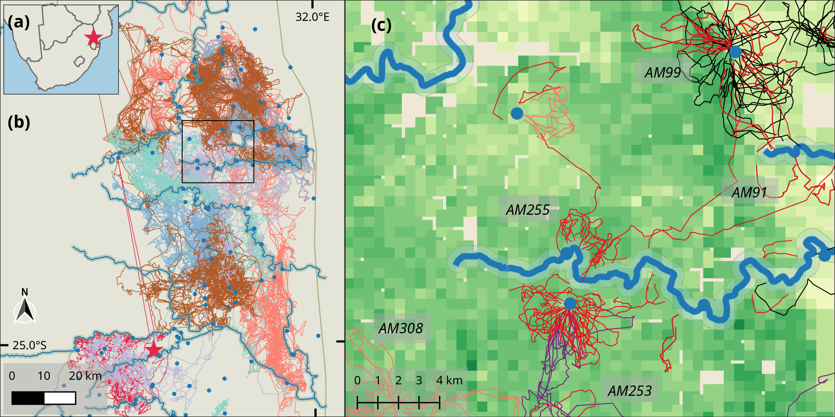

Fig. 1: (a) Study site in Kruger National Park, South Africa (red star), showing (b) park boundary (dashed grey line), weather station at Skukuza (red star), major rivers (solid blue lines), open waterholes (blue dots), and raw elephant tracks (coloured lines, n = 14). (c) Inset showing 12 – 24-hour long track segments between water sources (blue dots and lines), coloured by representative elephant ID (n = 5). The riparian zone along rivers (500m from river centre) is shaded in blue. Green squares in the background represent 2500m2 values of woody density (Bucini *et al.* 2010).

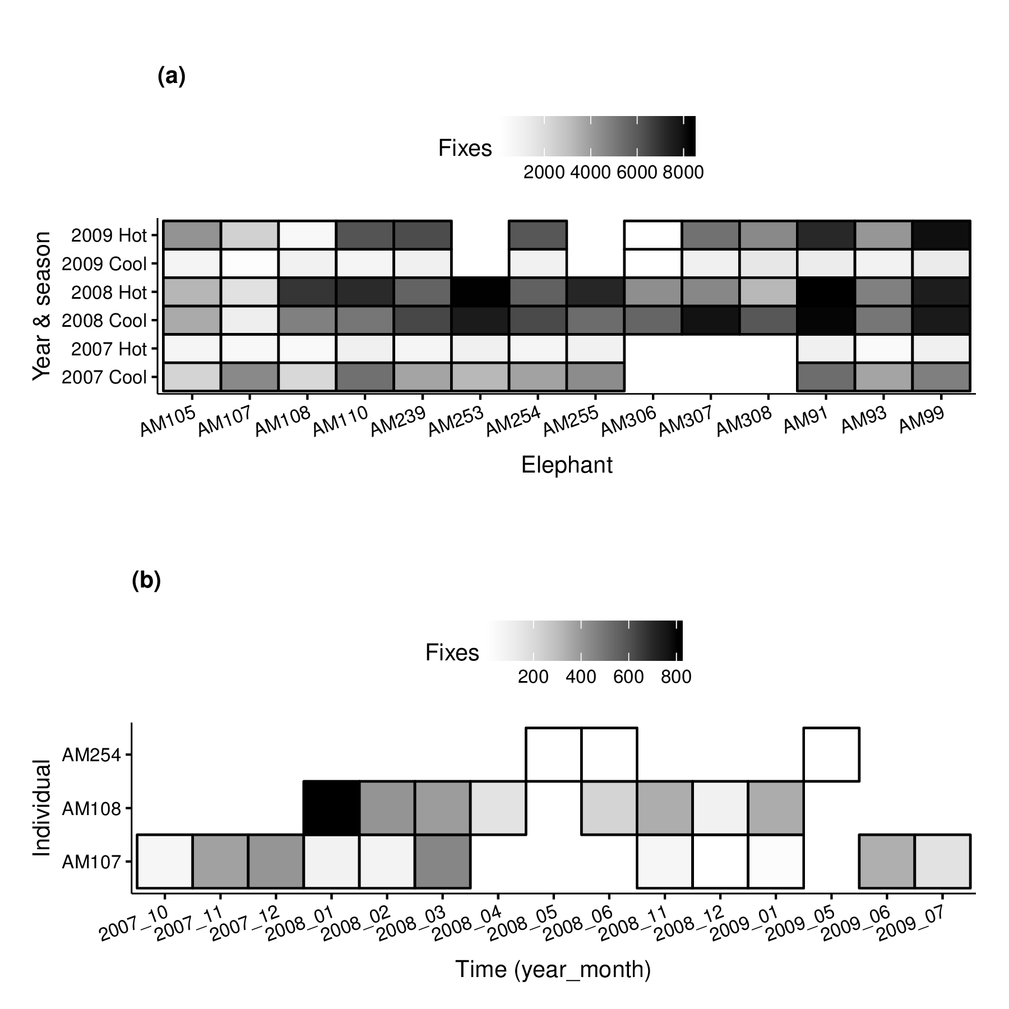  
Fig. 2: (a) Number of fixes per individual (n = 14) per year and season during the tracking period. Lighter boxed correspond to fewer fixes. Fix interval set at 30 minutes. (b) Number of fixes per individual per month of the tracking period withing 10km of the Skukuza weather station. These data were used to test the correlation between thermochron temperatures and ambient temperatures.

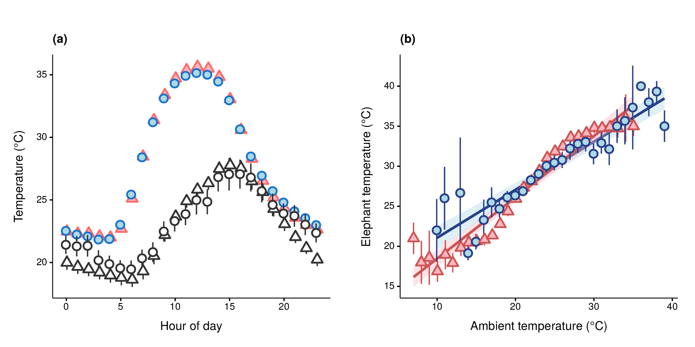  
Fig. 3: (a) Mean thermochron temperature (coloured points: cool-dry = blue, hot-wet = red) and measured ambient temperature (outline points: cool-dry = circles, hot-wet = triangles) at each hour of day in each season across the study period ( and (b) GLM fits (lines) in each season (cool-dry: blue circles & lines, hot-wet: red triangles & lines). Vertical lineranges and shaded areas (coloured by season) indicate 95% confidence intervals at each point.

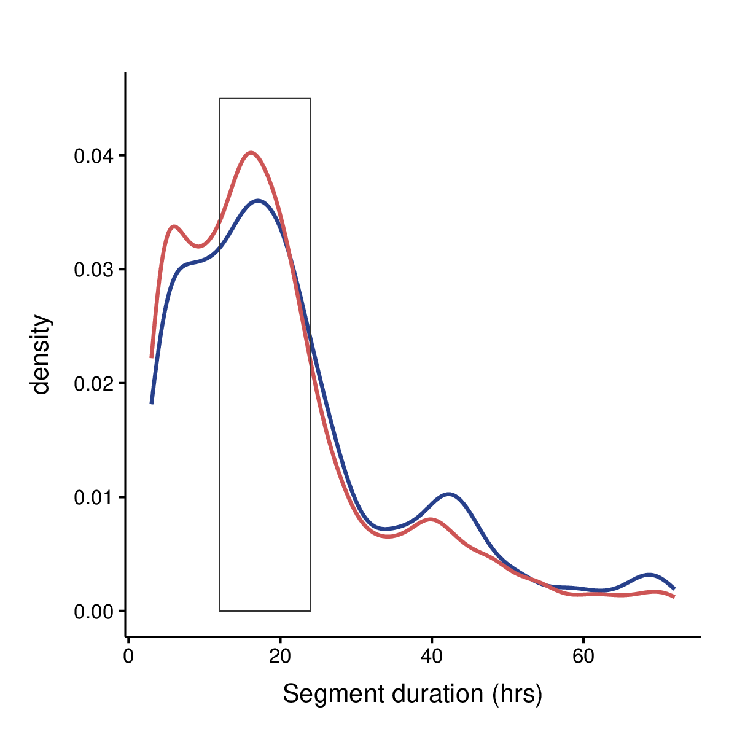

Fig. 4: Density of segment durations (in hours) for segments between water points. Upper and lower limits have been set at 72 and 3 hours, respectively. The rectangle shows the peak representing segments of a duration between 12 and 24 hours.

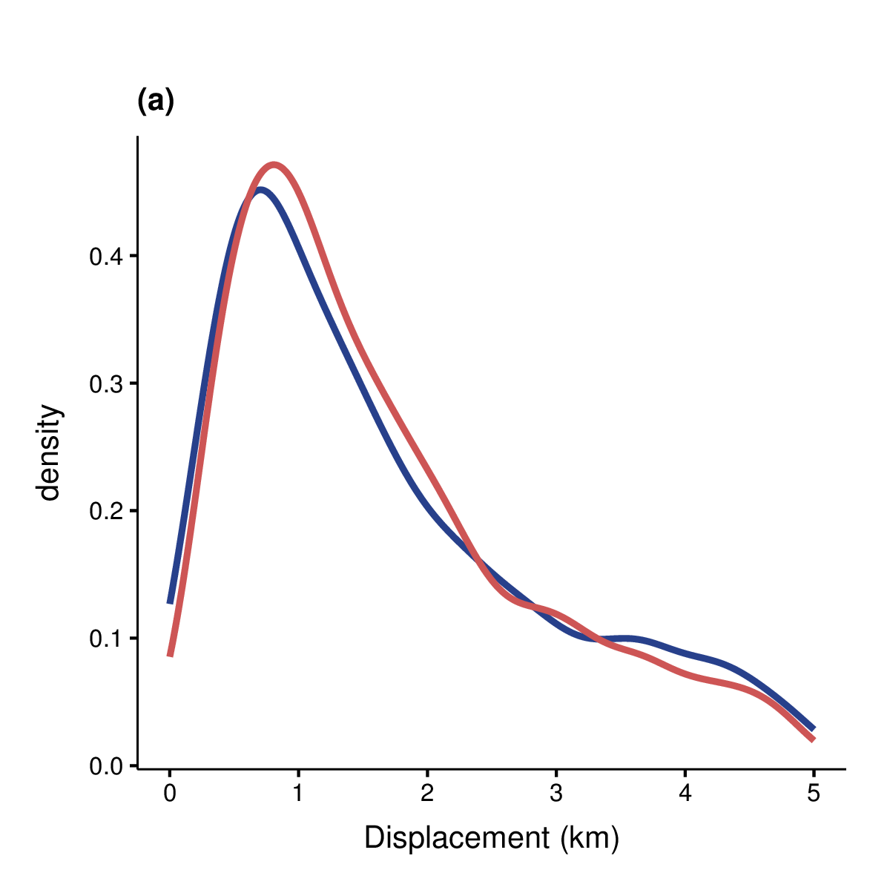  
Fig. 5: Density plot of displacements along 12 -- 24 hour track segments between water points. Elephants return to within 500m of the start of a track around 8% of the time, and to within 1km of the start around 46% of the time.

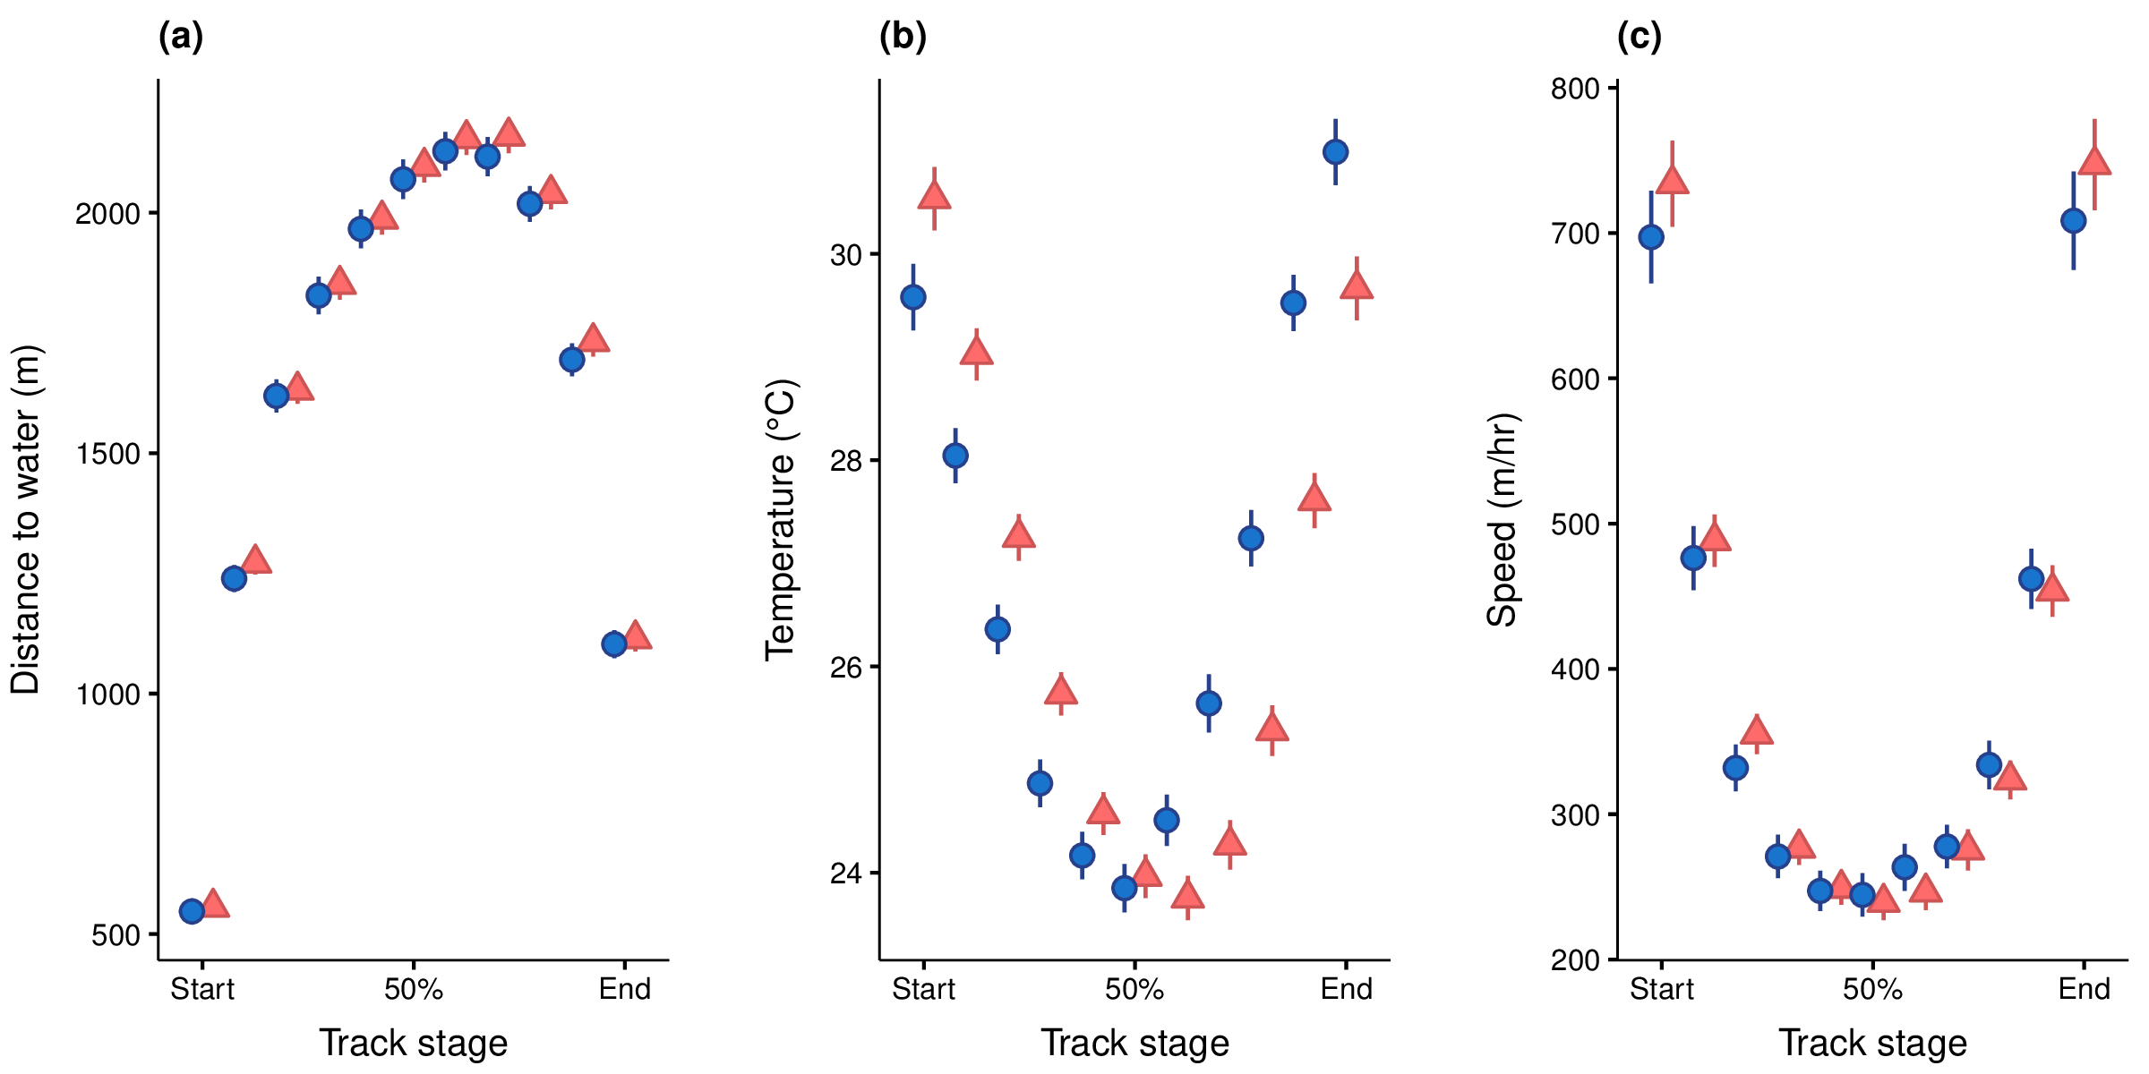

Fig. 6: Elephant variables along a track segment between water points at 10% intervals of a segment: (a) minimum distance to water (in metres), (b) thermochron temperature, and (c) speed (in m/hr). Points are separated by season (cool-dry = blue, hot-wet = red), and offset from each other to avoid overlap.

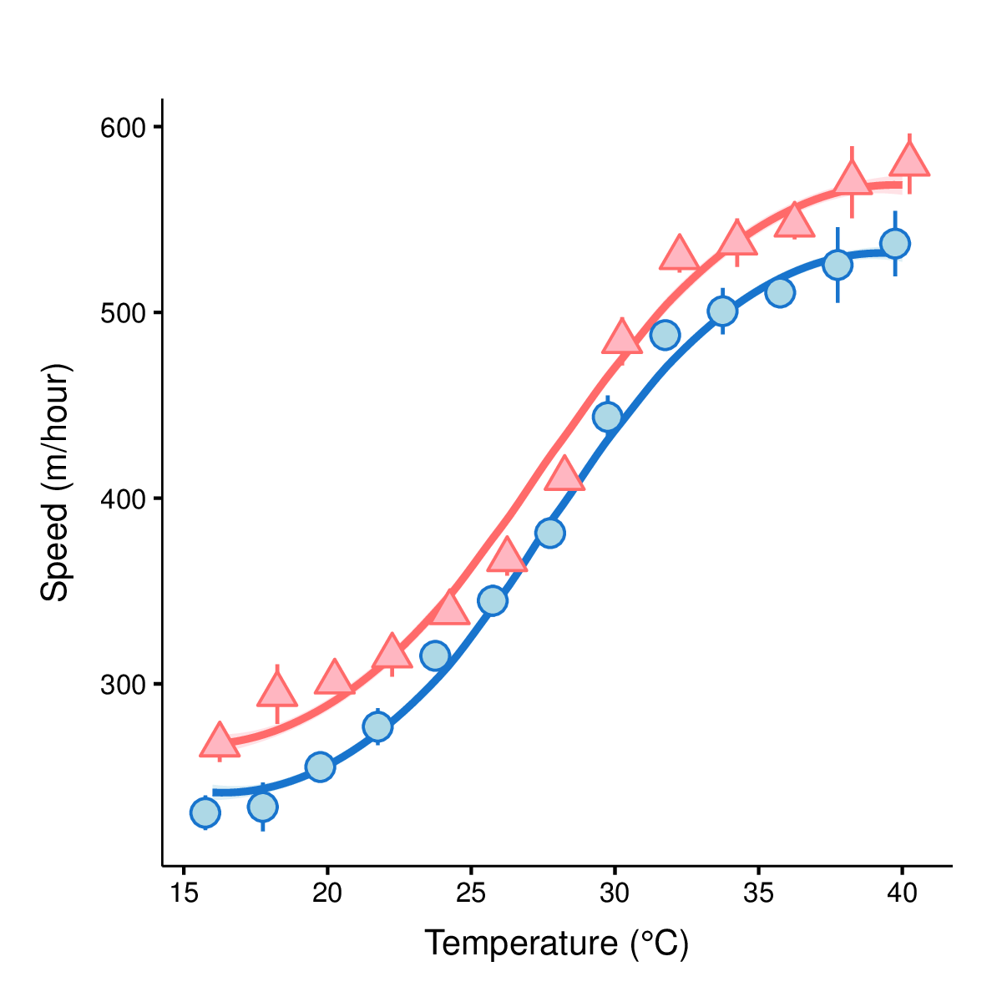

Fig. 8: Elephant speed (points) at 2°C temperature intervals in each season (cool-dry: blue circles,

hot-wet: red triangles). GAMM fit (lines), data error intervals (lineranges), and fit error intervals

(shaded areas) are shown.