
DevSecOps Lab

Submitted by: Submitted to:
Shelly Rajput Dr. Hitesh
500125383
B. tech. CSE (DevOps Batch -2)

Lab Exercise 18- Scanning IaC Templates for Vulnerabilities
Objective
- Learn how to scan Infrastructure as Code (IaC) templates for security vulnerabilities.
- Use open-source IaC security tools to detect misconfigurations.
- Understand common risks such as public access, unencrypted resources, and insecure network rules.

Prerequisites
- A Linux/Windows/Mac machine with:
  - Terraform installed (for sample IaC)
  - Checkov (pip install checkov) or tfsec (brew install tfsec or binary download)
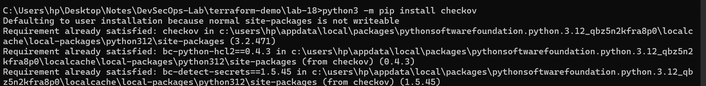
- Git installed (optional, for version control of IaC templates)

Step 1: Create an Insecure IaC Template
Create a file named main.tf with the following Terraform code:
provider "aws" {
region = "us-east-1"
}
resource "aws_s3_bucket" "insecure_bucket" {
bucket = "my-insecure-bucket-lab"
acl = "public-read"
}
resource "aws_security_group" "insecure_sg" {
name = "insecure-sg"
description = "Allow all inbound traffic"
ingress {
from_port = 0
to_port = 65535
protocol = "tcp"
cidr_blocks = ["0.0.0.0/0"]
}
}

Step 2: Scan the Template with Checkov
Run Checkov on the current directory:
checkov -d .
Expected Findings:
- Public S3 bucket access (public-read)
- Security group open to all inbound traffic

Expected Findings:
- Warns about S3 bucket without encryption
- Flags open Security Group rules

Step 4: Review the Report
Example output (Checkov):
Check: CKV_AWS_20: "S3 Bucket allows public read access"
FAILED for resource: aws_s3_bucket.insecure_bucket
Check: CKV_AWS_260: "Security group allows ingress from 0.0.0.0/0"
FAILED for resource: aws_security_group.insecure_sg
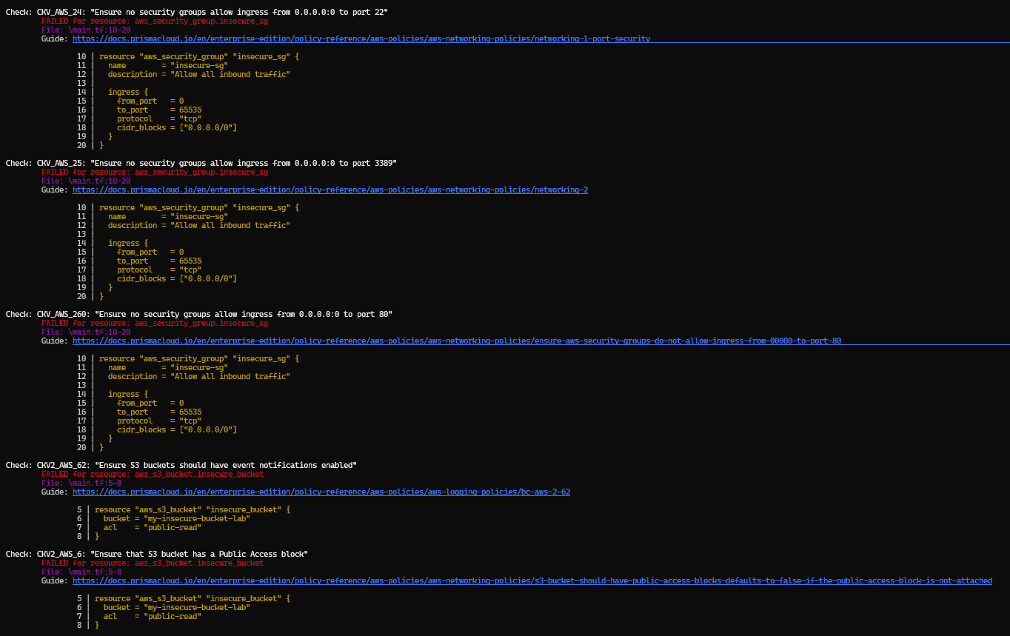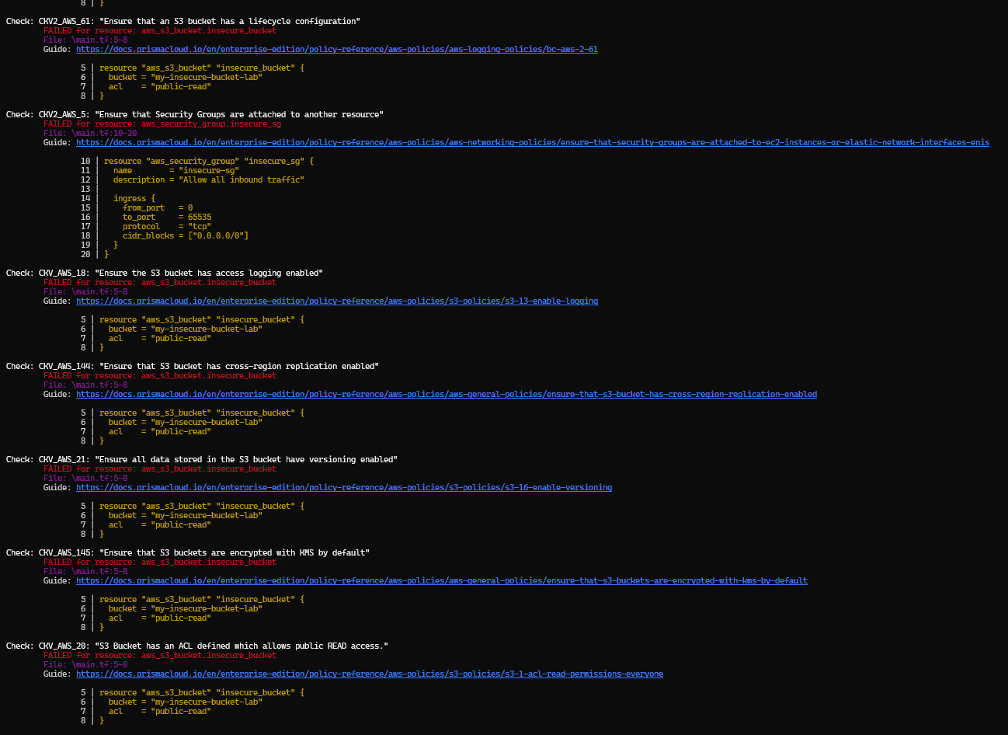

Step 5: Apply Fixes (Optional)
Modify the IaC template to:
- Set S3 bucket ACL to private
- Enable encryption (AES256)
- Restrict Security Group to specific IP ranges
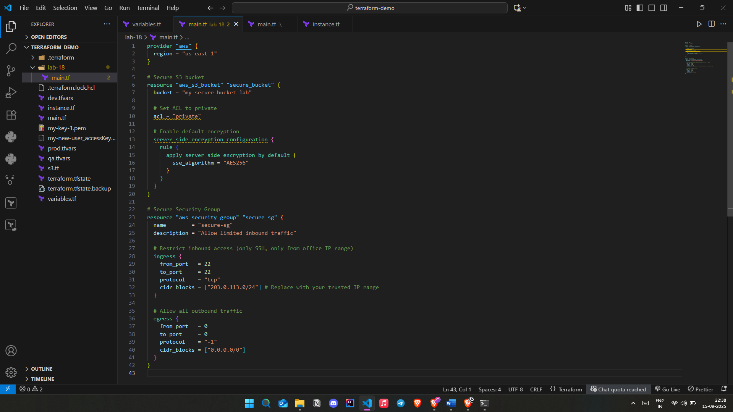

Step 6: Rescan the Template
Run the scan again:
checkov -d .
Now the findings should be resolved or reduced.
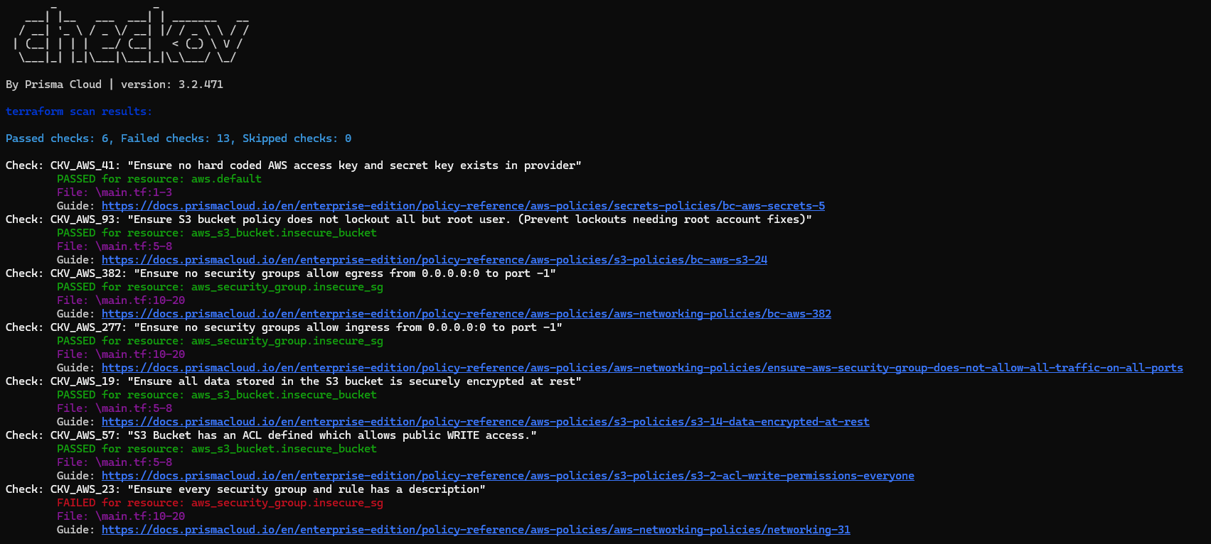

Step 7: Document Findings
Findings Log:
Fixed Vulnerabilities:
ID | Resource | Issue Detected | Risk | Fix Applied
1 | aws_s3_bucket.secure_bucket | S3 bucket ACL was public-read | Public exposure of data | Changed ACL to private
2 | aws_s3_bucket.secure_bucket | No encryption configured | Data at rest not protected | Enabled AES256 server-side encryption
3 | aws_security_group.secure_sg | Ingress allowed 0.0.0.0/0 on all TCP ports | Full internet exposure (critical risk) | Restricted ingress to specific CIDR (203.0.113.0/24) and limited to port 22 (SSH)

Remaining Issues:
Check ID | Description |  | Status | Notes
CKV_AWS_23 |  | Missing SG rule descriptions | ❌ Failed | Add descriptions to each rule
CKV_AWS_382 |  | SG allows egress 0.0.0.0/0 on all ports | ❌ Failed | Restrict egress to only required destinations
CKV2_AWS_5 |  | SG not attached to a resource | ❌ Failed | Attach SG to EC2 or relevant resource
CKV_AWS_18 |  | S3 bucket logging not enabled | ❌ Failed | Enable server access logging
CKV_AWS_21 |  | S3 bucket versioning not enabled | ❌ Failed | Enable versioning for recovery
CKV2_AWS_6 |  | No public access block on S3 bucket | ❌ Failed | Add aws_s3_bucket_public_access_block resource
CKV2_AWS_61 |  | No lifecycle configuration on S3 bucket | ❌ Failed | Add lifecycle rules for storage classes
CKV_AWS_145 |  | S3 not using KMS encryption | ❌ Failed | Switch from AES256 to KMS CMK
CKV_AWS_144 |  | No cross-region replication configured | ❌ Failed | Configure replication if needed
CKV2_AWS_62 |  | No event notifications configured | ❌ Failed | Add event notification configuration

