Lab Exercise 18- Scanning IaC Templates for Vulnerabilities

Name- Parthib Halder
SAP ID- 500126084
Batch-

Objective

- Learn how to scan Infrastructure as Code (IaC) templates for security vulnerabilities.

- Use open-source IaC security tools to detect misconfigurations.

- Understand common risks such as public access, unencrypted resources, and insecure network rules.

Step 1: Create an Insecure IaC Template

Create a file named main.tf with the following Terraform code:

provider "aws" { region = "us-east-1"
}

resource "aws_s3_bucket" "insecure_bucket" { bucket = "my-insecure-bucket-lab"
acl = "public-read"

}

resource "aws_security_group" "insecure_sg" { name = "insecure-sg"
description = "Allow all inbound traffic" ingress {
from_port = 0

to_port = 65535 protocol = "tcp" cidr_blocks = ["0.0.0.0/0"]
}

}

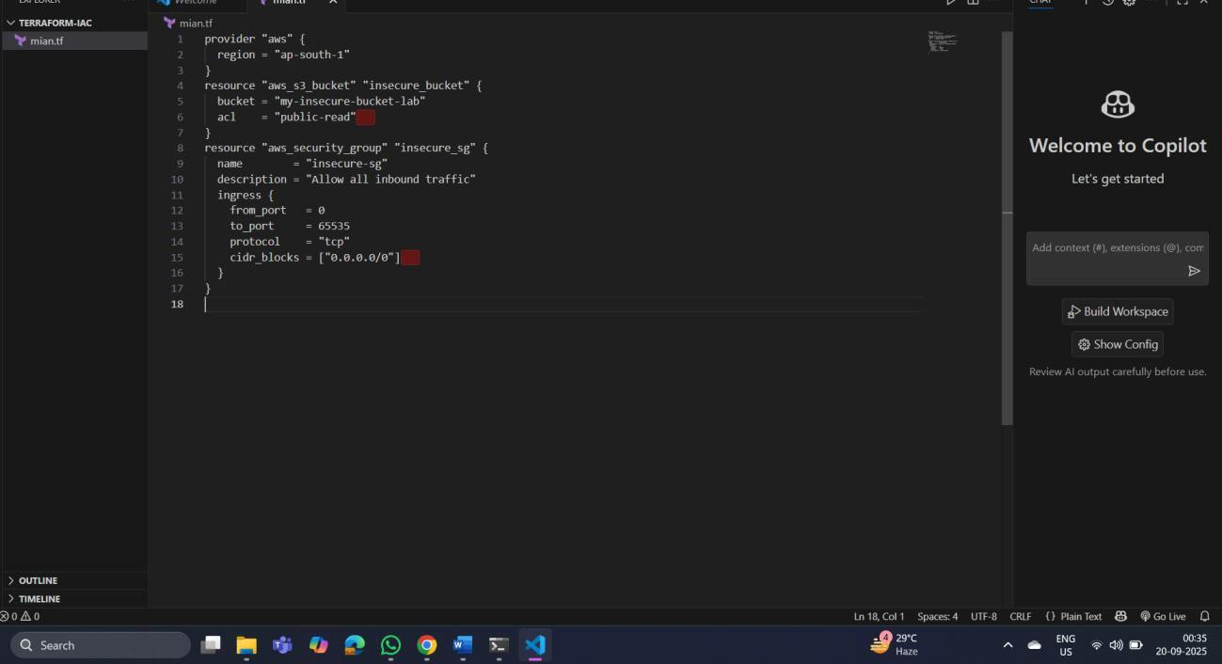

Step 2: Scan the Template with Checkov

Run Checkov on the current directory:

checkov -d .

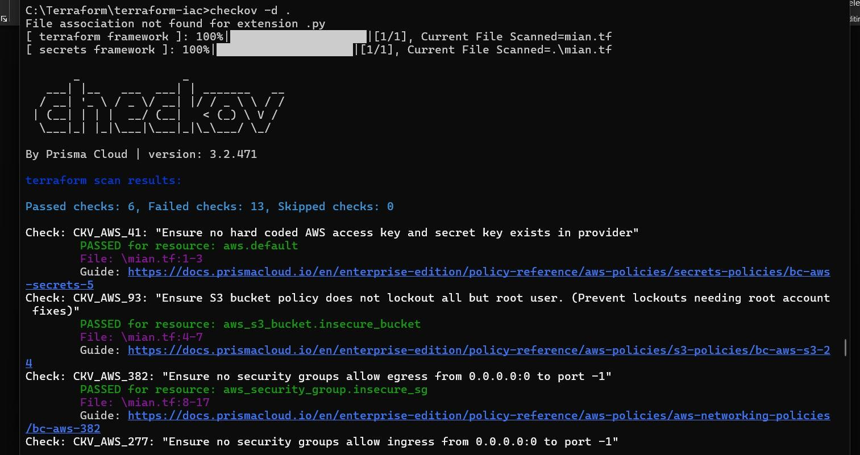

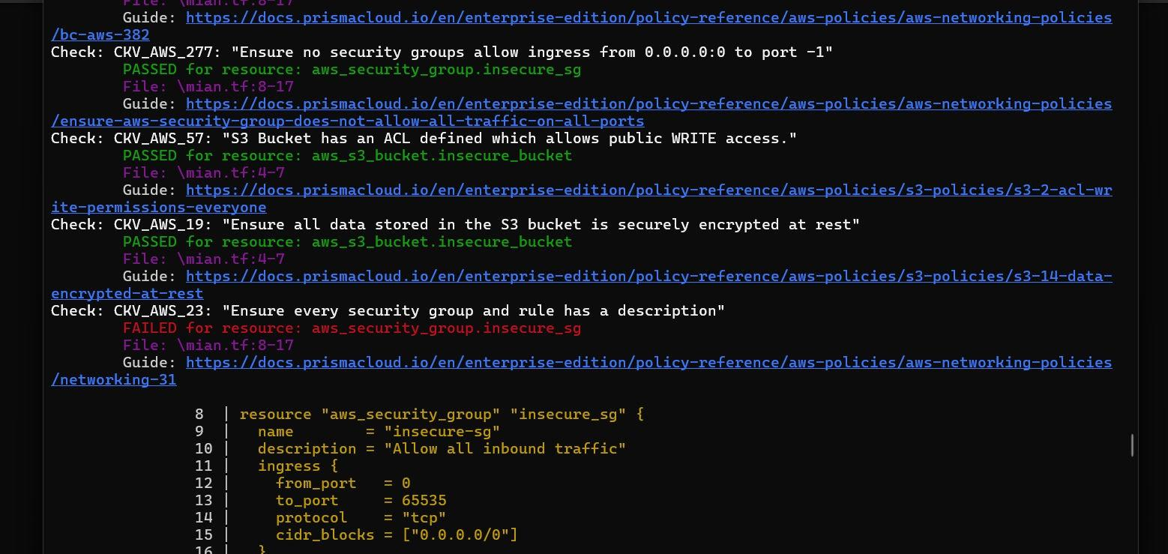

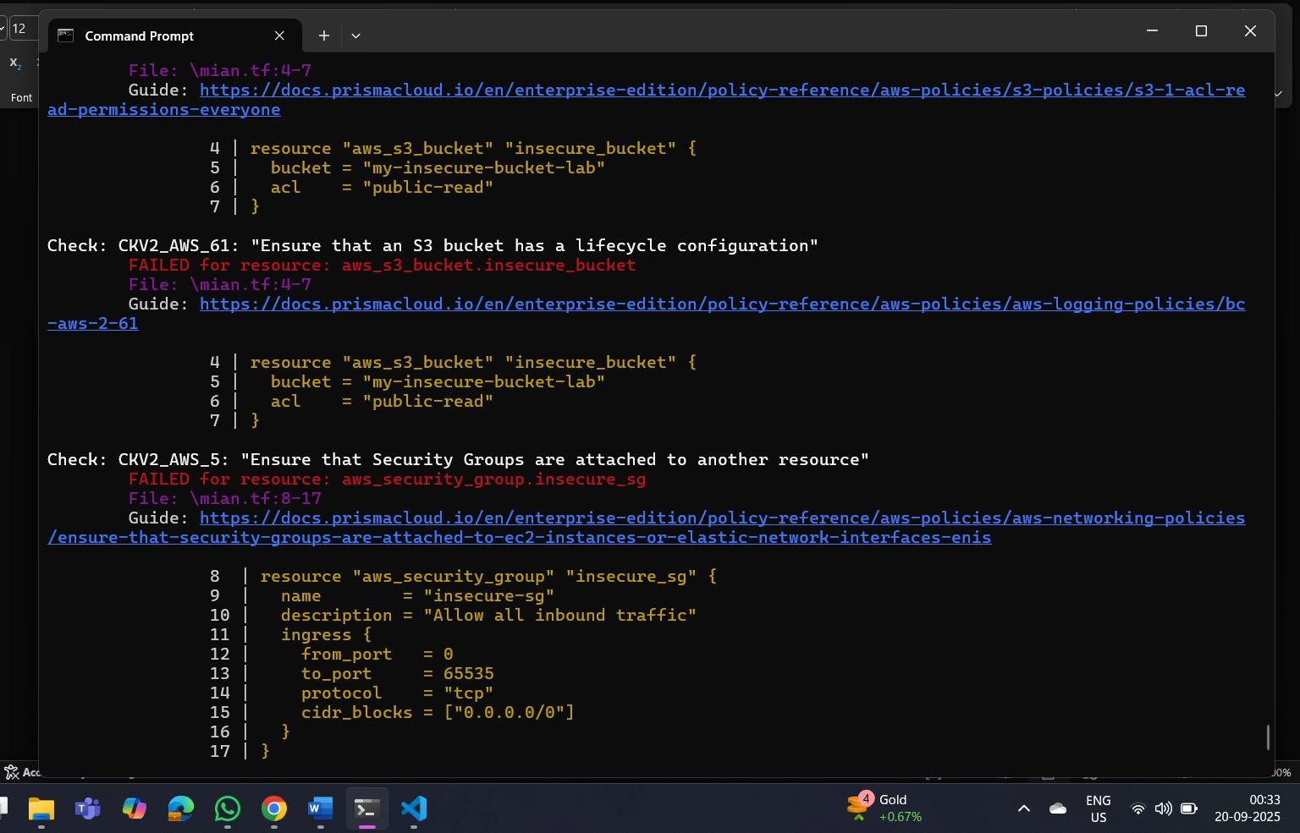

Expected Findings:

- Public S3 bucket access (public-read)

- Security group open to all inbound traffic

Expected Findings:

- Warns about S3 bucket without encryption

- Flags open Security Group rules

Step 4: Review the Report

Example output (Checkov):

Check: CKV_AWS_20: "S3 Bucket allows public read access" FAILED for resource: aws_s3_bucket.insecure_bucket
Check: CKV_AWS_260: "Security group allows ingress from 0.0.0.0/0"

FAILED for resource: aws_security_group.insecure_sg

Step 5: Apply Fixes (Optional)

Modify the IaC template to:

  - Set S3 bucket ACL to private

  - Enable encryption (AES256)

  - Restrict Security Group to specific IP ranges

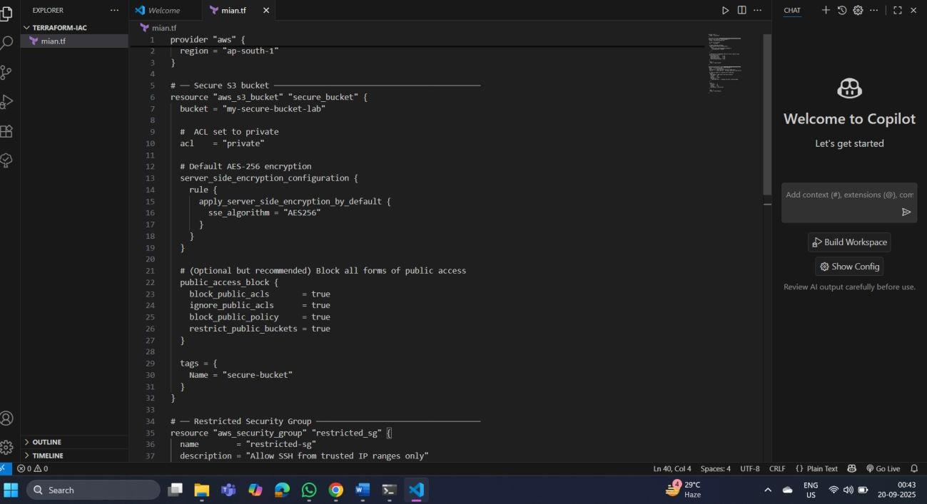

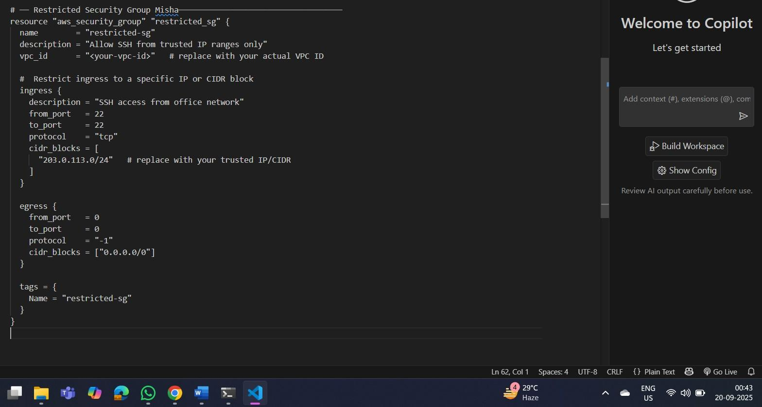

Step 6: Rescan the Template

Run the scan again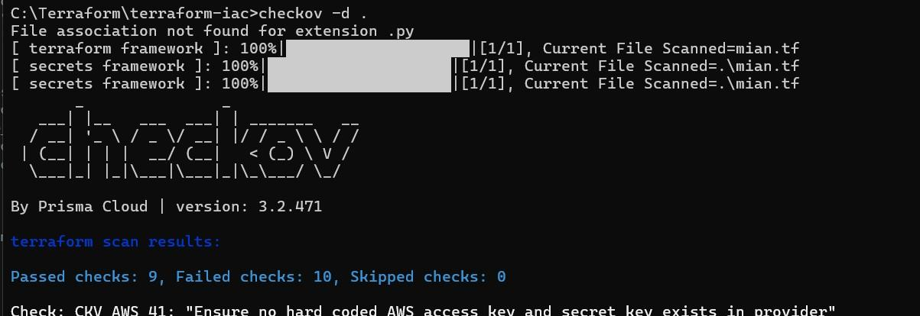:
Now the findings should be resolved or reduced.

Step 7: Document Findingss

Create a simple findings log:

Before the securing, terraform scan results

Passed checks: 6, Failed checks: 13, Skipped checks: 0

After securing- terraform scan results:
Passed checks: 9, Failed checks: 10, Skipped checks: The number of failed test checks reduced,.

