**Nurse Profile Data Entry Instructions**

1. TravelRN_INSERTNAME_Profile = #1 priority profiles to create
   1. Travel RNs may have multiple specialties
   2. Look in the Certifications section or Top Skills section to identify all of the specialties for the Travel RN
   3. Geographic Preference for Travel RNs = NATIONAL
2. Primary specialty = 1st word in file name (e.g., CriticalCare_JaneDoe_Profile)
3. Multiple specialties = please include all specialties listed in the profile. If a nurse has the following certifications, please include the appropriate specialties

|  |  |
| --- | --- |
| Certification | Specialty |
| CEN (Certified Emergency Room Nurse) | Emergency Room (ER) |
| CCRN (Certified Critical Care Registered Nurse) | Critical Care (ICU) |
| CNOR (Certified Perioperative Nurse) | Operating Room (OR) |
| CMSRN (Certified Medical Surgical RN) | Medical / Surgical / Telemetry (MST) |
| CPN (Certified Pediatric Nurse) | Pediatrics / PICU |
|  |  |
|  |  |

1. Geography Preference = all profiles should be set up as “Within 25 miles”
2. Education Acronyms and Guidance
   1. DNP = Doctor of Nurse Practice (Highest nursing degree)
   2. FNP = Family Nurse Practitioner (2nd highest nursing degree)
   3. MSN = Masters of Science Nursing (3rd highest nursing degree)
   4. BSN = Bachelors of Science Nursing (4th highest nursing degree)
   5. ADN = Associates Degree in Nursing (5th highest nursing degree)
   6. LVN/LPN = Licensed Vocational Nurse / Licensed Practical Nurse (Lowest nursing degree)
3. Years of Experience
   1. Look in the Education section of the profile to see when they received their earliest nursing degree
   2. Take the whole number of years between the date of their earliest nursing degree and 2020
   3. If their profile does not include the date when they received their nursing degree, use their first nursing job in the Experience section
4. Specialties for “Nurse Managers”
   1. All of the files saved as “NurseMgr_[NAME]_Profile” may have multiple specialties
   2. Please include all specialties that apply
   3. Please see the table below for keywords that align with specific specialties

|  |  |
| --- | --- |
| Specialty | Additional Acronyms & Keywords |
| Emergency Room (ER) | ER, ED, FSED |
| Critical Care (ICU) | CVICU, Neuro ICU, Intermediate Care, Intensive Care |
| Operating Room (OR) | Surgical Services, Surgery Dept., ASC, Ambulatory Surgery Center, Surgery Center |
| Medical / Surgical / Telemetry (MST) | MedSurg, Tele, |
| Pediatrics / PICU | CPN, Pedi, Pediatric Intensive Care Unit, Peds |
|  |  |
|  |  |

1. Leadership roles for “Nurse Managers”
   1. All “Nurse Managers” should have profiles that say “Yes” on the question “Are you interested in serving as a nurse leader?”
   2. Please select all roles that the Nurse Manager has on the profile

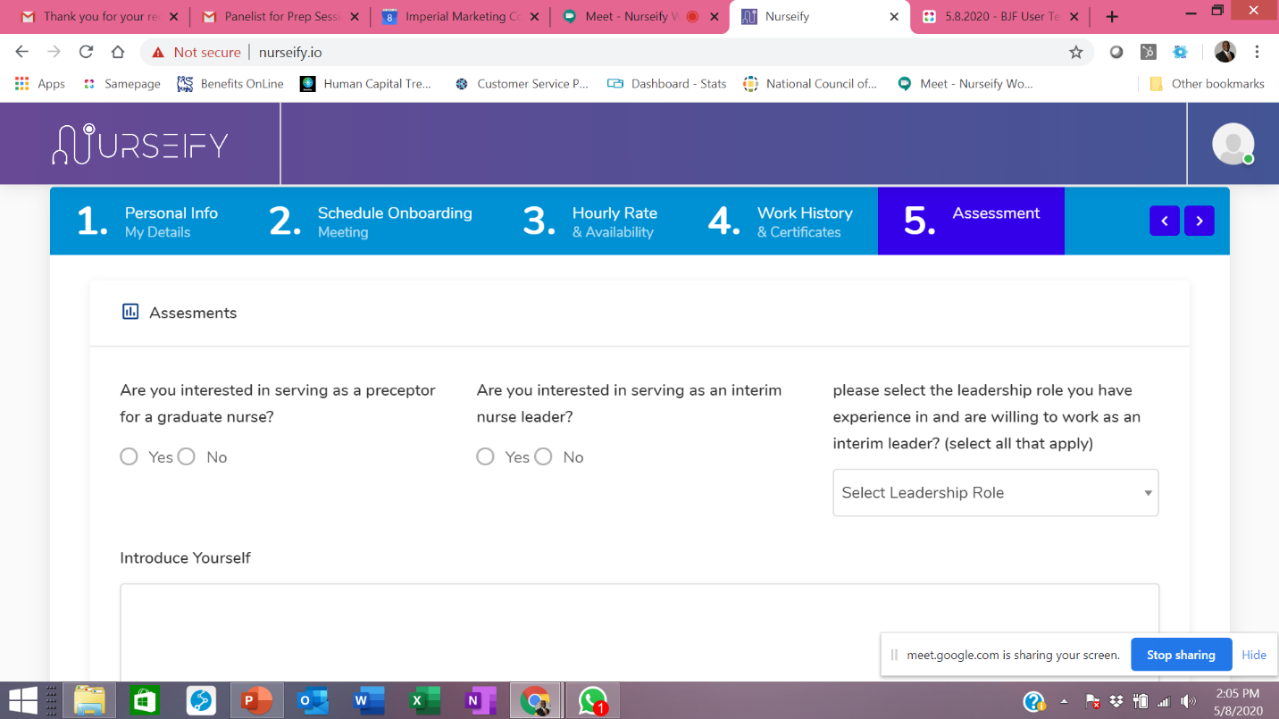

1. **Introduce Yourself** – Please use the LinkedIn SUMMARY section to fill in the Introduce Yourself section on Nurseify (see screenshot from #7 above)

Thoughts on the following sequencing for the speakeasy…

1. Finish staining / polishing the floor
2. Finish polishing marble counters
3. Finish electrical wiring for HVAC, existing outlets, and light fixtures (includes adding 6 external recessed lights)
4. Install 4-ton HVAC
5. Finish plumbing installation (install bathroom sinks, front bar sinks, and 3-basin sink in the kitchen)
6. Clean walls, ceilings, and floors to remove all dust
7. Paint main chandelier gold and pendant lights above the front bar gold
8. Install bathroom light fixtures, bathroom fans, and main chandelier
9. Install appliances (e.g., refrigerators, icemaker)
10. Move in furniture