Part 1: Getting Free Sepolia ETH

Step 1: Enable Test Networks & Step 2: Switch to Sepolia: First, you need to open your MetaMask wallet and go to the "Manage networks" section. From there, make sure the "Show test networks" toggle is turned on. Then, select "Sepolia" from the list of test networks.

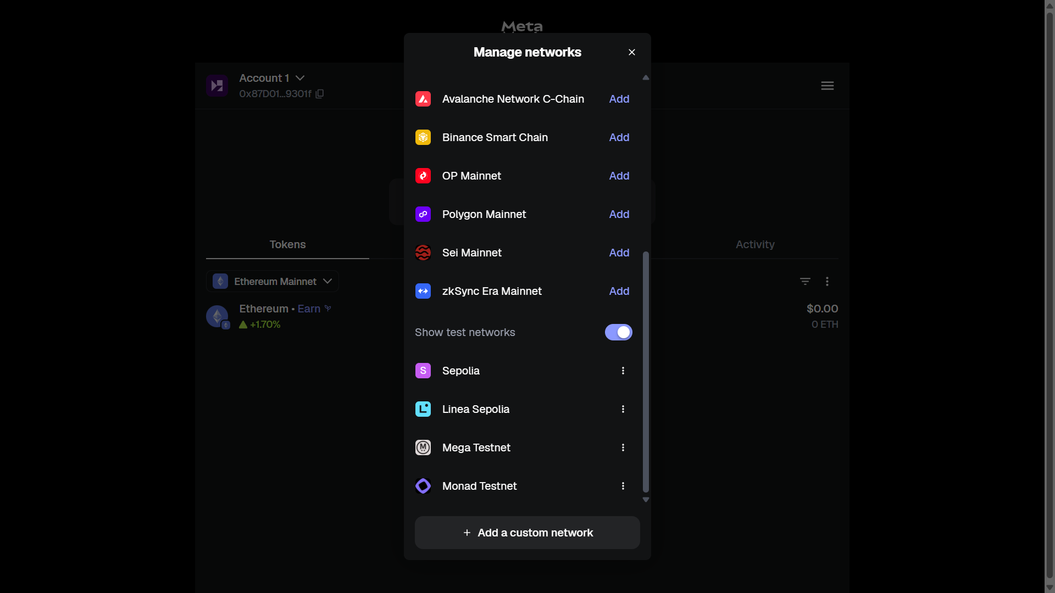
Step 3: Get Your Sepolia Wallet Address In your MetaMask wallet, copy your wallet address, which is the long string of characters starting with "0x" located under your account name.
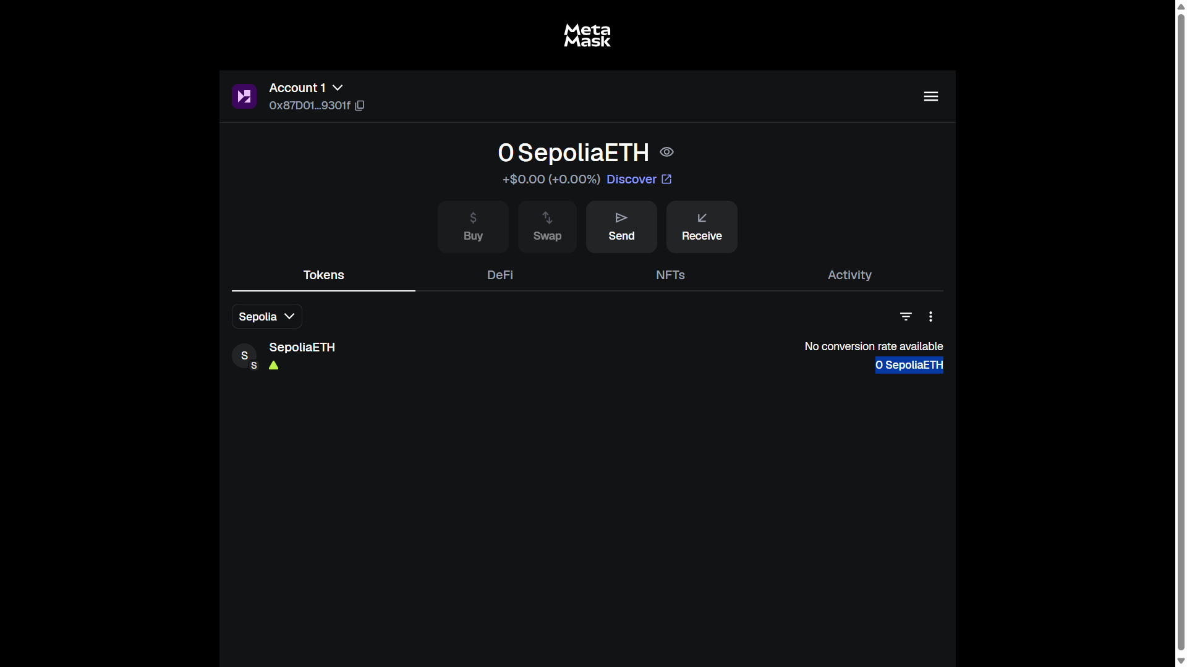

Step 4: Get Free Sepolia ETH from a Faucet Go to the Google Cloud Sepolia Faucet website. Paste your wallet address into the required field and click the button to receive 0.05 Sepolia ETH.
You will see a confirmation message once the transaction is complete.

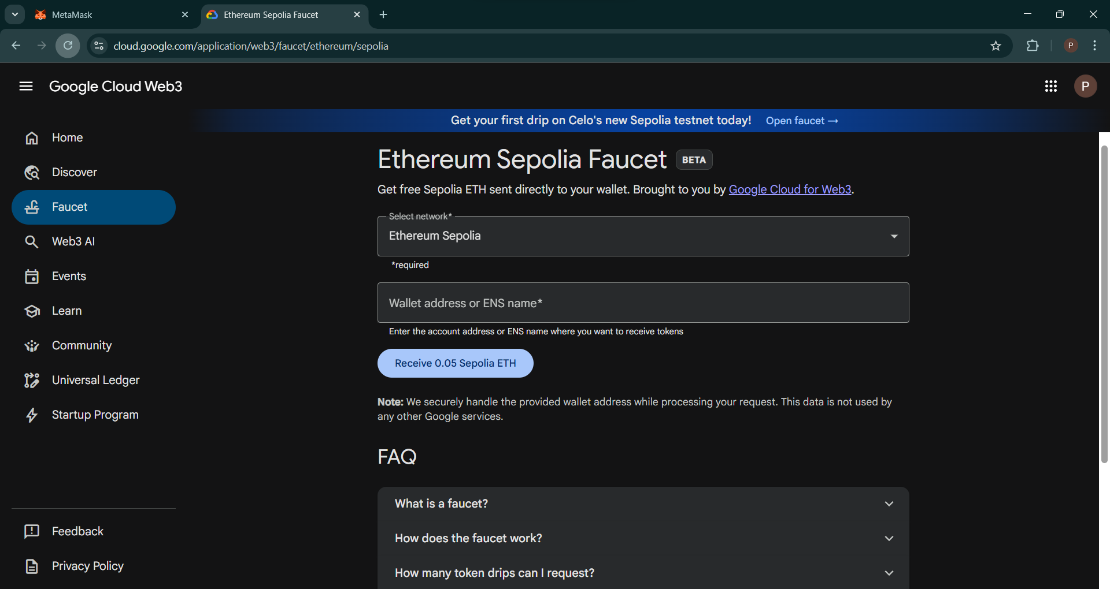

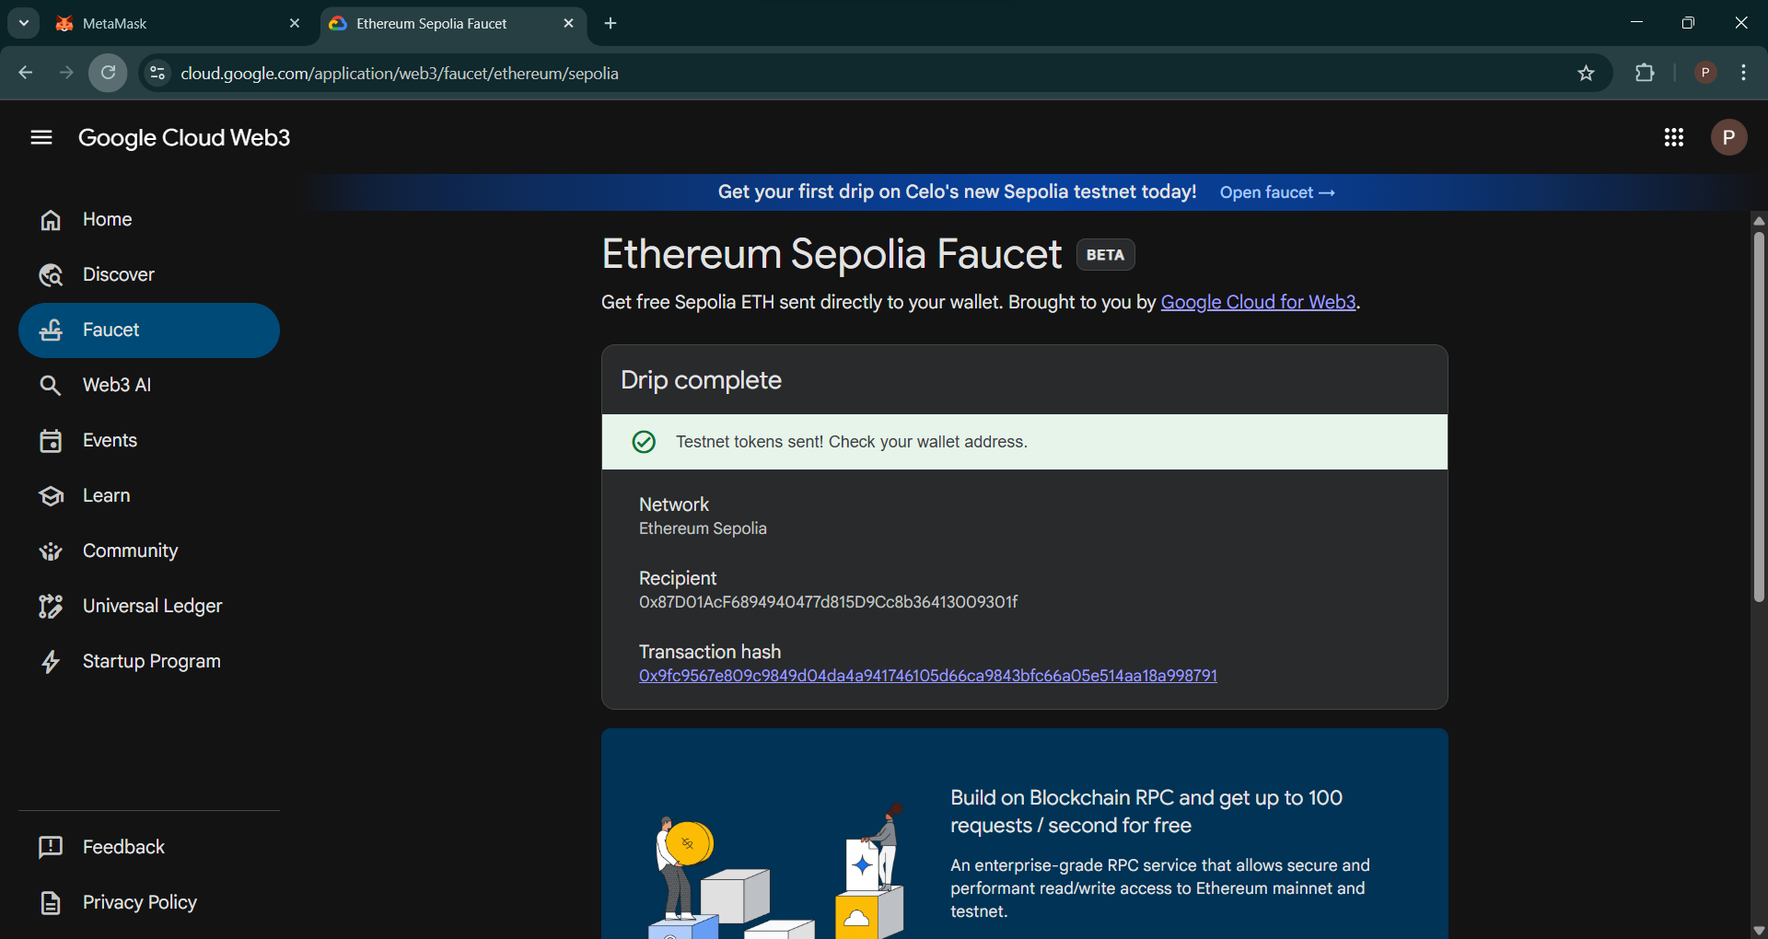

Step 5: Confirm the ETH is in Your Wallet Go back to your MetaMask wallet. You should now see a balance of 0.05 SepoliaETH.

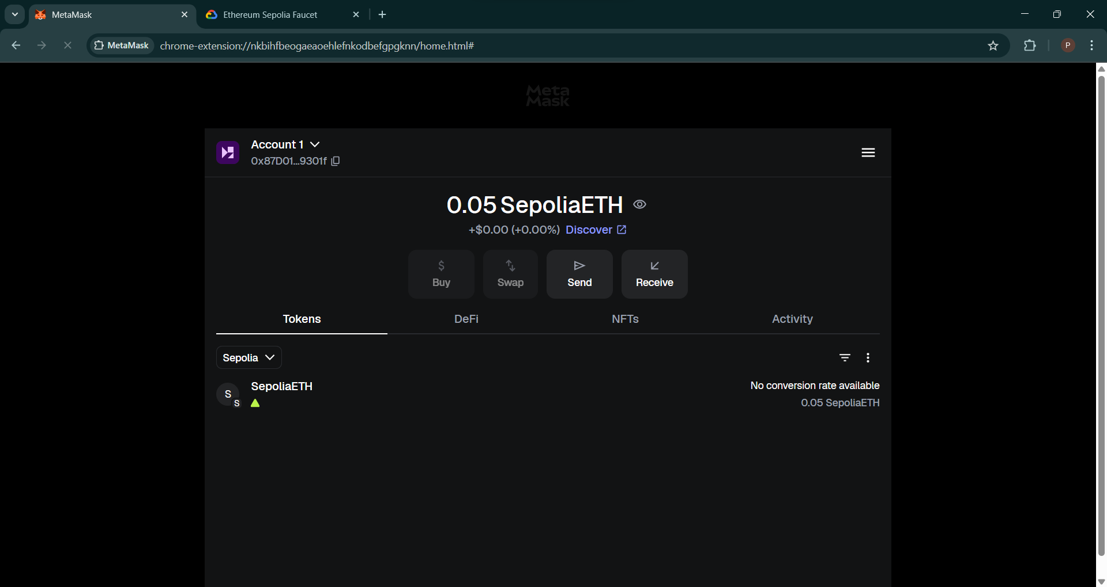

Part 2: Transferring Sepolia ETH

Step 6: Start the Transfer From your MetaMask wallet, click the "Send" button. Paste the recipient's wallet address in the "To" field and enter the amount you want to send. Click "Continue"

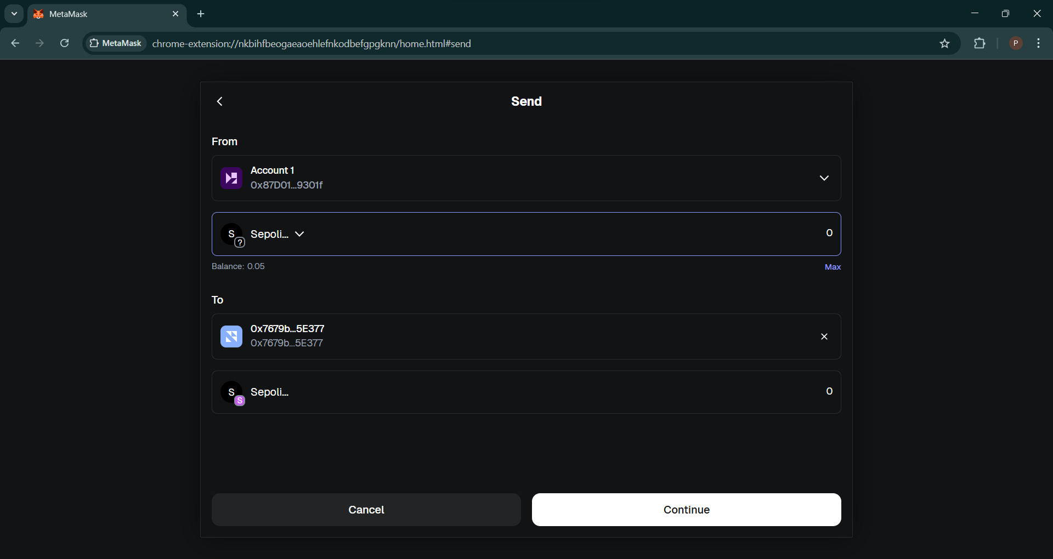

Step 7: Review and Confirm the Transaction A screen will appear for you to review the transaction details, including the amount (0.03 SepoliaETH in this example) and network fee. If everything is correct, click "Confirm".

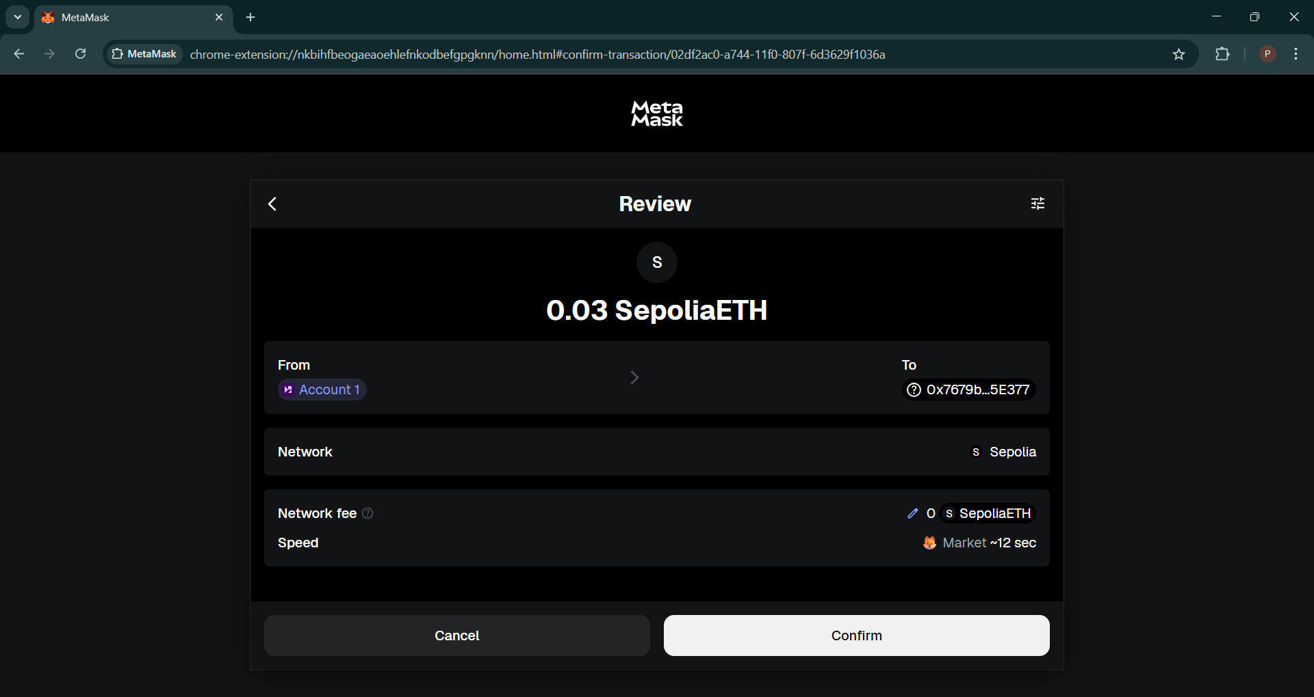

Step 8: Check Final Balances After the transaction is confirmed, the sender's balance will be updated to 0.02 SepoliaETH. The transaction will also appear in the "Activity" tab.
The receiver's wallet will now show the received amount, with their new balance being 0.08 SepoliaETH.
Receivers balance after Transaction :

