TEST AUTOMATION PROJECT REPORT
Ixigo Flight Booking Automation - BDD
Behavior Driven Development with Behave, Gherkin, Selenium WebDriver, POM, Allure and custom HTML reporting
Prepared for: Capstone testing project submission
Application under test: ixigo flight booking web journey
Test design approach: Behavior Driven Development using Gherkin scenarios
BDD framework: Behave feature files with Selenium-backed step definitions
Automation pattern: Page Object Model for browser/page actions
Execution browser: Microsoft Edge or Chrome, selected by environment hook
Report date: 23 May 2026
Behaviour coverage: 24 BDD scenarios across combined flow and full end-to-end booking flow

Source basis: This document is based on the current BDD code: feature files, step definitions, hooks, configuration, data files and the latest screenshots under logs. It is not copied from the README.

1. Synopsis
This project converts the ixigo Selenium automation into a BDD-style Behave framework. The tested behaviour remains the same: search flights, validate results, apply filter and sort actions, handle invalid search input, move into booking, enter traveller details, pass through add-ons and reach the payment page. The difference is in how the test intent is expressed. Instead of only Python test methods, the BDD version presents the flow through readable Gherkin scenarios and keeps the Selenium work inside step definitions.
The structure is deliberately close to the Selenium project so the evaluator can see that the framework changed while the business journey stayed consistent. The BDD code has two feature files and two step-definition folders: one for the combined flow and one for the richer full end-to-end booking flow.
Framework layers: BDD is the test design approach, Behave is the Python runner for Gherkin feature files, Selenium WebDriver controls the browser, and Page Object Model keeps page actions separate from BDD steps.

2. Project Scope
- Represent the major ixigo user behaviours in Gherkin using Given, When and Then steps.
- Keep assertions inside step definitions so each Then step validates a real browser state.
- Reuse the Page Object Model for browser interaction rather than placing Selenium locators in feature files.
- Run the combined search, negative and booking smoke checks separately from the full E2E booking flow.
- Capture screenshots during important actions and after each scenario for evidence.
- Generate Allure result files and a custom local HTML report after the Behave run.

3. BDD Architecture
The code uses BDD and POM together. BDD describes the expected behaviour in feature files; POM organises the Selenium implementation behind those steps. This means the evaluator can read the scenario intent without seeing locators, while the automation code remains maintainable.
Layer | Actual code location | Responsibility
Feature files | features/combined_flow.feature, features/e2e_full_booking.feature | Define behaviours in readable Gherkin language.
Combined steps | features/steps/combined_flow_steps/combined_steps.py | Search, result validation, filter, sort, negative scenarios and booking smoke checks.
E2E steps | features/steps/e2e_full_booking_steps/e2e_steps.py | Login, traveller details, add-ons, seat selection and payment checks.
Hooks | features/environment.py | Browser lifecycle, report cleanup, screenshots, HTML report generation and Allure opening.
Page objects | pages/ | Encapsulate Selenium interactions for search, results, booking, add-ons, payment and login.
Data/utilities | data/, utils/ | CSV test data, route reading, config reading, logging and screenshot capture.

4. Behaviour Files
The BDD project has two feature files. The combined feature checks the smaller behaviours that would normally be reviewed as separate regression checks. The full end-to-end feature keeps the booking journey in order so it looks like the Selenium E2E flow, but described as business behaviour.
Feature | Scenario count | Main behaviours
Ixigo combined flow | 9 | Open page, verify controls, search BOM to BLR, verify book buttons, filter/sort, print results, invalid source/destination, missing destination and booking-page smoke flow.
Ixigo full end-to-end booking | 15 | Open site, login, search random CSV route, filter, sort, print results, book, booking page, cancellation prompt, traveller details, add-ons, seat selection, skip to payment and payment page.

5. Assertion Strategy
The feature files are intentionally readable and do not contain Python assertions. The assertions are implemented in the step-definition files, which is the normal Behave pattern. The Gherkin says what should happen; the Python step code proves it using Selenium and page objects.
Action checkpoints: A few E2E scenarios are action checkpoints because the browser session is shared across the feature. For example, Click book is followed by Booking page, and Skip to payment is followed by Payment page. The validation is still present, but it is placed in the next Then scenario to preserve the Selenium-style ordered flow.

BDD check | Where it is asserted | Validation performed
Page loaded | combined_steps.py | Browser title contains ixigo.
Search controls visible | combined_steps.py | From, To and Search elements are present.
Matching results displayed | combined_steps.py | Results load and flight count is greater than zero.
Visible flights remain | combined_steps.py | Flight cards and Book buttons are visible.
Prices sorted | combined_steps.py | First visible prices are in ascending order when prices are parsed.
Booking page displayed | combined_steps.py | Booking URL or traveller/contact content is detected.
Traveller form filled | e2e_steps.py | CSV traveller details are entered and form fill returns true.
Payment page displayed | e2e_steps.py | Payment page wait condition returns true.
Negative route checks | combined_steps.py | Invalid route does not navigate to accepted result URL.

6. Execution Design
The hook file starts one browser per feature, matching the Selenium-style ordered flow. Scenarios tagged as isolated can still use their own browser, which keeps negative checks from damaging the main journey. Before every run, report folders and logs are cleaned so the output represents the latest execution.
- Nested step modules are enabled in behave.ini, so Behave loads both step-definition folders directly.
- The default formatter writes Allure result files to reports/allure-results.
- environment.py patches Allure behaviour labels, builds a custom HTML report and opens it after execution.
- If the Allure CLI is unavailable, the local HTML report still opens and the test run does not fail because of reporting.
- Screenshots are captured both during key actions and at scenario completion.

7. Test Environment
Area | Details
Language | Python
Test design approach | Behavior Driven Development with Given, When and Then scenarios
BDD framework / runner | Behave
Browser automation tool | Selenium WebDriver
Automation design pattern | Page Object Model
Step discovery | Nested step modules enabled in behave.ini
Reports | Allure result files, generated Allure report when CLI is installed, and custom report.html
Browser | Configured browser with Edge/Chrome fallback in environment.py
Data | CSV files for route, login and traveller input

8. BDD Scenario Summary
Coverage: The current BDD code defines 24 scenarios: 9 combined-flow behaviours and 15 full end-to-end booking behaviours. Recent screenshots in logs show the latest successful visual evidence from this run.

No. | Feature | Scenario | BDD validation | Status
1 | Combined | Open ixigo page | Then page title confirms ixigo loaded | Passed
2 | Combined | Page elements are present | Then From, To and Search controls are visible | Passed
3 | Combined | Search BOM to BLR flights | Then matching results and visible flights remain | Passed
4 | Combined | Flight count and book buttons | Then flights and at least two Book buttons are visible | Passed
5 | Combined | Apply nonstop filter and sort by price | Then flights remain and parsed prices are sorted | Passed
6 | Combined | Print flight results | Then at least one result remains | Passed
7 | Combined | Same source and destination | Then bom-bom route is not accepted | Passed
8 | Combined | Search without destination | Then user remains off results page | Passed
9 | Combined | Booking flow reaches traveller details | Then booking page is displayed after booking action | Passed
10 | E2E | Open site | Then ixigo page should be loaded | Passed
11 | E2E | Login | When mobile row is submitted and OTP wait completes | Passed
12 | E2E | Search flights | Then matching flight results are displayed | Passed
13 | E2E | Apply nonstop filter | Then at least one visible flight remains | Passed
14 | E2E | Sort by price | Then at least one visible flight remains | Passed
15 | E2E | Print results | Then at least one visible flight remains | Passed
16 | E2E | Click book | When first visible flight is booked | Passed
17 | E2E | Booking page | Then booking page should be displayed | Passed
18 | E2E | Decline cancellation | When cancellation prompt is declined | Passed
19 | E2E | Fill traveller | Then traveller form fill assertion passes | Passed
20 | E2E | Continue and confirm | When details are continued and confirmed | Passed
21 | E2E | Add-ons page | Then add-ons page should be displayed | Passed
22 | E2E | Select seat | When a seat is selected if available | Passed
23 | E2E | Skip to payment | When add-ons are skipped to payment | Passed
24 | E2E | Payment page | Then payment page should be displayed | Passed

9. Screenshot Evidence
The screenshots below are selected from the latest BDD run artifacts under logs. They are arranged in journey order so the report reads like the actual behaviour flow rather than a random screenshot dump.
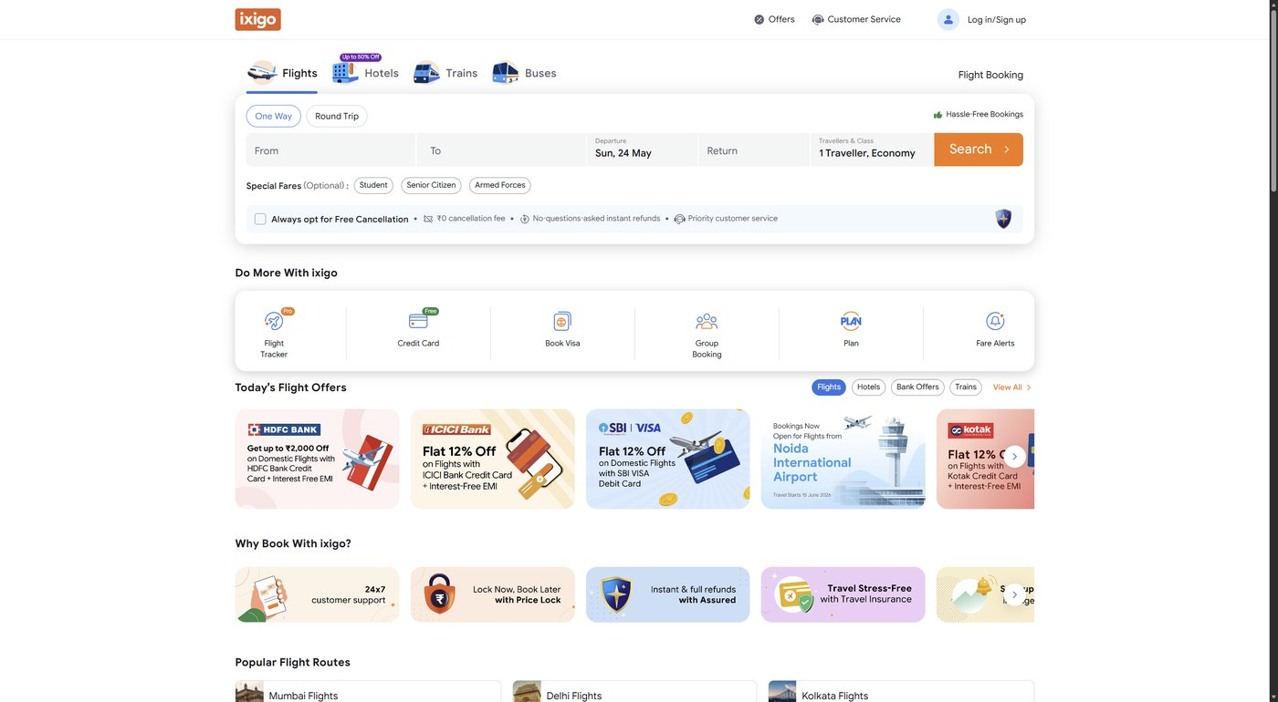
Figure 1. BDD scenario opens the ixigo flight page.
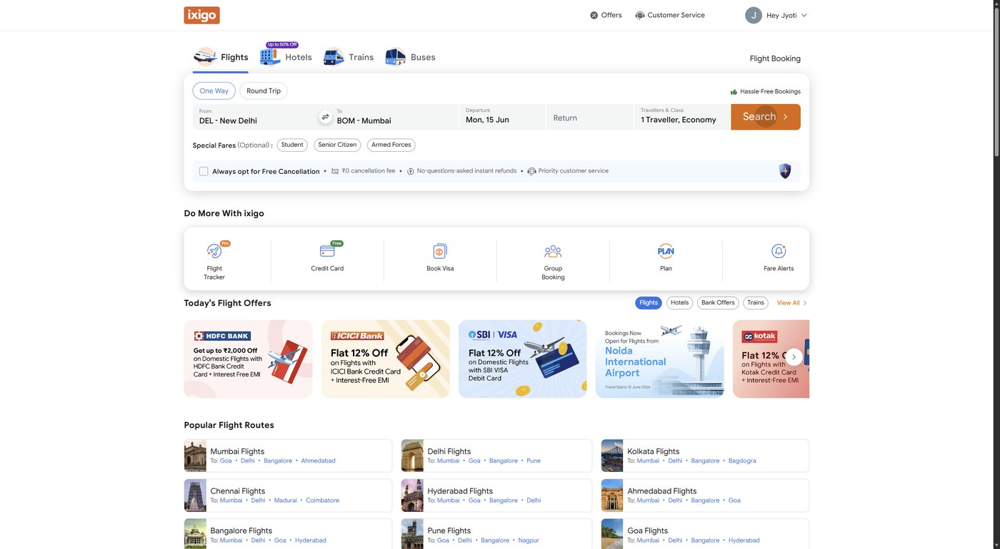
Figure 2. Route search executed from a BDD step.
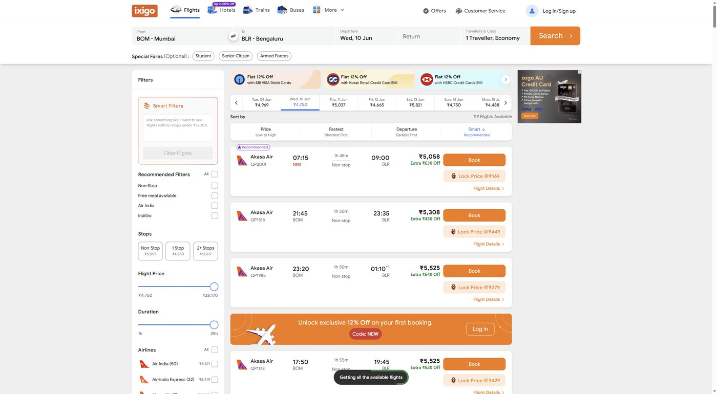
Figure 3. Combined flow validates that flight results are displayed.
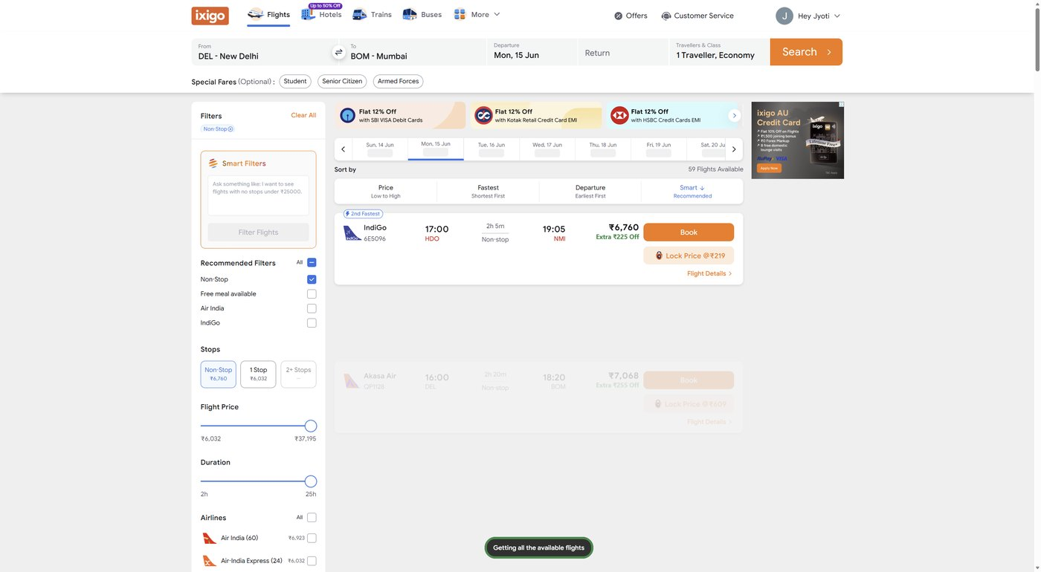
Figure 4. Non-stop filter applied during the behaviour flow.

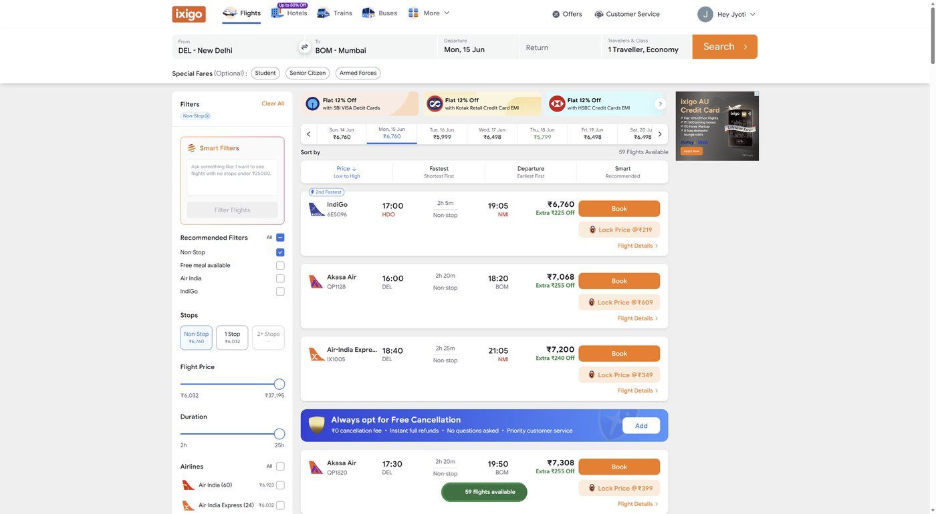
Figure 5. Price sorting evidence after filtering.
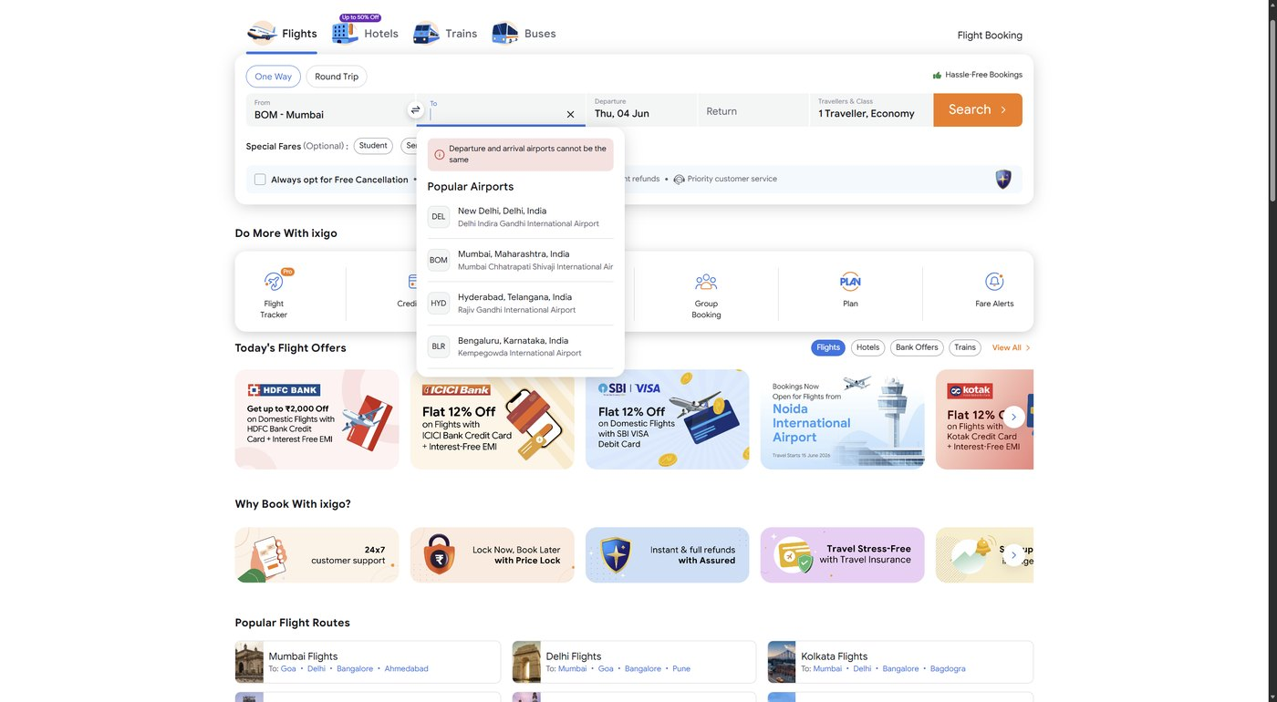
Figure 6. Negative behaviour confirms same source and destination are not accepted.
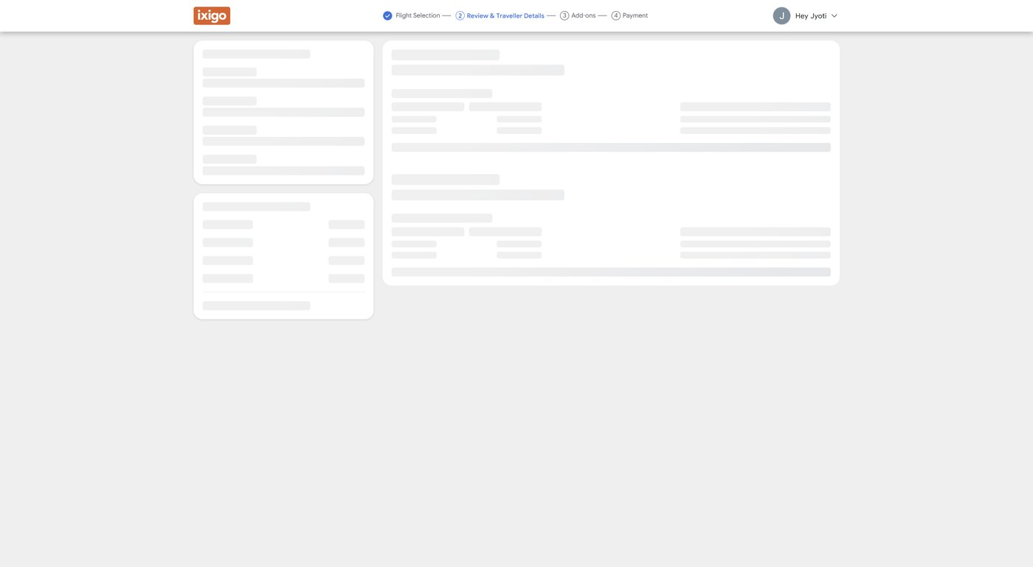
Figure 7. Booking action triggered from the result list.
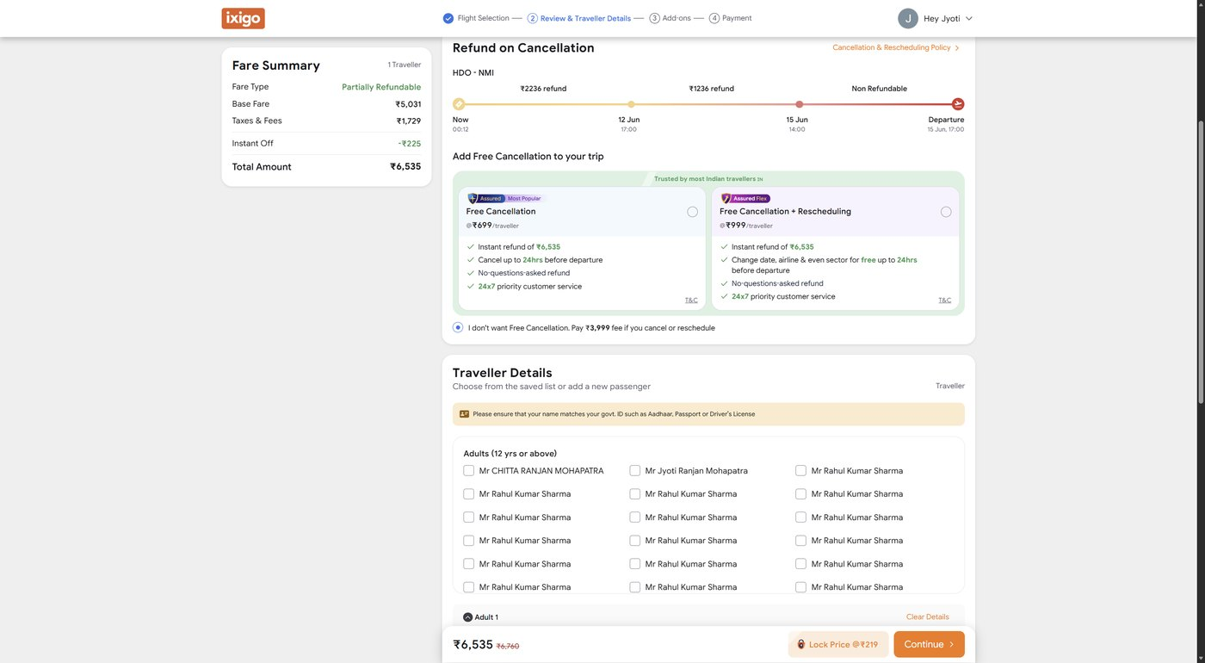
Figure 8. Cancellation prompt handled in the booking journey.

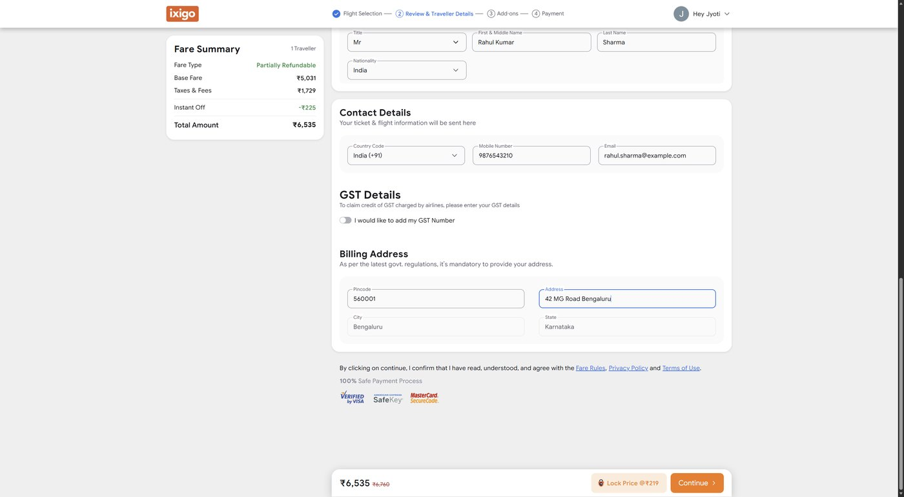
Figure 9. Traveller details filled from CSV data.
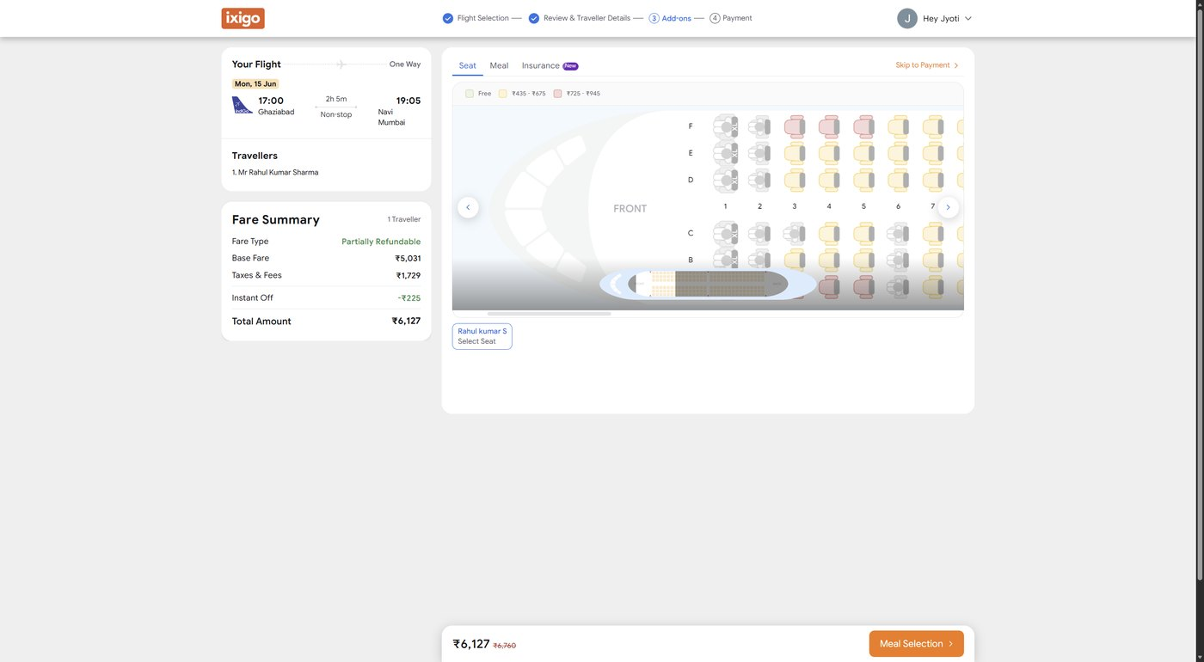
Figure 10. Add-ons page reached after confirming traveller details.
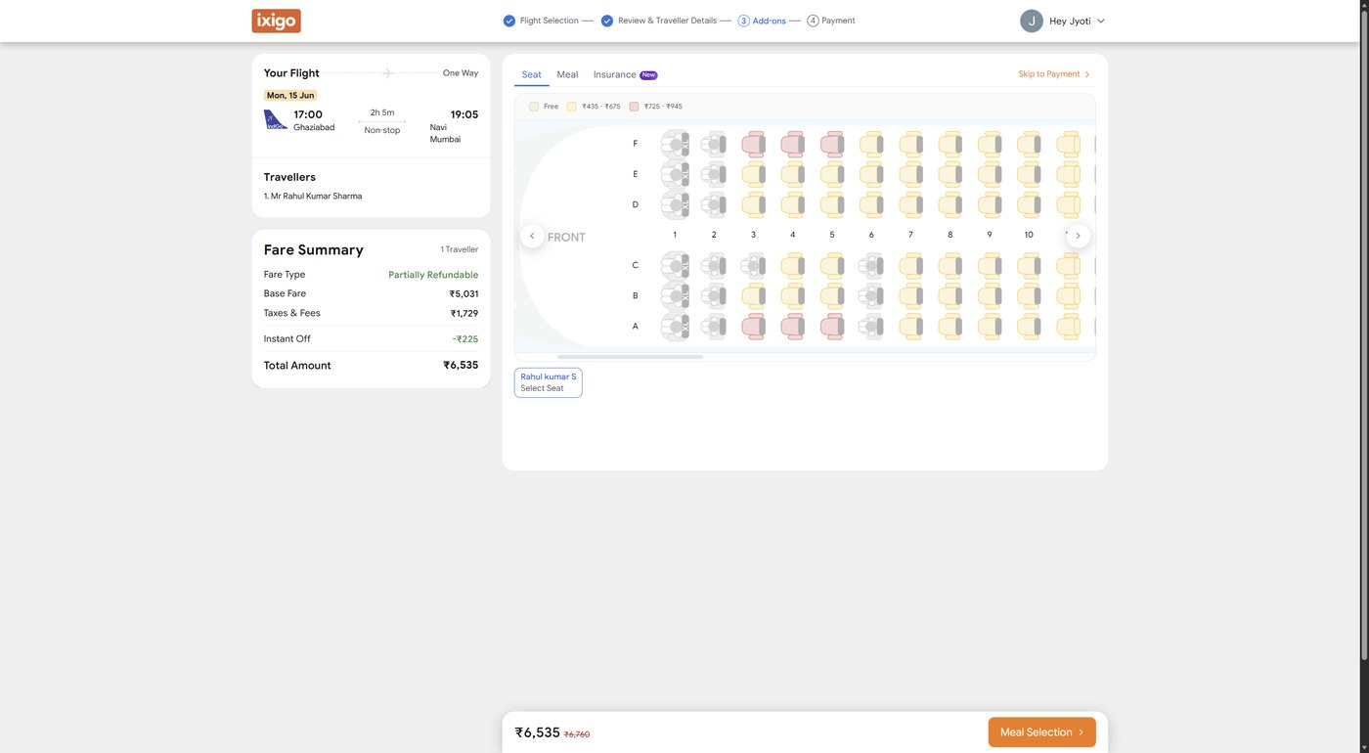
Figure 11. Seat selection behaviour executed where available.
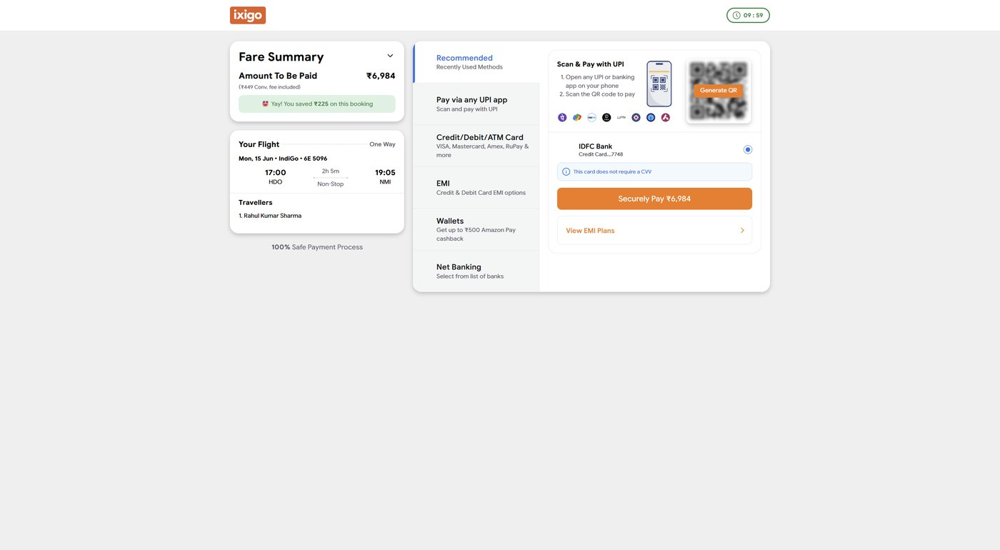
Figure 12. Payment page reached at the end of the BDD E2E flow.

10. Observations
- BDD is documented as the test design approach, while POM is documented as the automation code design pattern.
- The BDD layer makes the testing intent easier to explain because feature files read like user behaviour.
- The actual validations are still strong because Selenium assertions live inside the step-definition code.
- The two step folders give a clean evaluation structure: combined behaviours separately from the E2E booking journey.
- The browser lifecycle follows the Selenium style, with one feature-level browser and isolated browsers only where needed.
- The reporting hook keeps the project portable by opening HTML even when Allure CLI is missing.

11. Conclusion
The BDD project preserves the Selenium automation coverage while presenting it in a behaviour-driven format. The feature files communicate the business flow, the step folders keep implementation organised, and the assertions remain in Python where Selenium can verify the page state properly. The result is a Behave-based framework that is suitable for a capstone submission because it shows both testing discipline and readable behaviour coverage.

