Online Retail Return Risk & Profitability Analysis

--All Records in Online Retail Dataset
SELECT * FROM online_retail;
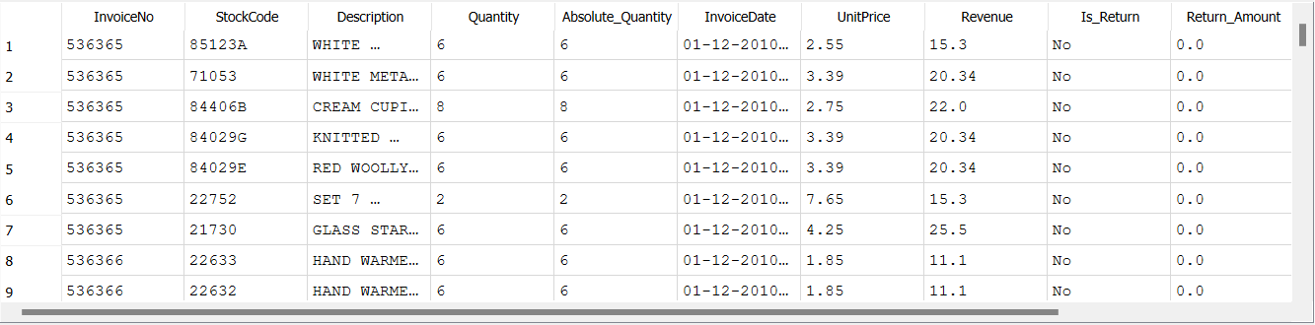

--Total Revenue
SELECT ROUND(SUM(Revenue), 2) AS total_sales
FROM online_retail
WHERE Quantity > 0;
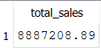

--Total Return Loss
SELECT
ROUND(SUM(Return_Amount), 2) AS total_return_loss
FROM online_retail;

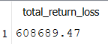

--Net Revenue After Returns

SELECT
ROUND(SUM(Revenue) - SUM(Return_Amount), 2) AS net_revenue
FROM online_retail
WHERE Quantity > 0;
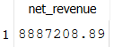

--Return Rate %
SELECT
(SUM(Return_Amount) * 100.0) /
SUM(CASE WHEN Quantity > 0 THEN Revenue ELSE 0 END)
AS return_rate_percent
FROM online_retail;

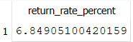

--Top 10 Products With Highest Return Rate

SELECT
Description,
SUM(Return_Amount) AS return_loss,
SUM(Revenue) AS total_revenue
FROM online_retail
GROUP BY Description
ORDER BY return_loss DESC
LIMIT 10;

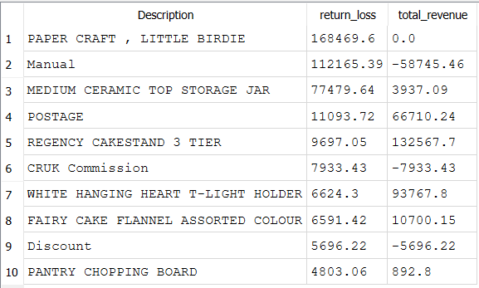
--Return Loss by Country

SELECT
Country,
ROUND(SUM(Return_Amount), 2) AS return_loss
FROM online_retail
GROUP BY Country
ORDER BY return_loss DESC;

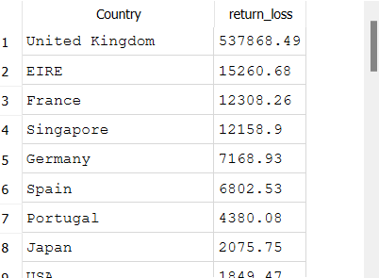

-- Top 10 Products by Return Loss

SELECT
Description,
ROUND(SUM(Return_Amount),2) AS return_loss
FROM online_retail
WHERE Description NOT IN (
'POSTAGE',
'Manual',
'CRUK Commission',
'Discount'
)
GROUP BY Description
ORDER BY return_loss DESC
LIMIT 10;
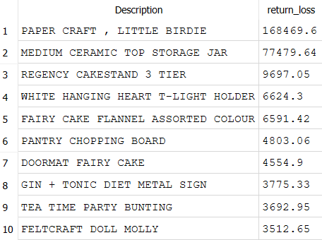
--What % of total return loss comes from the top product

SELECT
ROUND(
(168469.6 * 100.0) /
(SELECT SUM(Return_Amount) FROM online_retail),2) AS top_product_return_percent;

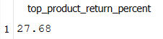

--Monthly Return Trend

SELECT
strftime('%Y-%m', InvoiceDate) AS month,
ROUND(SUM(Return_Amount),2) AS monthly_return_loss
FROM online_retail
GROUP BY month
ORDER BY month;

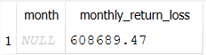

--Top Customers by Return

SELECT
CustomerID,
ROUND(SUM(Return_Amount),2) AS total_return_loss
FROM online_retail
GROUP BY CustomerID
ORDER BY total_return_loss DESC
LIMIT 10;

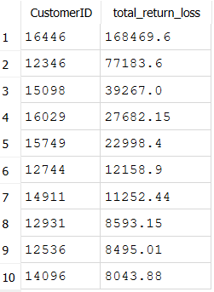
--Customer Return Behavior

SELECT
CustomerID,
ROUND(SUM(Return_Amount),2) AS total_return_loss,
ROUND((SUM(Return_Amount) * 100.0) /
(SELECT SUM(Return_Amount) FROM online_retail),2) AS percent_of_total_returns
FROM online_retail
GROUP BY CustomerID
ORDER BY total_return_loss DESC
LIMIT 10;

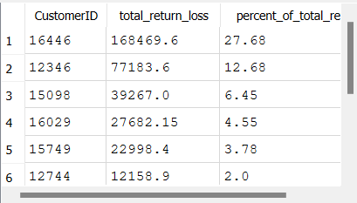

--Returns by Invoice Type

SELECT
InvoiceNo,
COUNT(*) AS total_items,
ROUND(SUM(Return_Amount),2) AS total_return_loss
FROM online_retail
WHERE Quantity < 0
GROUP BY InvoiceNo
ORDER BY total_return_loss DESC;

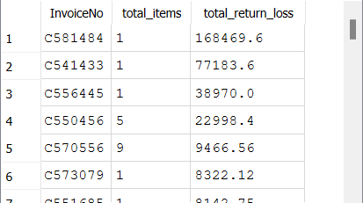
--Average Return Amount per Transaction

SELECT
ROUND(AVG(Return_Amount),2) AS avg_return_per_transaction
FROM online_retail
WHERE Quantity < 0;

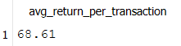

--Returns by Quantity Size

SELECT
CASE
WHEN ABS(Quantity) <= 5 THEN 'Small'
WHEN ABS(Quantity) BETWEEN 6 AND 20 THEN 'Medium'
ELSE 'Large'
END AS return_size,
COUNT(*) AS num_returns,
ROUND(SUM(Return_Amount),2) AS total_return_loss
FROM online_retail
WHERE Quantity < 0
GROUP BY return_size;

