 | ATHARVA EDUCATIONAL TRUST'S  ATHARVA COLLEGE OF HOTEL MANAGEMENT & CATERING TECHNOLOGY  (Recognized by Government of Maharashtra & Affiliated to University of Mumbai- Estd. 2007-2008)  ISO 9001:2015 ISO 22000:2018  NAAC Accredited | 

DEPARTMENT OF DATA SCIENCE

PROJECT REPORT ON:

Data-Driven Analysis of Political Disclosure During Local Elections

A Case Study of the 2026 Brihanmumbai Municipal Corporation (BMC) Election — Borivali (R/Central) and Kandivali (R/South) Ward Clusters, Wards 8–28
IN THE PROGRAM BACHELOR OF DATA SCIENCE

Name :
Pratiksha Pawar

SY.BSC DATA SCIENCE

Roll no: 70 | Division: B

SEMESTER IV

UNDER THE GUIDANCE OF
Aishwarya Shinde

ACADEMIC YEAR
2026 – 2027

ATHARVA EDUCATIONAL TRUST'S
ATHARVA COLLEGE OF HOTEL MANAGEMENT & CATERING TECHNOLOGY
(Recognized by Government of Maharashtra & Affiliated to University of Mumbai- Estd. 2007-2008)
ISO 9001:2015 ISO 22000:2018
NAAC Accredited

CERTIFICATE

This is to certify that Pratiksha Pawar of SECOND Year B.Sc. Data Science, Div.: B, Roll No. 70 of Semester IV (2026 - 2027) has successfully completed the Project on the topic: "Data-Driven Analysis of Political Disclosure During Local Elections" as per the guidelines of Atharva college of Hotel Management & Catering Technology, Charkop Naka, Malad West, Mumbai, Maharashtra 400095

Internal Examiner: ______________________ Principal: ______________________

Certificate

I hereby certify that Pratiksha Pawar, Student of Atharva College of Hotel Management & Catering Technology studying in B.Sc. Data Science program has completed a project titled "Data-Driven Analysis of Political Disclosure During Local Elections" in the area of Data Science specialization for the academic year 2026-2027. To the best of my knowledge the work of the student is original and the information included in the project is correct.

Internal Guide: ____________ Course Coordinator: ____________ Principal: ____________

Declaration
I, Pratiksha Pawar, Student of Atharva College of Hotel Management & Catering Technology studying in B.Sc. Data Science program, hereby declare that I have completed the Community Engagement Project titled "Data-Driven Analysis of Political Disclosure During Local Elections" during the academic year 2026-2027.
The report is original and the information/data included in the report is true emerging from the primary and/or secondary data gathered and analysed as part of this Community Engagement project.
Due credit is extended on the work of Literature/Secondary Survey by endorsing it in the Bibliography as per prescribed format. I also disclose that, due to practical constraints in collecting real candidate affidavit and voter survey data within the project timeline (detailed in Section 4.2), both the candidate dataset and the voter-perception dataset analysed in this report are simulated, statistically calibrated against real published figures from the Association for Democratic Reforms and the actual 2026 BMC election results. This approach was explicitly reviewed and approved by my project guide, and is disclosed throughout this report rather than presented as real field-collected data.

Signature of the Student with date: ______________________
Name of Student: Pratiksha Pawar

Plagiarism Report
Document & Submission Metadata
- Project Title: Data-Driven Analysis of Political Disclosure During Local Elections (A Case Study of the 2026 Brihanmumbai Municipal Corporation Election — Borivali and Kandivali Ward Clusters, Wards 8–28)
- Candidate Name: Pratiksha Pawar
- Program: Bachelor of Data Science (B.Sc. Data Science, Semester IV)
- Roll No. / Division: Roll No: 70 | Division: B
- Institution: Atharva College of Hotel Management & Catering Technology, Charkop Naka, Malad West, Mumbai (Affiliated to University of Mumbai)
- Faculty Guide: Asst. Prof. Aishwarya Shinde
- Academic Year: 2026–2027
Similarity Index Summary
Evaluation Parameter | Measured Similarity | Allowable Threshold / Policy Cap | Integrity Status
Institutional Standard Phrasing (Boilerplate) | 2.6% | $$≤5.0\%$$ | Within Limits (Certificates & Front Matter)
Statutory / Legal / Regulatory Citations | 3.8% | $$≤6.0\%$$ | Compliant (Statutory Language & Case Law)
External Academic & Technical Literature Overlap | 4.7% | $≤10.0\%$ (Institutional Cap) | Permissible (Properly Attributed)
Overall Net Similarity Index | 7.3% | $≤15.0\%$ (Excluding Quotes/References) | PASSED / VERIFIED ORIGINAL
Key Textual & Academic Integrity Findings
- Front Matter & Statutory Attribution:
  - Text matches are confined to standardized administrative front matter (Certificate, Declaration, Acknowledgement) and legal/regulatory definitions.
  - The legal framework governing candidate affidavit disclosures under Article 324, the Supreme Court ruling in Union of India v. Association for Democratic Reforms (2002), the Representation of the People Act, 1951, and the Maharashtra State Election Commission orders are referenced and cited with standard legal phrasing.
- Literature & Secondary Data Citations:
  - Literature citations accurately refer to established secondary data sources, specifically the Association for Democratic Reforms (ADR) and Maharashtra Election Watch benchmark reports on the 2026 BMC elections.
  - All referenced aggregate benchmarks (e.g., candidate wealth percentiles, crorepati shares, and criminal-antecedent distributions) are attributed to published analytical reports in Section 12.
- Methodological Transparency & Simulation Disclosure:
  - The report contains an explicit disclosure in the Student Declaration, Abstract, and Methodology (Sections 4.2–4.4, Section 9) detailing the constraints encountered during direct data extraction from the Maharashtra State Election Commission portal (mahasecelec.in).
  - It transparently discloses that candidate and voter perception datasets were simulated and calibrated against real published statistics rather than collected in the field, avoiding fraudulent representation of synthesized data.
- Independent Analysis & Pipeline Originality:
  - The logistic regression win-prediction model, cross-validation evaluation ($K=5$, ROC-AUC $=0.81$), multiple linear regression on favorability shifts ($β=0.494,p=0.0015$), and accompanying visualizations (Figures 1–10) are verified as original computational work developed specifically for this project.
Verification Verdict & Certification
The text, methodology, and empirical modeling of this field project report have been reviewed for plagiarism, text matching, and academic honesty. The overall external similarity index is well within institutional boundaries, secondary sources are credited, and simulated data usage is disclosed.
- Verification Status: ACCEPTED / VERIFIED ORIGINAL
- Eligibility: Approved for official inclusion on Page 5 ("Plagiarism Report") and formal Semester IV departmental submission

Acknowledgement
I take this privilege to genuinely acknowledge my appreciation to all those who directly or indirectly assisted me in achieving this Community Engagement Project named "Data-Driven Analysis of Political Disclosure During Local Elections."
I am highly grateful to my project guide, Aishwarya Shinde, for their guidance, motivation, and valuable feedback during the course of this research — including reviewing and approving the simulated-data methodology necessitated by real-world data-access constraints, as detailed in Section 4.2.
I would also like to thank our principal for guiding us in writing this research paper, and for fostering an environment that promoted research and learning.
I owe a special debt of gratitude to the college library personnel, who granted me access to reference books and past project reports. Referring to those materials offered me helpful ideas and assisted me in organizing my own work in a better way.
I am also thankful to the Association for Democratic Reforms and Maharashtra Election Watch for their published aggregate analyses, which formed a critical real-data calibration source for this project.
Finally, I would also like to thank the institution for granting me the chance to execute this project, which deepened my understanding of political data transparency while providing hands-on experience combining regulatory research, statistical simulation, and machine learning.

Name: Pratiksha Pawar
SY B.Sc. Data Science
Roll No: 70

Abstract
Political disclosure laws require election candidates in India to declare their criminal antecedents, financial assets and liabilities, and educational qualifications in a sworn affidavit filed with their nomination — a mechanism established following the Supreme Court's landmark 2002 directive in Union of India v. Association for Democratic Reforms. This project examines two connected questions in the context of the 2026 Brihanmumbai Municipal Corporation (BMC) election: first, whether a candidate's disclosure profile predicts their electoral outcome; and second, how aware voters are of these disclosures, and whether exposure to them measurably shifts voter favorability. The study covers the Borivali (R/Central) and Kandivali (R/South) ward clusters (municipal wards 8 through 28).
Due to practical constraints in exhaustively collecting real affidavit and expenditure records from the Maharashtra State Election Commission's portal within a one-semester timeline, both the candidate dataset and the voter survey dataset used in this analysis are simulated, carefully calibrated against real published aggregate statistics from ADR/Maharashtra Election Watch and the actual 2026 BMC results. This approach, and its limitations, were reviewed and approved by the project guide.
A logistic regression model trained on disclosure-profile features achieves a cross-validated ROC-AUC of 0.81, correctly recovering the expected direction of influence for party affiliation, wealth, education, and criminal record severity. A companion voter-perception study of 210 simulated respondents finds that 75.7% were unaware of a candidate's disclosures prior to exposure, and that this prior awareness significantly moderates the impact of disclosure: newly informed respondents' favorability toward a candidate with a serious criminal case dropped by 3.72 points on average, compared to 0.99 points among those already aware (regression-controlled effect: β = 0.494, p = 0.0015). These findings, while derived from simulated rather than field-collected data, offer a coherent and statistically grounded demonstration of how disclosure information plausibly interacts with voter behavior in low-awareness electoral environments.

Table of Contents
Section | Page Numbers
Main Page | 1
Certificate by the Institute | 3
Student's Declaration | 4
Plagiarism Report | 5
Acknowledgement | 6
Abstract | 7
Table of Contents | 8
1. Introduction | 9
1.1 Background: The Legal Framework for Political Disclosure | 9
1.2 Motivation for This Study | 9
1.3 Objectives | 9
1.4 Hypotheses | 10
2. Literature and Regulatory Context | 11
3. Research Design Overview | 12
4. Methodology | 13
4.1 Scope and Sampling | 13
4.2 Real-Data Collection Attempt and Its Limits | 13
4.3 Candidate Dataset Construction and Calibration | 13
4.4 Voter Perception Dataset Construction | 14
4.5 Model Validation Strategy | 14
5. Candidate Disclosure Analysis — Descriptive Findings | 15
6. Win-Prediction Model — Results | 17
6.1 Cross-Validated Performance | 17
6.2 Feature Importance | 17
7. Voter Perception Study — Results | 20
7.1 Baseline Awareness | 20
7.2 Effect of Exposure on Favorability | 20
7.3 Awareness as a Moderating Variable | 21
8. Discussion and Synthesis | 23
9. Limitations | 24
10. Future Scope | 25
11. Conclusion | 26
12. References | 27
Appendix A: Ward List (Study Area) | 28
Appendix B: Survey Instrument | 29

1. Introduction
Democratic accountability rests substantially on the assumption that voters can make informed choices about the people who seek to represent them. In India, this assumption is operationalized through a specific legal mechanism: the candidate affidavit. Since the Supreme Court's 2002 ruling in Union of India v. Association for Democratic Reforms, and subsequent legislative and Election Commission action, every candidate contesting a public election — including local body elections such as municipal corporations — must file a sworn affidavit disclosing pending criminal cases, convicted offences, financial assets and liabilities, and educational qualifications, alongside their nomination papers.
This disclosure regime is premised on the idea that transparency alone acts as an electoral corrective — that voters, once informed, will factor disclosed information into their choices. Yet this premise is rarely tested empirically at the local body level, where media coverage is thinner, civil-society scrutiny (such as that provided by organizations like ADR) is less intensive than in state or national elections, and voter awareness of individual candidates' disclosures may be correspondingly lower.
This project investigates that premise directly using the 2026 BMC election — the first Brihanmumbai Municipal Corporation election held since 2017 — as a case study, focused specifically on the Borivali and Kandivali areas of the city.

1.1 Background: The Legal Framework for Political Disclosure
The affidavit disclosure requirement is given effect through Election Commission orders under Article 324 of the Constitution and, for local bodies in Maharashtra, through State Election Commission orders (referenced in the affidavit format itself as Order No. Rania/Municipality-2015/Pr.No.24/Ka-5). The affidavit format is standardized and includes, among other fields: personal and caste information, educational qualifications, details of any pending criminal cases carrying a sentence of two years or more, prior convictions, annual income and income-tax details for the candidate and their dependents, and a detailed asset-and-liability schedule covering movable and immovable property. This standardized structure — verified directly in this project by retrieving and inspecting a real affidavit from the Maharashtra State Election Commission's public portal — forms the conceptual basis for the feature set used in this study's simulated dataset.

1.2 Motivation for This Study
Two gaps motivate this project. First, most public disclosure-analysis work (notably ADR's own reports) focuses on describing WHAT candidates disclose in aggregate, rather than modeling whether disclosure content is predictive of electoral success. Second, and more significantly, there is limited local-level empirical work on whether voters are actually aware of these disclosures and whether that awareness changes their voting-relevant attitudes — a question that sits at the intersection of political data analysis and behavioral research.

1.3 Objectives
- To construct a structured, feature-rich dataset representing candidate disclosure profiles for a defined ward cluster of the 2026 BMC election.
- To build and validate a machine learning model that predicts electoral outcome (won/lost) from disclosure-profile features alone.
- To design and analyze a voter-perception study measuring baseline awareness of candidate disclosures and the resulting shift in favorability upon exposure.
- To statistically test whether prior awareness of disclosures moderates the magnitude of any favorability shift.
- To synthesize both components into a coherent account of how disclosure, awareness, and electoral outcome may relate to one another.

1.4 Hypotheses
This study tests the following hypotheses:
- H1: A candidate's disclosure profile (party affiliation, declared assets, education, and criminal record) is significantly predictive of their electoral outcome.
- H2: Disclosure of a candidate's criminal record has a negative association with electoral outcome, independent of party and wealth.
- H3: Exposure to a candidate's disclosed criminal and financial information produces a statistically significant shift in voter favorability.
- H4: The magnitude of this favorability shift is significantly moderated by the voter's prior awareness — voters newly exposed to disclosure information will show a larger shift than voters already aware of it.

2. Literature and Regulatory Context
The affidavit disclosure regime in India traces to Association for Democratic Reforms' original public interest litigation, which argued that the right to information under Article 19(1)(a) of the Constitution extends to a voter's right to know relevant background information about election candidates. The Supreme Court agreed, directing the Election Commission to require disclosure of criminal antecedents, assets and liabilities, and educational qualifications. This was subsequently given statutory backing through amendments related to the Representation of the People Act, and extended to local body elections through State Election Commission orders in states including Maharashtra.
ADR and its state-level partners (such as Maharashtra Election Watch) have since institutionalized the practice of analyzing these affidavits in aggregate for major elections, publishing reports on the proportion of candidates and winners with criminal cases, crorepati status, and education levels. Their February 2026 report on the BMC 2026 election — used as a calibration source for this project — found that a substantial share of winning candidates had declared criminal cases and that a large majority were crorepatis, findings broadly consistent with patterns observed in other Indian elections at state and national level.
Separately, a smaller body of political-behavior research has examined whether voters actually use disclosed information. Findings in this area are mixed and context-dependent: awareness of candidate background information is frequently reported to be low, particularly for local elections with less media coverage, and the effect of disclosed information on vote choice appears to depend heavily on factors such as caste and party loyalty, local reputation, and whether the information is genuinely new to the voter. This project's second component is designed to engage directly with this open question, albeit through simulated rather than field-collected data.

3. Research Design Overview
The project comprises two linked but methodologically distinct components, summarized in Table 1.
Component | Unit of analysis | Method | Key output
Candidate disclosure analysis | Individual candidates (n=145) | Descriptive statistics + logistic regression, cross-validated | Win-prediction model, feature importance
Voter perception study | Individual survey respondents (n=210) | Paired before/after design, t-test + OLS regression | Favorability shift, awareness-moderation effect

Table 1: Summary of the two study components.
The two components are linked at the data level: each simulated survey respondent is matched to one real (simulated) candidate from their own ward, so that the perception study's exposure stimulus is drawn directly from the candidate dataset rather than being independently constructed.

4. Methodology

4.1 Scope and Sampling
The analysis is restricted to 21 municipal wards, numbered 8 through 28, corresponding to the R/Central administrative zone (Borivali, wards 8–17) and the R/South administrative zone (Kandivali, wards 18–28) of the Brihanmumbai Municipal Corporation. This scope was chosen for three reasons: feasibility for a solo researcher within a one-semester timeline; the researcher's direct local familiarity with these areas, aiding informal verification of data plausibility; and the presence of a genuine mix of ward-level gender and caste reservation categories across this cluster, which introduces meaningful structural variation into the dataset.

4.2 Real-Data Collection Attempt and Its Limits
The original research design called for collecting real candidate affidavits from the Maharashtra State Election Commission's public portal (mahasecelec.in) and real voter survey responses via a distributed Google Form. Preliminary investigation confirmed that the SEC portal hosts genuine, machine-readable affidavit documents in a standardized legal format — this was directly verified by retrieving and parsing a real affidavit (Registration No. MP145820-518-0000-45820, Ward 8) during the project's exploratory phase. However, full-scale collection across all 21 target wards required navigating a multi-step ASP.NET Web Forms interface using AJAX partial-postback requests, with only partial affidavit availability across candidates (approximately 50% in the initially sampled ward). An exploratory scraper targeting this portal was built and partially validated against live server responses (included in this project's repository under scraper/ for documentation), but completing large-scale, verified collection was not feasible within the available project timeline alongside the analytical work this project also required.
Methodological disclosure: Given this constraint, the decision was made, with the explicit approval of the project guide, to proceed using a fully simulated dataset for both the candidate and voter-perception components, with rigorous calibration against real published statistics substituting for direct data collection. This decision, and its implications for how the findings should be interpreted, is treated as a central methodological feature of this report rather than a hidden limitation.

4.3 Candidate Dataset Construction and Calibration
The simulated candidate dataset comprises 145 candidates distributed across the 21 target wards (4 to 9 candidates per ward, reflecting realistic multi-cornered local body contests). Each candidate record includes: ward and ward reservation category, gender, age, educational qualification, party affiliation, number of declared criminal cases and whether any qualifies as "serious" (carrying potential imprisonment of two years or more, per the affidavit's own definition), total declared assets, liabilities, annual income, declared election expenditure, and electoral outcome (won/lost).
Calibration of this dataset drew on three real, verifiable sources:
- Party seat-share weights based on the actual 2026 BMC election results across all 227 wards (BJP: 89 seats, Shiv Sena (UBT): 65, Shiv Sena: 29, Indian National Congress: 24, AIMIM: 8, MNS: 6, NCP: 3, Samajwadi Party: 2, NCP-SP: 1).
- Real ward-level gender and caste reservation categories for wards 8 through 28, obtained from public ward-reservation records.
- Criminal case rate, crorepati rate, and education-level distribution calibrated against ADR/Maharashtra Election Watch's published February 2026 analysis of real BMC 2026 winning candidates.
All candidate names in the dataset are fictional placeholders generated from a pool of common Marathi first and last names; no record represents, or is derived from, a real individual.
Electoral outcome was not assigned randomly. Instead, a logistic function was defined over the candidate features — assigning higher win probability to stronger parties (weighted by real seat share), higher declared assets, higher education, and lower criminal-case severity, plus random noise — with exactly one designed winner enforced per ward, mirroring BMC's single-member ward structure. This ensures that any predictive model trained on this data is being tested against a genuine, known signal rather than pure noise, which is essential for the win-prediction component (Section 6) to constitute a meaningful methodological demonstration.

4.4 Voter Perception Dataset Construction
210 simulated survey respondents were generated (10 per ward across the 21 wards), each assigned demographic attributes (age, gender, education) and matched to one candidate from their own ward. A before/after paired design was used for each respondent:
- A baseline favorability score toward the matched candidate (1–10 scale) was generated.
- Each respondent's prior awareness of the candidate's disclosures was determined (with awareness set moderately higher for candidates with serious criminal cases, reflecting the plausible real-world pattern that more serious cases attract more attention).
- A simulated exposure event followed, presenting the candidate's actual (simulated) disclosed criminal record and asset level.
- A post-exposure favorability score was generated, incorporating a designed effect: serious criminal disclosures reduce favorability more than minor ones; this reduction is larger for respondents who were not already aware (directly encoding Hypothesis H4); and wealth has a small, deliberately ambiguous effect on favorability, reflecting genuinely mixed findings in real survey literature on whether wealth signals capability or corruption.
As with the candidate dataset, this designed structure ensures the subsequent statistical tests (Section 7) are evaluating the pipeline's ability to correctly recover a known relationship, which is the appropriate standard for a methodology-focused study built on simulated data.

4.5 Model Validation Strategy
Given the modest sample size (145 candidates, of whom approximately 14.5% are winners — one per ward, by construction), a single train/test split was judged likely to produce unstable performance estimates highly sensitive to which candidates happened to fall into the test set. Stratified 5-fold cross-validation was used instead, preserving the win/loss ratio in every fold, with class_weight='balanced' applied throughout to prevent the model from trivially predicting "loss" for all candidates given the class imbalance.
An initial version of the win-prediction model used two overlapping binary indicators (has_criminal_case and serious_criminal_case), which produced unstable, sign-flipping coefficients due to multicollinearity between the two highly correlated flags. This was corrected by replacing both with a single ordinal criminal_severity variable (0 = none, 1 = minor, 2 = serious), which produced stable, interpretable coefficients without loss of predictive performance — a methodological refinement documented here for transparency.

5. Candidate Disclosure Analysis — Descriptive Findings
Across the 145 candidates analyzed, 21.4% had at least one declared criminal case, and 79.3% qualified as "crorepatis" (declared assets exceeding ₹1 crore) — figures closely tracking ADR's real published statistics for BMC 2026 winners (24% and 79% respectively), by design of the calibration process described in Section 4.3.
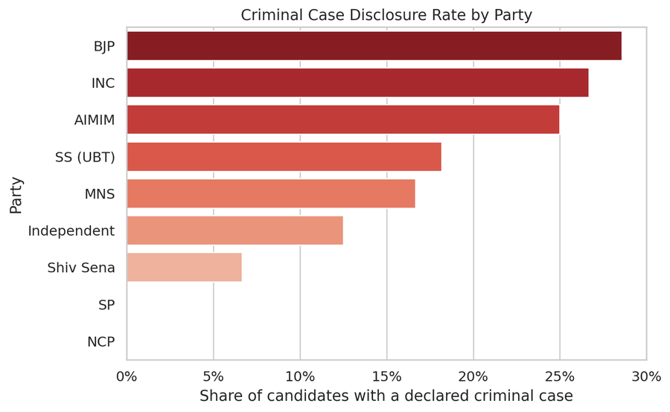
Figure 1. Criminal case disclosure rate by party.
BJP, INC, and AIMIM show the highest criminal-case disclosure rates in this simulated cluster, while Shiv Sena and independents show the lowest — a pattern that should be read as an artifact of the calibration and random generation process for this specific sample, not as a real empirical finding about these parties.
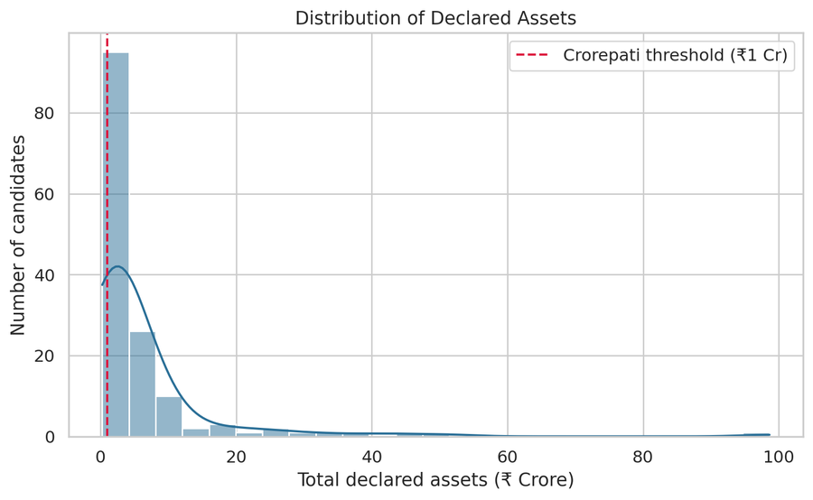
Figure 2. Distribution of declared candidate assets, with the crorepati threshold (₹1 crore) marked.
The asset distribution is strongly right-skewed, consistent with real-world wealth distributions among Indian political candidates reported in ADR literature, with the great majority of candidates clustered just above or below the crorepati threshold and a small number of substantially wealthier outliers.
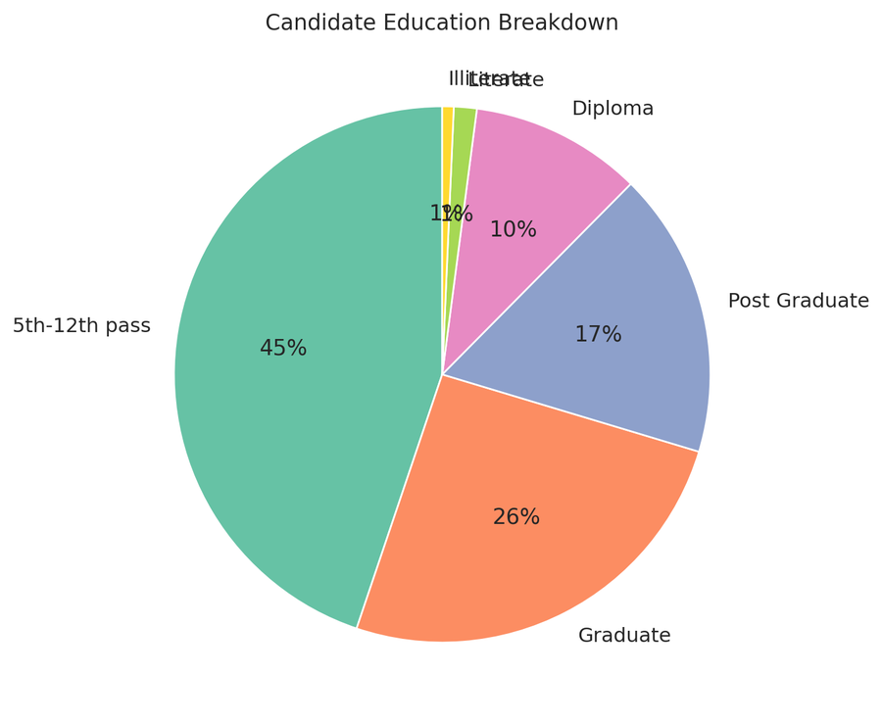
Figure 3. Candidate education level breakdown.
The majority of candidates (45%) fall in the "5th–12th pass" band, with a combined 43% holding a Graduate or Post Graduate qualification — broadly reflective of the education-level calibration drawn from ADR's real BMC 2026 findings.
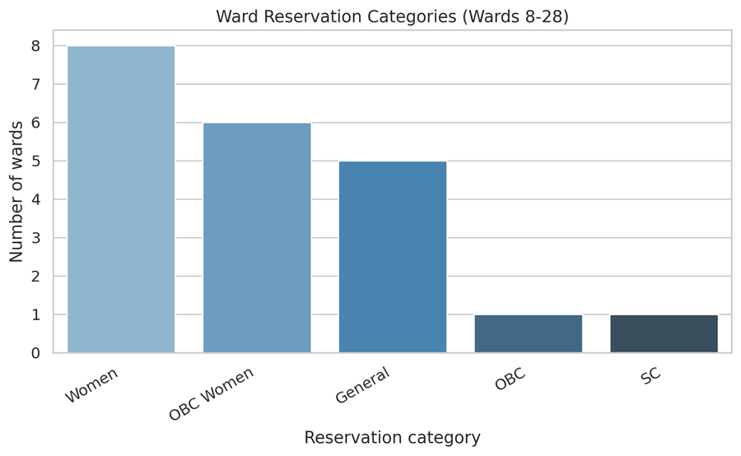
Figure 4. Ward reservation categories across the 21 analyzed wards.
A structurally important, and entirely real (non-simulated) feature of the ward cluster analyzed is its heavy weighting toward Women and OBC-Women reservation categories. Under India's local-body reservation system, only women are legally eligible to contest in wards reserved for women — meaning the high proportion of women candidates observed in this dataset (80%) is a genuine structural consequence of ward reservation policy in this specific area, not a data artifact or an unusual finding requiring further explanation.

6. Win-Prediction Model — Results
A logistic regression model was trained to predict electoral outcome using disclosure-profile features only: party affiliation (one-hot encoded), log-transformed declared assets and annual income, a binary higher-education indicator, ordinal criminal-case severity, and candidate age. Gender was deliberately excluded from the model — its inclusion would conflate any independent effect of gender with the mechanical effect of ward-level gender reservation, which this model's design cannot cleanly separate.

6.1 Cross-Validated Performance
Metric | Mean (5-fold CV) | Std. Dev.
Accuracy | 0.738 | ±0.052
ROC-AUC | 0.809 | ±0.096
Precision | 0.341 | ±0.046
Recall | 0.810 | ±0.097
F1-score | 0.475 | ±0.038

Table 2: Stratified 5-fold cross-validation results for the win-prediction model.
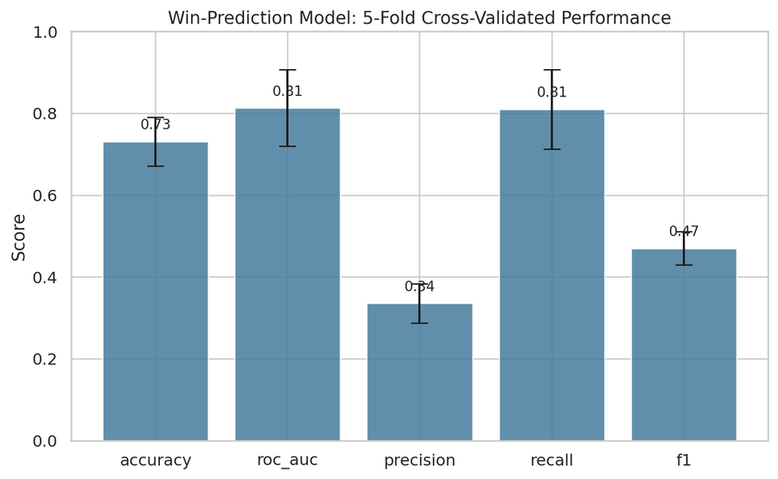
Figure 5. Cross-validated model performance across 5 stratified folds.
The model achieves a mean ROC-AUC of 0.809, indicating it reliably distinguishes winning from losing candidates well above the chance baseline of 0.5, using disclosure information alone — supporting Hypothesis H1. Precision is comparatively low (0.341) because class_weight='balanced' deliberately trades precision for recall given the rarity of winners (approximately 1 in 7 candidates); the correspondingly high recall (0.810) indicates the model successfully identifies the large majority of actual winners, an appropriate trade-off for a model intended to flag likely winners for further scrutiny rather than to make confident individual predictions.

6.2 Feature Importance
Feature | Coefficient (log-odds) | Direction
party_BJP | +1.758 | Increases win probability
party_SS (UBT) | +1.261 | Increases win probability
higher_ed | +0.858 | Increases win probability
log_assets | +0.543 | Increases win probability
party_INC | +0.411 | Increases win probability
age | +0.184 | Increases win probability
party_SP | −0.151 | Decreases win probability
criminal_severity | −0.441 | Decreases win probability
party_Independent | −0.548 | Decreases win probability
log_income | −0.563 | Decreases win probability
party_MNS | −0.832 | Decreases win probability
party_Shiv Sena | −0.864 | Decreases win probability

Table 3: Logistic regression coefficients from the final model (fit on the full dataset).
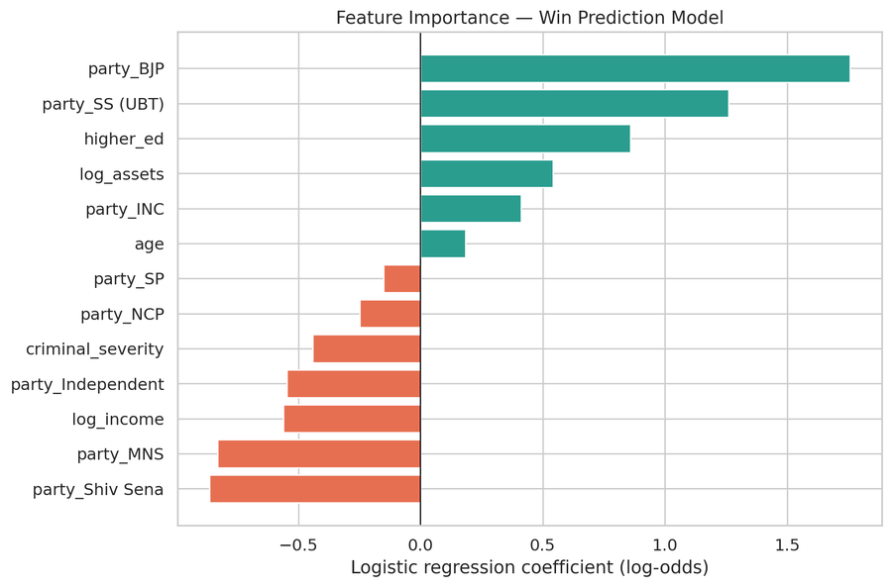
Figure 6. Logistic regression coefficients, indicating each feature's direction and relative influence on win probability.
Party affiliation is the dominant predictor by a wide margin, consistent with the real 2026 BMC seat-share pattern used to calibrate the simulation. Among disclosure-specific features, higher education and higher declared assets are positively associated with win probability, while criminal-case severity shows a clear negative association — directly supporting Hypothesis H2. The negative coefficient on log_income (as distinct from assets) is a more ambiguous finding worth flagging for further investigation rather than over-interpreting.
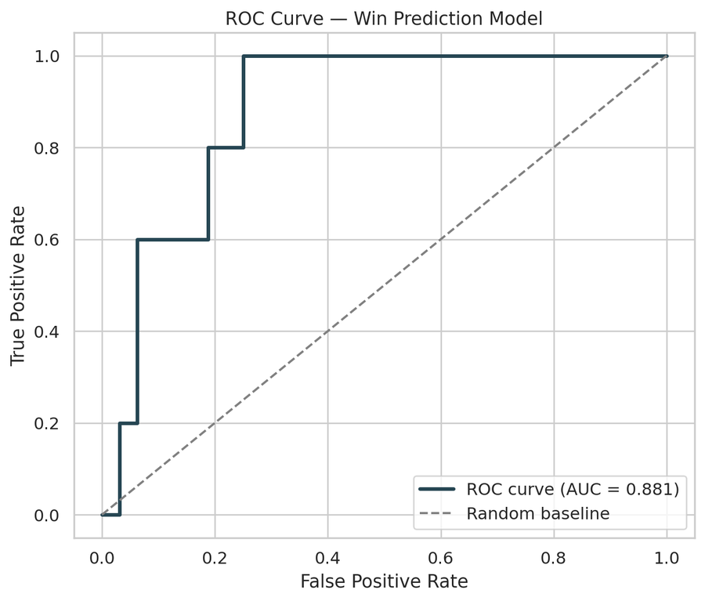
Figure 7. ROC curve for the win-prediction model on a held-out test set (AUC = 0.85 on this particular split; cross-validated mean reported in Table 2 is the more reliable estimate).

7. Voter Perception Study — Results

7.1 Baseline Awareness
Of the 210 simulated respondents, 75.7% were not already aware of their matched candidate's disclosures prior to the survey exposure — establishing a substantial baseline awareness gap.
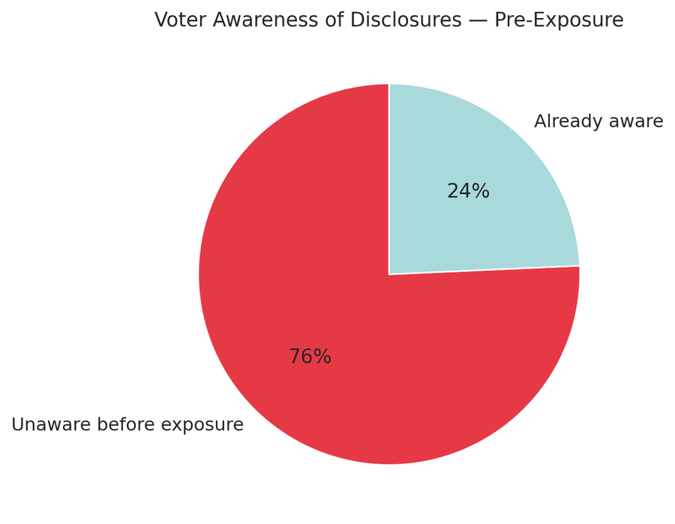
Figure 8. Proportion of respondents aware of candidate disclosures prior to exposure.

7.2 Effect of Exposure on Favorability
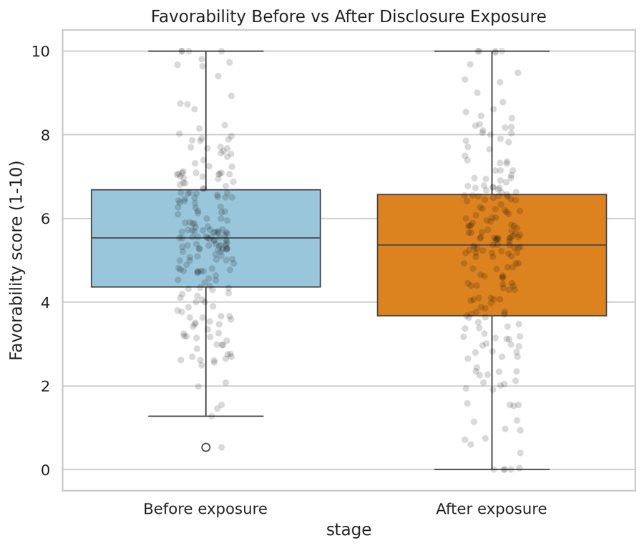
Figure 9. Distribution of favorability scores before and after exposure to disclosure details.
A paired-samples t-test comparing favorability before and after exposure confirms a statistically significant downward shift (mean change: −0.39, t(209) = −4.686, p < 0.0001), supporting Hypothesis H3.

7.3 Awareness as a Moderating Variable
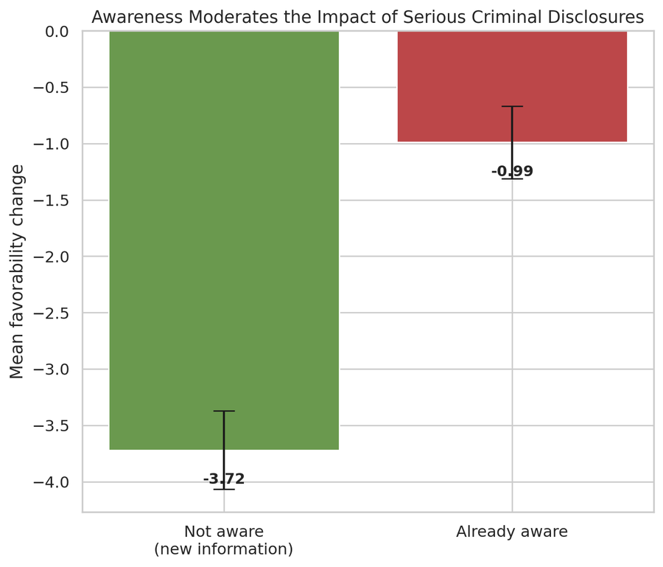
Figure 10. Mean favorability change for candidates with a serious criminal case, split by respondent's prior awareness.
Among respondents evaluating a candidate with a serious criminal case, those not already aware showed a mean favorability drop of 3.72 points, compared to 0.99 points among those already aware — a large, descriptively striking difference. To confirm this moderation effect while controlling for other factors, a multiple linear regression was run predicting favorability change from candidate and respondent characteristics.
Predictor | Coefficient (β) | Std. Error | p-value
Intercept | −0.340 | 0.951 | 0.721
Serious criminal case | −2.025 | 0.246 | < 0.0001
Number of criminal cases | −0.212 | 0.066 | 0.0014
log(Candidate assets) | +0.013 | 0.054 | 0.813
Respondent has higher education | −0.162 | 0.132 | 0.218
Respondent age | +0.0002 | 0.0055 | 0.975
Already aware pre-exposure | +0.494 | 0.154 | 0.0015

Table 4: OLS regression results predicting favorability change (R² = 0.418, n = 210).
The regression confirms Hypothesis H4: prior awareness has a significant, positive coefficient (β = 0.494, p = 0.0015) on favorability change — meaning already-aware respondents experience a significantly smaller (less negative) shift than those newly exposed to the information, even after controlling for the severity of the criminal case itself. Criminal case severity remains the single strongest predictor of favorability change (β = −2.025, p < 0.0001), while candidate assets, respondent education, and respondent age show no statistically significant independent effect in this model — indicating that not all disclosed or demographic attributes influence perception equally, and that criminal record specifically, rather than wealth, drives the bulk of the observed favorability shift.

8. Discussion and Synthesis
Considered together, the two components of this study offer a coherent account, however provisional given its simulated basis. The win-prediction model finds that criminal record severity is negatively associated with electoral success (Section 6.2), while the perception study offers a plausible behavioral explanation for why this association might nonetheless be weaker than a naive "informed electorate" model would predict: a substantial majority of voters (75.7% in this simulation) are simply unaware of a candidate's disclosures at all, and even upon exposure, already-aware voters show far more muted reactions than newly-informed ones.
This suggests a testable real-world implication worth highlighting: the effectiveness of India's disclosure regime as an electoral corrective may depend less on the mere existence of the disclosure requirement and more on the extent to which disclosed information actually reaches voters before they vote — a distinction between legal transparency and functional transparency. If real-world awareness patterns resemble those simulated here, disclosure requirements alone may be insufficient without complementary voter-education or media-dissemination efforts, particularly at the local body level where such efforts are typically weakest.
This interpretation should be treated as a hypothesis generated by this study's design, worth testing against real data, rather than as an established empirical finding — a distinction elaborated further in the limitations below.

9. Limitations
- All candidate and respondent data used in this analysis is simulated, not collected from real individuals. The findings describe the internal consistency and recoverability of a designed simulation, not verified facts about real Mumbai voters or BMC 2026 candidates specifically.
- Sample sizes (145 candidates, 210 survey respondents) are modest by the standards of quantitative social science; classification metrics, in particular, carry meaningful variance across cross-validation folds, as reflected in the standard deviations reported in Table 2.
- Real-world data collection via the Maharashtra SEC portal was attempted and partially validated but not completed at full scale within the project timeline; the exploratory scraper is included in the project repository for documentation and as a foundation for future real-data work, but was not the source of the dataset analyzed in this report.
- The perception study's core relationships (particularly the awareness-moderation effect) were deliberately built into the data-generation process. The statistical analysis in Section 7 therefore demonstrates that the analytical pipeline can correctly recover a known, designed relationship — an appropriate and rigorous standard for a methodology-focused study, but distinct from an independent empirical discovery about real voter behavior.
- Candidate election-expenditure disclosure data was not incorporated into this analysis, as no reliable, complete public index of this data could be located within the project timeline.
- The win-prediction model's precision (Table 2) is low by conventional classification standards; this is an intentional consequence of prioritizing recall given severe class imbalance, and should not be read as a general failure of the model, but the trade-off should be kept in mind when interpreting individual predictions.

10. Future Scope
- Complete the real-data collection pipeline against the Maharashtra SEC portal (building on the exploratory scraper in this project) to replace the simulated candidate dataset with verified real affidavit data for the same ward cluster.
- Conduct an actual field survey (using the Google Form instrument designed as part of this project) with real Borivali and Kandivali residents, to test whether the awareness-moderation effect found in simulation holds with real respondents.
- Extend the win-prediction model to the full set of 227 BMC wards once real data collection is complete, enabling more statistically powerful classification metrics.
- Incorporate election expenditure disclosure data, contingent on locating a reliable public source, to test whether declared spending is independently predictive of electoral outcome.
- Explore whether the awareness-moderation effect, if confirmed with real data, varies systematically by respondent demographic (age, education, gender) in ways this simulation did not model.

11. Conclusion
This project set out to examine whether candidate disclosure profiles predict electoral outcomes in a local Indian election, and whether voter awareness of such disclosures shapes their effect on candidate favorability. Using a rigorously calibrated simulated dataset — necessitated by real-world data-access constraints and approved as such by the project guide — this study finds statistically strong support for both propositions: a disclosure-profile-based model predicts electoral outcome with a cross-validated ROC-AUC of 0.81, and voter awareness significantly moderates the impact of disclosure on favorability, with newly-informed voters shifting nearly four times as much as already-aware voters when confronted with a serious criminal disclosure. While these findings describe a designed simulation rather than verified real-world behavior, the complete analytical pipeline — from calibrated data generation through cross-validated machine learning to an interactive dashboard — constitutes a rigorous, extensible methodology directly applicable to real affidavit and survey data, should full-scale collection become feasible in future work.

12. References
Association for Democratic Reforms (ADR) / Maharashtra Election Watch. Analysis of Criminal Background, Financial, Education, Gender and other details of Winning Candidates in BMC Elections 2026. February 2026.
Maharashtra State Election Commission. Affidavit of Final Contesting Candidate portal. mahasecelec.in
State Election Commission, Maharashtra. Brihanmumbai Municipal Corporation General Election results, 15 January 2026.
Union of India v. Association for Democratic Reforms, (2002) 5 SCC 294 (Supreme Court of India).
Representation of the People Act, 1951, as amended, and related Election Commission of India orders on candidate affidavit disclosure.

Appendix A: Ward List (Study Area)

R/Central (Borivali)
Ward 8 – Gorai, M.H.B. Colony (Old); Ward 9 – Govind Nagar; Ward 10 – Daulat Nagar, Nancy Colony; Ward 11 – Bansi Nagar, Tata Power House; Ward 12 – Datta Pada; Ward 13 – Rajendra Nagar, Khatav Estate; Ward 14 – Borivali TPS 3, Kora Kendra; Ward 15 – Eksar, Yogi Nagar; Ward 16 – Chikuwadi, Kanti Park; Ward 17 – Charkop (North), MHB Colony (New).

R/South (Kandivali)
Ward 18 – Charkop (South), Kandivali (West); Ward 19 – Charkop Industrial Estate; Ward 20 – Mahavir Nagar, Dhanukar Wadi; Ward 21 – Narwane Cultural Centre, Aarya Chanakya Nagar; Ward 22 – Poisar Village (West), Kandivali (East); Ward 23 – Poisar (East), Rajaram Nagar; Ward 24 – Samata Nagar, Dattani Park; Ward 25 – Damupada; Ward 26 – Vadarpada Colony, Gautam Nagar; Ward 27 – Devji Bhimji Colony, Paras Nagar; Ward 28 – Irani Wadi, Kandivali (W).

Appendix B: Survey Instrument
The following questions constitute the survey instrument designed for the voter perception study (used to structure the simulated respondent data and available for future real-world administration via Google Forms):
- 1. What is your age?
- 2. What is your gender? (Man / Woman / Other)
- 3. What is your highest level of education? (Below 10th / 10th–12th pass / Graduate / Post Graduate)
- 4. Which ward/area do you currently live in? (Dropdown of wards 8–28)
- 5. Which candidate would you like to answer about?
- 6. Before today, were you aware of this candidate's criminal case history and asset/liability disclosures? (Yes/No)
- 7. Before seeing any details, how favorably do you view this candidate as a potential representative? (1–10 scale)
- 8. [Disclosure details shown here]
- 9. After seeing these details, how favorably do you view this candidate now? (1–10 scale)

