**CLASS: BE (E&TC) SUBJECT: MC**

**EXPT. NO: 01 DATE: 23/02/23**

**Roll no: 42325 Batch: S7**

**I. AIM**: **Simulate** and **analyze** the operations of multiple access techniques for CDMA.

**II. APPARATUS:**OS: Unix or windows 7/8/10,

Processor: i3/i5/i7,

Software: Python ( Jupyter Notebook) or java.

**III. Theory:**

CDMA stands for Code Division Multiple Access. It is a digital cellular standard that utilizes spread-Spectrum Technology. It spreads the signal over a fully available spectrum or over multiple channels through division. It is a channelization protocol for Multiple Access, where information can be sent simultaneously through several transmitters over a single communication channel.

It is achieved in below steps: A signal is generated which extends over a wide bandwidth. The code which performs this action is called spreading code. Later, a specific signal can be selected with a given code even in the presence of many other signals. It is mainly used in mobile networks like 2G and 3G. It is a more secure and private line. It has good voice and data communication capabilities.

Procedure or Working:

1. The station encodes its data bit as follows.

If bit = 1 then +1

If bit = 0 then -1

No signal (interpreted as 0) if station is idle

1. Each station is allocated a different orthogonal sequence (code) which is N bit long for N stations
2. Each station does a scalar multiplication of its encoded data bit and code sequence.
3. The resulting sequence is then stored on the channel.
4. Since the channel is common, amplitudes add up and hence resultant channel sequence is the sum of sequences from all channels.
5. If station 1 wants to listen to station 2, it multiplies (inner product) the channel sequence with code of station S2.
6. The inner product is then divided by N to get data bit transmitted from station 2.

Theoretical Calculations:

To see how CDMA works, we must understand orthogonal sequences (also known as chips).Let N be the number of stations establishing multiple access over a common channel. Then the properties of orthogonal sequences can be stated as follows:

An orthogonal sequence can be thought of as a 1xN matrix.

Eg: [+1 -1 +1 -1] for N = 4.

Scalar multiplication and matrix addition rules follow as usual.

Eg: 3.[+1 -1 +1 -1] = [+3 -3 +3 -3]

Eg: [+1 -1 +1 -1] + [-1 -1 -1 -1] = [0 -2 0 -2]

Inner Product: It is evaluated by multiplying two sequences element by element and then adding all elements of the resulting list.

Inner Product of a sequence with itself is equal to N

[+1 -1 +1 -1].[+1 -1 +1 -1] = 1 + 1 + 1 + 1 = 4

Inner Product of two distinct sequences is zero

[+1 -1 +1 -1].[+1 +1 +1 +1] = 1-1+1-1 = 0

**IV. CODE:**

Import numpy as np

c1=[1,1,1,1]

c2=[1,-1,1,-1]

c3=[1,1,-1,-1]

c4=[1,-1,-1,1]

rc=[]

print("Enter the data bits :")

d1=int(input("Enter D1 :"))

d2=int(input("Enter D2 :"))

d3=int(input("Enter D3 :"))

d4=int(input("Enter D4 :"))

r1=np.multiply(c1,d1)

r2=np.multiply(c2,d2)

r3=np.multiply(c3,d3)

r4=np.multiply(c4,d4)

resultant_channel=r1+r2+r3+r4;

print("Resultant Channel",resultant_channel)

Channel=int(input("Enter the station to listen for C1=1 ,C2=2, C3=3 C4=4 : "))

if Channel==1:

rc=c1

elif Channel==2:

rc=c2

elif Channel==3:

rc=c3

elif Channel==4:

rc=c4

inner_product=np.multiply(resultant_channel,rc)

print("Inner Product",inner_product)

res1=sum(inner_product)

data=res1/len(inner_product)

print("Data bit that was sent",data)

**Results:**

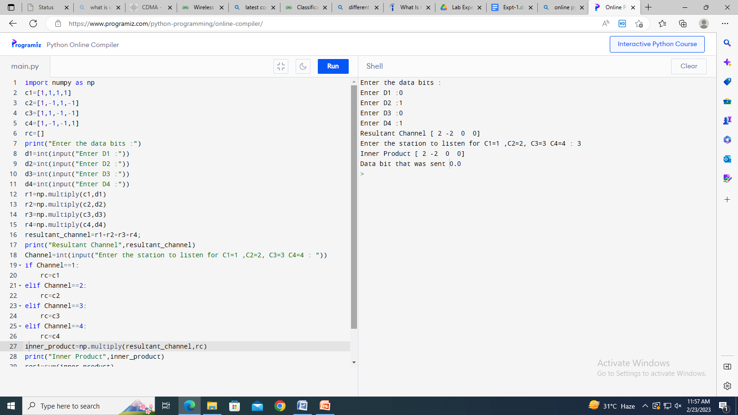

**V. CONCLUSION:**

**SIGNATURE**

**REFERENCES**:

1. “Mobile Communications” – Jochen Schiller.