**Assessment**

You can check here nodejsapp:

Ip: 54.91.132.3:3000

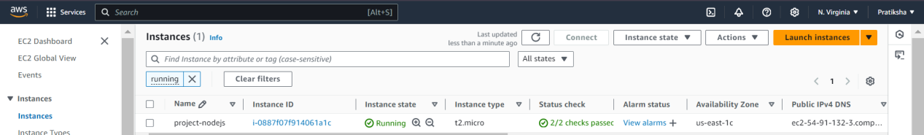

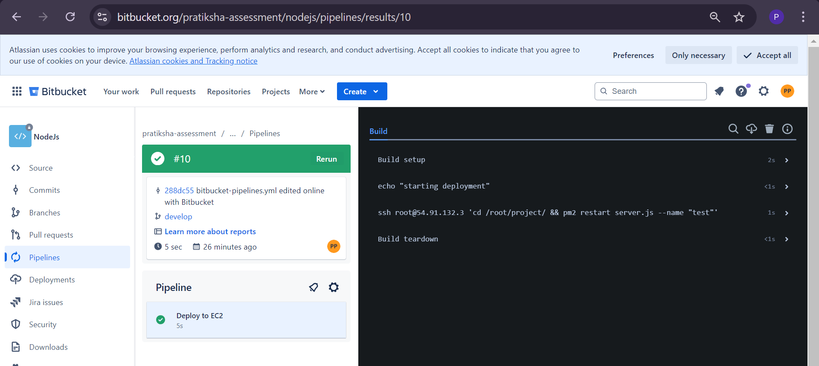

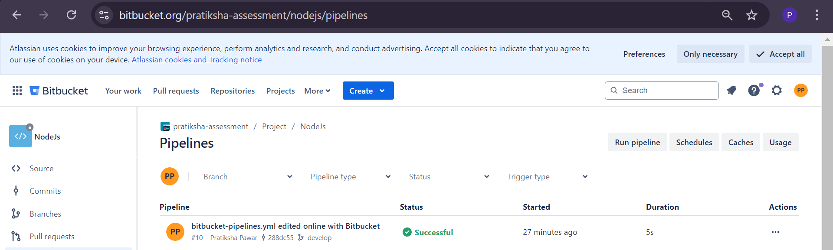

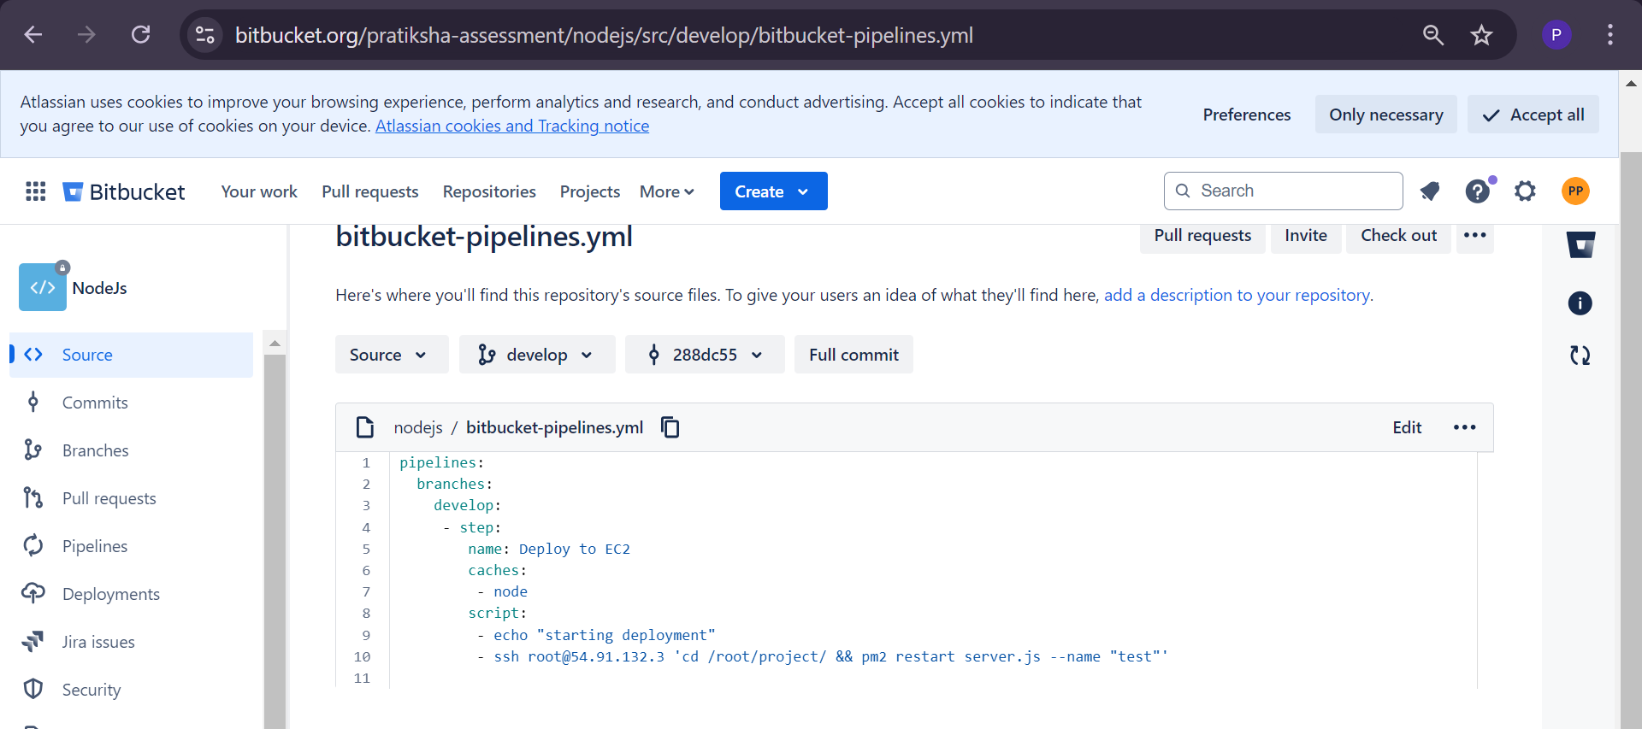

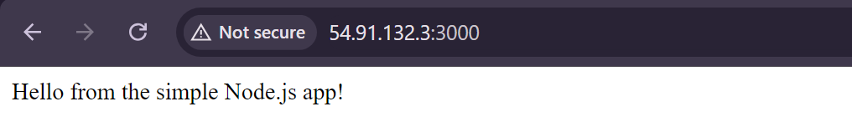

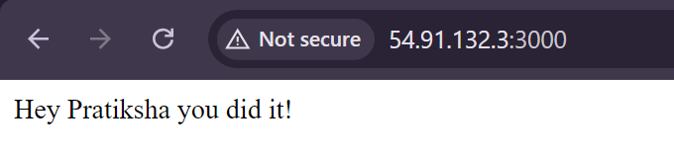

I encountered an indentation error in the pipeline, but I resolved it.

In the last 30 seconds of the recording, the pipeline was successful. You can check it!

Thank you!

Pratiksha Pawar