**Campus Connect**

**Assignment 1**

Name: Pratiksha Gupta

Course: M.Sc. (Computer Science) - Part 1

Language: C

Q1) Write a program to print all Perfect numbers between 1 to n.

* **Code:**

#include<stdio.h>

int main()

{

int i, j, upper, sum;

printf("Enter upper limit: ");

scanf("%d", &upper);

printf("All Perfect numbers between 1 to %d:\n", upper);

for(i=1; i<=upper; i++)

{

sum = 0;

for(j=1; j<i; j++)

{

if(i % j == 0)

{

sum += j;

}

}

if(sum == i)

{

printf("%d \n", i);

}

}

return 0;

}

* 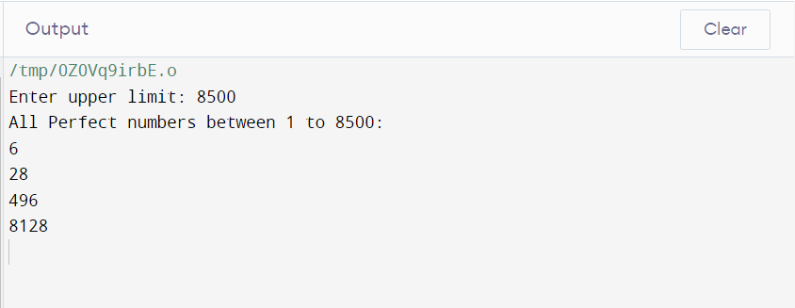**Output:**

Q2) Write a program to find occurrence of each digit in a given number.

* **Code:**

#include <stdio.h>

int occurrence(int num,int dig)

{

int rem, cnt;

cnt=0;

while(num>0)

{

rem=num%10;

if(rem==dig)

cnt++;

num/=10;

}

return cnt;

}

int main()

{

int num, digit, cnt;

printf("Enter a number: ");

scanf("%d",&num);

printf("Enter digit to search: ");

scanf("%d",&digit);

cnt=occurrence(num,digit);

printf("Total occurrence of digit is: %d in number: %d.",cnt,num);

return 0;

}

* **Output:**

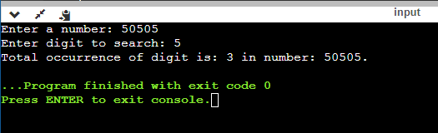

**Assignment 2**

Q1) Write a code to convert number into words.

* **Code:**

#include<stdio.h>

#include<stdlib.h>

int main(){

long int n,sum=0,r;

system("cls");

printf("enter the number=");

scanf("%ld",&n);

while(n>0)

{

r=n%10;

sum=sum*10+r;

n=n/10;

}

n=sum;

while(n>0)

{

r=n%10;

switch(r)

{

case 1:

printf("one ");

break;

case 2:

printf("two ");

break;

case 3:

printf("three ");

break;

case 4:

printf("four ");

break;

case 5:

printf("five ");

break;

case 6:

printf("six ");

break;

case 7:

printf("seven ");

break;

case 8:

printf("eight ");

break;

case 9:

printf("nine ");

break;

case 0:

printf("zero ");

break;

default:

printf("tttt");

break;

}

n=n/10;

}

return 0;

}

* 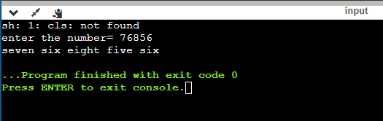**Output:**