A

PROJECT REPORT ON

**“E-Recruitment Portal”**

SUBMITTED BY

**Ms. Pratiksha Manoj Jadhav**

SUBMITTED TO

**SAVITRIBAI PHULE PUNE UNIVERSITY, PUNE**

IN PARTIAL FULFILLMENT OF DEGREE

**MASTER OF COMPUTER APPLICATION (SEM-II)**

UNDER THE GUIDANCE OF

**Prof. Girish Bal**

Through,



**Sadhu Vaswani Institute of Management Studies for Girls, Koregaon Park, Pune-411001**

**2023-24**

**CHAPTER 1: INTRODUCTION**

* 1. **Client / Organization Profile**

1. **Job Search:** Users can search for jobs based on various criteria such as location, industry, job title, experience level, and keywords.
2. **Resume/CV Upload:**  Job seekers can upload their resumes or CVs to the platform, which can be accessed by employers/recruiters.
3. **Profile Creation:** Users can create profiles containing their personal information, work experience, skills, education, and other relevant details.
4. **Job Alerts:** Job seekers can set up alerts based on their preferences to receive notifications about new job postings matching their criteria.
5. **Application Tracking:**  Job seekers can track the status of their job applications, including whether they have been viewed by employers and if they have been shortlisted for interviews.
6. **Company Profiles:** Users can access information about companies posting job openings, including company profiles, culture, benefits, and reviews from current or former employees.
7. **Messaging/Communication:** Job seekers can communicate with employers/recruiters directly through the platform, asking questions about job postings or scheduling interviews.
8. **Filtered Search:** Advanced search filters allow job seekers to refine their search based on specific criteria such as salary range, employment type (full-time, part-time, contract), and date posted.
   1. **Need for System**
9. **Efficient Job Matching:** A system facilitates the efficient matching of job seekers with relevant job listings based on various criteria such as skills, experience, location, and preferences. It should employ algorithms to recommend suitable job opportunities to candidates and ensure that employers receive applications from qualified candidates.

**2. User Management:** An online job portal caters to different types of users, including job seekers, employers, and administrators. A system manages user registration, authentication, profiles, preferences, and permissions effectively to provide personalized experiences and maintain security.

**3. Job Posting and Management:** Employers need a streamlined process to post job openings, including entering job details, setting requirements, specifying application deadlines, and managing applications received. A system should support these functionalities, providing employers with tools to manage their job listings efficiently.

**4. Application Management:** Job seekers submit applications for positions they are interested in, and employers need a system to manage these applications. This includes reviewing applications, shortlisting candidates, scheduling interviews, and communicating with applicants. An effective system automates these processes and provides tools for efficient applicant tracking.

**5. Search and Filtering Capabilities**: Job seekers rely on search and filtering functionalities to find relevant job opportunities quickly. A system should offer advanced search options, allowing users to filter job listings based on criteria such as location, industry, salary, and keywords, enhancing the overall user experience.

* 1. **Scope & Feasibility Work**

The system focuses specifically on the vacancy match for the company through this portal. If the need is satisfied employee ca apply for the job. However, a similar system can be built for identifying the best applications in any other domain.

**Feasibility Study**

**Technical Feasibility:**

* Evaluate the technical requirements and infrastructure needed to develop and maintain the online job portal.
* Assess the availability of technology platforms, tools, and resources required for website/app development, hosting, and maintenance.
* Consider scalability, security, and performance requirements of the platform.

**Operational Feasibility:**

* Evaluate the operational aspects of running the online job portal, including staffing, management, and support.
* Assess the organizational capabilities and resources available to launch and operate the portal effectively.
* Consider any potential challenges or risks related to day-to-day operations.
  1. **Operating Environment – H/w & S/w**

***Software:***

**Operating System:** Minimum Windows 10 or Above

**Application:** Web Application

**XAMPP:** 3.3.0

**PHP:** 3.3.0

**Apache server:** version 2.4.

**MySQL:** 8.1

* 1. **Architecture of System**

**Component Diagram**

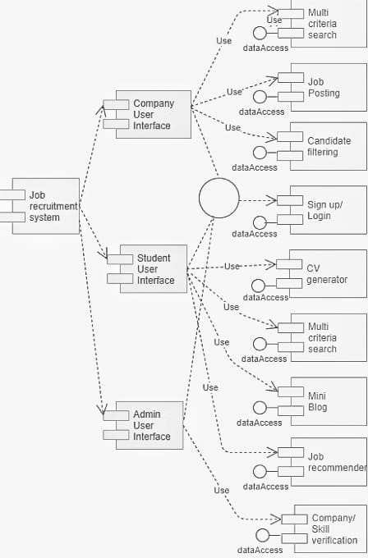

**Deployment Diagram**

* 1. **Detail Description of Technology Used**

**PHP:**

PHP is an acronym for "PHP: Hypertext Preprocessor”.

PHP is a widely used, open-source scripting language.

PHP scripts are executed on the server.

PHP is free to download and use.

It is powerful enough to be at the core of the biggest blogging system on the web (WordPress)!

It is deep enough to run large social networks!

It is also easy enough to be a beginner's first server-side language!

**HTML:**

* HTML stands for Hyper Text Markup Language
* HTML is the standard markup language for creating Web pages
* HTML describes the structure of a Web page
* HTML consists of a series of elements
* HTML elements tell the browser how to display the content
* HTML elements label pieces of content such as "this is a heading", "this is a paragraph", "this is a link", etc.

**CSS:**

* CSS stands for Cascading Style Sheets
* CSS describes how HTML elements are to be displayed on screen, paper, or in other media.
* CSS saves a lot of work. It can control the layout of multiple web pages all at once.
* External stylesheets are stored in CSS files.

**JavaScript:**

* JavaScript is the world's most popular programming language.
* JavaScript is the programming language of the Web.
* JavaScript is easy to learn.
* This tutorial will teach you JavaScript from basic to advanced.

**Bootstrap:**

* Bootstrap is the most popular HTML, CSS, and JavaScript framework for developing a responsive and mobile friendly website.
* It is free to download and use.
* It is a front-end framework used for easier and faster web development.
* It includes HTML and CSS based design templates for typography, forms, buttons, tables, navigation, modals, image carousels and many others.
* It can also use JavaScript plug-ins.
* It facilitates you to create responsive designs.

**MySQL:**

* MySQL is a relational database management system.
* MySQL is open source.
* MySQL is free.
* MySQL is ideal for both small and large applications.
* MySQL is very fast, reliable, scalable, and easy to use.
* MySQL is cross-platform.
* MySQL is compliant with the ANSI SQL standard.
* MySQL was first released in 1995.
* MySQL is developed, distributed, and supported by Oracle Corporation
* MySQL is named after co-founder Monty Widenius's daughter.

**CHAPTER 2: PROPOSED SYSTEM**

**2.1 Proposed System**

The proposed system is very useful for the client side of JOB PORTAL. This avoids the overheads of maintaining data manually. This can minimize the working stress and can keep essential documents related to registration and complaints as a softcopy.

The registration form details like Name, email, phone number, gender, date of birth, user id, password can be easily managed. The whole data is saved in a database which is a secure way to keep the records.

**2.2 Objectives of System**

* The project avoids the maintaining data manually.
* This can minimize the working stress and can keep essential documents related to registration and complaints as a softcopy.
* to help employers to post their job offers online and search their database to find people who best suit their vacant job positions.

**2.3 User Requirements**

**1. User Registration and Authentication:**

Users should be able to register for an account on the platform easily.

The registration process should be intuitive and require minimal information.

Users should be able to log in securely using email/password or social media accounts.

**2. Profile Creation and Management:**

Users should be able to create and manage their profiles with personal information, contact details, work experience, education, skills, and preferences.

The profile should be customizable and allow users to upload resumes, portfolios, and other relevant documents.

Users should have the option to update or modify their profiles at any time.

**3. Job Search and Filtering:**

Job seekers should be able to search for job listings based on various criteria such as location, industry, job title, salary range, experience level, and keywords.

Advanced search and filtering options should be available to refine search results and find relevant job opportunities quickly.

**4. Job Application and Tracking:**

Job seekers should be able to view detailed job descriptions and apply for positions directly through the platform.

The application process should be straightforward and allow users to submit resumes, cover letters, and other required documents.

Users should be able to track the status of their job applications, including whether they have been viewed, shortlisted, or rejected by employers.

**5. Communication and Messaging:**

Users should be able to communicate with employers, recruiters, and other users directly through the platform.

Messaging features should support real-time communication, notifications, and file attachments.

Users should have the option to receive notifications about new job listings, messages, or updates related to their applications.

**6. Company Profiles and Reviews:**

Employers should be able to create and manage company profiles with information about their organization, culture, values, benefits, and job openings.

Job seekers should be able to view company profiles, read reviews from current or former employees, and assess the reputation and suitability of potential employers.

**7. Recommendations and Personalization:**

The platform should provide personalized job recommendations based on user profiles, preferences, and past interactions.

Users should receive recommendations for relevant job opportunities, career development resources, and networking events tailored to their interests and goals.

**8. Feedback and Support:**

Users should have the ability to provide feedback, report issues, and contact customer support easily.

The platform should have a dedicated support team to address user inquiries, resolve technical issues, and provide assistance when needed.

**CHAPTER 3: ANALYSIS & DESIGN**

**3.1 Table Specifications**

TBLAPPLICANTS

|  |  |  |  |
| --- | --- | --- | --- |
| FIELD NAME | DATA TYPE | DESCRIPTION | CONSTRAINTS |
| **APPLICANTID** | INT(11) | **APPLICANT ID** | NULL |
| **FNAME** | VARCHAR(90) | **FIRST NAME** | NULL |
| **LNAME** | VARCHAR(90) | **LAST NAME** | NULL |
| **MNAME** | VARCHAR(90) | **MIDDLE NAME** | NULL |
| **ADDRESS** | VARCHAR(255) | **ADDRESS** | NULL |
| **SEX** | VARCHAR(11) | **SEX** | NULL |
| **CIVILSTATUS** | VARCHAR(30) | **CIVIL STATUS** | NULL |
| **BIRTHDATE** | DATE | **BIRTH DATE** | NULL |
| **BIRTHPLACE** | VARCHAR(255) | **BIRTH PLACE** | NULL |
| **AGE** | INT(11) | **AGE** | NULL |
| USERNAME | VARCHAR(90) | USERNAME | NULL |
| PASS | VARCHAR(90) | PASSWORD | NULL |
| EMAILADDRESS | VARCHAR(90) | EMAIL ADDRESS | NULL |
| CONTACTNO | VARCHAR(90) | CONTACT NUMBER | NULL |
| DEGREE | TEXT | DEGREE | NULL |
| APPLICANTPHOTO | VARCHAR(255) | APPLICANT PHOTO | NULL |
| NATIONALID | VARCHAR(255) | NATIONAL ID | NULL |

TBLATTACHMENTFILE

|  |  |  |  |
| --- | --- | --- | --- |
| FIELD NAME | DATA TYPE | DESCRIPTION | CONSTRAINTS |
| ID | INT(11) | ID | NULL |
| FILEID | VARCHAR(90) | FILE ID | NULL |
| **JOBID** | INT(11) | **JOB ID** | NULL |
| **FILE_NAME** | VARCHAR(90) | **FILE NAME** | NULL |
| **FILE_LOCATION** | VARCHAR(255) | **FILE LOCATION** | NULL |
| **USERATTACHMENTID** | INT(11) | **USER ATTACHMENT ID** | NULL |

TBLAUTONUMBER

|  |  |  |  |
| --- | --- | --- | --- |
| FIELD NAME | DATA TYPE | DESCRIPTION | CONSTRAINTS |
| **AUTOID** | INT(11) | **AUTO ID** | NULL |
| **AUTOSTART** | VARCHAR(30) | **AUTO START** | NULL |
| **AUTOEND** | INT(11) | **AUTO END** | NULL |
| **AUTOINC** | INT(11) | **AUTO INCREMENT** | NULL |
| **AUTOKEY** | VARCHAR(30) | **AUTO KEY** | NULL |

TBLCATEGORY

|  |  |  |  |
| --- | --- | --- | --- |
| FIELD NAME | DATA TYPE | DESCRIPTION | CONSTRAINTS |
| CATEGORYID | INT(11) | CATEGORY ID | NULL |
| CATEGORY | VARCHAR(250) | CATEGORY NAME | NULL |

TBLCOMPANY

|  |  |  |  |
| --- | --- | --- | --- |
| FIELD NAME | DATA TYPE | DESCRIPTION | CONSTRAINTS |
| COMPANYID | INT(11) |  | NULL |
| COMPANYNAME | VARCHAR(90) |  | NULL |
| COMPANYADDRESS | VARCHAR(90) |  | NULL |
| COMPANYCONTACTNO | VARCHAR(90) |  | NULL |
| COMPANYSTATUS | VARCHAR(90) |  | NULL |
| COMPANYMISSION | TEXT |  | NULL |

TBLEMPLOYEES

|  |  |  |  |
| --- | --- | --- | --- |
| FIELD NAME | DATA TYPE | DESCRIPTION | CONSTRAINTS |
| INCID | INT(11) | INC ID | NULL |
| **EMPLOYEEID** | VARCHAR(30) | **EMPLOYEE ID** | NULL |
| **FNAME** | VARCHAR(50) | **FIRST NAME** | NULL |
| **LNAME** | VARCHAR(50) | **LAST NAME** | NULL |
| **MNAME** | VARCHAR(50) | **MIDDLE NAME** | NULL |
| **ADDRESS** | VARCHAR(90) | **ADDRESS** | NULL |
| **BIRTHDATE** | DATE | **BIRTH DATE** | NULL |
| **BIRTHPLACE** | VARCHAR(90) | **BIRTH PLACE** | NULL |
| AGE | INT(11) | AGE | NULL |
| SEX | VARCHAR(30) | SEX | NULL |
| **CIVILSTATUS** | VARCHAR(30) | **CIVIL STATUS** | NULL |
| **TELNO** | VARCHAR(40) | **TELEPHONE NO** | NULL |
| **EMP_EMAILADDRESS** | VARCHAR(90) | **EMPLOYEE EMAIL ADDRESS** | NULL |
| **CELLNO** | VARCHAR(30) | **CELLPHONE NO** | NULL |
| **POSITION** | VARCHAR(50) | **POSITION** | NULL |
| **WORKSTATS** | VARCHAR(90) | **WORK STATS** | NULL |
| **EMPPHOTO** | VARCHAR(255) | **EMPLOYEE PHOTO** | NULL |
| **EMPUSERNAME** | VARCHAR(90) | **EMPLOYEE USERNAME** | NULL |
| **EMPPASSWORD** | VARCHAR(125) | **EMPLOYEE PASSWORD** | NULL |
| **DATEHIRED** | DATE | **DATE HIRED** | NULL |
| **COMPANYID** | INT(11) | **COMPANYID** | NULL |

TBLFEEDBACK

|  |  |  |  |
| --- | --- | --- | --- |
| FIELD NAME | DATA TYPE | DESCRIPTION | CONSTRAINTS |
| FEEDBACKID | INT(11) | FEEDBACK ID | NULL |
| APPLICANTID | INT(11) | APPLICANT ID | NULL |
| REGISTRATIONID | INT(11) | REGISTRATION ID | NULL |
| FEEDBACK | TEXT | FEEDBACK | NULL |

TBLJOB

|  |  |  |  |
| --- | --- | --- | --- |
| FIELD NAME | DATA TYPE | DESCRIPTION | CONSTRAINTS |
| JOBID | Int(11) | JOB ID | NULL |
| COMPANYID | Int(11) | COMPANY ID | NULL |
| CATEGORY | Varchar(250) | CATEGORY | NULL |
| OCCUPATIONTITLE | Varchar(90) | OCCUPATION TITLE | NULL |
| REQ_NO_EMPLOYEES | Int(11) | REQUESTED NUMBER OF EMPLOYEES | NULL |
| SALARIES | Double | SALARY | NULL |
| DURATION_EMPLOYMENT | Varchar(90) | DURATION OF EMPLOYMENT | NULL |
| **QUALIFICATION_WORKEXPERIENCE** | Text | QUALIFICATION AND WORK EXPERIENCE | NULL |
| **JOBDESCRIPTION** | Text | JOB DESCRIPTION | NULL |
| **PREFEREDSEX** | Varchar(90) | GENDER | NULL |
| **SECTOR_VACANCY** | Text | VACANCY | NULL |
| **JOBSTATUS** | Varchar(30) | JOB STATUS | NULL |
| **DATEPOSTED** | date | DATE POSTED | NULL |

TBLJOBREGISTRATION

|  |  |  |  |
| --- | --- | --- | --- |
| FIELD NAME | DATA TYPE | DESCRIPTION | CONSTRAINTS |
| REGISTRATIONID | INT(11) | REGISTRATION ID | NULL |
| COMPANYID | INT(11) | COMPANY ID | NULL |
| JOBID | INT(11) | JOB ID | NULL |
| APPLICANTID | INT(11) | APPLICANT ID | NULL |
| APPLICANT | VARCHAR(90) | APPLICANT NAME | NULL |
| REGISTRATIONDATE | DATE | REGISTRATION DATE | NULL |
| REMARKS | VARCHAR(255) | REMARK | NULL |
| FILEID | VARCHAR(30) | FILE ID | NULL |
| PENDINGAPPLICATION | TINYINT | PENDING APPLICATION | NULL |
| HVIEW | TINYINT | VIEWS | NULL |
| DATETIMEAPPLICATION | DATETIME | DATE AND TIME | NULL |

TBLUSERS

|  |  |  |  |
| --- | --- | --- | --- |
| FIELD NAME | DATA TYPE | DESCRIPTION | CONSTRAINTS |
| USERID | VARCHAR(30) | USER ID | NULL |
| FULLNAME | VARCHAR(40) | FULL NAME | NULL |
| USERNAME | VARCHAR(90) | USERNAME | NULL |
| PASS | VARCHAR(90) | PASSWORD | NULL |
| ROLE | VARCHAR(30) | ROLE | NULL |
| PICLOCATION | VARCHAR(255) | PHOTO LOCATION | NULL |

**3.2 ERD**

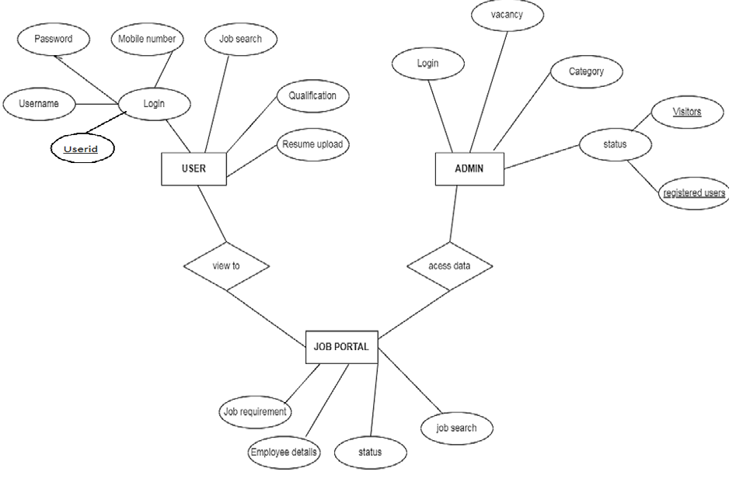

**3.3 Object Diagram**

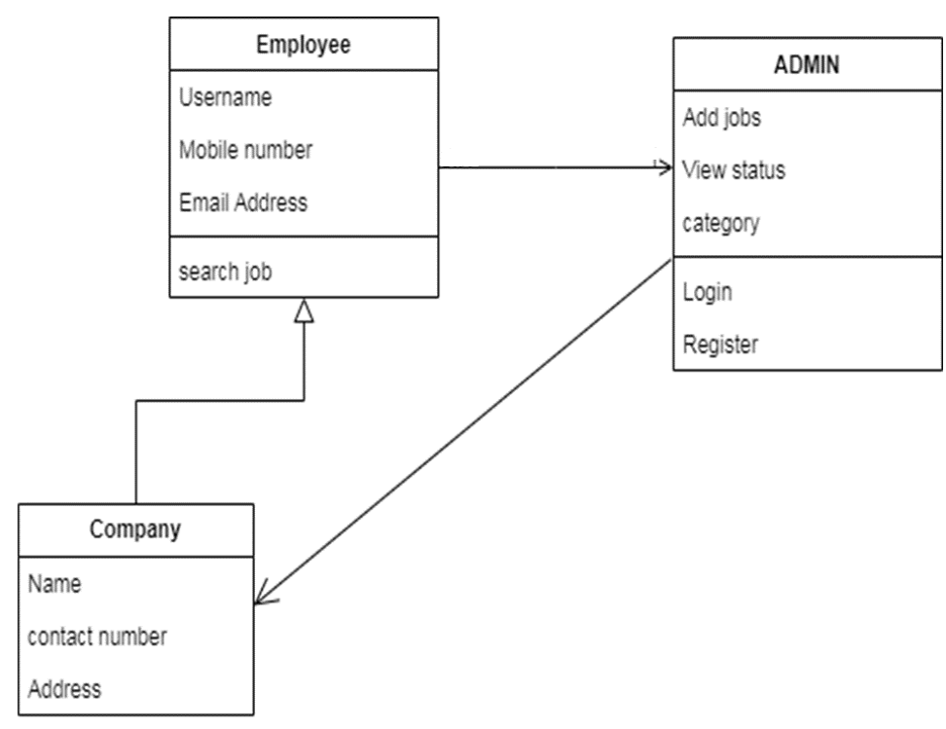

**3.4 Class Diagram**

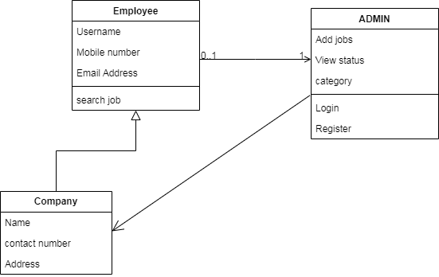

**3.5 Use Case Diagrams**

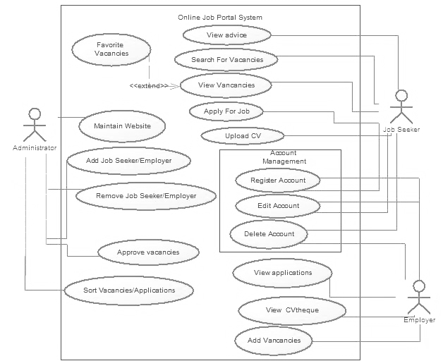

**3.7 Activity Diagram**

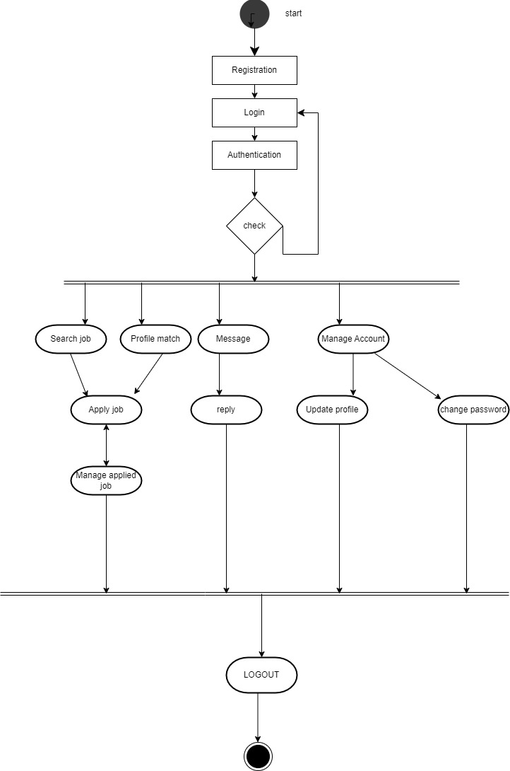

**CHAPTER 4: USER MANUAL**

**4.1 User Interface Design**

*Admin panel*

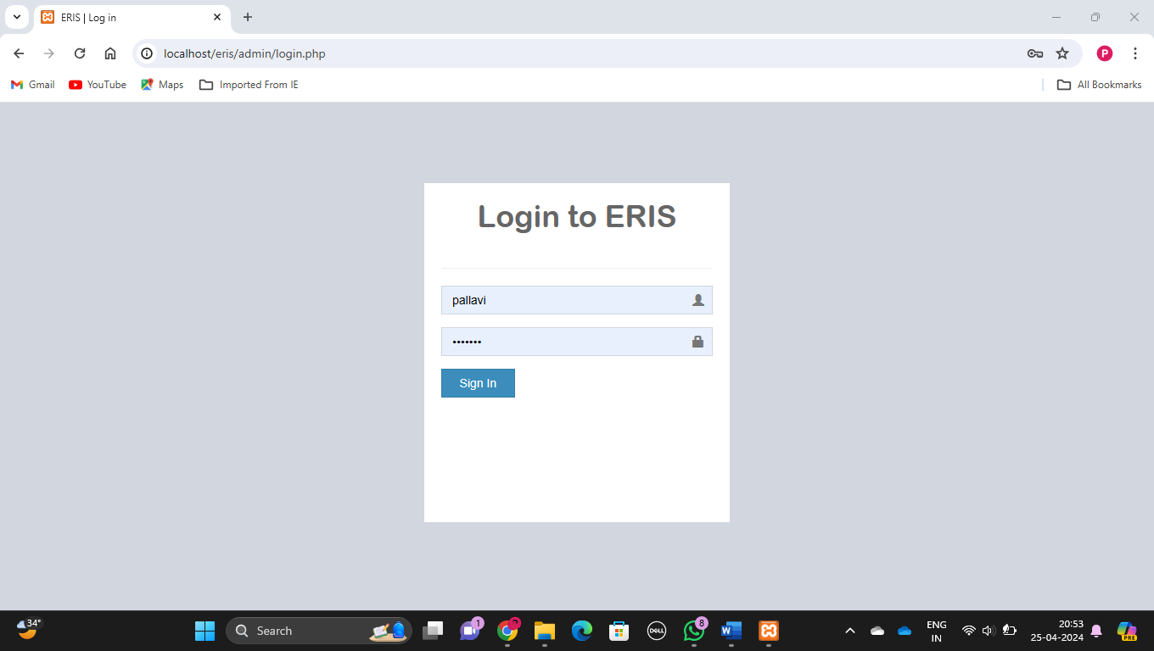

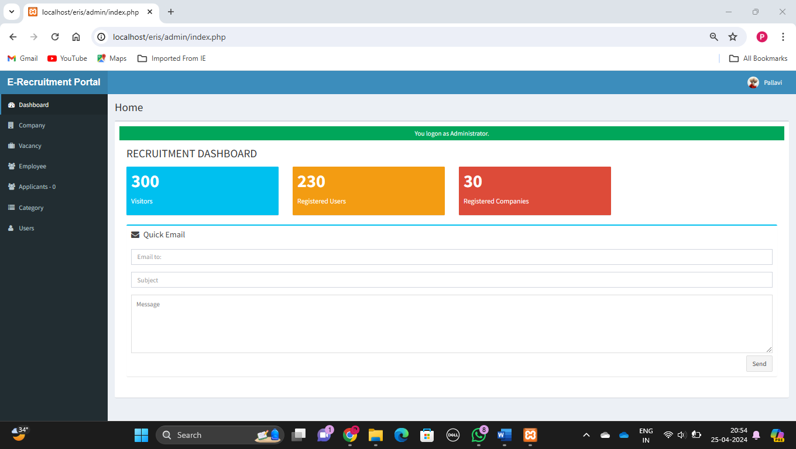

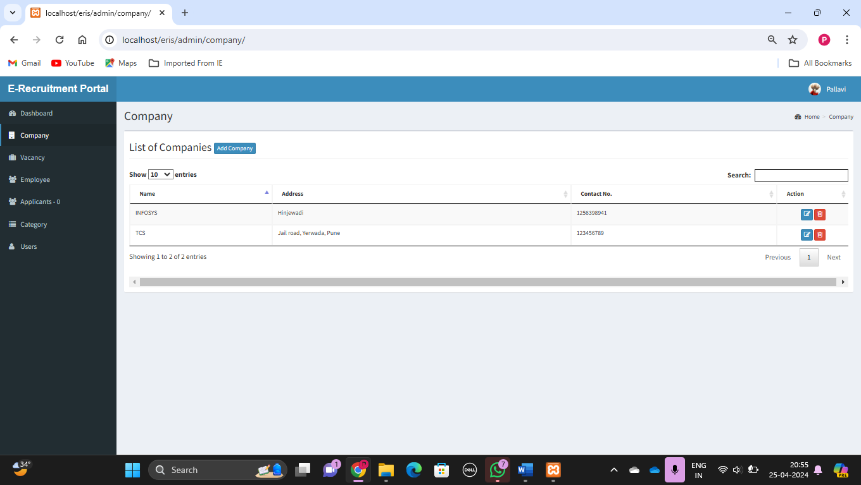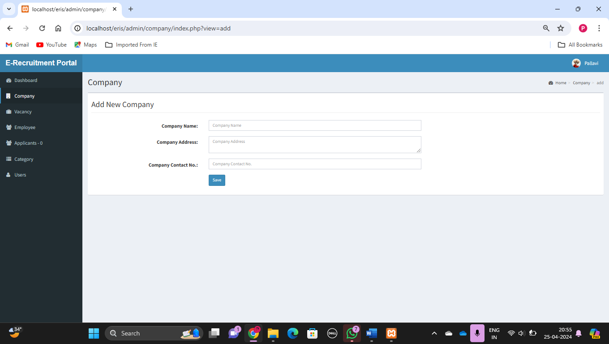 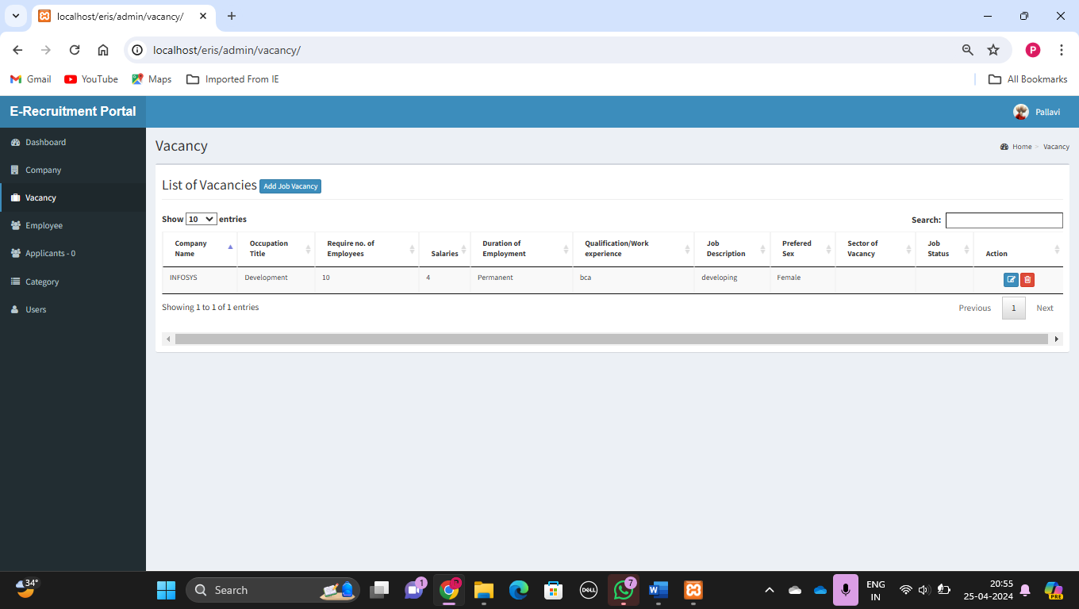

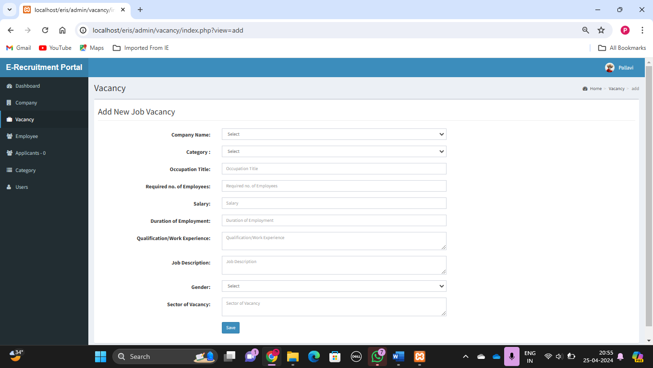

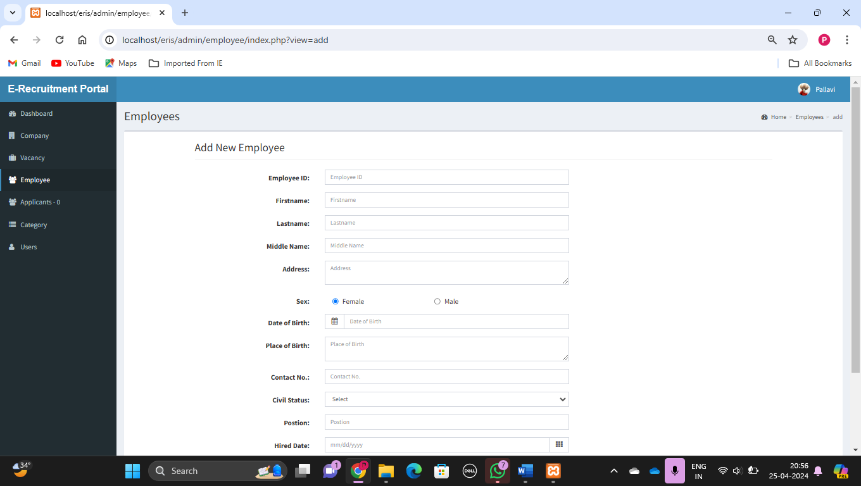

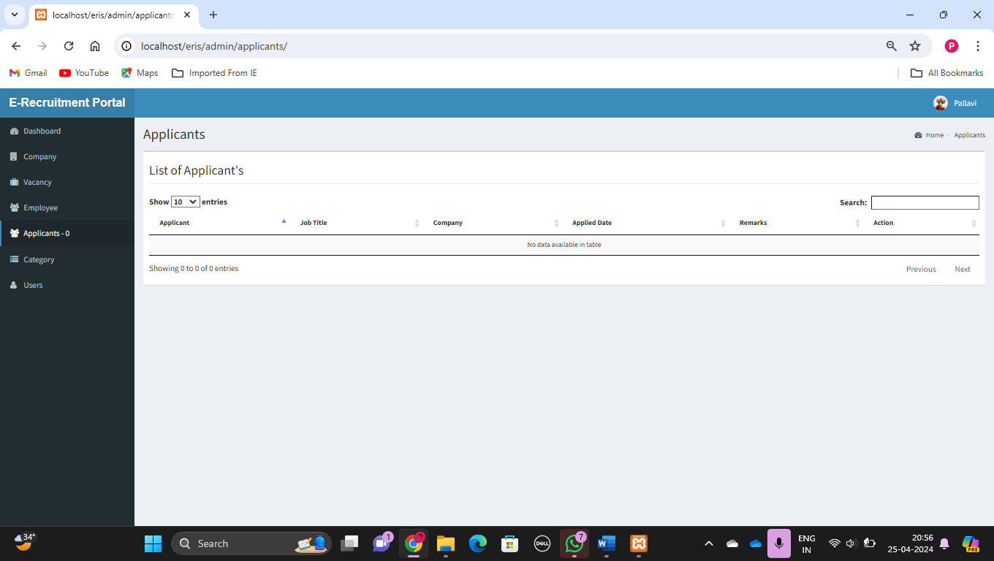

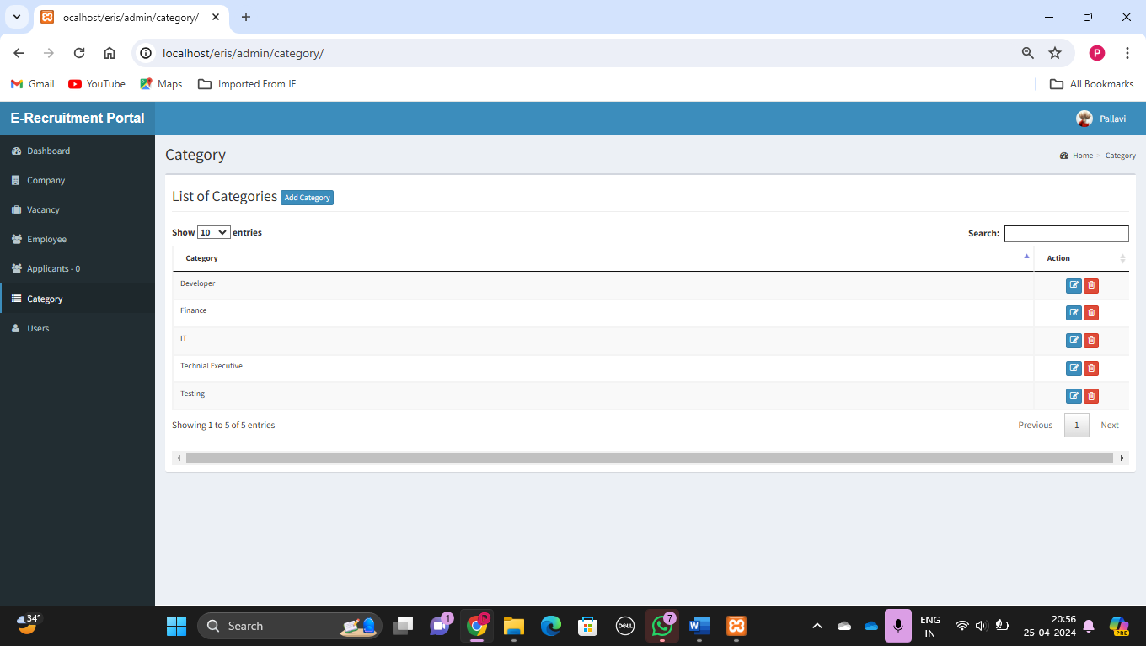

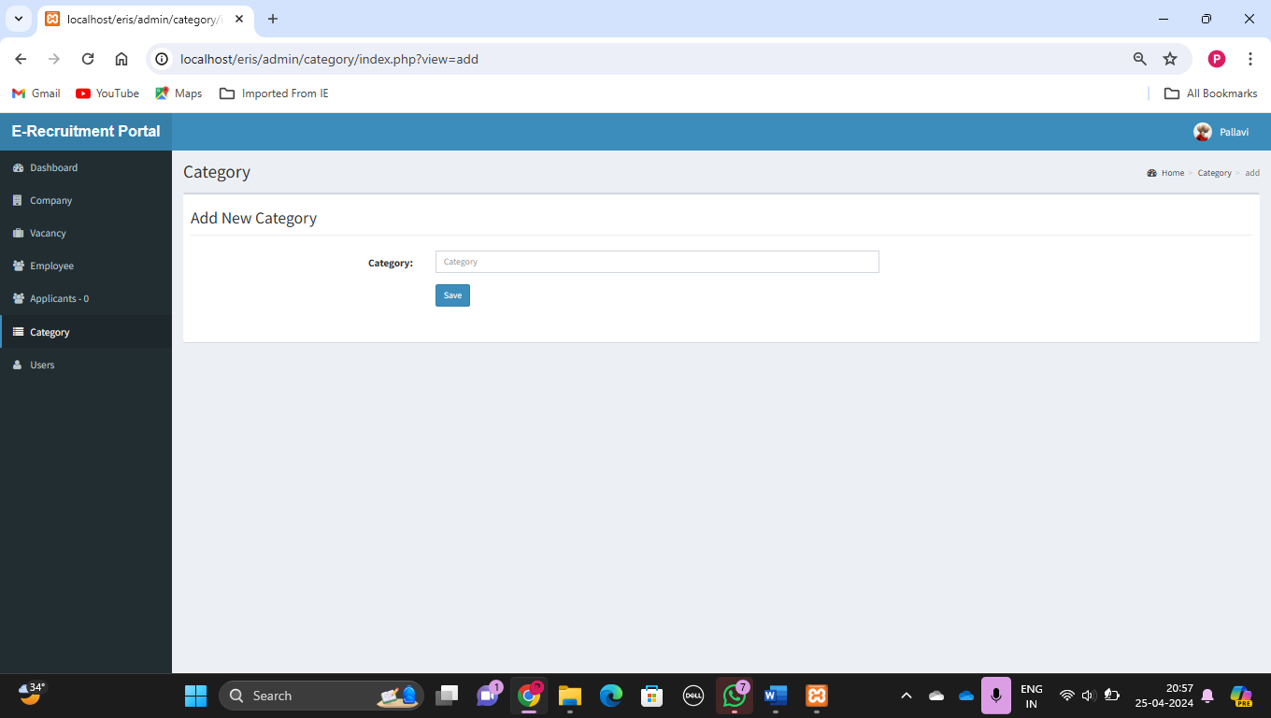

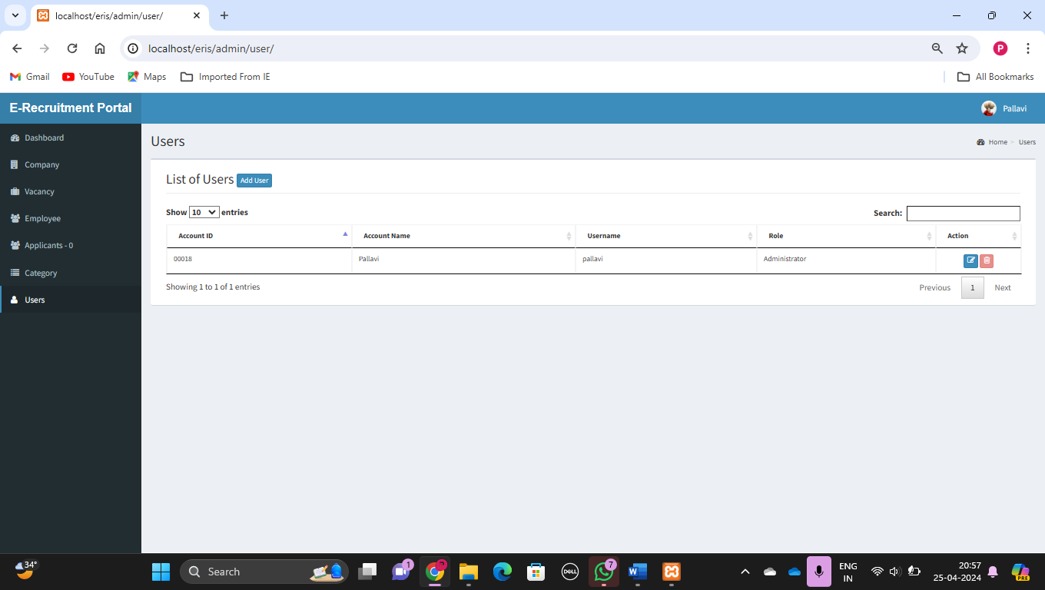

*Employee Pannel-*

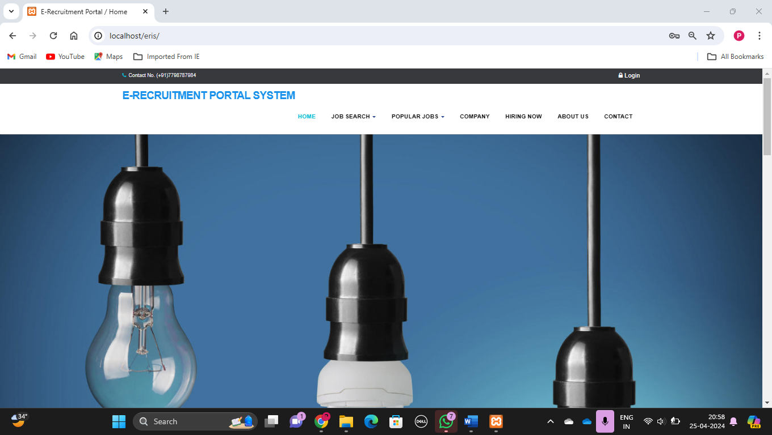

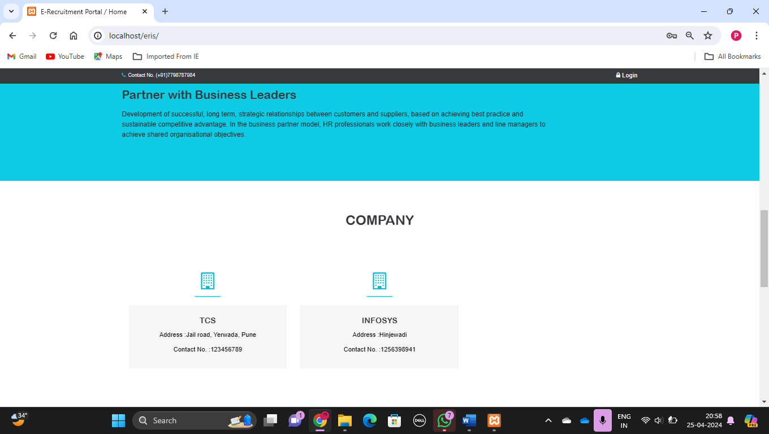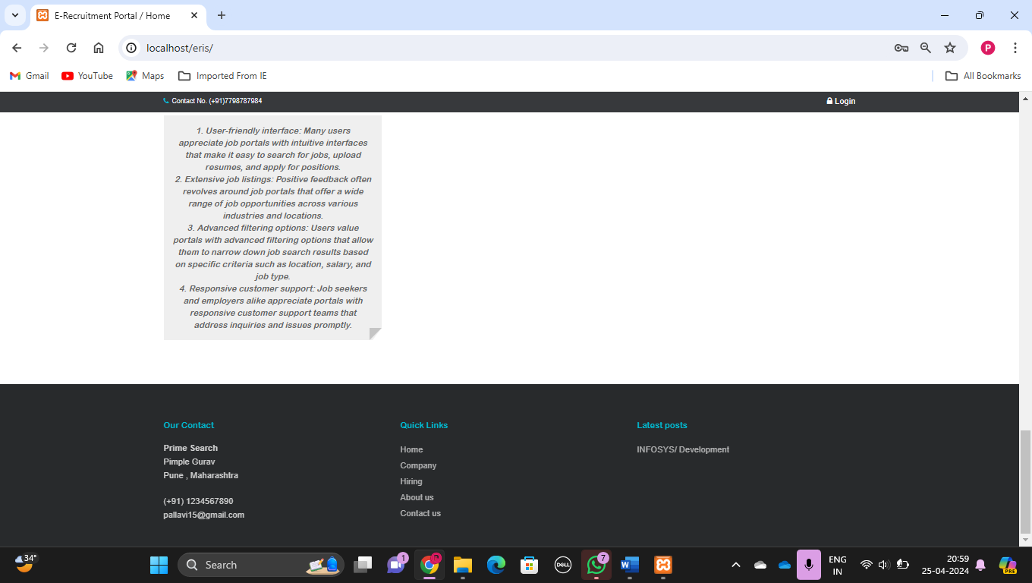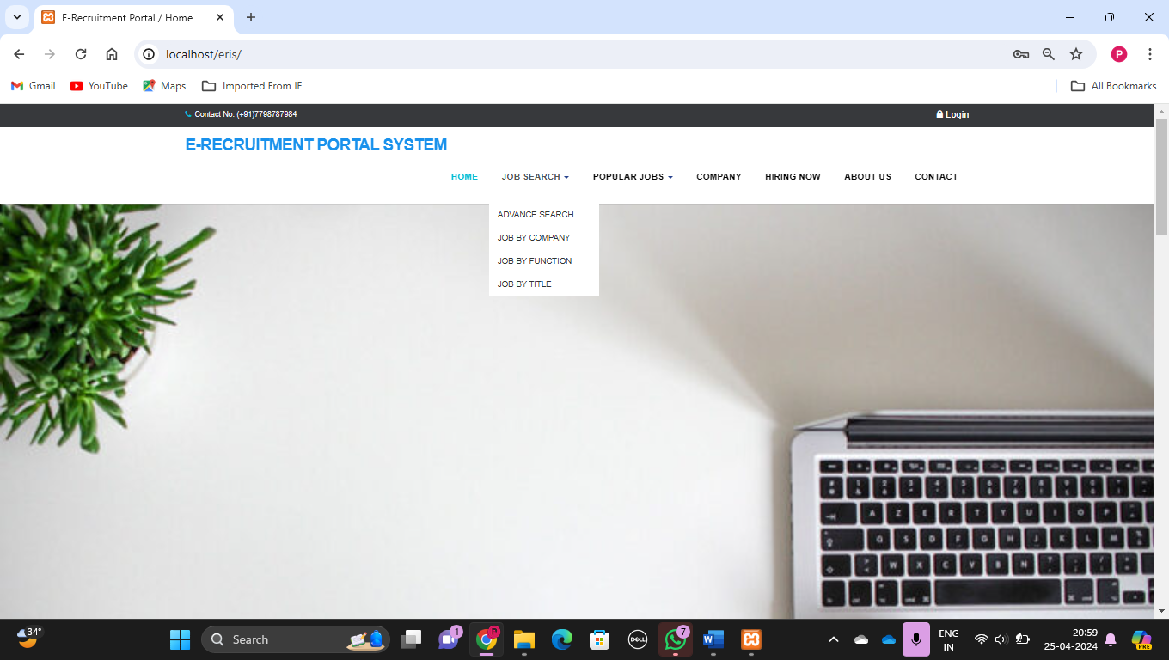 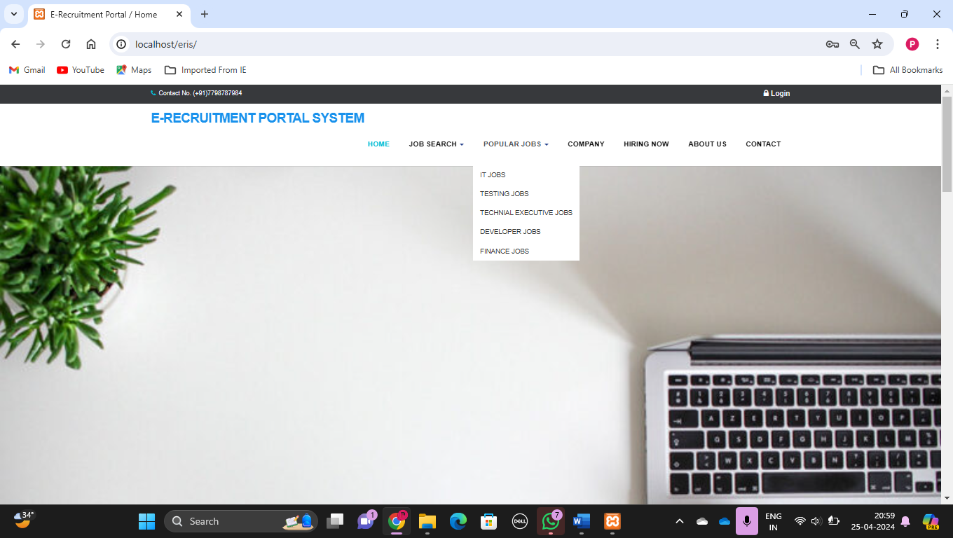

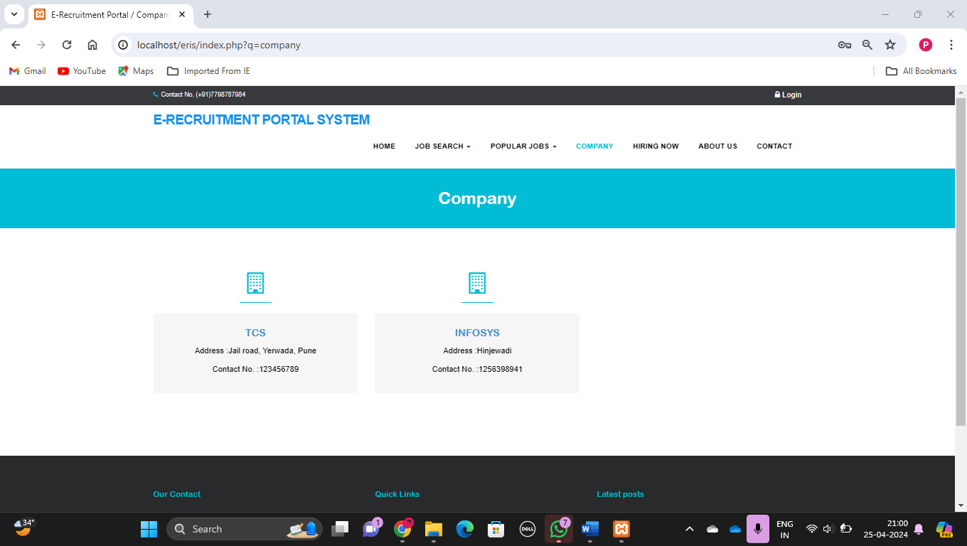

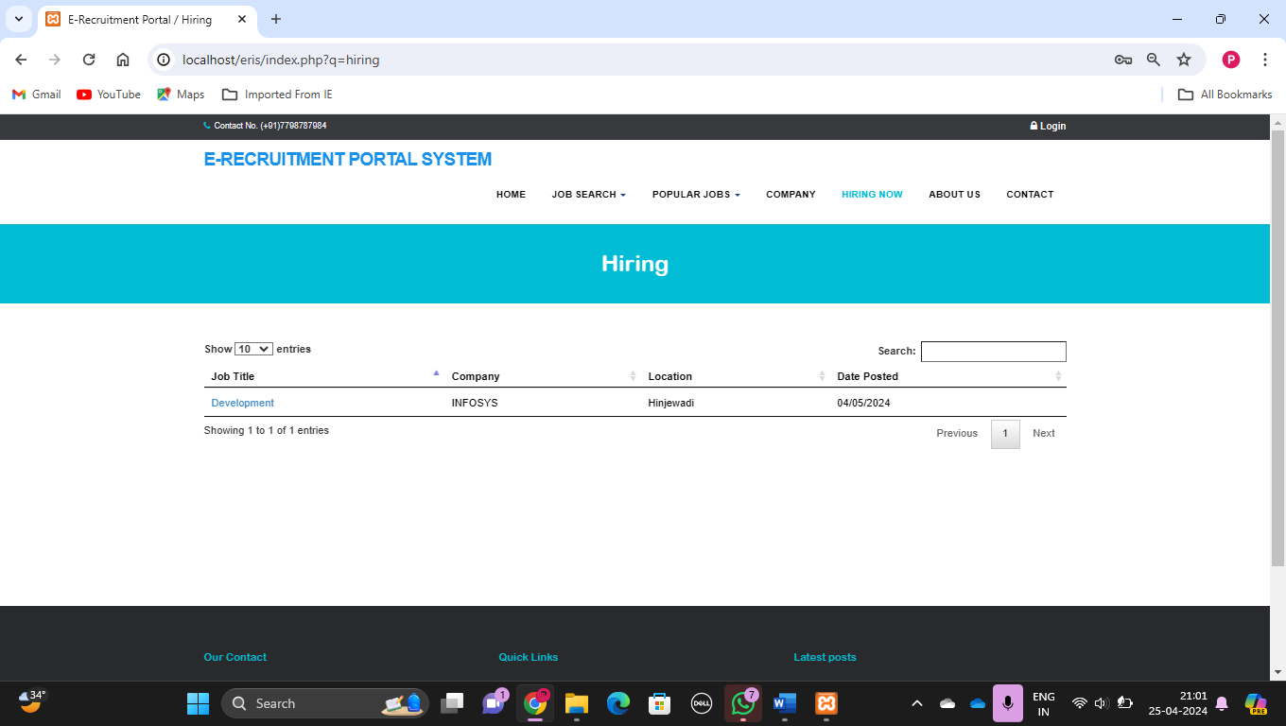

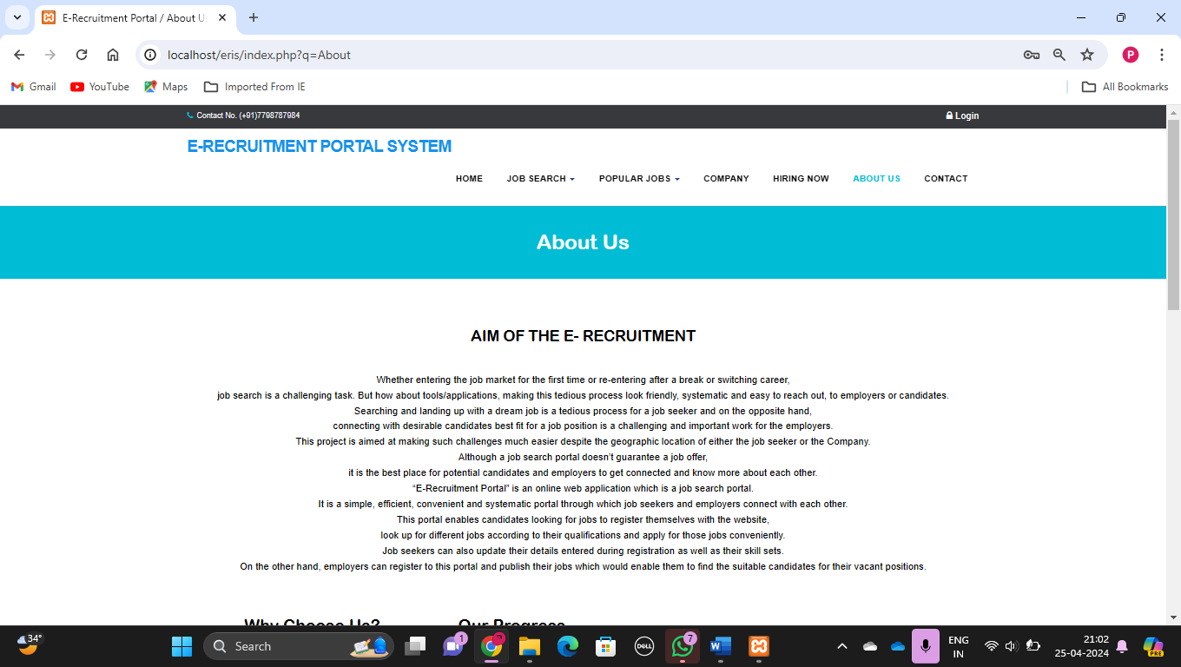

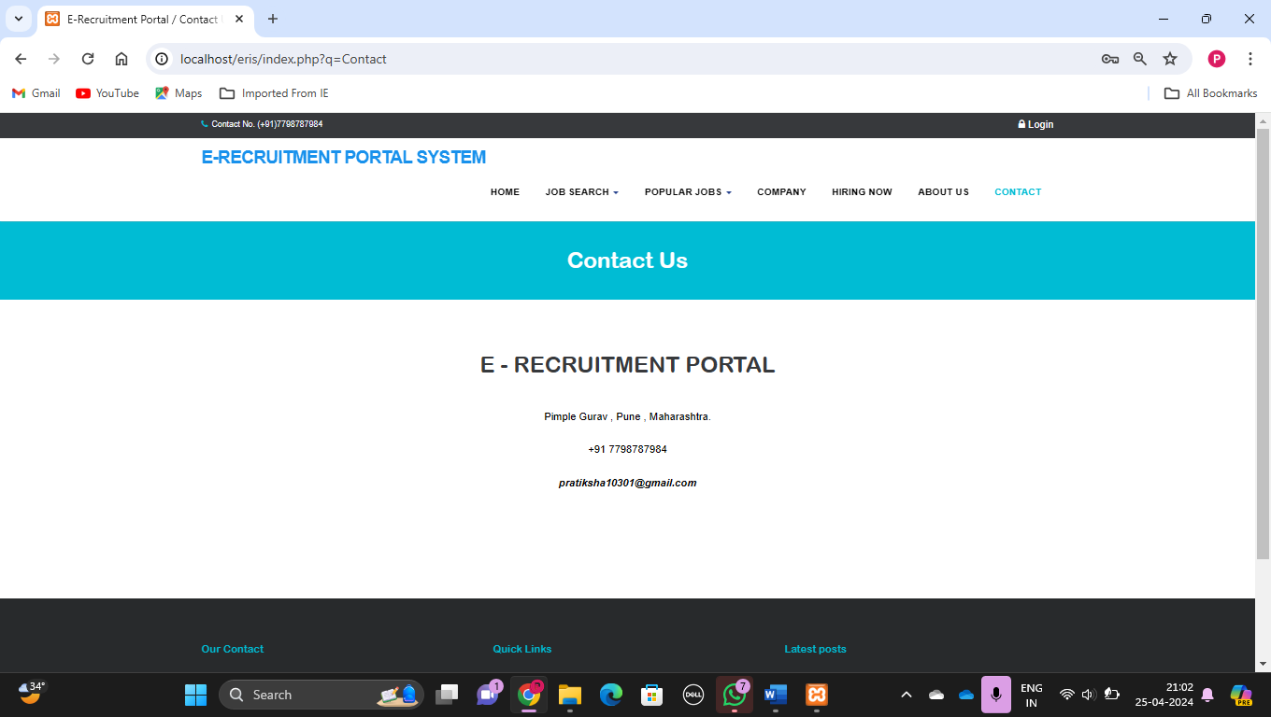

**4.2 Limitations**

1. Competition: Job seekers often face intense competition on online job portals due to the large number of applicants for popular positions. This can make it challenging for qualified candidates to stand out among the crowd.

2. Impersonal Interaction: Online job portals can lack the personal touch of face-to-face interactions. Candidates may feel like they're sending their resumes into a void, and employers may struggle to gauge a candidate's personality or cultural fit from an online application.

3. Mismatched Expectations: Job descriptions on online portals may not always accurately reflect the actual responsibilities or requirements of a position. This can lead to mismatches between what job seekers expect and what employers are offering.

4. Incomplete Information: Sometimes, job postings on online portals lack sufficient information about the company, job role, or compensation package. This can make it difficult for job seekers to evaluate whether a position is the right fit for them.

**4.3 Future Enhancement**

* Empower job seekers with an integrated resume builder that simplifies the process of creating and formatting professional resumes.
* Integrate social media platforms to allow job seekers to sign up or log in using their social media accounts, making the registration process convenient.
* Implement a secure payment gateway to facilitate transactions related to premium job postings or subscription plans.
* Incorporate the option for job seekers to upload video resumes and conduct video interviews, providing a more interactive and engaging experience.
* Privacy Settings regarding user profile

**BIBLIOGRAPHY**

*1. Barua, Animesh, et al. "Online Job Portal System." International Journal of Scientific and Research Publications, vol. 3, no. 5, May 2013, pp. 1-5.*

*2. Gupta, Richa, and Gargi Goel. "Design and Implementation of Online Job Portal System." International Journal of Computer Applications, vol. 138, no. 5, March 2016, pp. 38-42.*

*3. Rani, Vinita, et al. "Design and Implementation of a Job Portal." International Journal of Innovative Research in Computer and Communication Engineering, vol. 3, no. 5, May 2015, pp. 4173-4177.*

*4. Singh, Deepali, and Megha Gupta. "Analysis and Design of Online Job Portal System." International Journal of Innovative Research in Computer Science & Technology, vol. 3, no. 4, April 2015, pp. 28-34.*

*5. Suryawanshi , Shital S., et al. "Online Job Portal System: A Case Study." International Journal of Computer Applications, vol. 126, no. 2, September 2015, pp. 21-24.*

*6. Vijayakumar, M., et al. "Design and Development of Online Job Portal System Using PHP and MySQL." International Journal of Science and Research (IJSR), vol. 4, no. 3, March 2015, pp. 2319-7064.*

*7. Yin, Xiaohui, et al. "Design and Implementation of Online Job Portal Based on B/S Architecture." 2019 IEEE International Conference on Computational Science and Engineering (CSE) and IEEE International Conference on Embedded and Ubiquitous Computing (EUC), August 2019, pp. 221-225.*

*8. Zaidi, Sayed Feroz, and Feroz Farazi. "Design and Implementation of a Job Portal System Using PHP." International Journal of Advanced Research in Computer Science, vol. 8, no. 4, May 2017, pp. 133-137.*

**ANNEXURE: Sample program code**

<!DOCTYPE html>

<html lang="en">

<head>

<meta charset="UTF-8">

<meta name="viewport" content="width=device-width, initial-scale=1.0">

<title>Job Listings</title>

</head>

<body>

<h1>Job Listings</h1>

<?php

// Connect to database

$conn = mysqli_connect("localhost", "username", "password", "recruitment");

// Check connection

if (!$conn) {

die("Connection failed: " . mysqli_connect_error());

}

// Fetch job listings

$sql = "SELECT * FROM jobs";

$result = mysqli_query($conn, $sql);

if (mysqli_num_rows($result) > 0) {

// Output data of each row

while($row = mysqli_fetch_assoc($result)) {

echo "<h2>" . $row["title"] . "</h2>";

echo "<p>" . $row["description"] . "</p>";

echo "<form action='apply.php' method='post'>";

echo "<input type='hidden' name='job_id' value='" . $row["id"] . "'>";

echo "<input type='submit' value='Apply'>";

echo "</form>";

}

} else {

echo "No jobs available";

}

mysqli_close($conn);

?>

</body>

</html>

<!DOCTYPE html>

<html lang="en">

<head>

<meta charset="UTF-8">

<meta name="viewport" content="width=device-width, initial-scale=1.0">

<title>Post a Job</title>

</head>

<body>

<h1>Post a Job</h1>

<form action="submit_job.php" method="post">

<label for="title">Job Title:</label><br>

<input type="text" id="title" name="title" required><br>

<label for="description">Job Description:</label><br>

<textarea id="description" name="description" required></textarea><br>

<input type="submit" value="Post Job">

</form>

</body>

</html>