Q1 ) 1. create all given tables

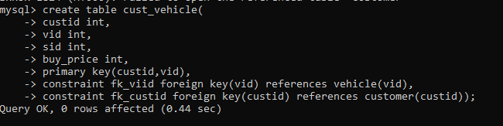

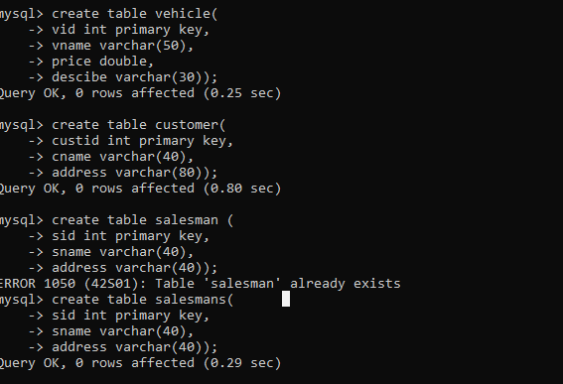

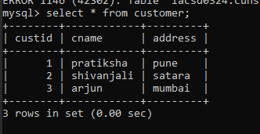

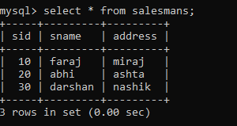

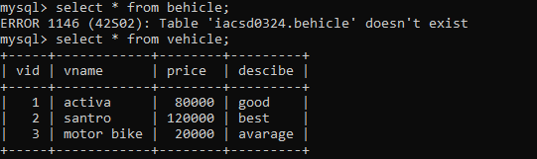

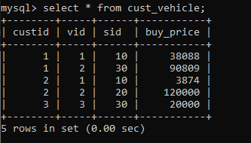

2. create index on vehicle table based on price

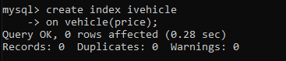

**3. find all customer name,vehicle name, salesman name, discount earn by all customer**

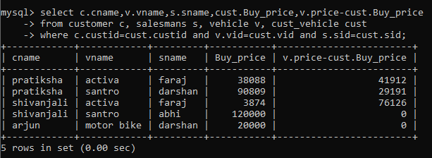

**4. find all customer name,vehicle name,salesman name for all salesman who stays in pune**

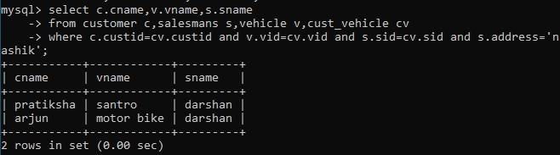

**5. find how many customers bought motor bike**

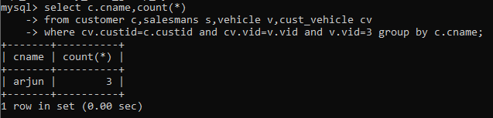

**6. create a view find_discount which displays output**

**-------to create view**

**create view find_discount**

**as**

**select cname,vname,price,buying_price,price-buying_price “discount”**

**from customer c inner join cust_vehicle cv on c.custid=cv.cid inner join vehicle v on**

**v.vid=cv.vid**

**--------to display discount**

**select * from find_discount;**

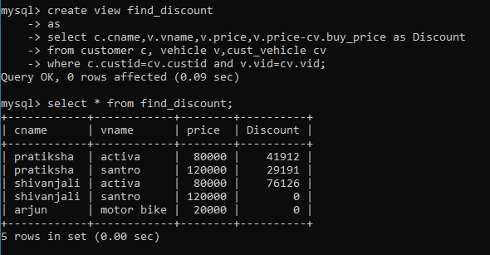

**7. find all customer name, vehicle name, salesman name, discount earn by all customer**

**8. creat view my_hr to display empno,ename,job,comm for all employees who earn**

**Commission**

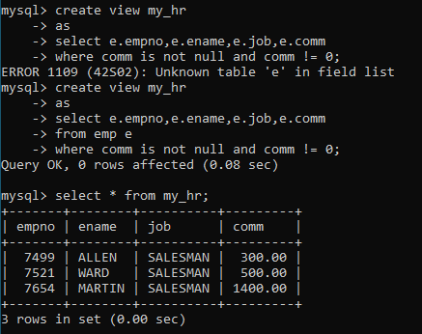

**9. create view mgr30 to display all employees from department 30**

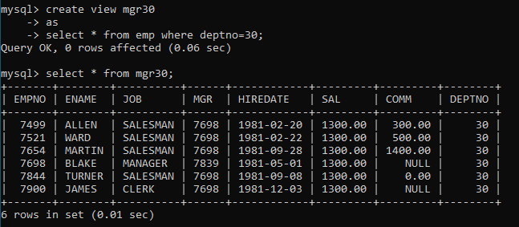

**10. insert 3 employees in view mgr30 check whether insertion is possible**

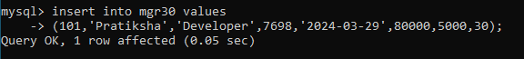

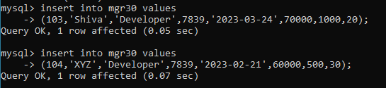

**11. insert 3 records in dept and display all records from dept**

**12. use rollback command check what happens**

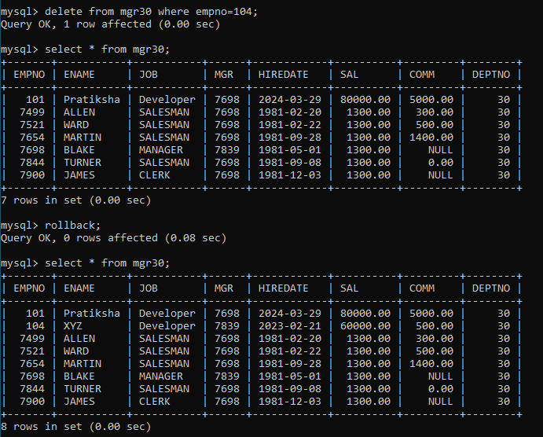

**13. do the following**

**insert row in emp with empno 100**

**insert row in emp with empno 101**

**insert row in emp with empno 102**

**add savepoint A**

**insert row in emp with empno 103**

**insert row in emp with empno 104**

**insert row in emp with empno 105**

**add savepoint B**

**delete emp with empno 100**

**delete emp with emp no 104**

**rollback upto svaepoint B**

**check what all records will appear in employee table**

**rollback upto A**

**check what all records will appear in employee table**

**commit all changes**

**check what all records will appear in employee table**

**check whether you can roll back the contents.**

